TITLE: spatial and seasonal genomic variation across cryptic clades of Acartia tonsa
Matthew Sasaki University of Massachusetts Lowell
Melissa Pespeni University of Vermont
Correspondence: Matthew_Sasaki@uml.edu
Code: https://github.com/ZoopEcoEvo/spatiotemp_genomics
This draft is current as of October 24, 2026
Abstract
ABSTRACT HERE.
Keywords: keyword1, keyword2, keyword3

Introduction

Methods

Statistical Analysis

Results
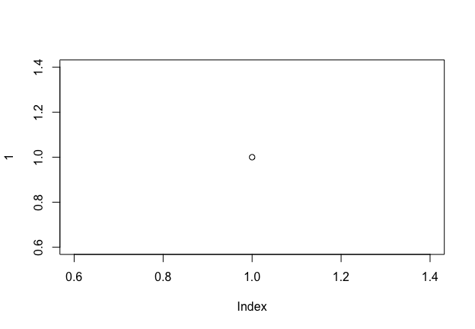
Figure 1: CAPTION HERE.
Table 1: CAPTION HERE
x
1

Discussion

References

Supplementary Material
Figure 2: CAPTION HERE.

