Phenotypic and genomic variation diverge across space and season in a coastal copepod
Matthew Sasaki University of Massachusetts Lowell
Melissa Pespeni University of Vermont
Correspondence: Matthew_Sasaki@uml.edu
Code: https://github.com/ZoopEcoEvo/spatiotemp_genomics
This draft is current as of November 10, 2026
Abstract
ABSTRACT HERE. (Draft once Results are settled: question - design - four cryptic clades differ heritably in CTmax and turn over through the season - CTmax tracks seasonal temperature plastically, but differs among sites more than acclimation predicts - genomes are structured by site, with no seasonal evolution beyond drift and no seasonal echo of spatial temperature associations - a single CTmax misplaces vulnerability; forecasts should be built on clades, plasticity and turnover.)
Keywords: thermal tolerance, cryptic species, phenotypic plasticity, seasonal evolution, low-coverage whole-genome sequencing, Acartia tonsa

Introduction
Forecasts often assume spatial gradients predict responses through time (Space-for-time substitution). This assumption can hold for phenotypes and fail for genomes, or vice versa, but is rarely tested.
Key Scales of variation
- Genetic diversity within species: clades/lineages shift ranges or replace one another; local adaptation
- Within populations: rapid evolution tracks changes in conditions (e.g. seasonal change)
- Individual acclimation buffers warming over shorter timescales
Seasonal evolution has been shown in Drosophila (Bergland et al., 2014; Machado et al., 2021; Rudman et al., 2022), with seasonal allele-frequency change that parallels latitudinal clines.
[Outline implications of these space-for-time substitutions here; Need for both phenotypic and genomic insights]. Warming tolerance (CTmax minus habitat temperature) is a common proxy for vulnerability to warming. These estimates are often based on a single CTmax per species - if there is intraspecific variation in tolerance (local adaptation, cryptic lineages, acclimation, etc.), a single value will lead to incorrect predictions about where and when populations are at risk.
Most field studies testing space-for-time substitution at both the phenotypic and genomic levels use plant systems; studies in animal systems have largely relied on Drosophila. Few studies examine aquatic systems, or have compared across closely related groups (e.g. how generalizable are patterns).
Acartia tonsa is a dominant coastal copepod and an emerging model for ecophysiology and evolutionary ecology. It has short generations (several per season) and large populations. It is also a complex of deeply diverged, co-occurring cryptic clades.
Organizing questions: At what scale does thermal tolerance vary in a widespread coastal copepod, and does variation across space predict change through time?
Hypotheses:
- Thermal limits vary strongly across both space and season
- Seasonal shifts in allele frequency will mirror changes across latitude
- Accounting for intra-specific variation and acclimation increases predicted vulnerability at high latitudes, while reducing predicted vulnerability at lower latitudes
We sampled eight sites from 27.5°N (Florida) to 47°N (Gulf of St. Lawrence), two or three times between July and December 2023. We measured CTmax for individual copepods, and the same individual was sequenced at low coverage, providing paired estimates of phenotypic and genomic variation across both space and time.

Methods

Field collections and site temperatures
Copepods were collected by surface plankton tow from eight sites along the western Atlantic and Gulf of Mexico, from Florida to the Gulf of St. Lawrence, at two or three times between July and December 2023 (Table 1). Water temperature and salinity were measured at the time of collection with a handheld thermometer and an optical refractometer, respectively. Collections were timed to span the warm season, when Acartia tonsa is most abundant. The six sites from the Chesapeake to the Gulf of St. Lawrence were sampled three times: early (July), peak (late August to early September) and late (October–November), after temperatures had cooled. The two Florida sites were sampled twice, at peak (August), after an extended period of high temperatures, and late (December).
To place the collections in a longer-term seasonal context, we used daily sea surface temperature from the Multi-scale Ultra-high Resolution (MUR) analysis [JPL MUR SST v4.1, 0.01°; 2014–2023; Chin et al. (2017); JPL (n.d.)]. For each site we averaged across pixels within 5 km of the collection point (or the nearest water pixel in cases where none fell within that radius). Coastal systems can be highly advective, so this larger spatial resolution may be a better reflection of the conditions experienced by these copepod populations. MUR temperatures were checked against continuous records from nearby monitoring stations (USGS, Chesapeake Bay Program, NOAA CO-OPS and Fisheries and Oceans Canada). Biases were within ±0.5 °C at all stations except the upper Chesapeake, where the Ganey’s Wharf series was corrected month by month against station ET5.1. No station was available to verify the Ritchie Wharf series. From these records we calculated each site’s long-term mean temperature, seasonal range and generation-averaged temperatures. Collection-day temperatures, measured in the shallow nearshore water where tows were taken, often exceeded the MUR value for the same day in summer: by 1.6–8.1 °C in the early and peak collections at the three northern sites (ME, TK, RW) and by 3.0–5.3 °C in the Florida peak collections, compared with −1.4 to +3.7 °C at the Chesapeake and Connecticut sites and −2.1 to +2.1 °C in late-season collections. CTmax models therefore use collection-day temperature, the temperature the copepods were acclimated to, while long-term context and the vulnerability scenarios use MUR data.
Table 1: Locations of the collection sites.
Site | Region | Lat | Long
Manatee River | Florida | 27.51 | -82.57
Ft. Hamer | Florida | 27.52 | -82.43
Tyler Cove | Maryland | 38.35 | -76.23
Ganey’s Wharf | Maryland | 38.81 | -75.91
Esker Point | Connecticut | 41.32 | -72.00
Sawyer Park | Maine | 43.91 | -69.87
St. Thomas de Kent Wharf | New Brunswick | 46.45 | -64.64
Ritchie Wharf | New Brunswick | 47.00 | -65.56

Thermal tolerance
Plankton samples were held in an insulated flask to maintain them at the collection temperature. Within three hours of collection, mature Acartia tonsa females were sorted from the tow into a mixture of equal parts 63-µm filtered seawater and artificial seawater (bottled spring water adjusted to the collection salinity with Instant Ocean), to acclimate animals to the artificial seawater before the thermal limit assays.
Critical thermal maximum (CTmax) was measured for individual copepods using a custom setup (Sasaki et al., 2023), comprising a reservoir with a heating element and water pump, a clear plexiglass water bath holding thirteen 50-ml flat-bottom glass shell vials, and an Arduino temperature logger. During the assay the heating element warms water in the reservoir, which is pumped through the water bath and back into the reservoir. Copepods are placed individually into ten of the vials, and observed through the sides of the water bath. The remaining three vials held temperature sensors that recorded water temperature every five seconds.
To start each assay, the water bath was adjusted to the collection temperature, and copepods were transferred individually into the vials. Control individuals were held in vials at ambient temperature throughout each assay; none showed changes in behaviour or mortality. After a brief rest, the heating element was turned on initiating the temperature ramp. Ramping rates started at about 0.3 °C per minute and slowed to about 0.1 °C per minute (Figure 18), typical for CTmax assays with copepods and other small invertebrates (Sasaki & Dam, 2021; Sunday et al., 2019; Terblanche et al., 2007). Copepods were monitored continuously until they no longer responded to gentle stimulus (water movement from slowly turning the vial), and the temperature at that point was taken from the continuous record as the individual’s CTmax. All individuals recovered after the assay, differentiating this endpoint from other metrics such as Upper Lethal Temperature.
After the assay, each individual was photographed using either a handheld microscope (Em1 600) or dissection microscope (Olympus SZX7) and prosome length measured in Fiji (Schindelin et al., 2012) against an image of a 1-mm scale bar. Body size is reported (@fig-supp-size) but was not used as a covariate in the main analyses; there was no effect of size on CTmax (see Statistical analysis of CTmax). Each copepod was preserved individually in 95% ethanol, kept at room temperature for several days in the field and stored at -20 °C in the laboratory. Generally about 20 individuals were measured per collection (two assays of ten individuals each). The late-season tow in Maine was dominated by the congener Acartia hudsonica; all A. tonsa recovered were assayed, but sample sizes at that time point were reduced.

DNA extraction, library preparation and sequencing
DNA was extracted from each individual copepod with a modified magnetic-bead protocol (Ali et al., 2015). Individual copepods were soaked in molecular-grade water for 1 hour at room temperature and then added, on ice, to the wells of a 96-well plate containing 100 µl of digestion buffer (90.5 µl Lifton’s buffer, 7 µl of 20 mg/ml Proteinase K and 2.5 µl of 1 M DTT), making sure each copepod was fully submerged before the wells were sealed. Plates were incubated overnight at 55 °C. After incubation, 80 µl of hybridization buffer (2.5 M NaCl, 20% PEG 8000, 0.025 M DTT) and 20 µl of resuspended AMPure XP beads were added to each well; plates were briefly vortexed and incubated for five minutes at room temperature. Plates were placed on a magnetic rack, the supernatant was discarded, and the beads were washed three times with 150 µl of freshly prepared 80% ethanol. After the final wash the beads were air-dried for 11 minutes, resuspended in 20 µl low TE, incubated for five minutes at room temperature and returned to the magnetic rack, and the supernatant containing the purified DNA was transferred to a new plate.
Low-coverage whole-genome libraries were prepared with Twist Bioscience 96-plex library preparation kits following the manufacturer’s instructions. The resulting 436 libraries were sequenced by Novogene (Sacramento, CA, USA) on two lanes of an Illumina NovaSeq X Plus 25B flow cell (150-bp paired-end).

Read processing, mapping and site filtering
- Read pairs per library varied over two orders of magnitude; 23 libraries failed (< 500,000 reads) and were excluded (Figure 7 A). Mapping rate and usable depth per read were highest in clade X, the clade the reference genome was sequenced from (Figure 7 B, C).
- Reads were demultiplexed (fqtk) and cleaned (fastp) (Chen et al., 2018; Kiu, 2022) before mapping to a recent A. tonsa reference genome (GCF_053477335.1), with added mitogenome contigs for each clade (see below).
- Repeats, NUMTs and paralogs were masked
- Determination of per-clade depth bounds
- SNPs were called within each clade from genotype likelihoods (ANGSD). Retained SNPs had a minor-allele frequency ≥ 0.05, data for at least half of the clade’s individuals, and were within the clade’s depth bounds. These filters yielded 2,350,761 SNPs in clade X, 599,934 in clade F, 341,633 in clade S and 165,869 in clade IV. For analyses that assume independent SNPs, one SNP was kept per 10-kb window (X: 71,277, F; 57,721, S; 35,105 and IV: 33,320).
- The seasonal and concordance tests (see below) used the unlinked SNPs with at least three individuals in every collection and mean frequency 0.05–0.95 (42,357 in X, 38,608 in F and 26,484 in S; the IV clade was excluded from these analyses due to limited collection pairs, not due to SNP filtering).
- The CTmax association scan used all SNPs called within each lineage (2.21 million in X, 314,000 in F-N, 223,000 in S, 183,000 in F-FH and 89,000 in IV).
- Exclusions: A. hudsonica, the 23 failed libraries, two individuals that could not be assigned to a clade, and two individuals from the peak Manatee River collection that seem to have been mixed during library preparation (MR_peak_2_04 and MR_peak_2_05).

Clade and lineage assignment
Acartia tonsa comprises several deeply divergent cryptic clades, typically distinguished by mitochondrial COI sequence (Figueroa et al., 2020). Mitogenome contigs were assembled for each clade (MEGAHIT and NOVOPlasty (Dierckxsens et al., 2016; Li et al., 2015)) from individuals whose COI matched published clade haplotypes, and added to the nuclear reference so that mitochondrial reads map to their own clade’s contig rather than to nuclear copies (NUMTs). Each individual was assigned to the clade whose contig received at least 90% of its reads in the COI region (with at least 20 reads). Clade calls agreed with genome-wide structure (PCAngsd and NGSadmix (Meisner & Albrechtsen, 2018; Skotte et al., 2013)) in every retained individual (Figure 21 B). Genome-wide structure further split clade F into four geographically separated lineages (F-N, F-NE, F-FH and F-MR; Figure 21 A). Previous single-gene studies observed similar intra-clade diversity in the F clade (Chen & Hare, 2011). Relationships among clades and lineages were estimated from the COI maximum-likelihood tree (IQ-TREE (Minh et al., 2020)) and from genome-wide distances [neighbour-joining on net distances between lineages from the PCAngsd covariance, with negative branch lengths set to zero; Figure 23]. Given the limited geographic coverage within the lineages and that previous genetic and physiological work treats F as a single clade (Chen & Hare, 2008), we retain clade as the primary analysis unit throughout. The exception is the CTmax association scan, which was run within lineages so that population structure within F did not confound genotype–CTmax associations.

Pooled mitogenomes and mitochondrial proteins
To compare mitochondrial proteins across clades, we assembled one mitogenome per clade (per lineage within F), from pooled reads. Each of six pools of individual sequences combined the mitochondrial read pairs of the 12 individuals from that site with the most mitochondrial reads (individuals assigned to clade X from RW, S from MD, IV from TK, and the F lineages F-N from GW, F-FH from FH and F-MR from MR). We excluded 16 individuals carrying trematodes (Section 2.11), because the parasites’ mitogenome otherwise assembled alongside the copepod mitogenome. Read pairs were taken from each individual’s alignments: pairs with a read on the clade mitogenome contig or in a NUMT-masked region, plus pairs with both mates unmapped. Each pool was assembled with MEGAHIT, GetOrganelle and NOVOPlasty (Dierckxsens et al., 2016; Jin et al., 2020; Li et al., 2015). Mitochondrial contigs were those matching the clade contigs (BLASTN (Camacho et al., 2009)) at mitochondrial read depth, plus contigs joined to them by read pairs. Candidate assemblies were compared on length, circularity, read support across the circular junction and evenness of depth. The best results were polished by mapping the pool’s reads back to the contig (BWA-MEM and samtools consensus (Danecek et al., 2021; Li, 2013)). Where the best candidate was linear, the other unjoined mitochondrial contigs were added as separate pieces. Genes still missing were then sought in the full assembly with the annotated genes of the closed S mitogenome as queries, accepting only contigs at mitochondrial depth (at least ten times the median depth of nuclear contigs). Genes were annotated with MITOS2 (Donath et al., 2019). For each pool and gene, we kept the copy covering most of the S gene (BLASTN), and discarded pieces that supplied no kept gene (nuclear copies and stray assembly paths). Proteins were translated with the invertebrate mitochondrial code and aligned to the S protein sequence. Clades were compared at positions where all of a clade’s pools had the same residue, so positions variable among the F lineages were excluded from comparisons involving F.
Individual mitogenomes were called by mapping all reads of each assigned individual (BWA-MEM2) to the pooled mitogenome of its lineage (Vasimuddin et al., 2019). After removing duplicates and reads with mapping quality below 20, a consensus was called (samtools consensus (Danecek et al., 2021)) at sites covered by at least 8 reads where one base had at least 80% of the reads, and set to N otherwise, so mixed sites (heteroplasmy, nuclear copies) were not called. Individuals with at least 80% of protein-coding bases called were kept (385 of 392). Haplotype and nucleotide diversity, and differentiation between collections, were computed from the 13 concatenated protein-coding genes using sites called in both individuals of each pair. Differentiation was measured with Fst (Hudson et al., 1992), with the null distribution assembled by shuffling individuals between collections (999 shuffles); seasons within sites and sites within seasons were tested by shuffling season labels within sites or site labels within seasons. Within lineages, nonsynonymous and synonymous polymorphism were counted per gene against Nei–Gojobori sites (Nei & Gojobori, 1986); between clades, McDonald–Kreitman tests (McDonald & Kreitman, 1991) compared polymorphism within clades with fixed differences between them (Fisher’s exact test; neutrality index, (Rand & Kann, 1996)). Genes with fewer than 80% of bases called in a lineage (atp8 and nad4l in X and F-MR, nad4l in F-N) were left out of the selection tests.

Population genetics within clades
- Site frequency spectra, θ, Tajima’s D and FST were estimated from genotype likelihoods under the GATK model (ANGSD), which is less biased than the SAMtools model at low coverage (Lou et al., 2021); SNP calling, structure and association analyses used the SAMtools model.
- Diversity, Tajima’s D, FST, LD decay, relatedness and inbreeding (ANGSD, ngsRelate, ngsLD); local PCA to detect structural variants; LD decay was used only in relative terms, to space unlinked SNPs.
- Local PCA flagged one structural signal: in clade X, most of chromosome 6 (0.1–53.3 Mb) was identified as an outlier. The chromosome was examined with a regional PCA (PCAngsd). We examined each individual’s heterozygosity on chromosome 6 relative to its genome-wide heterozygosity, and LD up to 2 Mb, all compared with a control region on chromosome 1 Figure 22. The seasonal GLMs, the concordance test, and the association scan in clade X were run both with and without chromosome 6.

Seasonal allele-frequency change
- Split-half calibration of low-coverage sampling noise (c $≈$ 0.58–0.70); calibrated temporal Fc and Ne.
- Per-SNP binomial GLMs against time in season and against generation-averaged temperature; exact within-site permutations (every ordering of collections within sites: 12 for time and 24 for temperature in X, 24 and 48 in F).
- Allele-frequency variance partitioning, spatial vs seasonal, with per-population sampling variance; chromosome jackknife.
- Space-for-time concordance: per-SNP spatial (site-mean MUR temperature) and seasonal temperature slopes; seasonal null from every ordering of collections within sites (24 in X, 48 in F) and spatial null from every assignment of site temperatures (6 in X, 24 in F). We define agreement as the share of the top 1% spatial SNPs whose seasonal slope has the same sign. In the figure, each SNP’s seasonal z-score is signed by the direction of its spatial slope; values beyond ±4.5 are collapsed into the end bins.

Statistical analysis of CTmax
Thermal limits were analysed for individuals verified as adult A. tonsa females with a clade assignment. 32 phenotyped individuals were excluded: 5 were identified after the assay as late-stage juveniles, 23 could not be assigned because their sequencing libraries failed, 2 were A. hudsonica, and 2 libraries contained DNA from two individuals of different clades. The analysis set comprised 395 individuals in four clades (X 118, F 151, S 71, IV 55).
CTmax was analysed with linear mixed-effects models (lme4 (Bates et al., 2015)). The first model included clade, collection temperature (centered) and their interaction as fixed effects, with random intercepts for site (non-thermal variation among sites), collection (site × season), assay replicate (time between collection and assay) and vial position in the water bath (“tube”). Collection temperature varies only between collections, so the collection term prevents individuals from acting as independent replicates of temperature. Model fit was checked visually with the performance package (Lüdecke et al., 2021), and clade marginal means (at 22 °C) and temperature slopes (acclimation responses) were extracted with emmeans (Lenth, 2025).
To compare the response of CTmax to seasonal and to spatial temperature variation, each collection’s temperature was split into a seasonal component and a spatial component. The seasonal components was calculated as the mean collection temperature of that season (early, peak or late) across all sites. The spatial component was calculated as the collection’s deviation from the season mean [i.e. how much warmer or cooler each site was than the other sites during that season; Figure 9 A]. Both components were fitted together, with clade and the random effects above, first with common slopes and then with clade-specific slopes; the difference between the spatial and seasonal slopes and its standard error were taken from the model’s covariance matrix. Seasons were defined by the seasonal temperature cycle at each site rather than by calendar date, and the Florida sites were not sampled in the early season. As a sensitivity analysis we used the standard within/between-site decomposition (Van De Pol & Wright, 2009): each site’s mean collection temperature (spatial) and each collection’s deviation from it (seasonal). Variance in CTmax was partitioned among clade, spatial and seasonal temperature (the variance of each fitted fixed effect), other site and collection differences, the assay and individuals (Nakagawa & Schielzeth, 2013), with 95% intervals from 200 parametric bootstraps. Finally, collections containing two or more clades ($≥$ 3 individuals each) served as natural common gardens: animals collected together share recent conditions, so clade differences estimated with collection as a fixed effect quantify the difference between thermal limits across the clades under shared acclimation conditions.
Seasonal changes in clade composition were tested at each site with Fisher’s exact test (clade × season, simulated p-value) and across sites with the sum of per-site chi-square statistics against 10,000 permutations of season labels within sites. The CTmax expected from composition alone (the mean of each collection’s clade effects, temperature-adjusted, from the model with seasonal and spatial temperature) was regressed, weighted by the number of individuals, on the seasonal and spatial components of collection temperature. These composition slopes add to the within-clade slopes; their sum is the slope of the community’s CTmax. 95% intervals come from 2,000 bootstraps that resampled individuals within collections and drew clade effects from their sampling distribution. Each slope was tested against 10,000 permutations of clade labels: among seasons within sites for the seasonal slope, and among sites within seasons for the spatial slope.
To check whether body size affected these estimates, prosome length was centered within clade, split into each individual’s deviation from the mean of its clade in its collection and that collection mean, and added to the clade × temperature model and to the seasonal–spatial model (maximum-likelihood fits, likelihood-ratio tests).

Genetic basis of CTmax
Within lineages that had at least 30 phenotyped and sequenced individuals and collections with at least 8 individuals (clades X, S and IV, and the F lineages F-N and F-FH), CTmax was regressed on genotype dosage (the expected number of minor alleles from ANGSD genotype posteriors (Korneliussen et al., 2014)) at every SNP, with collection and log mean sequencing depth as covariates. This compared individuals within collections, removing differences across sites or collections. Genotypes were not imputed; the association scan used expected dosages from genotype posteriors.
A genome-wide null distribution came from 100 replicates with CTmax shuffled among individuals of the same collection. Power was estimated by simulation on each lineage’s own data: for 2,000 SNPs sampled across the genome, true genotypes were drawn from each individual’s genotype posterior, a causal effect of 0.25–3 °C per allele was added to within-collection-shuffled CTmax, and the scan’s test was repeated against a genome-wide 5% threshold (the 5th percentile of the smallest p across SNPs in each permutation). Between clades, mitochondrial protein-coding sequences were compared among clade consensus sequences.
For nuclear genes, a consensus sequence was called for each clade from all of its individuals’ reads using ANGSD (at least three reads, within the final site list and the clade’s depth bounds). For the longest protein of every RefSeq gene, codons called in at least three of the four clades were compared, and a nucleotide difference carried by one clade while the other called clades shared the base was assigned to that clade’s branch as nonsynonymous (N) or synonymous (S). Requiring all four clades would have excluded many genes, because reads from S and IV, the clades most divergent from the reference, map less often in coding sequence. Genes were annotated with GO terms and KEGG pathways by eggNOG-mapper v2.1.12 (DIAMOND, more-sensitive mode; eggNOG 5.0 (Buchfink et al., 2021; Cantalapiedra et al., 2021; Huerta-Cepas et al., 2019)). For each GO term and KEGG pathway with at least 10 genes and 20 substitutions, we tested (i) amino-acid divergence (N per codon compared, summed over branches) and (ii) N/(N + S) on each clade’s branch, against genes annotated in the same ontology, using the sampling variance of a ratio estimator for random gene sets of the same size; p values were adjusted by Benjamini–Hochberg correction within each test, and significant terms were checked against 2,000 random gene sets. Branch-specific acceleration of single genes was tested by comparing N/(N + S) on one branch with the same gene’s other branches (one-sided Fisher test).
Fifteen transcripts that responded to selection in a previous experimental evolution study using A. tonsa (Brennan et al., 2022) were placed on the reference genome with megablast and assigned to the RefSeq genes they overlap (18 genes). SNPs in these genes (± 2 kb) were compared with SNPs in 1,000 random sets of the same number of other genes for the spatial temperature association, seasonal change, sign agreement of seasonal and spatial slopes, and the within-lineage CTmax association; clade-specific amino-acid substitutions in the genes were compared with random background gene sets.

Additional analyses
Parasites and epibionts were detected from reads that did not map to the A. tonsa reference, by screening for small-subunit rRNA (phyloFlash (Gruber-Vodicka et al., 2020), SILVA 138.1 (Quast et al., 2012)); an organism group was called present at ≥ 5 read pairs and ≥ 2 per million library pairs (Figure 15 A). Their effect on CTmax was estimated within collections with both carriers and non-carriers (CTmax ~ status + clade + (1 | collection)). To test for phenotypic signatures of seasonal selection, the spread of CTmax within clades (absolute deviation from the collection median) was compared among seasons within each clade × site with a mixed model (|deviation| ~ season + (1 | clade × site)). Long-term effective size was estimated from nucleotide diversity (π = 4N_{e}µ) for mutation rates of 10⁻⁹–10⁻⁸ per site per generation, and compared with temporal N_{e}.

Power of the seasonal tests
The power of the seasonal tests was estimated by injecting selection into the observed allele frequencies (unlinked SNPs) and rerunning each test exactly as in the analysis, so that drift, sampling noise and the sampling design were those of the real data. For the seasonal GLM and temporal Fc, a random fraction of SNPs (0.1–10%) had their logit frequency shifted by a fixed amount between each site’s first and last sample, in the same direction at every site. For the concordance test, the most temperature-associated SNPs across sites (top 1–100% by spatial z) were given a seasonal temperature response equal to a fraction (0.05–1) of their spatial slope. Detection meant ranking above every within-site permutation (seasonal GLM, concordance) or an added excess Fc larger than the observed excess plus 1.96 standard errors (inverse-variance pooled over sites); ten replicates per scenario.

Warming tolerance scenarios
To illustrate how clade differences and acclimation change estimates of vulnerability, we calculated daily warming tolerance (CTmax minus habitat temperature (Deutsch et al., 2008)) at each site from the bias-corrected MUR temperatures for August–September 2014–2023 (the warmest months and the period of peak abundance), and pooled nearby sites into six regions (Florida: MR and FH; Chesapeake: MD and GW; Connecticut; Maine; Shediac: TK; Miramichi: RW), weighting sites equally after applying each site’s own composition and temperature terms. We compared three scenarios. Scenario 1 assumes a single CTmax for the species, the mean of all peak-season individuals, so variation in warming tolerance comes only from temperature. Scenario 2 uses each clade’s peak-season mean CTmax (its mean across all collections when it had fewer than five peak-season individuals), weighted by the clade make-up of the site’s peak-season collection. Scenario 3 adds acclimation: CTmax was predicted for each clade and day from the season-mean model, splitting each day’s MUR temperature into its mean across the eight sites (seasonal) and the site’s deviation from that mean (spatial), with each component limited to the range at which the clade was sampled; uniform warming of 4 °C shifted the seasonal component. As a sensitivity analysis, scenario 3 was repeated with each site’s clade make-up across all collections instead of the peak collection. Because the acclimation model was fitted to collection-day temperatures but is applied here to MUR temperatures, which in summer run cooler than collection-day temperatures at the northern and Florida sites, scenario 3 evaluates acclimation at lower temperatures than copepods there experienced.
For each region and scenario we summarised the mean warming tolerance of the peak-season population, and the warming tolerance on the warmest August–September day of each year (averaged over years) for the least tolerant clade making up at least 10% of the peak collection. Intervals are 95% ranges from 1,000 bootstrap resamples of individuals (scenarios 1 and 2) or 1,000 draws of the model’s fixed effects (scenario 3). All scenarios were repeated with 4 °C of warming applied uniformly. These are illustrations rather than forecasts: they assume no change in clade composition and no evolutionary response, and only scenario 3 allows CTmax to respond to warming (through acclimation, up to the sampled limit).

Results

1. Thermal limits vary across space and through the season
Collection temperatures ranged from 10 °C to 36 °C, with strong seasonal variation at all eight sites (Figure 1). Thermal limits varied substantially among collections. CTmax generally declined through the season, highest in the early or peak collections and markedly lower in the late collections, and was higher at the southern sites than the northern ones in every season (Figure 1 C). Body size differed among clades, from a median prosome length of 0.72 mm in F to 1.00 mm in IV (Figure 19).
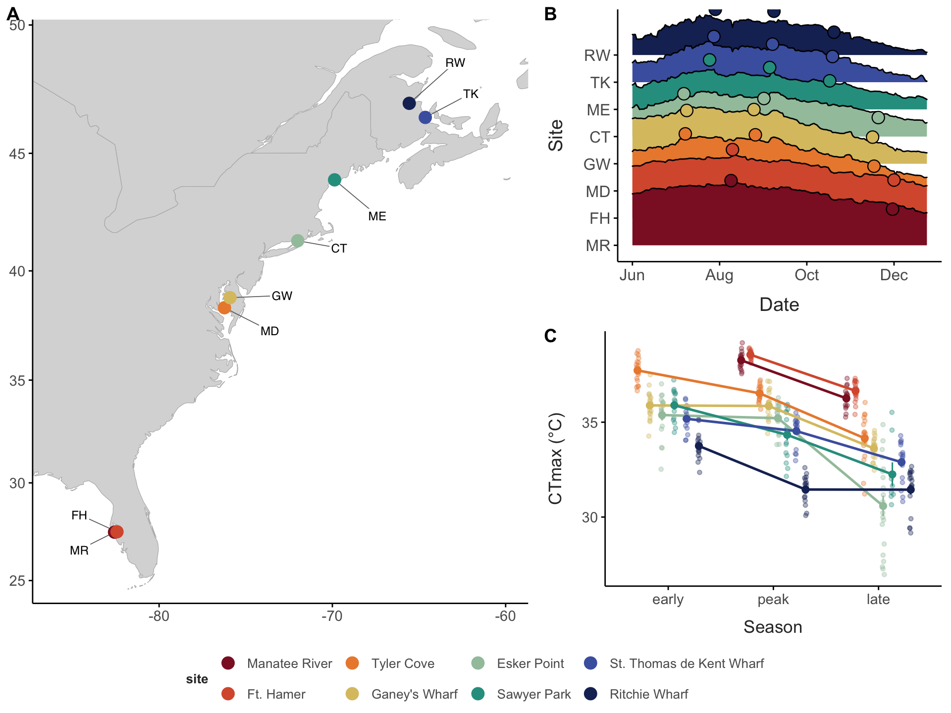
Figure 1: Collection sites and thermal limits. (A) Collection sites. (B) Water temperature at each collection. (C) CTmax of individuals (small points) and collection means ± SE (large points, connected within sites) by season. Colours: sites, south (red) to north (blue).

2. Cryptic clades are structured by site and turn over through the season
Genome-wide PCA and admixture separated the four clades completely (Figure 2 A; Figure 21). Within clades, individuals clustered by site rather than by season (Figure 2 B; Figure 21): F separated Florida (FH, MR) from the Chesapeake (MD, GW) and Connecticut, S separated the Chesapeake from Florida and Connecticut, X separated the Gulf of St. Lawrence (TK, RW) from Connecticut and Maine, and IV showed a similar north–south split. In F, this structure corresponds to four geographically separated lineages (Figure 21), whose mitochondrial and nuclear trees agree (Figure 23).
Clade composition varied strongly across both space and time (Figure 2 C). The low-latitude sites were dominated by F and S, and the northern sites by X and IV. Composition changed through the season at six of the seven sites with more than one clade (combined permutation test, p < 10⁻⁴; RW, p = 0.11; Table 4). In Connecticut the early collection contained all four clades, the peak collection was mostly S and the late collection mostly IV; at TK, X made up the early and peak collections and IV the entire late collection; in the Chesapeake, F dominated the early collections and S increased at the peak (MD) or late (GW). These seasonal shifts mirror the spatial pattern: clades common at warm sites dominate warm collections, and IV, a northern clade, dominates the cold late-season collections (Figure 20). Because the clades differ in CTmax (Result 3), these shifts change the thermal tolerance of the community as a whole (Result 4).
- Caveat: about 20 individuals per collection, one year of sampling.
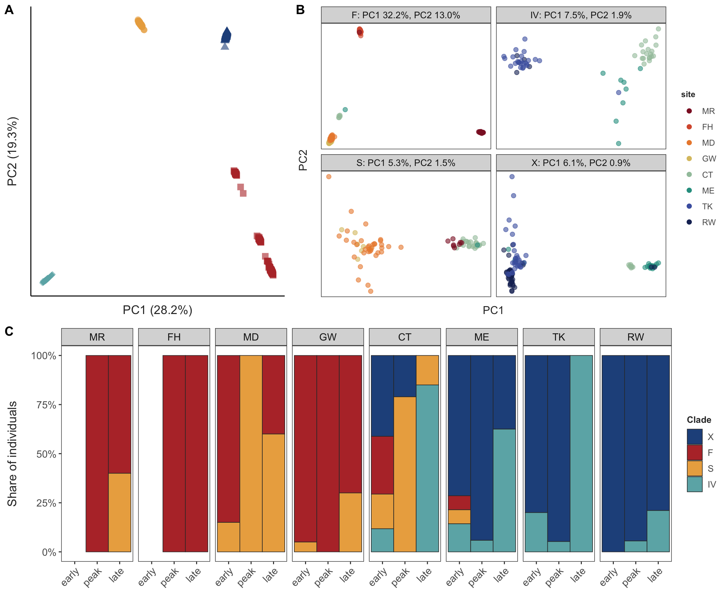
Figure 2: Genomic structure and clade composition. (A) PCA of all individuals (PCAngsd), coloured by clade. (B) PCAs within each clade; labels mark the median position of each site’s individuals (sites with at least three individuals). (C) Clade composition of each collection by site and season.

3. Clades differ heritably in thermal tolerance, and IV acclimates most
The clades differed strongly in thermal tolerance (Figure 3). At the mean collection temperature (22 °C), marginal mean CTmax was 35.9 °C in F (95% CI 35.0–36.8), 35.2 °C in S, 34.8 °C in X and 33.4 °C in IV; F exceeded S and X by 0.7–1.1 °C, IV was 1.5–2.5 °C below every other clade, and S and X did not differ (0.35 °C, p = 0.57). CTmax rose with collection temperature in every clade, at 0.13–0.15 °C per °C in F, S and X and about twice that in IV (0.27 °C per °C; IV vs others p = 0.01–0.02). A single regression ignoring clade gives a steeper slope (0.24 °C per °C) than any clade except IV, because the more tolerant clades were collected in warmer water.
Because clades occupy different sites and seasons, these comparisons could partly reflect the conditions each was collected in. Collections containing two or more clades resolve this (Figure 10 B): IV was 2.5 °C less tolerant than X (three shared collections) and 2.8 °C less tolerant than S (one), and F was 0.6 °C more tolerant than S (five) and 1.0 °C more tolerant than X (one). The S–X difference was small and not significant within shared collections (0.4 °C, two collections), as in the model. Clade differences in CTmax are therefore not explained by recent conditions. Body size did not change these results. Within collections, larger individuals had slightly lower CTmax (−0.36 °C per 0.1 mm of prosome length, SE 0.10, p < 0.001; the within-collection SD of prosome length was 0.04 mm, so about −0.15 °C per SD), but collections of larger individuals did not differ in CTmax (p = 0.69). With size in the model, clade means at 22 °C changed by at most 0.3 °C and acclimation slopes by at most 0.02 °C per °C, and the spatial and seasonal slopes changed from 0.25 to 0.22 and from 0.13 to 0.12 °C per °C.
- Caveat: “heritable” here means not explained by shared recent conditions; it could include developmental or maternal effects.
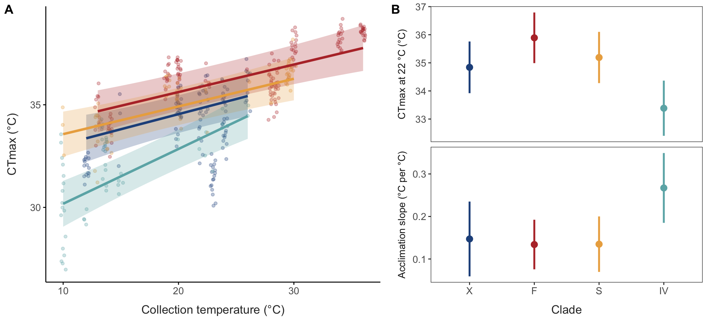
Figure 3: Clade differences in thermal tolerance. (A) CTmax against collection temperature (points: individuals; lines and bands: fitted values and 95% CI from the mixed model with clade × temperature, over each clade’s sampled range). (B) Marginal mean CTmax at the mean collection temperature (22 °C; top) and acclimation slope (bottom) for each clade, with 95% CI.

4. Thermal tolerance differs more across space than through the season
Collection temperature was split into its seasonal component (the season’s mean across sites) and its spatial component (how much warmer or cooler a site was than the other sites in the same season). CTmax rose with both, but more steeply with spatial temperature: 0.25 °C per °C (SE 0.06) against 0.13 °C per °C (SE 0.02) for seasonal temperature, a difference of 0.12 °C per °C (95% CI −0.00 to 0.24, p = 0.054; Figure 4 A; Figure 8). The spatial slope was the steeper of the two in every clade, and clearly so in X (difference 0.22, 95% CI 0.05–0.39) and S (0.18, 0.01–0.35); the intervals for F (0.13, −0.06 to 0.31) and IV (0.16, −0.08 to 0.39) were wider. The conventional within/between-site decomposition (Figure 9 B; Table 5), which compares eight site means instead of collections within seasons, gave the same direction but could not resolve the difference (0.11, −0.10 to 0.32; Table 5). Sites therefore differ in CTmax by more than seasonal acclimation to their temperatures predicts, consistent with the heritable differences in thermal tolerance among populations found in laboratory common-garden experiments (Sasaki & Dam, 2019).
Clade composition adds to both responses. Because the clades differ in CTmax (Result 3), the CTmax expected from composition alone, with each individual given its clade’s temperature-adjusted mean, rose by 0.05 °C per °C of seasonal temperature (95% CI 0.03–0.06; permutation p < 0.001) and by 0.12 °C per °C of spatial temperature (0.08–0.16; p < 0.001; Figure 4 B). Composition therefore favours tolerant clades in warm water in both directions and, like plasticity, more strongly across sites than through the season (difference 0.07, 0.03–0.11). The seasonal shift came mostly from IV dominating the cold late-season collections at CT, TK and ME. For the community as a whole, CTmax rose by 0.18 °C per °C through the season and by 0.37 °C per °C across sites (difference 0.19, 0.06–0.32): turnover adds about a third to the seasonal and about half to the spatial response of plasticity within clades.
Clade, temperature and site together structured most of the variation in CTmax (Figure 4 C). Without temperature terms, collection (32%), clade (35%) and site (19%) were the largest components, with 13% among individuals within a collection. With the temperature terms, spatial temperature explained 22% (95% CI 7–42%) and seasonal temperature 10% (5–22%) of CTmax variance; they absorbed most of the collection component (6% remaining), leaving 14% to other site differences. Clade accounted for 34%, with a wide interval (2–64%) because there are only four clades.
- Infection does not explain CTmax variation: within collections, individuals carrying parasites (Paradinium, trematodes) or epibiotic ciliates, detected from unmapped reads, did not differ in CTmax from non-carriers (Table 7; Figure 15 B). [in hand]
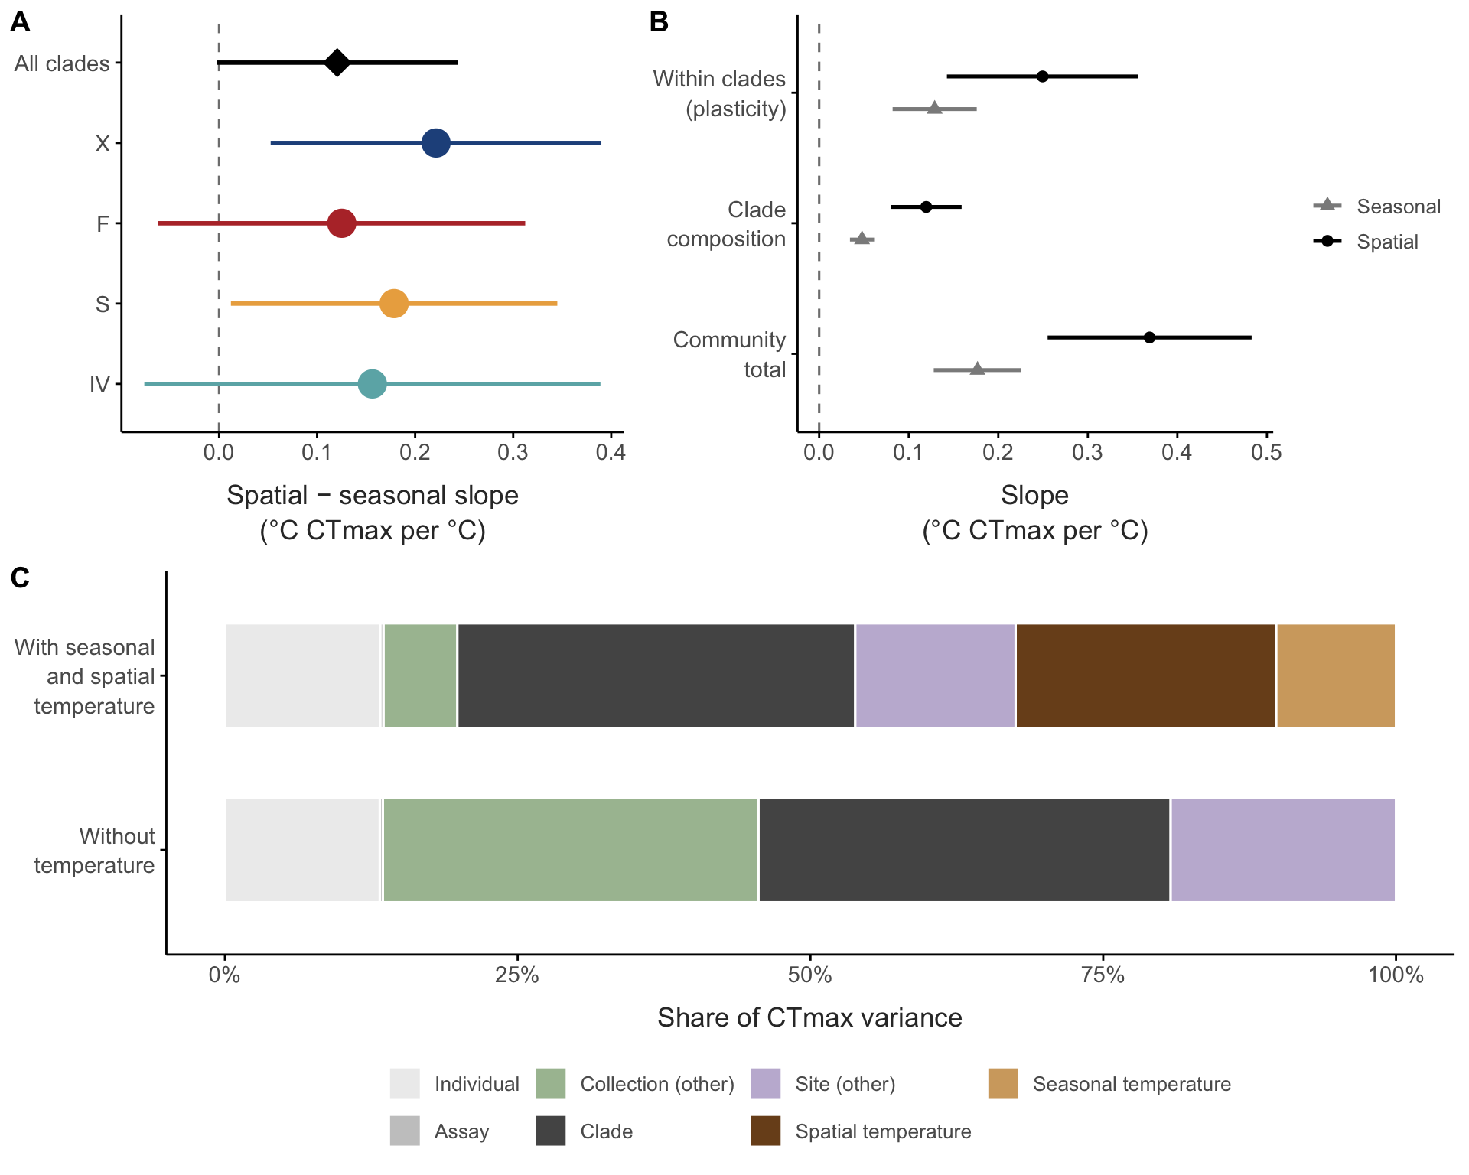
Figure 4: Thermal tolerance responds more strongly to spatial than to seasonal temperature, within clades and through clade composition. (A) Difference between the spatial and seasonal CTmax slopes (°C CTmax per °C; 95% CI), for all clades together and for each clade. Collection temperature was split into the season’s mean across sites (seasonal) and each collection’s deviation from that mean (spatial). (B) Seasonal (grey) and spatial (black) CTmax slopes within clades (plasticity), from clade composition alone (turnover), and their sum for the community as a whole (95% CI). (C) Share of CTmax variance explained by clade, spatial and seasonal temperature, other site and collection differences, the assay and individuals, without and with the temperature terms.

5. Genomic variation is spatial, and seasonal change does not echo spatial temperature associations
- Allele-frequency variance between sites far exceeds that between seasons within sites (Figure 5 A): about 13 times in X (0.030 vs 0.002, scaled by $\overset{‾}{p}(1−\overset{‾}{p})$), and the seasonal component is indistinguishable from zero in S. In F, between-site variance (0.41) includes the divergence between Florida and Chesapeake populations. IV had no site sampled in two seasons. [in hand]
- One chromosome in X carries a rare structural variant (@fig-supp-chr6). On chromosome 6, 12 of 118 X individuals separated on the regional PC1, all from the Gulf of St. Lawrence and Maine (TK 8, RW 3, ME 1). Ten were about 4% more heterozygous on chromosome 6 than non-carriers (median ratio to genome-wide heterozygosity 1.00 vs 0.95), as expected for heterozygous carriers, and the two most extreme (both TK peak) were less heterozygous, as expected for homozygotes of the rare arrangement. This fits a large inversion or other rearrangement spanning most of the chromosome, at about 6% of chromosomes overall and 17% at TK; at this frequency LD on chromosome 6 was only slightly higher than on the control. Excluding chromosome 6 did not change any seasonal or association result in X (seasonal GLM, time: observed count of SNPs with p < 0.001 ranked 2nd of 12 orderings; temperature: 22nd of 24; sign agreement 55.5% vs 55.3%, 10th of 24 orderings; association scan: smallest p 10^−7.2^, genome-wide threshold 10^−8.5^, with or without chromosome 6).
- After calibrating low-coverage sampling noise, seasonal change is about what drift predicts (calibrated excess Fc 0.000–0.011; Figure 12). No genome-wide excess of seasonal association in X or F, against time in season or against temperature (Figure 16 A); S uninformative. [in hand]
- Concordance: alleles associated with warmer sites did not rise after warm periods. The seasonal z-scores of the 1% of SNPs with the strongest spatial temperature association were centered on zero, like those of all other SNPs (Figure 5 B): the seasonal slope matched the spatial direction in 55% (X) and 49% (F), within the range of the permutations (32–68% of 24 orderings and 45–55% of 48; Figure 13). Across all SNPs, spatial and seasonal z-scores were uncorrelated (r = 0.03 in X, −0.02 in F). [in hand]
- This absence is informative: had these SNPs responded to seasonal temperature at 10% of their spatial slope in X (about 9 percentage points of seasonal change) or 5% in F (about 7 points), sign agreement would have exceeded every permutation (Figure 16 C). In F the spatial associations mostly reflect the Florida–Chesapeake split, so X is the cleaner test. [in hand]
- Seasonal GLM power (Figure 16 B): ≥ 80% power for changes of about 18 percentage points at ≥ 5% of SNPs or 23 points at ≥ 1% (s ≈ 0.04–0.06 per generation in F, 0.13–0.18 in X, which has fewer generations between samples); temporal Fc is less sensitive (23 points at ≥ 5% of SNPs). With 12–24 (X) or 24–48 (F) orderings (time and temperature models), the smallest attainable p is 0.042–0.083 and 0.021–0.042. Strong seasonal selection, and any seasonal echo of the spatial temperature associations, is excluded; weak, polygenic seasonal change is not. [in hand]
- Temporal Ne (about 200–5,400) is 26–244 times smaller than long-term Ne from nucleotide diversity, even at a high mutation rate of 10⁻⁸ (Table 6)
- High diversity and large long-term Ne in every clade; Tajima’s D negative in all populations (−0.5 to −1.3) except the F-N lineage (−0.1 to +0.1), consistent with large, expanding populations; no close kin (Figure 11).
- Phenotypic check: CTmax spread within clades did not narrow through the season, as strong selection removing intolerant individuals would cause (mean absolute deviation +0.02 °C at peak, +0.05 °C late vs early; CIs span zero; Figure 14 B). [in hand]
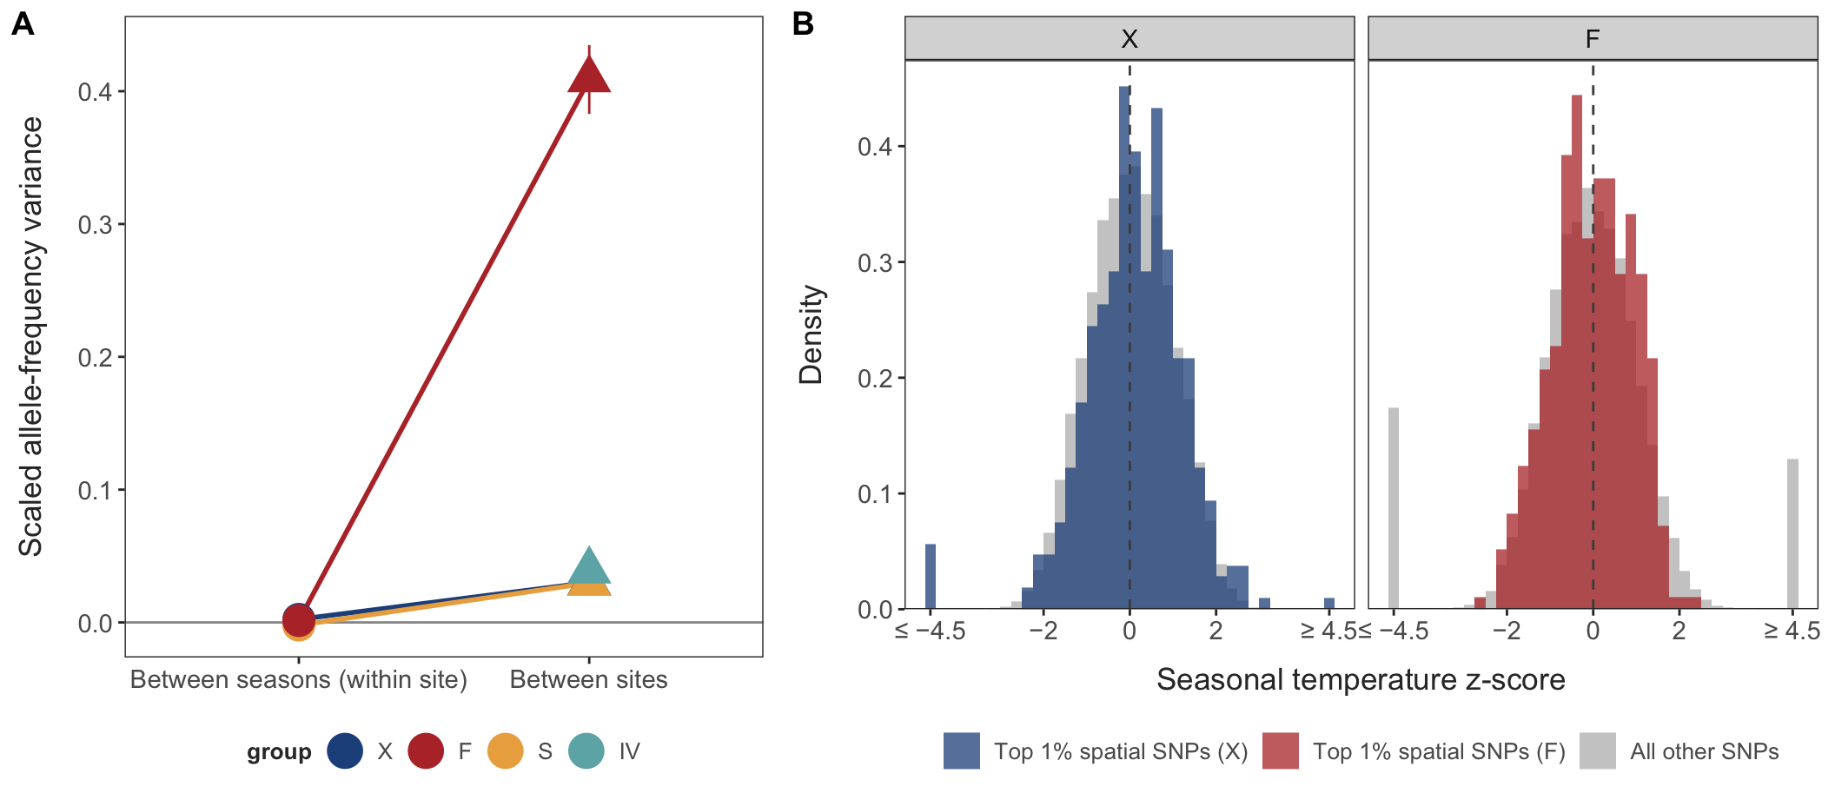
Figure 5: Genomic variation is spatial, and seasonal allele-frequency change does not echo spatial temperature associations. (A) Allele-frequency variance between sites and between seasons within sites, scaled by $\overset{‾}{p}(1−\overset{‾}{p})$, after removing sampling noise (unlinked SNPs; 95% CI from a chromosome jackknife); each clade on its own scale; IV had no site with enough individuals sampled in two seasons. (B) Seasonal temperature z-score of each SNP, signed by the direction of its spatial temperature association (positive: the allele favoured at warmer sites also rose after warmer periods), for the 1% of SNPs with the strongest spatial association (colour) and all other SNPs (grey), in X and F (unlinked SNPs); values beyond ±4.5 are pooled in the end bins. The z-score is the seasonal temperature slope divided by its standard error, from a binomial GLM with site as a covariate; without a seasonal response it is approximately standard normal. The power of this test is shown in Figure 16 C.

6. Genetic basis of thermal tolerance
- Within lineages (exploratory): no SNP was associated with CTmax beyond what within-collection permutations produced (Figure 17 A), but the scan could detect only loci of roughly 2–3 °C per allele in the two largest groups (X, F-N; 50% power at minor-allele frequency 0.3–0.5) and essentially none in S, F-FH and IV (Figure 17 B). A 3 °C locus would explain 60–96% of within-collection CTmax variance, and genotype accuracy at < 1× coverage was r² = 0.39–0.44. The scan therefore does not constrain the polygenic basis of within-clade variation. Detecting a locus explaining 5% of within-collection variance would need several thousand individuals per group at this coverage. [in hand]
- Between clades, mitochondrial: the pooled mitogenomes recovered all 13 protein-coding genes in every clade and F lineage (S closed, 18.6 kb; atp6 partial in X and IV, cox3 in F-FH; Table 8). Across the 13 proteins, clades differed at 8–18% of aligned amino-acid positions, from X–F (270 of 3,293) to S–IV (642 of 3,512; Figure 24 B). Each clade carried substitutions unique to it, from 1.1% of positions in F to 4.8% in S and 5.0% in IV (Table 9).
- Individual mitogenomes (385 individuals) were highly diverse (haplotype diversity 0.91–1.00 in all collections but X at RW peak and late; π 0.0006–0.011) and under strong purifying selection (pN/pS 0.08–0.12; neutrality index 0.34–0.60 in every clade pair, with no gene showing an excess of fixed amino-acid changes; Table 10; Table 11). IV carried no more clade-unique amino-acid changes than S (5.0% and 4.8% of positions). Mito differentiation tracked nuclear FST (Spearman ρ = 0.59 over 40 pairs) at about twice its value, with structure among sites in X, S and IV (p = 0.001) but none between the two F-N sites (Figure 25 A, B). S at MR carries mitogenomes found at no other site (mito FST 0.65–0.71, against nuclear FST of about 0.05), and in X at RW one mitogenome group rose from 8 of 16 individuals early to all 15 late (mito FST early–late 0.19; nuclear 0.020), differing from other X at only three conservative amino-acid positions (Figure 25 C).
- Candidate genes from experimental evolution: 15 transcripts that responded to selection in the laboratory (Brennan et al., 2022) map to 18 genes, including a mitochondrial HSP90 (Trap1), an HSP90 co-chaperone (AHSA1), complex I and III genes and vitellogenin. In the field these genes showed no excess spatial, seasonal or CTmax-associated SNP variation (17 tests, p = 0.17–0.84; Table 12), and no clade had an excess of amino-acid substitutions in the 12 with enough coverage (Table 13). [in hand]
- Genome-wide, protein divergence among clades followed functional class in the same way on every branch: fast in ribosome biogenesis and mitochondrial translation, slow in neuronal and developmental genes (Table 14). Genes annotated to heat response, protein folding and oxidative phosphorylation showed no excess of amino-acid change in any clade, and heat-shock genes were strongly conserved (41 genes; N/(N + S) 0.05–0.11 vs 0.18–0.21 genome-wide; p = 0.002–0.008 in F, S and IV, 0.10 in X; Table 13). Branch-specific acceleration of single genes was no more common than chance. Heritable clade differences in CTmax therefore cannot be traced to protein change in thermal-function genes with these data, pointing to regulatory or polygenic differences. [in hand]

7. Accounting for clades, acclimation and turnover changes where A. tonsa is vulnerable
With clade-specific CTmax and acclimation, daily warming tolerance over the sampled season was lowest in Florida and the Chesapeake, where the warmest days came within a few degrees of zero under 4 °C of warming, and highest in Maine and the Gulf of St. Lawrence (Figure 6 A). The scenarios differed most on the warmest days (Figure 6). With a single CTmax for the species, peak-season warming tolerance ranged 13 °C across regions, from 5.8 °C in Florida to 18.8 °C in Maine. Clade-specific CTmax narrowed this range by 31% (Table 2), raising warming tolerance in Florida by 1.9 °C and in the Chesapeake by 1.1 °C (F and S are the most tolerant clades) and lowering it in Maine and the Gulf of St. Lawrence by about 2 °C (X and IV are less tolerant than the species average). Adding acclimation left the range 30% narrower than with a single CTmax. With 4 °C of warming, the single-CTmax scenario brought warming tolerance on Florida’s warmest days to zero (−0.2 °C), whereas clade-specific CTmax kept it 1.7 °C above, and 2.6 °C with acclimation. Using each site’s clade make-up across all collections, instead of the peak-season collection, lowered the warmest-day margin by about 2 °C in Connecticut, Maine and Shediac, because IV, the least tolerant clade, is common there only in autumn.
- Caveat: MUR summer temperatures run below in-situ collection temperatures at the northern sites; the acclimation model was fitted to in-situ temperatures.
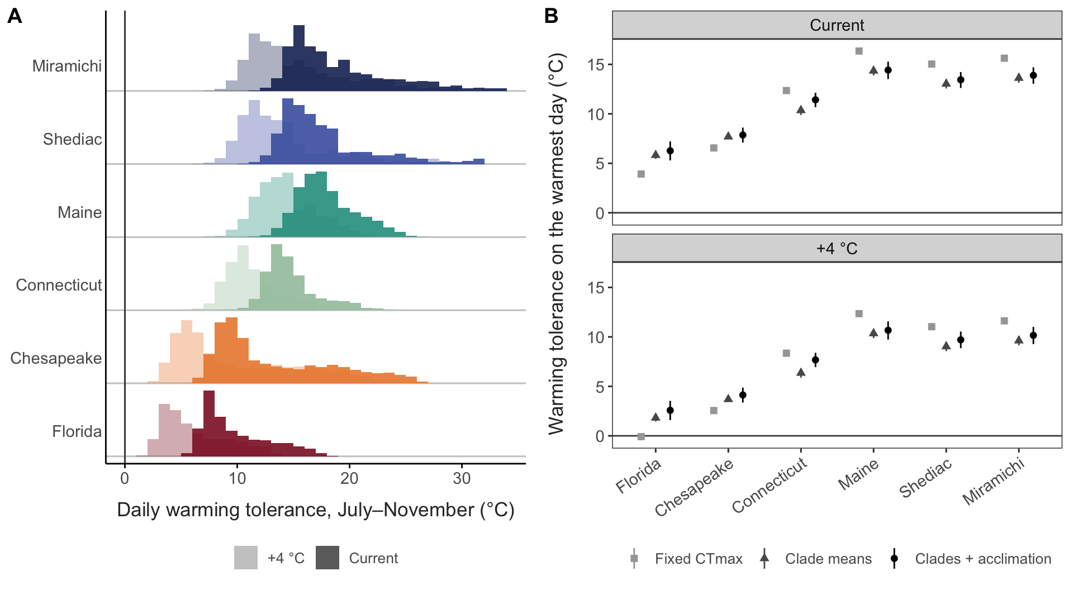
Figure 6: Warming tolerance (CTmax − habitat temperature). (A) Distribution of daily warming tolerance in each region over the sampled season (July–November, MUR SST 2014–2023) with clade-specific CTmax and acclimation; days weighted by the clade make-up of the matching collection. Dark: current conditions; pale: +4 °C uniform warming. (B) Warming tolerance on the warmest August–September day (mean over years) for the least tolerant clade making up at least 10% of the peak collection, under a single fixed CTmax, clade means, and clades with acclimation; 95% intervals.
Table 2: Spread of warming tolerance among regions under current conditions, and its change relative to a fixed CTmax. The last scenario uses annual instead of peak-season clade make-up.
Scenario | Metric | Range among regions (°C) | Change vs fixed (%)
Fixed CTmax | Aug–Sep mean | 13.3 | –
Clade means | Aug–Sep mean | 9.3 | -30
Clades + acclimation | Aug–Sep mean | 8.8 | -34
Clades + acclimation (annual make-up) | Aug–Sep mean | 8.7 | -35
Fixed CTmax | Warmest day, least tolerant common clade | 12.4 | –
Clade means | Warmest day, least tolerant common clade | 8.5 | -31
Clades + acclimation | Warmest day, least tolerant common clade | 8.2 | -34
Clades + acclimation (annual make-up) | Warmest day, least tolerant common clade | 8.3 | -33

Discussion
Thermal tolerance varied at every scale we examined, but the genome tracked only some of them (Table 3).
Table 3: Variation in thermal tolerance and in the genome at each scale of the study, and what it implies for responses to warming. Values summarise Results 3–6.
Scale | Thermal tolerance (CTmax) | Genome | Interpretation
Clade | Differs by up to 2.5 °C at a common temperature; IV acclimates most | Deeply divergent (mitochondrial proteins differ at 8–18% of positions) | Heritable differences; turnover among clades shifts community tolerance
Site within clade | Spatial temperature explains 22% of variance; responds more per degree than to season | Differentiated among sites (FST 0.01–0.07), many times more than among seasons | Plasticity plus a persistent site-level component
Season within site | Seasonal temperature explains 10% of variance, through acclimation and clade turnover | Change consistent with drift; no echo of spatial temperature associations (one maternal-lineage shift, X at RW) | No detectable seasonal adaptation
Individual | 13% of variance among individuals within a collection | No locus with an effect above 2–3 °C per allele detected (50% power in X and F-N; less in other lineages) | Polygenic or non-genetic

- Main message: thermal tolerance in this “species” is structured by cryptic clades (heritable variation), by plasticity, and by persistent differences among sites, not by seasonal evolution. Phenotype and genome agree that sites differ, but diverge through the season: plasticity and turnover of clades drives the observed seasonal changes in CTmax, with no corresponding signal in allele frequencies.
- Space vs season in the phenotype. CTmax rises about twice as steeply with spatial compared with seasonal temperature change. The spatial component beyond acclimation is consistent with heritable population differences (i.e. local adaptation) shown in common-garden experiments (Sasaki & Dam, 2019), though developmental plasticity and longer-term transgenerational plasticity may contribute. Spatial gradients in CTmax therefore overstate the short-term plastic response to warming within a site.
- Why no strong seasonal evolution, despite short generations?
  - Open populations: advection and mixing reset local allele frequencies; the gap between long-term and temporal Ne.
  - Overlapping generations and egg banks slow the response to selection within a season.
  - Plasticity absorbs seasonal temperature change, weakening selection on tolerance.
  - This highlights several factors that may vary between terrestrial and aquatic systems; contrast with Drosophila seasonality studies.
- Clade turnover as the seasonal response. Composition shifts with temperature and adds about a third to the seasonal CTmax change from acclimation, and about half to the spatial change. The community responds to season through sorting of heritably different clades (cf. seasonal species succession in plankton), not through allele-frequency change within them. Where do clades go between seasons: resting eggs, advection from offshore or other estuaries? Within a season, local allele frequencies changed far more than closed populations of the long-term size would allow, consistent with sites open to immigration and mixing of water masses.
- Genetic differences observed in common garden experiments across seasons may reflect this turnover, rather than rapid adaptation (Sasaki & Dam, 2020)
- Physiological variation in thermal limits and body size is similar to variation in life history traits across clades (Drillet et al., 2008)
- Implications for forecasting: A single species-level CTmax overstates vulnerability in warm regions and understates it in cool ones; seasonal turnover means peak-season composition, not annual composition, sets exposure.
- Implications for lab studies: experiments that treat “A. tonsa” as one unit can mix clades that differ by up to ~2.5 °C in CTmax.
- Space-for-time predictions and ecological acclimation: variation in clade composition of a sample is analogous to community-level ‘ecological acclimation’ through species turnover (Stemkovski et al., 2025); here the turnover happens among cryptic clades within a single nominal species.
- Future directions: structure within clade F. F comprises four geographically separated lineages with concordant mitochondrial and nuclear trees (Figure 23). The Florida lineages had the highest CTmax in the dataset - whether these are locally adapted populations or incipient cryptic species is unknown. However, cultures collected at these sites in the past differ in thermal physiology under common-garden conditions. Notably, the MR and FH collection sites are separated by only ~15 km. No mixed anceestry individuals for these two lineages were detected (but several individuals were recovered from the opposing sitel; this suggests finescale structuring of the nearshore environment is sufficient to maintain reproductive isolation.
- Caveats: the seasonal tests detect only strong selection (roughly 10–20 percentage-point seasonal changes), and few sites and seasons cap the permutation p values (0.083 for X); the spatial–seasonal slope difference rests on three phenological seasons and is marginal overall (p = 0.054), though consistent across clades; the within-clade genetic basis of CTmax was beyond reach at this sample size and coverage (the association scan is reported for completeness, with its power); CTmax as one measure of tolerance; collection-day temperature vs MUR; the mitochondrial comparison uses one pooled consensus per clade or lineage, so it reflects fixed or majority differences rather than variation within clades; clade consensus sequences at < 1x coverage against a single reference under-call S and IV in coding sequence, which limits the protein comparisons.

Data Availability
Data availability. Raw sequence reads are available in the NCBI Sequence Read Archive under BioProject PRJNA[XXXXXX] (BioSamples SAMN[…]–SAMN[…]). Mitogenome sequences and annotations are available in GenBank under accessions [XXXXXX–XXXXXX]. Phenotypic data (CTmax, prosome length), collection metadata and the processed tables used for all analyses and figures are available at [repository] (doi:[…]).
Code availability. The Snakemake workflow used for read processing, genotype-likelihood analyses and mitogenome assembly is available at github.com/ZoopEcoEvo/aton_lcwg (archived at doi:[…]); the R project containing all statistical models, figures and the manuscript source is available at github.com/ZoopEcoEvo/spatiotemp_genomics (archived at doi:[…]).

References
Ali, O.A., O’Rourke, S.M., Amish, S.J., Meek, M.H., Luikart, G., Jeffres, C., et al. (2015) RAD capture (rapture): Flexible and efficient sequence-based genotyping. Genetics, 202, 389–400.
Bates, D., Mächler, M., Bolker, B. & Walker, S. (2015) Fitting linear mixed-effects models using lme4. Journal of Statistical Software, 67.
Bergland, A.O., Behrman, E.L., O’Brien, K.R., Schmidt, P.S. & Petrov, D.A. (2014) Genomic evidence of rapid and stable adaptive oscillations over seasonal time scales in drosophila. PLOS Genetics, 10, e1004775.
Brennan, R.S., deMayo, J.A., Dam, H.G., Finiguerra, M.B., Baumann, H. & Pespeni, M.H. (2022) Loss of transcriptional plasticity but sustained adaptive capacity after adaptation to global change conditions in a marine copepod. Nature Communications, 13, 1147.
Buchfink, B., Reuter, K. & Drost, H.-G. (2021) Sensitive protein alignments at tree-of-life scale using DIAMOND. Nature Methods, 18, 366–368.
Camacho, C., Coulouris, G., Avagyan, V., Ma, N., Papadopoulos, J., Bealer, K., et al. (2009) BLAST+: Architecture and applications. BMC Bioinformatics, 10, 421.
Cantalapiedra, C.P., Hernández-Plaza, A., Letunic, I., Bork, P. & Huerta-Cepas, J. (2021) eggNOG-mapper v2: Functional annotation, orthology assignments, and domain prediction at the metagenomic scale. Molecular Biology and Evolution, 38, 5825–5829.
Chen, G. & Hare, M.P. (2008) Cryptic ecological diversification of a planktonic estuarine copepod, Acartia tonsa. Molecular Ecology, 17, 1451–1468.
Chen, G. & Hare, M.P. (2011) Cryptic diversity and comparative phylogeography of the estuarine copepod acartia tonsa on the US atlantic coast: PHYLOGEOGRAPHY OF ACARTIA TONSA. Molecular Ecology, 20, 2425–2441.
Chen, S., Zhou, Y., Chen, Y. & Gu, J. (2018) Fastp: An ultra-fast all-in-one FASTQ preprocessor. Bioinformatics, 34, i884–i890.
Chin, T.M., Vazquez-Cuervo, J. & Armstrong, E.M. (2017) A multi-scale high-resolution analysis of global sea surface temperature. Remote Sensing of Environment, 200, 154–169.
Danecek, P., Bonfield, J.K., Liddle, J., Marshall, J., Ohan, V., Pollard, M.O., et al. (2021) Twelve years of SAMtools and BCFtools. GigaScience, 10, giab008.
Deutsch, C.A., Tewksbury, J.J., Huey, R.B., Sheldon, K.S., Ghalambor, C.K., Haak, D.C., et al. (2008) Impacts of climate warming on terrestrial ectotherms across latitude. Proceedings of the National Academy of Sciences, 105, 6668–6672.
Dierckxsens, N., Mardulyn, P. & Smits, G. (2016) NOVOPlasty: de novo assembly of organelle genomes from whole genome data. Nucleic Acids Research, gkw955.
Donath, A., Jühling, F., Al-Arab, M., Bernhart, S.H., Reinhardt, F., Stadler, P.F., et al. (2019) Improved annotation of protein-coding genes boundaries in metazoan mitochondrial genomes. Nucleic Acids Research, 47, 10543–10552.
Drillet, G., Goetze, E., Jepsen, P.M., Højgaard, J.K. & Hansen, B.W. (2008) Strain-specific vital rates in four acartia tonsa cultures, i: Strain origin, genetic differentiation and egg survivorship. Aquaculture, 280, 109–116.
Figueroa, N.J., Figueroa, D.F. & Hicks, D. (2020) Phylogeography of acartia tonsa dana, 1849 (calanoida: Copepoda) and phylogenetic reconstruction of the genus acartia dana, 1846. Marine Biodiversity, 50, 23.
Gruber-Vodicka, H.R., Seah, B.K.B. & Pruesse, E. (2020) phyloFlash: Rapid small-subunit rRNA profiling and targeted assembly from metagenomes. mSystems, 5, e00920–20.
Hudson, R.R., Slatkin, M. & Maddison, W.P. (1992) Estimation of levels of gene flow from DNA sequence data. Genetics, 132, 583–589.
Huerta-Cepas, J., Szklarczyk, D., Heller, D., Hernández-Plaza, A., Forslund, S.K., Cook, H., et al. (2019) eggNOG 5.0: A hierarchical, functionally and phylogenetically annotated orthology resource based on 5090 organisms and 2502 viruses. Nucleic Acids Research, 47, D309–D314.
Jin, J.-J., Yu, W.-B., Yang, J.-B., Song, Y., dePamphilis, C.W., Yi, T.-S., et al. (2020) GetOrganelle: A fast and versatile toolkit for accurate de novo assembly of organelle genomes. Genome Biology, 21, 241.
JPL, N. (n.d.) GHRSST level 4 MUR global foundation sea surface temperature analysis (v4.1).
Kiu, R. (2022) Fqtk: A toolkit to perform common tasks on FASTQ reads.
Korneliussen, T.S., Albrechtsen, A. & Nielsen, R. (2014) ANGSD: Analysis of next generation sequencing data. BMC Bioinformatics, 15, 356.
Lenth, R. (2025) Emmeans: Estimated marginal means, aka least-squares means.
Li, D., Liu, C.-M., Luo, R., Sadakane, K. & Lam, T.-W. (2015) MEGAHIT: An ultra-fast single-node solution for large and complex metagenomics assembly via succinct de Bruijn graph. Bioinformatics, 31, 1674–1676.
Li, H. (2013) Aligning sequence reads, clone sequences and assembly contigs with BWA-MEM.
Lou, R.N., Jacobs, A., Wilder, A.P. & Therkildsen, N.O. (2021) A beginner’s guide to low-coverage whole genome sequencing for population genomics. Molecular Ecology, 30, 5966–5993.
Lüdecke, D., Ben-Shachar, M., Patil, I., Waggoner, P. & Makowski, D. (2021) Performance: An r package for assessment, comparison and testing of statistical models. Journal of Open Source Software, 6, 3139.
Machado, H.E., Bergland, A.O., Taylor, R., Tilk, S., Behrman, E., Dyer, K., et al. (2021) Broad geographic sampling reveals the shared basis and environmental correlates of seasonal adaptation in drosophila. eLife, 10, e67577.
McDonald, J.H. & Kreitman, M. (1991) Adaptive protein evolution at the adh locus in drosophila. Nature, 351, 652–654.
Meisner, J. & Albrechtsen, A. (2018) Inferring population structure and admixture proportions in low-depth NGS data. Genetics, 210, 719–731.
Minh, B.Q., Schmidt, H.A., Chernomor, O., Schrempf, D., Woodhams, M.D., Von Haeseler, A., et al. (2020) IQ-TREE 2: New models and efficient methods for phylogenetic inference in the genomic era. Molecular Biology and Evolution, 37, 1530–1534.
Nakagawa, S. & Schielzeth, H. (2013) A general and simple method for obtaining R² from generalized linear mixed-effects models. Methods in Ecology and Evolution, 4, 133–142.
Nei, M. & Gojobori, T. (1986) Simple methods for estimating the numbers of synonymous and nonsynonymous nucleotide substitutions. Molecular Biology and Evolution, 3, 418–426.
Quast, C., Pruesse, E., Yilmaz, P., Gerken, J., Schweer, T., Yarza, P., et al. (2012) The SILVA ribosomal RNA gene database project: Improved data processing and web-based tools. Nucleic Acids Research, 41, D590–D596.
Rand, D.M. & Kann, L.M. (1996) Excess amino acid polymorphism in mitochondrial DNA: Contrasts among genes from drosophila, mice, and humans. Molecular Biology and Evolution, 13, 735–748.
Rudman, S.M., Greenblum, S.I., Rajpurohit, S., Betancourt, N.J., Hanna, J., Tilk, S., et al. (2022) Direct observation of adaptive tracking on ecological time scales in Drosophila. Science, 375, eabj7484.
Sasaki, M.C. & Dam, H.G. (2019) Integrating patterns of thermal tolerance and phenotypic plasticity with population genetics to improve understanding of vulnerability to warming in a widespread copepod. Global Change Biology, 25, 4147–4164.
Sasaki, M.C. & Dam, H.G. (2020) Genetic differentiation underlies seasonal variation in thermal tolerance, body size, and plasticity in a short-lived copepod. Ecology and Evolution, 10, 12200–12210.
Sasaki, M. & Dam, H.G. (2021) Global patterns in copepod thermal tolerance. Journal of Plankton Research, 43, 598–609.
Sasaki, M., Woods, C. & Dam, H.G. (2023) Parasitism does not reduce thermal limits in the intermediate host of a bopyrid isopod. Journal of Thermal Biology, 117, 103712.
Schindelin, J., Arganda-Carreras, I., Frise, E., Kaynig, V., Longair, M., Pietzsch, T., et al. (2012) Fiji: An open-source platform for biological-image analysis. Nature Methods, 9, 676–682.
Skotte, L., Korneliussen, T.S. & Albrechtsen, A. (2013) Estimating individual admixture proportions from next generation sequencing data. Genetics, 195, 693–702.
Stemkovski, M., Bernhardt, J.R., Blonder, B.W., Bradford, J.B., Clark-Wolf, K., Dee, L.E., et al. (2025) Ecological acclimation: A framework to integrate fast and slow responses to climate change. Functional Ecology, 39, 1923–1939.
Sunday, J., Bennett, J.M., Calosi, P., Clusella-Trullas, S., Gravel, S., Hargreaves, A.L., et al. (2019) Thermal tolerance patterns across latitude and elevation. Philosophical Transactions of the Royal Society B: Biological Sciences, 374, 20190036.
Terblanche, J.S., Deere, J.A., Clusella-Trullas, S., Janion, C. & Chown, S.L. (2007) Critical thermal limits depend on methodological context. Proceedings of the Royal Society B: Biological Sciences, 274, 2935–2943.
Van De Pol, M. & Wright, J. (2009) A simple method for distinguishing within- versus between-subject effects using mixed models. Animal Behaviour, 77, 753–758.
Vasimuddin, Md., Misra, S., Li, H. & Aluru, S. (2019) 2019 IEEE international parallel and distributed processing symposium (IPDPS). IEEE, Rio de Janeiro, Brazil, pp. 314–324.

Supplementary Material
Table 4: Seasonal change in clade composition at each site: Fisher’s exact test of clade × season (simulated p, 10⁴ replicates). Sites with a single clade or a single season cannot be tested. Combined test across sites (sum of per-site χ² statistics against 10⁴ permutations of season labels within sites): p < 10⁻⁴.
Site | Seasons | Clades | Individuals | p
MR | 2 | 2 | 37 | 0.0039
FH | 2 | 1 | 39 | –
MD | 3 | 2 | 60 | <1e-04
GW | 3 | 2 | 60 | 0.0132
CT | 3 | 4 | 56 | <1e-04
ME | 3 | 4 | 39 | 0.0081
TK | 3 | 2 | 54 | <1e-04
RW | 3 | 2 | 53 | 0.1141

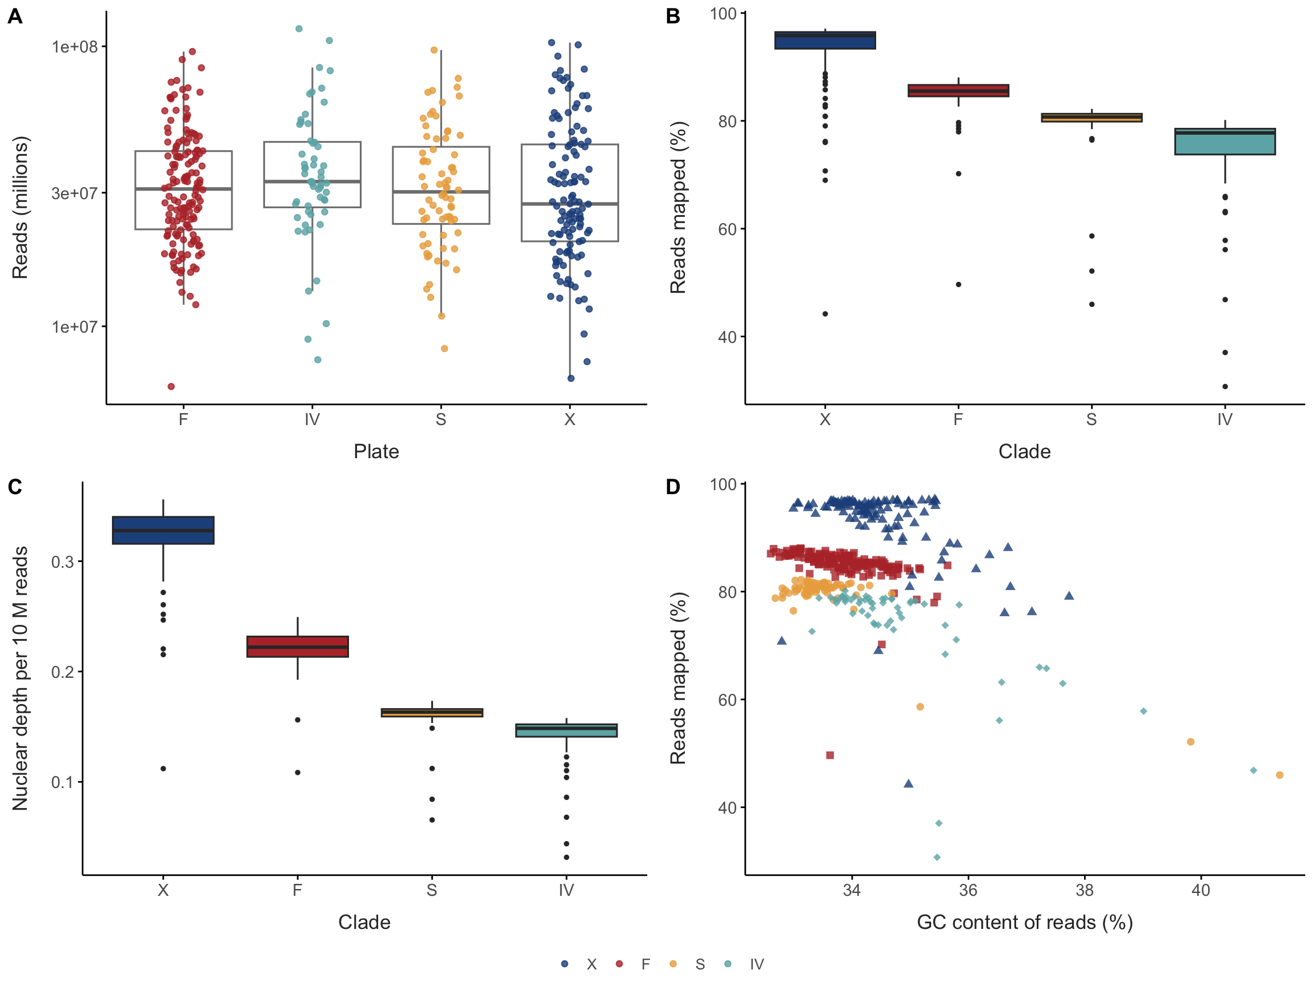
Figure 7: Sequencing overview. (A) Read pairs per library by library-preparation plate (log scale), coloured by clade; grey, failed libraries (< 500,000 reads). Boxes summarise the successful libraries. (B) Percentage of reads mapped to the reference and (C) usable nuclear depth per 10 million reads, by clade: the reference genome is closest to clade X, so the other clades yield less usable depth per read. (D) GC content of reads against percentage mapped; libraries with high GC and low mapping carry DNA from other organisms.
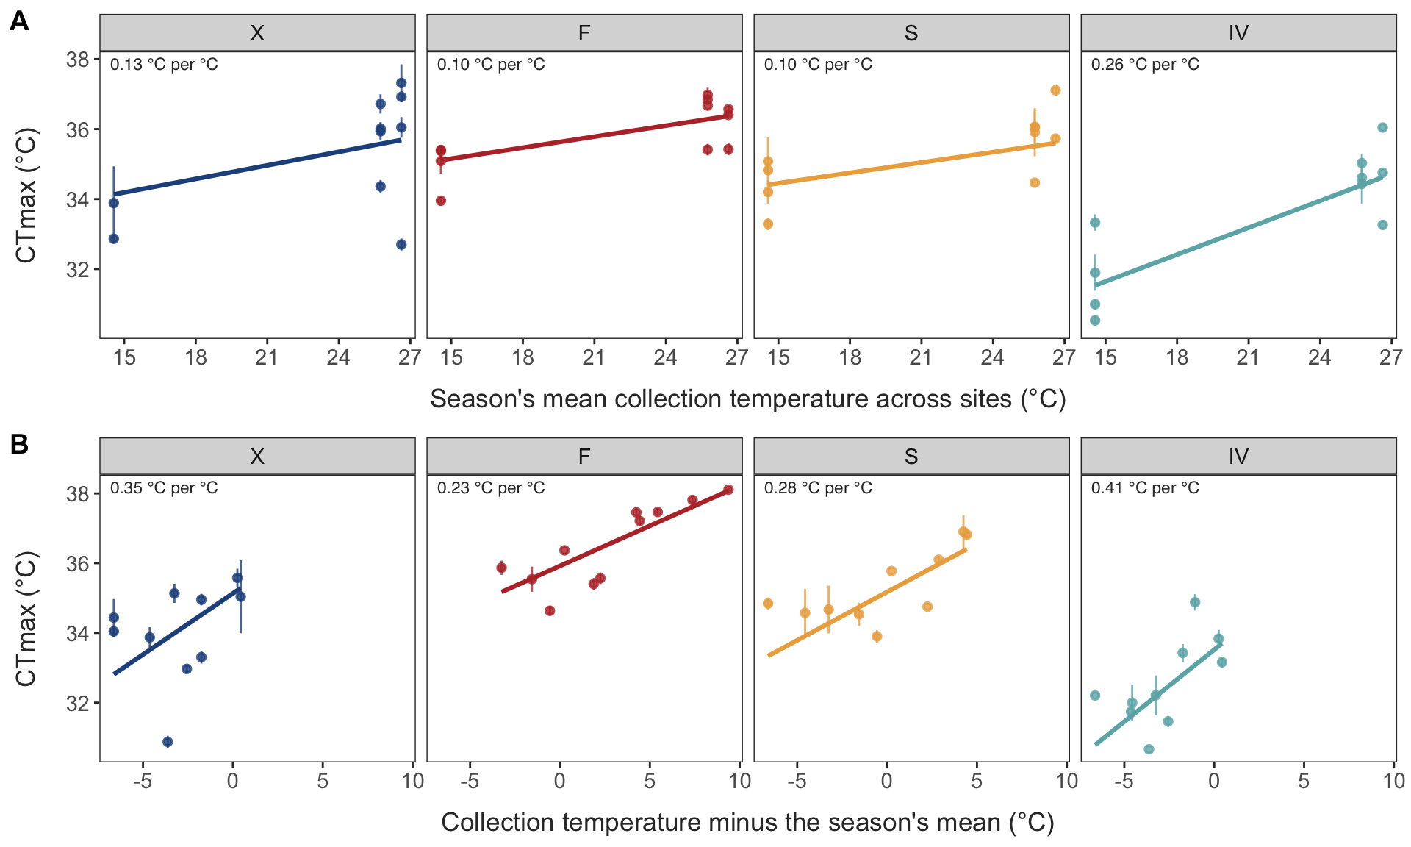
Figure 8: CTmax against the seasonal and spatial components of collection temperature, by clade: the data behind Figure 4 A. (A) Seasonal: the season’s mean collection temperature across sites. (B) Spatial: each collection’s temperature minus that season mean. Points: collections, mean ± SE of individual CTmax after removing the effect of the other component (partial residuals from the season-mean model); lines and labels: clade-specific slopes from the same model (CTmax ~ clade + clade:seasonal + clade:spatial, with random intercepts for site, collection, assay run and vial).
Table 5: Seasonal and spatial CTmax slopes (°C per °C, ± SE) and their difference under two decompositions of collection temperature. Season-mean split (main text): seasonal = the season’s mean collection temperature across sites; spatial = a collection’s deviation from it. Site-mean split: spatial = the site’s mean collection temperature; seasonal = a collection’s deviation from it. All models include clade and random intercepts for site, collection, assay replicate and tube.
Decomposition | Group | Seasonal slope | Spatial slope | Spatial − seasonal (95% CI) | p
Season-mean split | All clades | 0.13 ± 0.02 | 0.25 ± 0.05 | 0.12 (-0.00, 0.24) | 0.054
Season-mean split | X | 0.13 ± 0.04 | 0.35 ± 0.09 | 0.22 (0.05, 0.39) | 0.010
Season-mean split | F | 0.10 ± 0.04 | 0.23 ± 0.07 | 0.13 (-0.06, 0.31) | 0.190
Season-mean split | S | 0.10 ± 0.04 | 0.28 ± 0.07 | 0.18 (0.01, 0.35) | 0.036
Season-mean split | IV | 0.26 ± 0.04 | 0.41 ± 0.12 | 0.16 (-0.08, 0.39) | 0.190
Site-mean split | All clades | 0.15 ± 0.02 | 0.26 ± 0.11 | 0.11 (-0.10, 0.32) | 0.300
Site-mean split | X | 0.14 ± 0.05 | 0.24 ± 0.23 | 0.10 (-0.37, 0.56) | 0.690
Site-mean split | F | 0.13 ± 0.03 | 0.24 ± 0.12 | 0.11 (-0.13, 0.35) | 0.370
Site-mean split | S | 0.13 ± 0.03 | 0.27 ± 0.12 | 0.14 (-0.10, 0.38) | 0.260
Site-mean split | IV | 0.26 ± 0.04 | 0.45 ± 0.27 | 0.19 (-0.36, 0.73) | 0.510

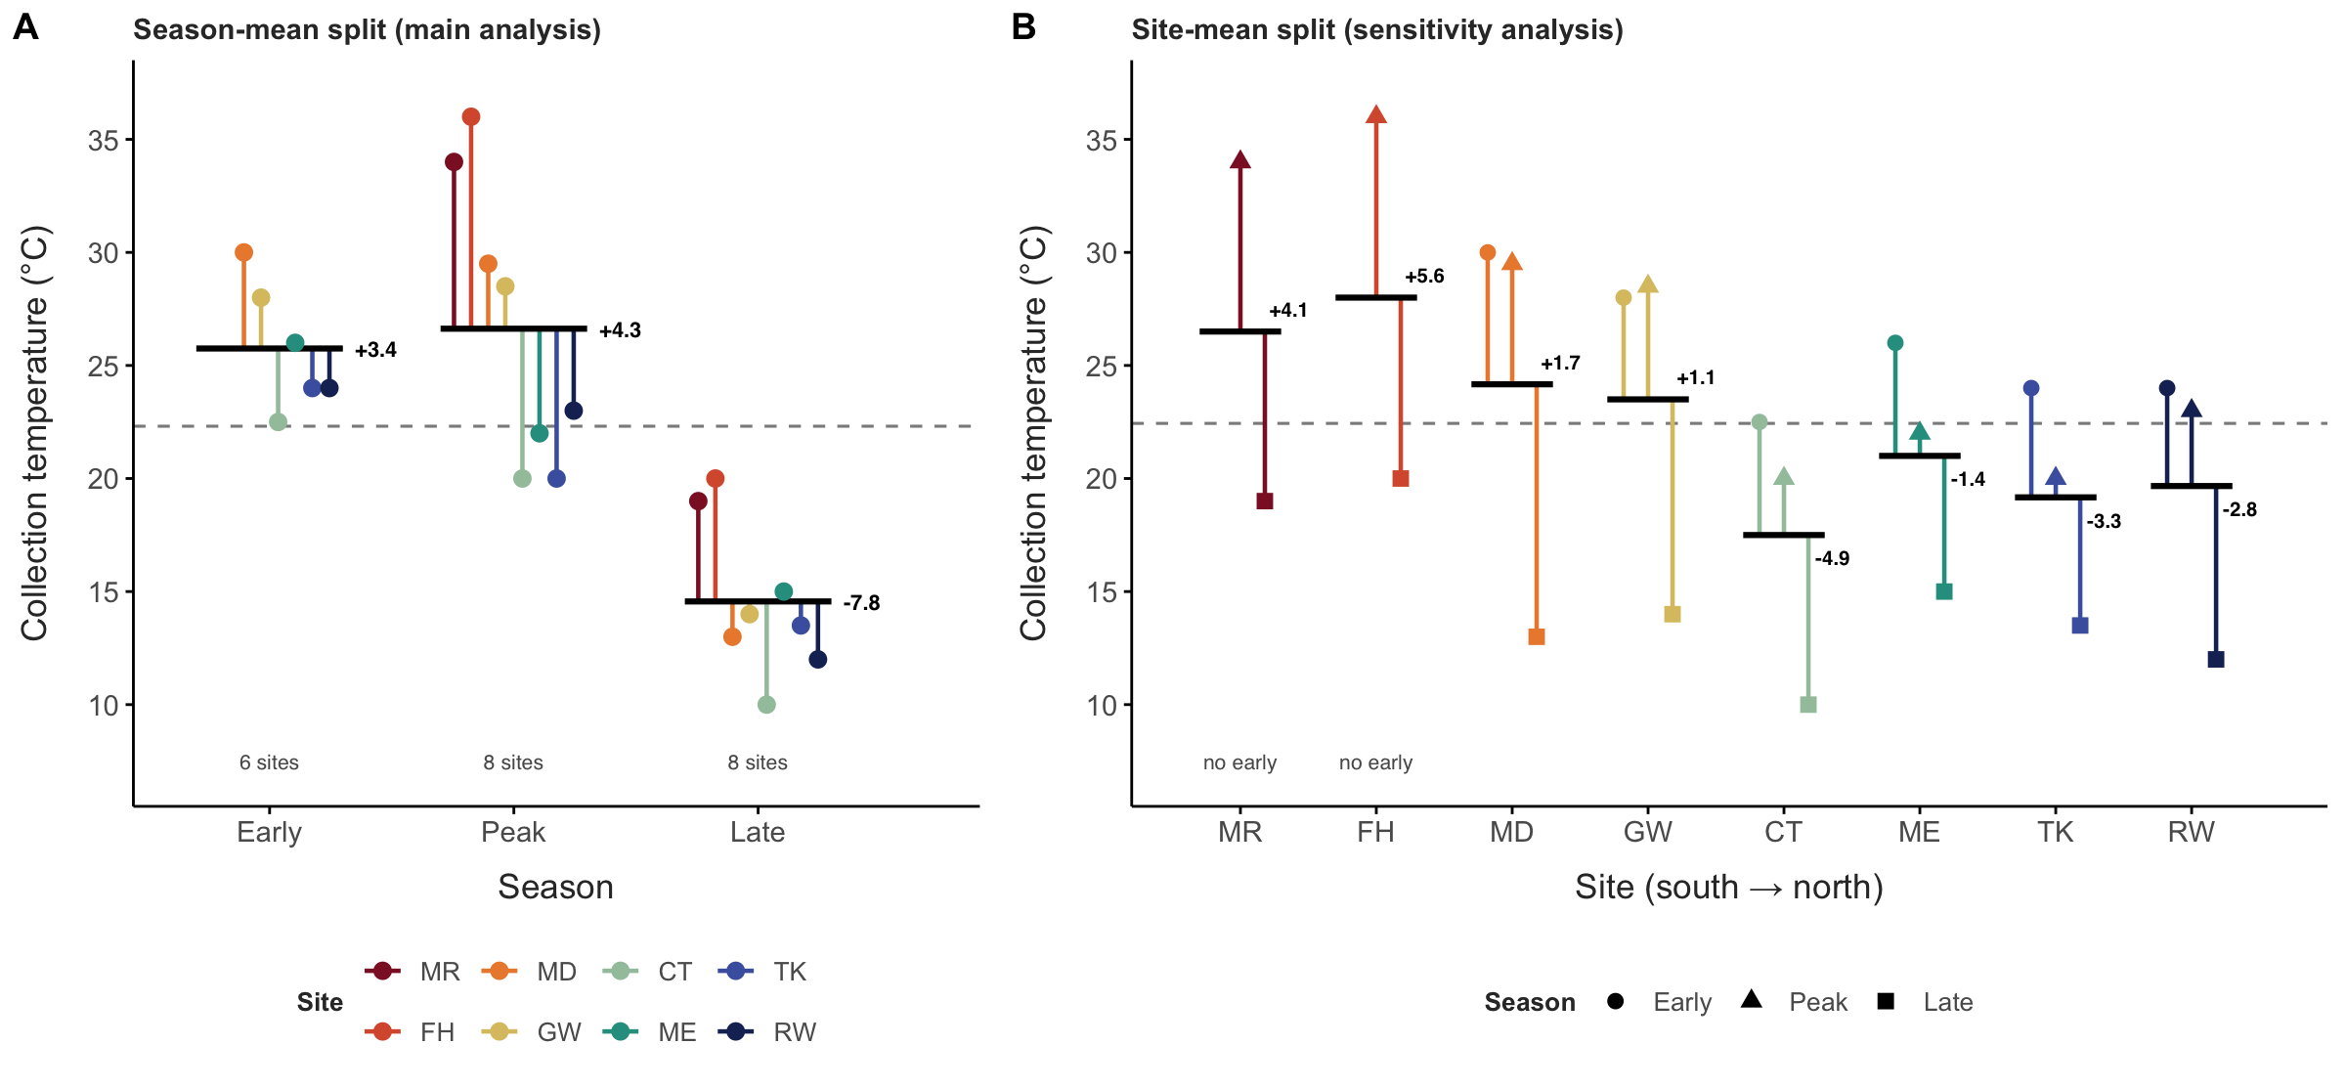
Figure 9: Two ways of splitting collection temperature into seasonal and spatial components, shown for the 22 collections. In each, a collection’s temperature equals a reference temperature (dashed line) plus its two components. (A) Season-mean split, used in the main analysis: the seasonal component is the season’s mean collection temperature across the sites sampled in that season (black bars; arrows give its deviation from the mean of the three season means), and the spatial component is each collection’s deviation from that season mean (coloured lines). (B) Site-mean split, used as a sensitivity analysis: the spatial component is each site’s mean collection temperature (black bars; arrows give its deviation from the mean of the site means), and the seasonal component is each collection’s deviation from its site’s mean (coloured lines). MR and FH were not sampled early, so their site means average only the peak and late collections. Slopes under both splits are compared in Table 5.
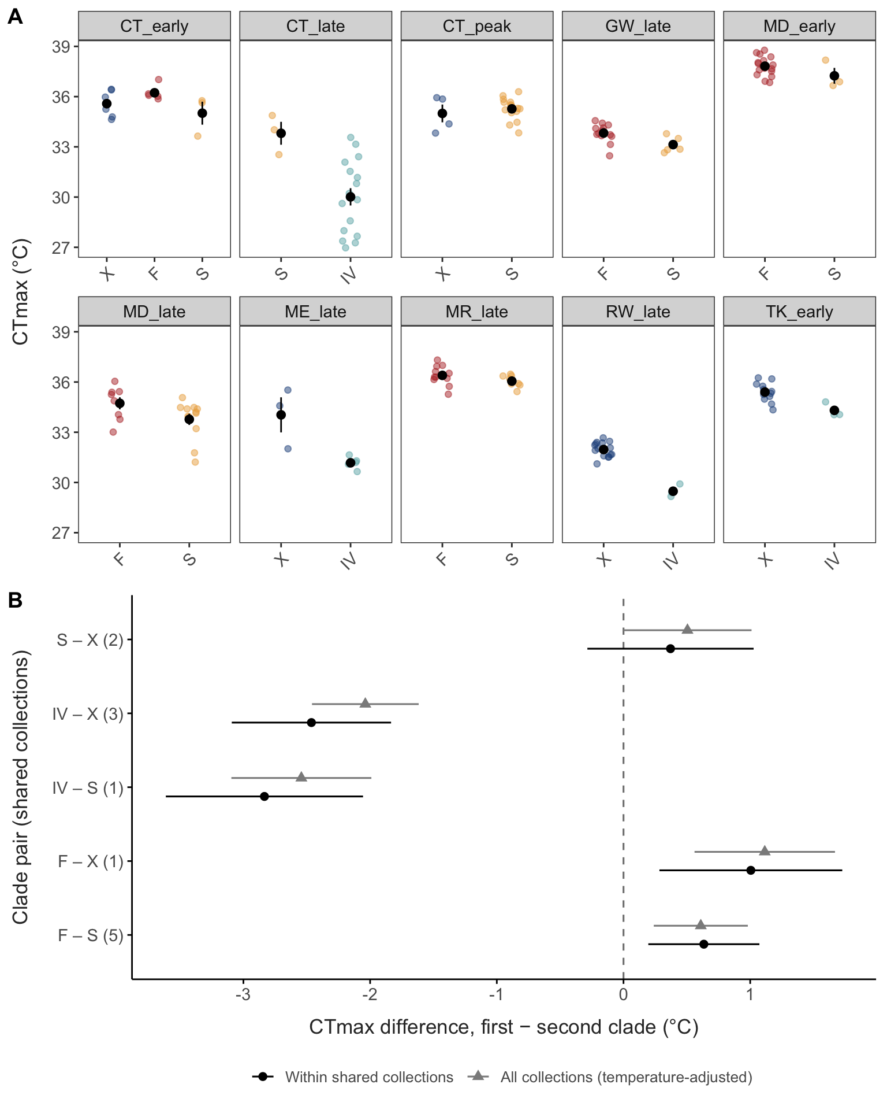
Figure 10: Natural common gardens. (A) CTmax of clades collected together at the same place and time (collections with at least two clades of at least three individuals each). Points are individuals; black, mean ± SE. (B) Pairwise clade differences in CTmax (95% CI) estimated within the shared collections (black; lm(CTmax ~ collection + clade)) and from all collections with temperature adjustment (grey); in parentheses, the number of shared collections. Differences that persist within shared collections cannot be explained by acclimation to different conditions.
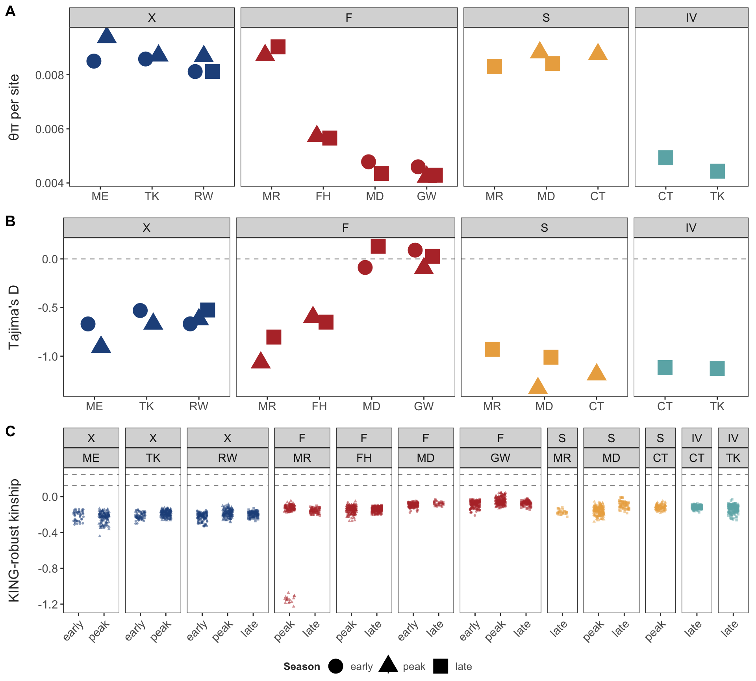
Figure 11: Genetic diversity and relatedness within populations (clade × site × season). (A) Nucleotide diversity (θπ per site) and (B) Tajima’s D, with 95% CI from a block bootstrap over 1 Mb blocks; spectra are folded, so values are compared within clades. (C) KING-robust kinship for every pair of individuals within each population (ngsRelate); dashed lines mark second-degree (0.125) and first-degree (0.25) relatives. No pair reached second-degree kinship. The cluster near −1.1 in MR peak consists of the pairs involving one F-FH individual collected among F-MR copepods.
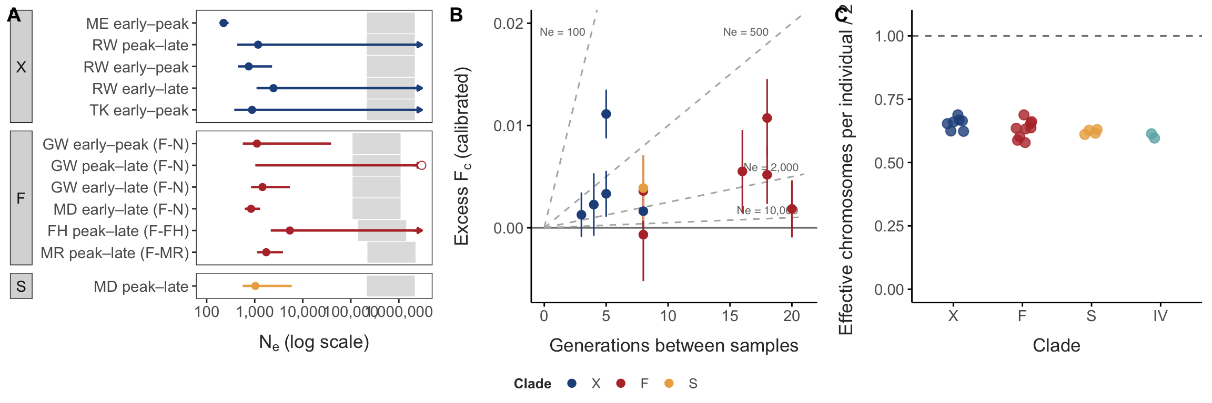
Figure 12: Seasonal allele-frequency change and temporal effective population size. (A) Temporal N_{e} for each pair of seasonal samples from the same site (95% CI from a delete-one-chromosome jackknife; arrows: upper bound unbounded because the change is not distinguishable from sampling noise; open point: change not above sampling noise), by clade, with the F lineage in brackets. Grey bands: long-term N_{e} of the same clade or lineage from nucleotide diversity (π = 4N_{e}µ, for µ = 10⁻⁸ to 10⁻⁹ per site per generation). (B) Allele-frequency change between the same pairs of samples (F_{c} minus sampling noise calibrated from split halves; 95% CI) against the number of generations between them. Dashed lines: change expected from drift alone for N_{e} = 100, 500, 2,000 and 10,000 (t / 2N_{e}). Unlinked SNPs. (C) Split-half calibration: each population was split at random into two halves (two replicates), and F_{c} between the halves, which reflects sampling alone, was compared with the 1/(2n) expected for known genotypes. The ratio c is the effective number of chromosomes per individual divided by two; one point per population; dashed line, c = 1. The calibrated sampling noise used in (A) and (B) is 1/(2cn) per sample.
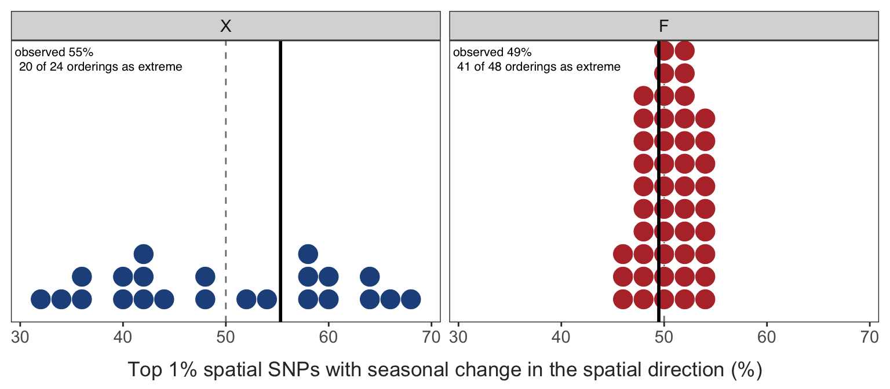
Figure 13: Sign agreement between seasonal and spatial temperature associations among the 1% of SNPs with the strongest spatial association, in X and F. Dots: the null distribution, one per distinct within-site ordering of the sampling events (temperatures permuted among each site’s collections); black line: observed value; dashed line: 50%, the expectation without concordance. S (one alternative ordering) and IV (no site sampled in more than one season) cannot be tested. Text annotation provides the observed value and the number of orderings at least as far from 50%.
Table 6: Long-term effective size from nucleotide diversity (π = 4Neµ; µ = 10⁻⁸ to 10⁻⁹ per site per generation) against the temporal (within-season) Ne estimated from calibrated F_{c}.
Group | π (median) | Long-term Ne | Temporal Ne, median (range) | Ratio (µ = 10⁻⁸)
F-FH | 0.0057 | 140,000 – 1,400,000 | 5,398 (5,398 – 5,398) | 26×
F-MR | 0.0089 | 220,000 – 2,200,000 | 1,735 (1,735 – 1,735) | 128×
F-N | 0.0043 | 110,000 – 1,100,000 | 1,113 (838 – 1,450) | 98×
S | 0.0086 | 210,000 – 2,100,000 | 1,029 (1,029 – 1,029) | 208×
X | 0.0086 | 210,000 – 2,100,000 | 880 (225 – 2,459) | 244×

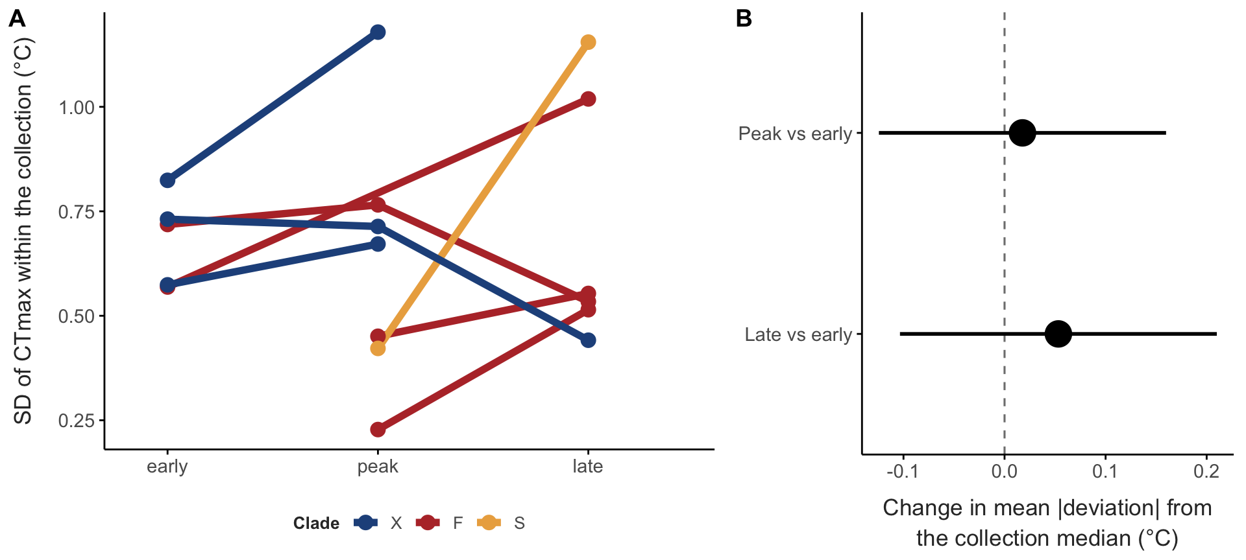
Figure 14: Spread of CTmax within clades through the season. (A) Standard deviation of CTmax in each collection, for each clade at each site sampled in two or more seasons (collections with at least five individuals of the clade); lines join the same clade and site, point size shows the number of individuals. (B) Change in the mean absolute deviation of CTmax from the collection median relative to the early season (Brown–Forsythe; mixed model with clade × site as a random intercept), with 95% CI. Strong selection removing intolerant individuals would narrow the spread (negative values).
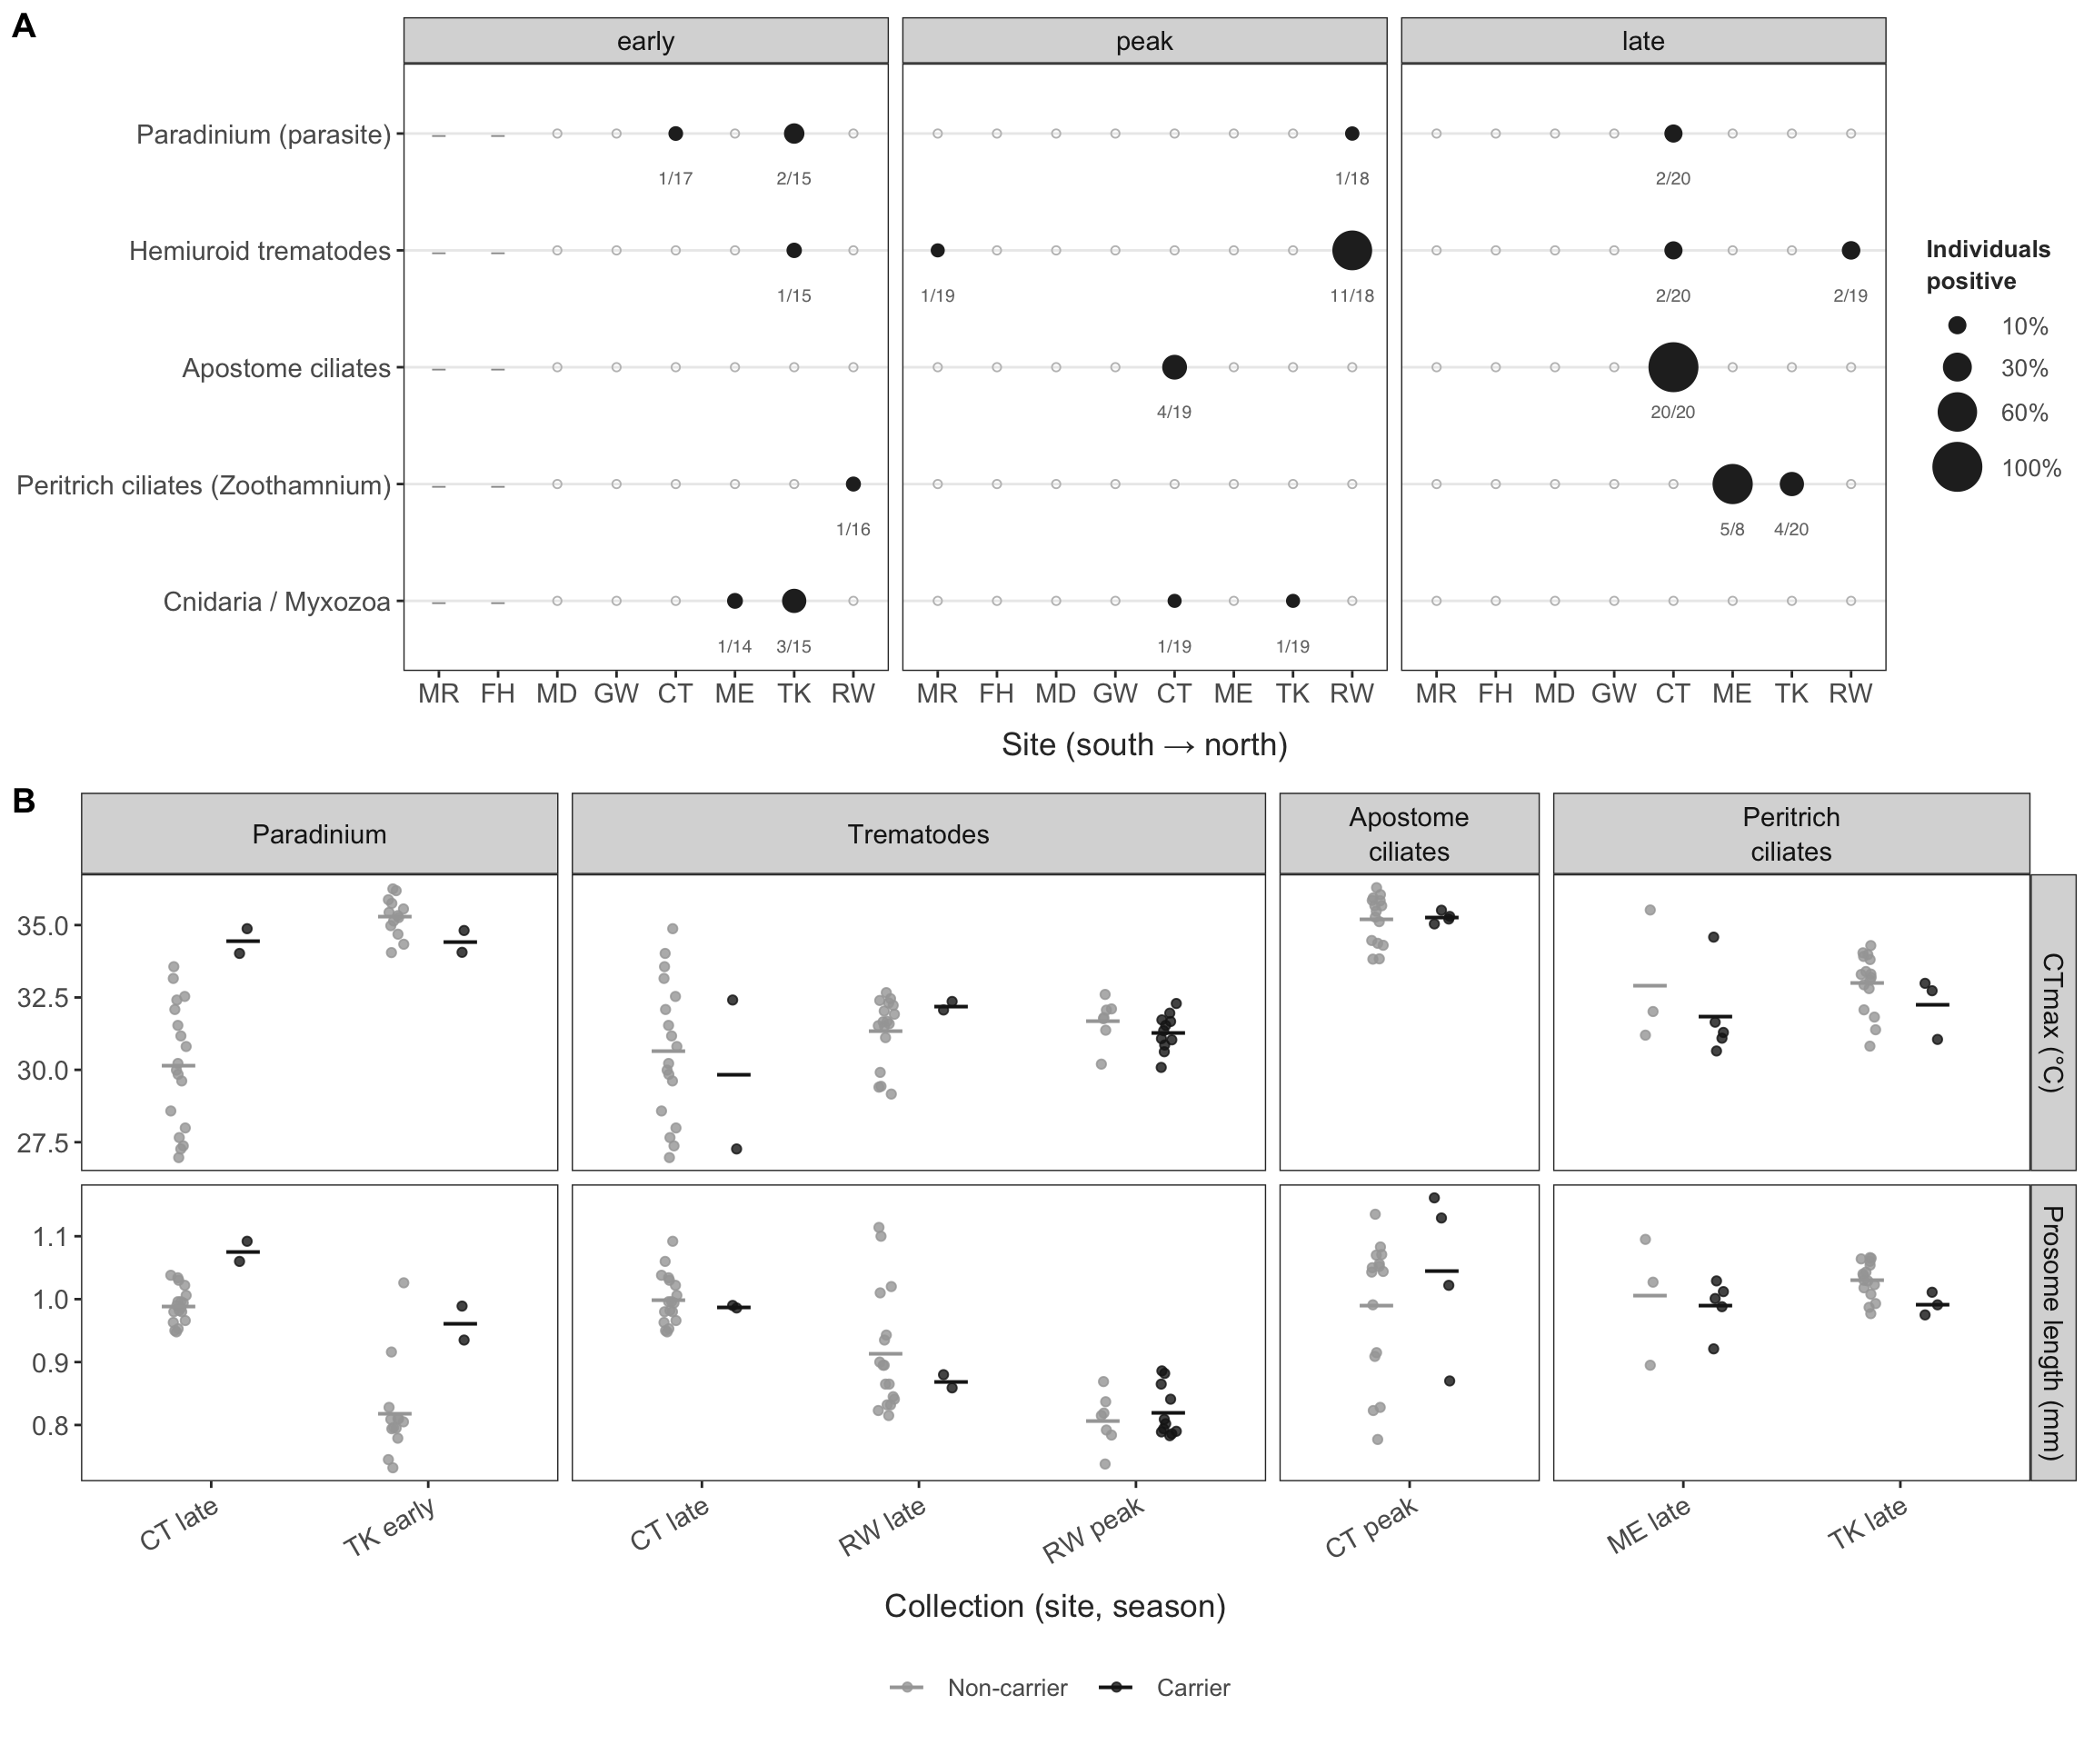
Figure 15: Parasites and epibionts. (A) Share of individuals carrying each group in each collection (dot size; labels, positives/individuals sequenced; open circles, none detected; –, not sampled), from small-subunit rRNA reads that did not map to the A. tonsa reference (present at ≥ 5 read pairs and ≥ 2 per million library pairs). (B) CTmax and body size of carriers and non-carriers within the same collections (collections with at least two of each); points are individuals, bars are means. Effects within collections are given in Table 7.
Table 7: Effect of carrying a parasite or epibiont on CTmax and body size within collections (trait ~ status + clade + (1 | collection)).
Carrier of | Trait | Collections | Carriers | Effect | SE
Parasite | CTmax (°C) | 6 | 23 | 0.361 | 0.304
Parasite | Prosome length (mm) | 6 | 23 | 0.009 | 0.012
Epibiont | CTmax (°C) | 4 | 13 | -0.233 | 0.312
Epibiont | Prosome length (mm) | 4 | 13 | -0.013 | 0.023

Table 9: Clade-unique mitochondrial amino acids: percentage of aligned positions in each protein where one clade differs from a residue shared by the other three (F requires all three F lineages to agree). Positions are those aligned in all four clades.
Protein | F | S | X | IV
nad1 | 1.4 | 7.8 | 3.5 | 4.3
nad2 | 1.3 | 11.8 | 3.8 | 7.6
nad3 | 0.0 | 3.0 | 4.0 | 4.0
nad4 | 1.5 | 7.6 | 5.0 | 7.3
nad4l | 1.3 | 11.4 | 2.5 | 12.7
nad5 | 2.0 | 4.3 | 1.8 | 7.7
nad6 | 2.9 | 2.9 | 2.9 | 3.7
cob | 0.6 | 2.5 | 1.1 | 3.1
cox1 | 0.0 | 0.6 | 0.4 | 1.8
cox2 | 1.9 | 1.9 | 0.5 | 4.2
cox3 | 0.0 | 3.2 | 1.9 | 0.7
atp6 | 0.9 | 3.7 | 0.9 | 6.5
atp8 | 0.0 | 12.0 | 2.0 | 8.0
All (n) | 1.1 (35) | 4.8 (149) | 2.2 (70) | 5.0 (158)

Table 10: Mitochondrial polymorphism within lineages: nonsynonymous (Pn) and synonymous (Ps) polymorphic sites summed over the protein-coding genes, and pN/pS (per Nei–Gojobori site). Genes with fewer than 80% of bases called in a lineage are left out.
Lineage | Individuals | Pn | Ps | pN/pS | Genes left out
F-MR | 28 | 78 | 237 | 0.092 | atp8, nad4l
F-FH | 39 | 56 | 193 | 0.080
F-N | 78 | 199 | 619 | 0.090 | nad4l
S | 72 | 184 | 599 | 0.085
IV | 54 | 93 | 271 | 0.099
X | 114 | 127 | 305 | 0.116 | atp8, nad4l

Table 11: McDonald–Kreitman tests between clades over the protein-coding genes: polymorphic sites within either clade (Pn, Ps) and fixed differences between them (Dn, Ds), neutrality index NI = (Pn/Ps)/(Dn/Ds) and Fisher’s exact test. NI below 1 indicates an excess of amino-acid polymorphism relative to fixed amino-acid differences.
Clade pair | Pn | Ps | Dn | Ds | NI | p
F–S | 631 | 2000 | 475 | 505 | 0.34 | 1.0e-43
F–X | 508 | 1663 | 244 | 364 | 0.46 | 1.7e-15
F–IV | 513 | 1657 | 470 | 627 | 0.41 | 7.6e-29
S–X | 288 | 854 | 608 | 786 | 0.44 | 3.4e-22
S–IV | 265 | 859 | 768 | 1038 | 0.42 | 3.5e-26
X–IV | 205 | 555 | 608 | 991 | 0.60 | 1.2e-07

Table 12: SNP-level signals in genes that responded to selection in experimental evolution [REF] against random sets of the same number of other genes (one-sided p for a larger value in the candidates). Statistics are the mean squared z (or t) over SNPs in the genes, or the share of SNPs whose seasonal and spatial slopes have the same sign.
Test | Group | Genes | SNPs | Candidates | Other genes | p
Seasonal change (time) | F | 18 | 657 | 0.964 | 0.946 | 0.39
Seasonal change (time) | S | 16 | 400 | 0.559 | 0.595 | 0.63
Seasonal change (time) | X | 18 | 2371 | 1.000 | 0.994 | 0.41
Seasonal change (temperature) | F | 18 | 657 | 0.933 | 0.930 | 0.47
Seasonal change (temperature) | S | 16 | 400 | 0.559 | 0.595 | 0.65
Seasonal change (temperature) | X | 18 | 2371 | 1.035 | 0.988 | 0.17
Spatial temperature association | F | 18 | 657 | 7.590 | 7.633 | 0.48
Seasonal–spatial sign agreement | F | 18 | 657 | 0.480 | 0.473 | 0.41
Spatial temperature association | S | 16 | 368 | 1.217 | 1.149 | 0.28
Seasonal–spatial sign agreement | S | 16 | 368 | 0.489 | 0.498 | 0.59
Spatial temperature association | X | 18 | 2371 | 1.604 | 1.806 | 0.84
Seasonal–spatial sign agreement | X | 18 | 2371 | 0.515 | 0.510 | 0.39
CTmax association | F-FH | 17 | 303 | 0.992 | 1.035 | 0.58
CTmax association | F-N | 17 | 516 | 0.868 | 0.991 | 0.83
CTmax association | IV | 12 | 91 | 1.298 | 1.231 | 0.38
CTmax association | S | 16 | 345 | 1.131 | 1.028 | 0.19
CTmax association | X | 18 | 2623 | 1.036 | 0.991 | 0.18

Table 13: Clade-specific amino-acid substitutions (N, nonsynonymous; S, synonymous) in the experimental-evolution genes and in heat-shock and nuclear OXPHOS genes (selected by product name), against random background gene sets of the same size (two-sided permutation p). Genes with at least 50 codons called in at least three clades.
Set | Genes | Clade | N | S | N/(N+S) | Background | p
Heat shock | 41 | F | 5 | 106 | 0.05 | 0.20 | 0.002
Heat shock | 41 | S | 7 | 99 | 0.07 | 0.18 | 0.008
Heat shock | 41 | X | 9 | 70 | 0.11 | 0.19 | 0.096
Heat shock | 41 | IV | 18 | 147 | 0.11 | 0.21 | 0.004
Nuclear OXPHOS | 13 | F | 8 | 15 | 0.35 | 0.20 | 0.100
Nuclear OXPHOS | 13 | S | 7 | 15 | 0.32 | 0.18 | 0.120
Nuclear OXPHOS | 13 | X | 5 | 17 | 0.23 | 0.19 | 0.670
Nuclear OXPHOS | 13 | IV | 6 | 20 | 0.23 | 0.21 | 0.810
Experimental evolution | 12 | F | 16 | 39 | 0.29 | 0.20 | 0.300
Experimental evolution | 12 | S | 12 | 31 | 0.28 | 0.18 | 0.340
Experimental evolution | 12 | X | 3 | 47 | 0.06 | 0.19 | 0.130
Experimental evolution | 12 | IV | 17 | 61 | 0.22 | 0.21 | 0.960

Table 14: Nonsynonymous fraction N/(N + S) on each clade’s branch for selected GO terms and KEGG pathways, with q values in parentheses, against genes annotated in the same ontology (bottom row). The full results are in the report (function_enrichment.csv).
Group | Term | Source | X | F | S | IV
Fast on all branches | ribosome biogenesis | GO:BP | 0.26 (<0.001) | 0.30 (<0.001) | 0.23 (0.022) | 0.26 (0.026)
Fast on all branches | nucleolus | GO:CC | 0.19 (0.0042) | 0.22 (<0.001) | 0.18 (0.032) | 0.22 (<0.001)
Fast on all branches | mitochondrial gene expression | GO:BP | 0.25 (0.14) | 0.29 (0.0067) | 0.30 (0.012) | 0.28 (0.058)
Conserved on all branches | neuron projection | GO:CC | 0.11 (0.017) | 0.12 (0.0065) | 0.10 (0.0045) | 0.13 (<0.001)
Conserved on all branches | cellular anatomical entity morphogenesis | GO:BP | 0.10 (<0.001) | 0.12 (0.0015) | 0.11 (0.063) | 0.15 (0.058)
Thermal function | response to heat | GO:BP | 0.12 (0.59) | 0.11 (0.32) | 0.10 (0.53) | 0.15 (0.63)
Thermal function | protein folding | GO:BP | 0.13 (0.83) | 0.09 (0.17) | 0.09 (0.51) | 0.14 (0.48)
Thermal function | heat shock protein binding | GO:MF | 0.14 (0.99) | 0.14 (0.85) | 0.13 (0.93) | 0.17 (0.93)
Thermal function | Oxidative phosphorylation | KEGG | 0.13 (0.99) | 0.14 (0.98) | 0.18 (0.84) | 0.21 (0.7)
Thermal function | respiratory chain complex | GO:CC | 0.21 (0.54) | 0.24 (0.36) | 0.24 (0.25) | 0.25 (0.38)
Clade-specific (S) | mitochondrial large ribosomal subunit | GO:CC | 0.36 (0.032) | 0.29 (0.16) | 0.43 (0.0011) | 0.27 (0.3)
Clade-specific (S) | mitochondrial protein-containing complex | GO:CC | 0.17 (0.68) | 0.20 (0.3) | 0.27 (<0.001) | 0.20 (0.58)
 | Background (annotated genes, GO:BP) |  | 0.15 | 0.16 | 0.14 | 0.18

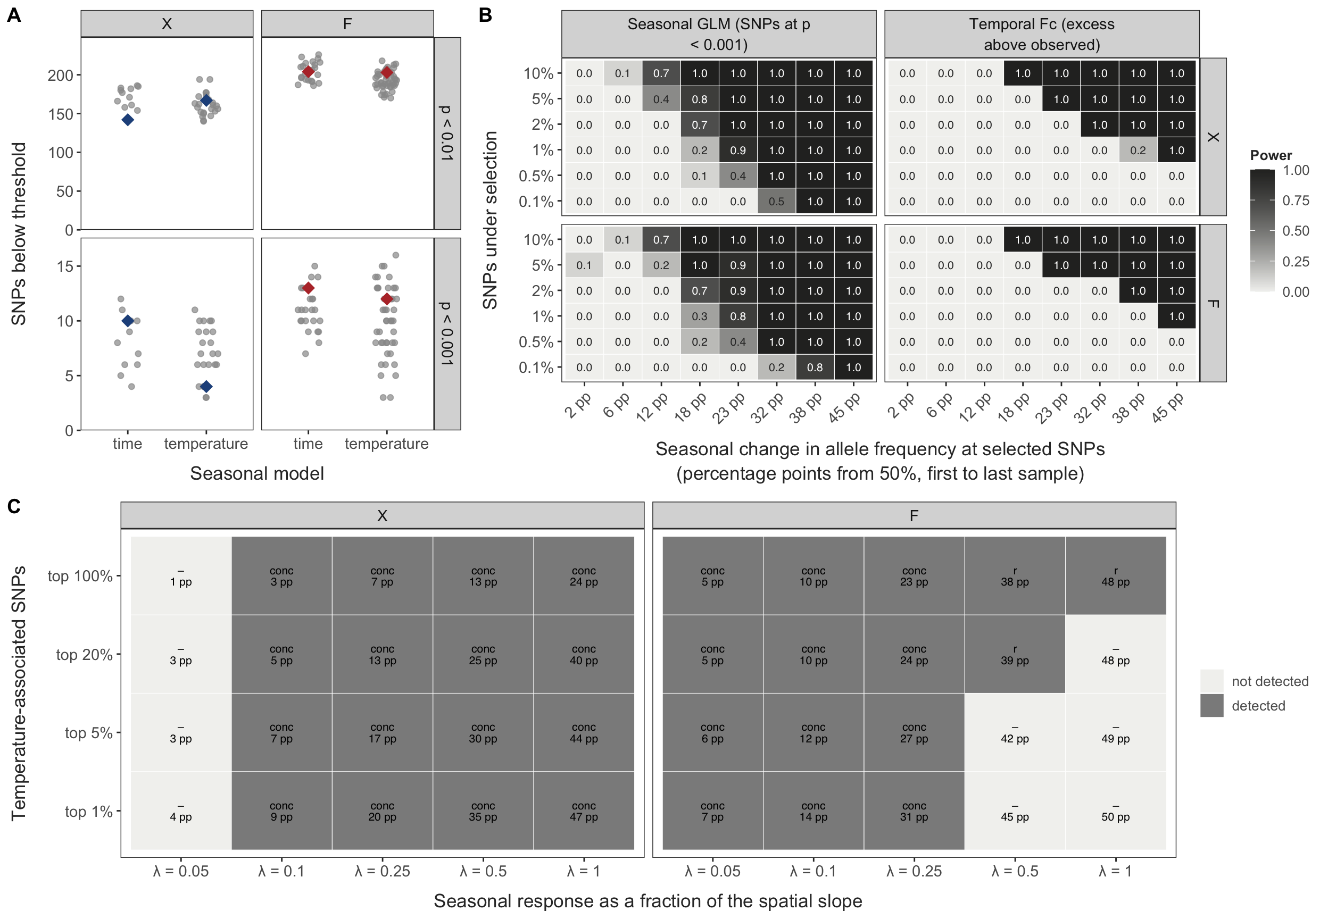
Figure 16: Genome-wide seasonal test and its power. (A) Number of SNPs below p < 0.01 and p < 0.001 in the per-SNP seasonal GLM (count ~ site + x; x = time in season or temperature before collection) with the observed sampling order (diamonds), against every within-site reordering of the sampling events (grey); unlinked SNPs, X and F. (B) Power of the seasonal GLM (more SNPs at p < 0.001 than every reordering) and of temporal F_{c} (added excess above the observed excess + 1.96 SE) when selection was injected into the observed allele frequencies: a fraction of SNPs (rows) shifted in logit frequency between each site’s first and last sample, expressed as percentage points from 50% (columns); ten replicates per cell. (C) Detection of space-for-time concordance when the most temperature-associated SNPs (rows) respond to seasonal temperature at a fraction λ of their spatial slope (columns). Cells: the statistic that ranked above every reordering (conc: sign agreement in the top 1%; r: correlation of z-scores) and the implied seasonal change.
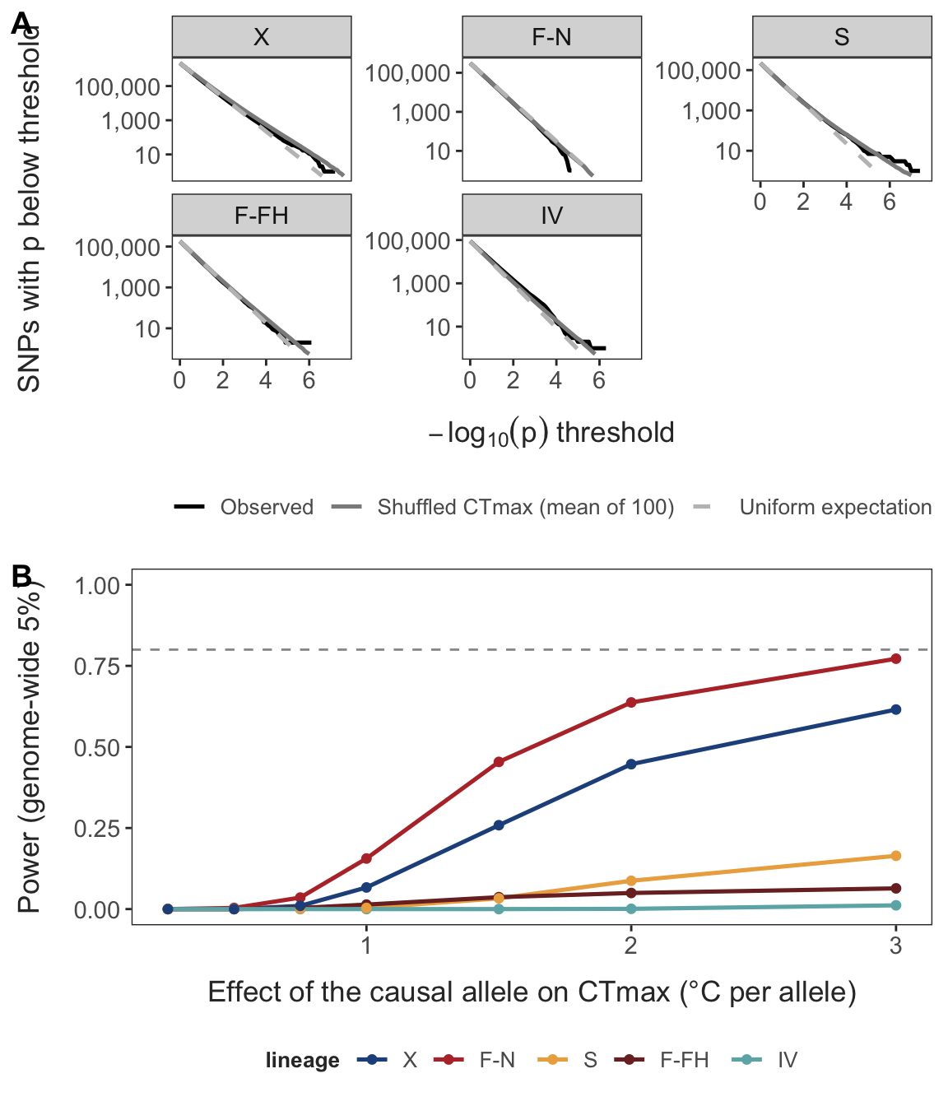
Figure 17: Within-lineage CTmax association scan. (A) Number of SNPs with p below each threshold in the per-SNP regression CTmax ~ collection + log(sequencing depth) + dosage: observed (black), mean of 100 replicates with CTmax shuffled within collections (grey), and the uniform expectation (dashed). (B) Power to detect a causal SNP at the genome-wide 5% threshold (from the shuffles), simulated on each lineage’s own data: true genotypes drawn from each individual’s genotype posterior and an effect of 0.25–3 °C per allele (minor-allele frequency 0.3–0.5) added to within-collection-shuffled CTmax; dashed line, 80% power. Lineages with ≥ 30 phenotyped and sequenced individuals (X 104, F-N 78, S 54, F-FH 38, IV 36).
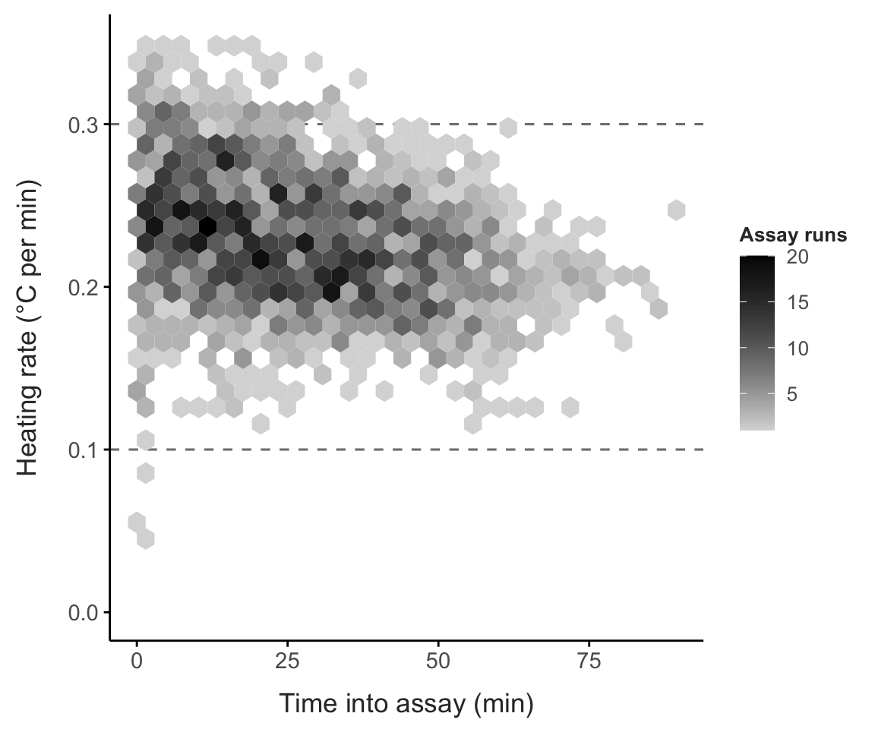
Figure 18: Heating rate during the CTmax assays. Mean rate of temperature increase for each assay run and minute since the heating element was switched on (hexagons: number of run × minute values). Dashed lines: 0.3 and 0.1 °C per minute; rates started near 0.3 °C per minute and slowed to about 0.1 °C per minute as the bath approached CTmax.
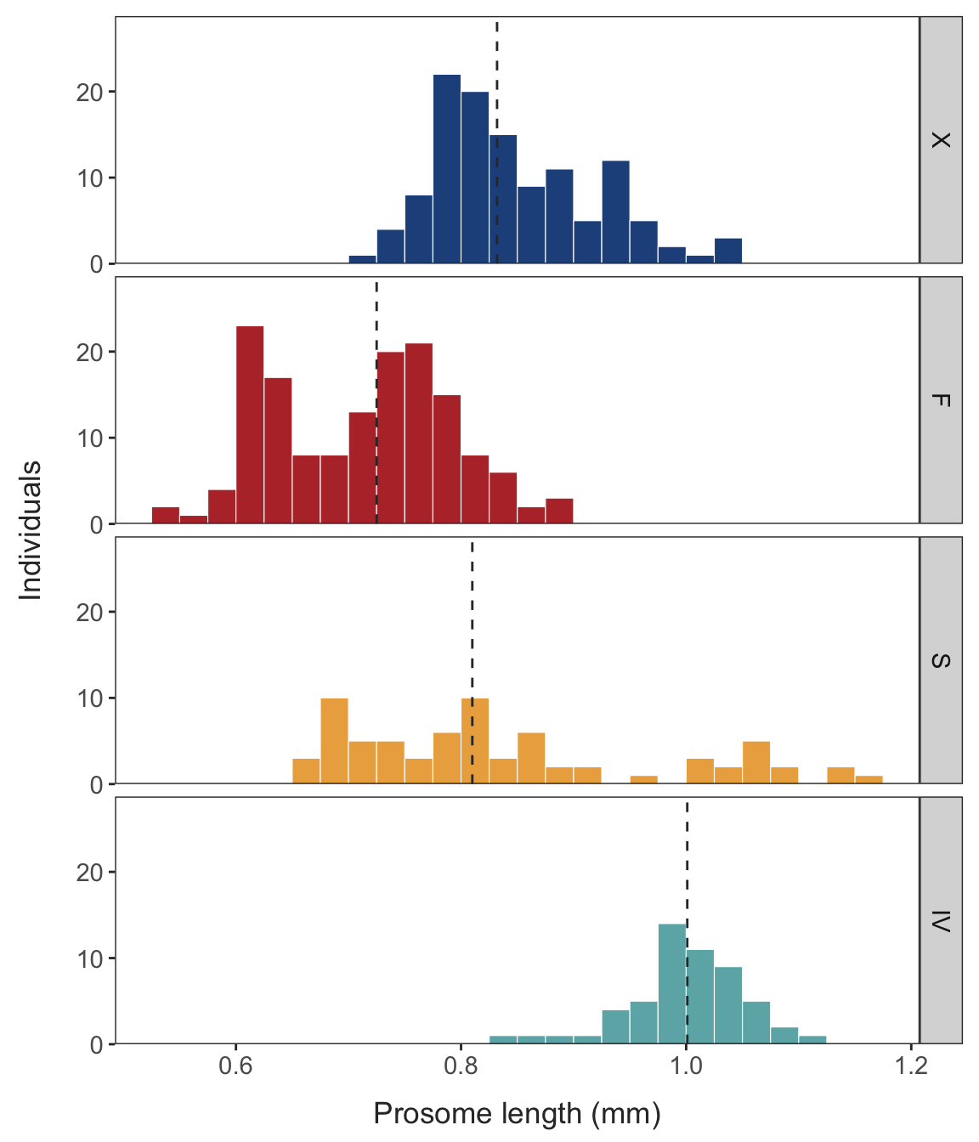
Figure 19: Body size (prosome length) of the individuals in the phenotype analysis set, by clade. Dashed lines: clade medians. The two size classes in S reflect site: S from Connecticut (n = 21, median 1.04 mm) were larger than S from the Chesapeake and Florida (n = 50, median 0.76 mm).
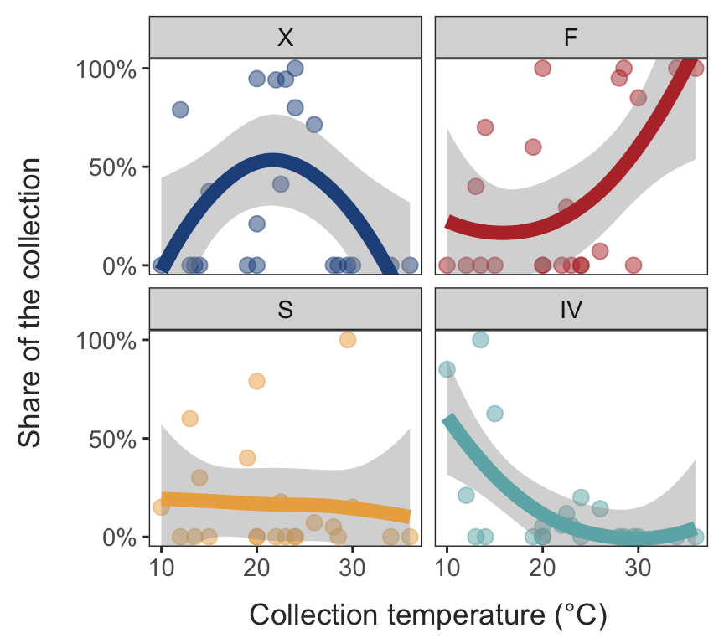
Figure 20: Share of each clade in a collection against the collection temperature. Points: collections (site × season; individuals as in Figure 2 C), including collections where the clade was absent (0%); lines: loess smoother (span = 2) with 95% band. F is most common in warm collections, IV in cold ones and X at intermediate temperatures; S is rare in most collections.
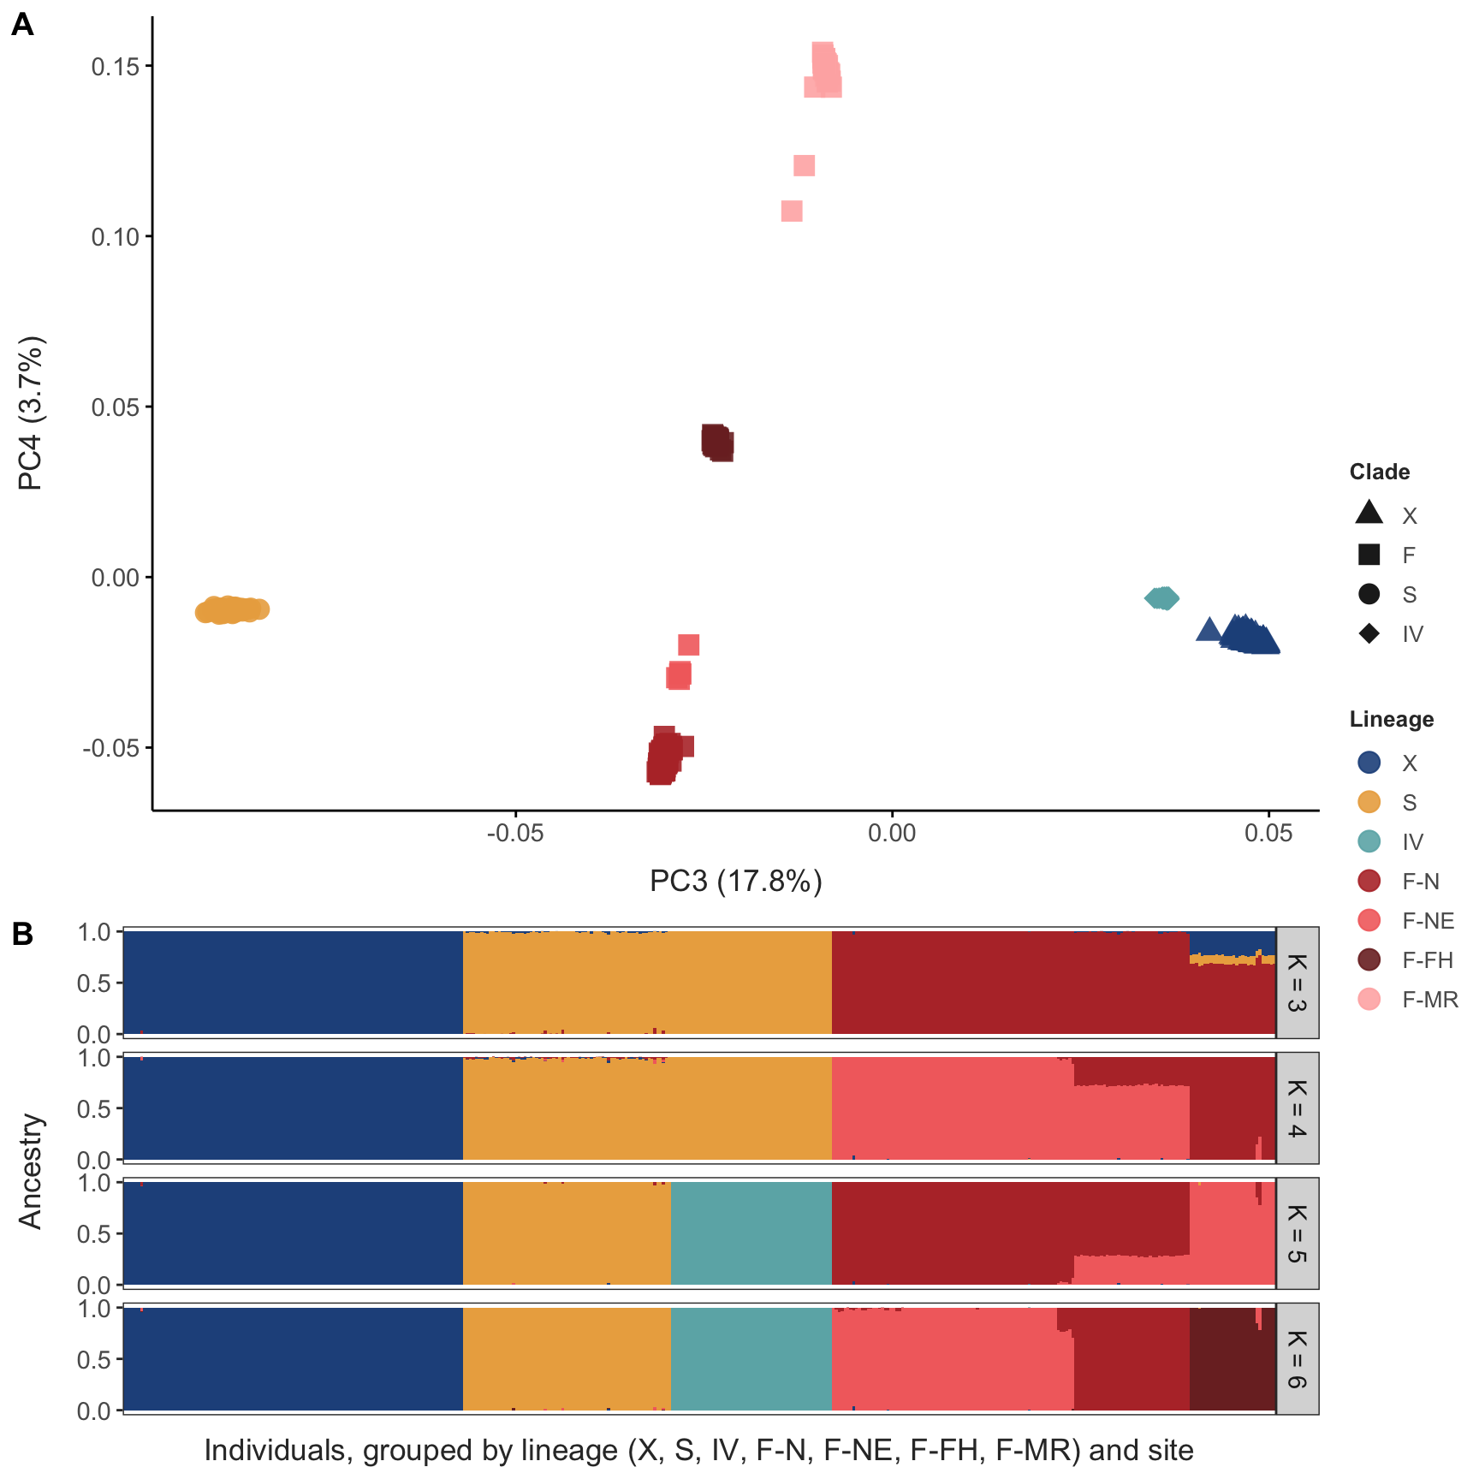
Figure 21: Genome-wide structure of all individuals. (A) PC3 against PC4 of the PCAngsd covariance (PC1–PC2 in Figure 2 A), coloured by lineage: PC4 separates the F lineages. (B) NGSadmix ancestry proportions for K = 3–6 (best of three runs per K), individuals grouped by lineage and site; clusters are coloured by the clade they mostly represent, with clusters within F in shades of the F colour. Own-clade ancestry was ≥ 0.96 in 400 of 402 individuals; the two exceptions, libraries containing DNA of two clades, are omitted.
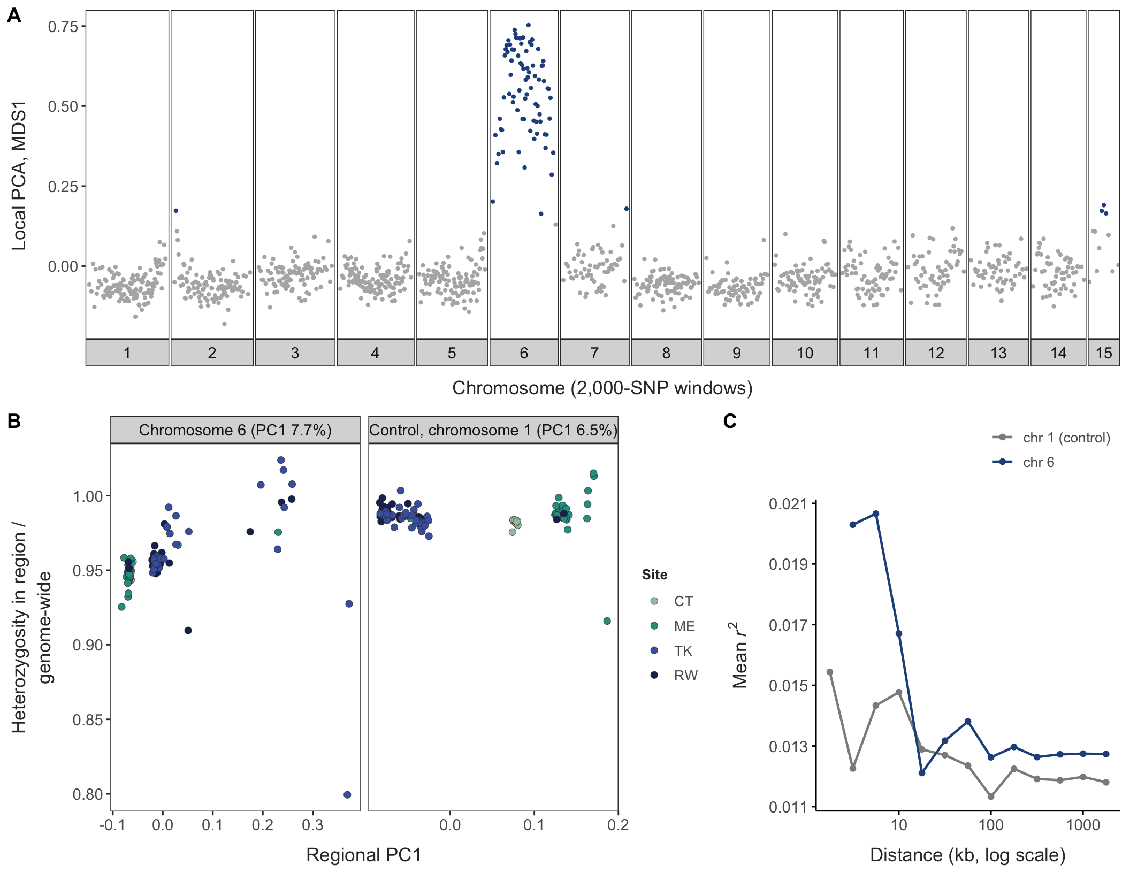
Figure 22: A rare structural variant on chromosome 6 in clade X. (A) Local PCA along the genome: MDS1 of 2,000-SNP windows, with outlier windows (|robust z| > 4) in colour; nearly every window on chromosome 6 is an outlier. (B) Regional PCA against each individual’s heterozygosity in the region relative to its genome-wide heterozygosity, for chromosome 6 and a control region on chromosome 1; points coloured by site. On chromosome 6, ten TK, RW and ME individuals with raised heterozygosity (heterozygous carriers) and two TK individuals with reduced heterozygosity (homozygotes for the rare arrangement) separate on PC1; on the control, PC1 separates sites. (C) LD decay (mean r² corrected for genotype uncertainty) on chromosome 6 and the control region.
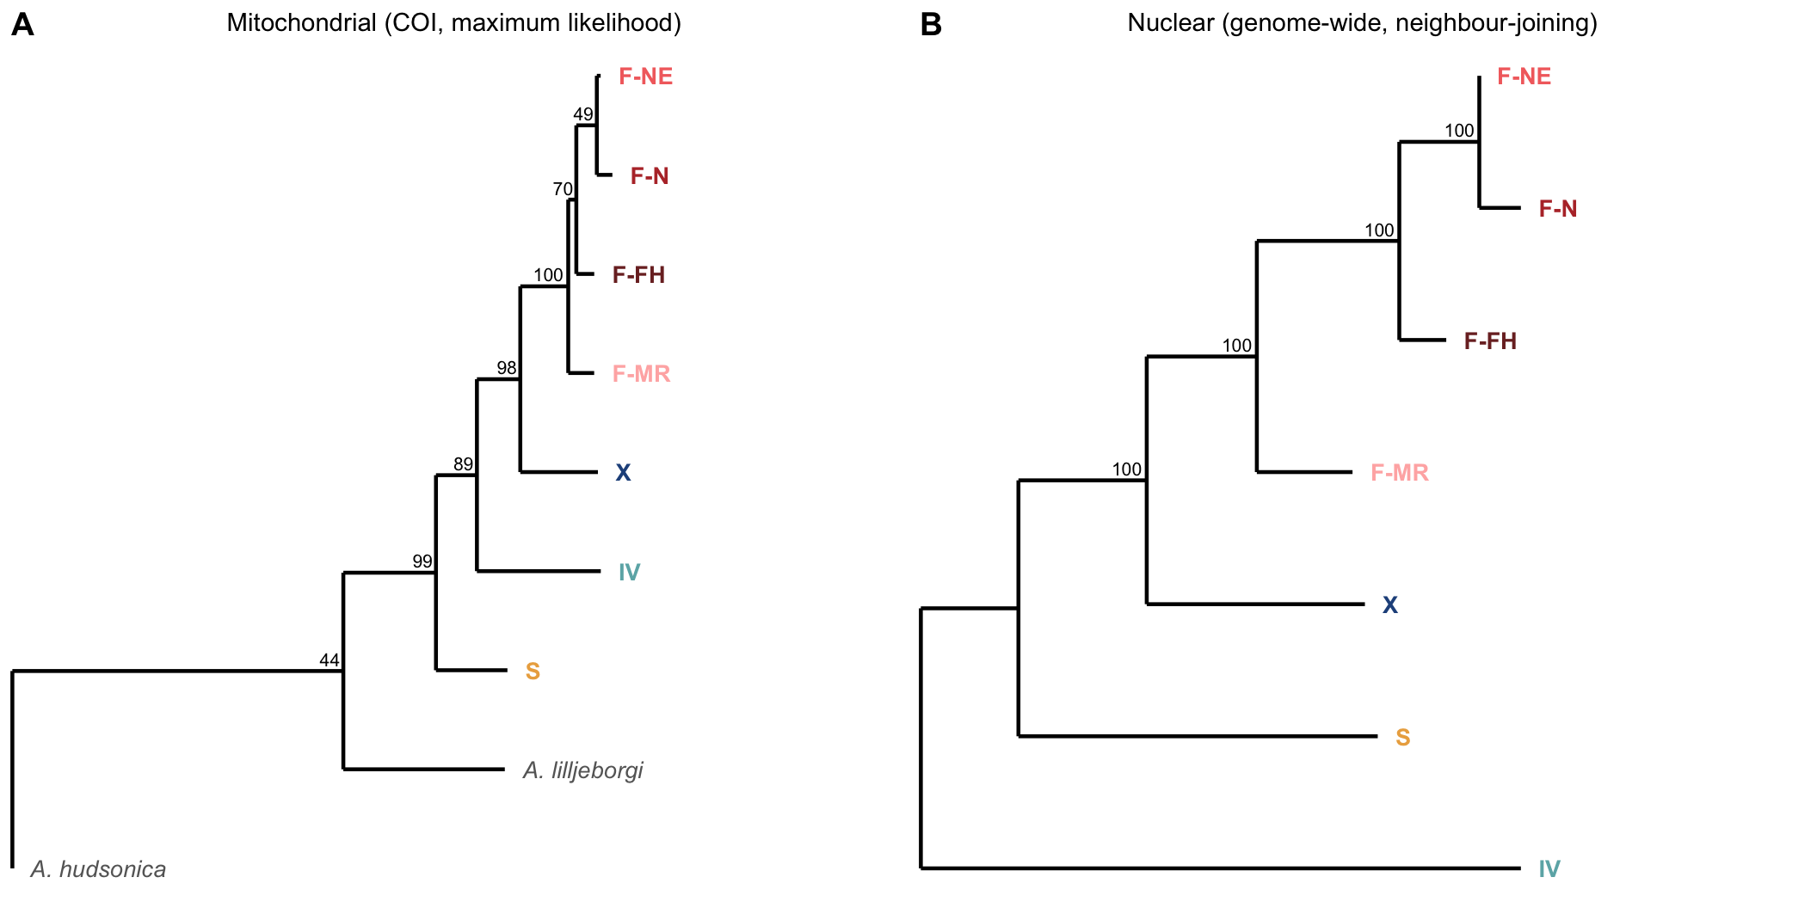
Figure 23: Relationships among clades and the lineages within F. (A) Mitochondrial (COI, maximum likelihood, rooted on A. hudsonica) and (B) nuclear (genome-wide net distances, neighbour-joining, midpoint-rooted) trees; numbers are bootstrap support. Both trees separate {S, IV} from {X, F}, place X as sister to F, and order the four F lineages identically (F-MR, F-FH, then F-N with F-NE).
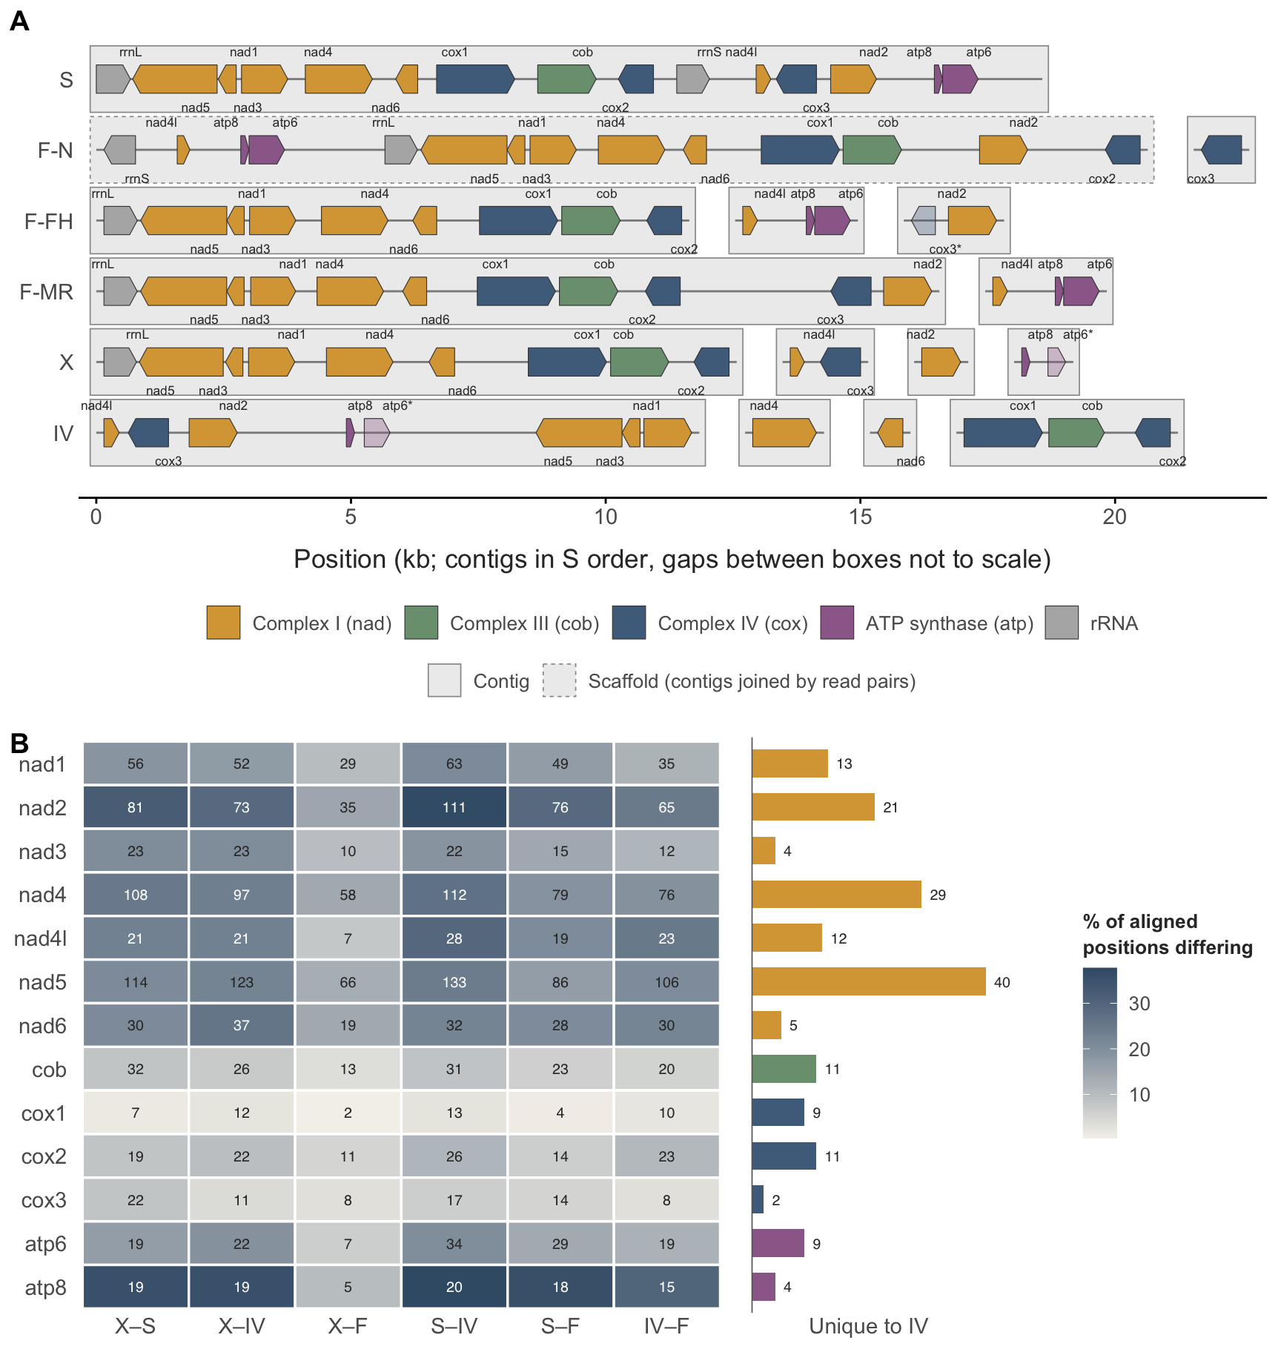
Figure 24: Pooled mitogenomes of the four clades and the F lineages. (A) Assembled pieces of each pool (shaded boxes), trimmed to the stretch carrying genes, with the 13 protein-coding genes and two rRNAs (arrows point 5’ to 3’; faded and * = partial). Each box is one assembled contig, except the F-N main piece (dashed), a scaffold of contigs joined by read pairs. Only gene order within a contig box is supported by the assembly. Boxes are oriented and ordered to match the closed S mitogenome, shown opened at rrnL, and the order and spacing between boxes are not resolved. (B) Amino-acid differences between clades in each protein (cells: number of differing positions; fill: percentage of aligned positions), and substitutions unique to IV (bars). Positions where the three F lineages differ are excluded from comparisons with F.
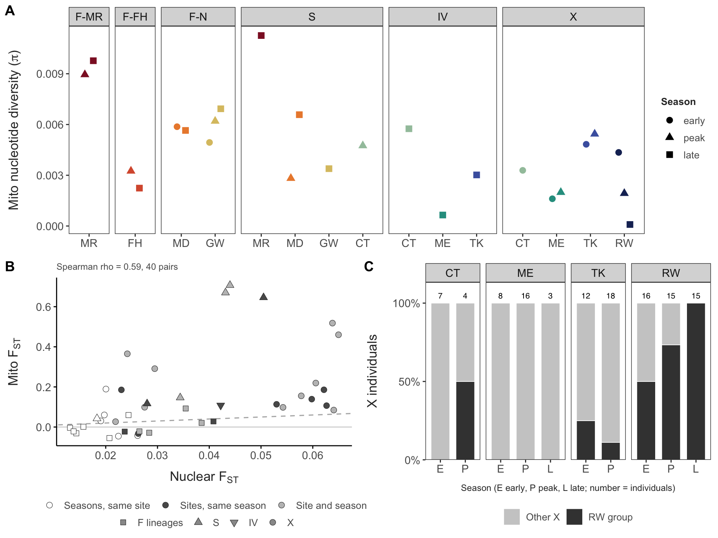
Figure 25: Individual mitogenomes (385 individuals, 13 protein-coding genes). (A) Nucleotide diversity per collection with at least five individuals, by lineage. (B) Mito against nuclear FST for the same pairs of collections within lineages; dashed line, equal values. (C) Share of X individuals carrying the mitogenome group that makes up all of RW late, by site and season.

