TITLE: spatial and seasonal genomic variation across cryptic clades of Acartia tonsa
Abstract
ABSTRACT HERE.

Introduction

Methods

Statistical Analysis

Results
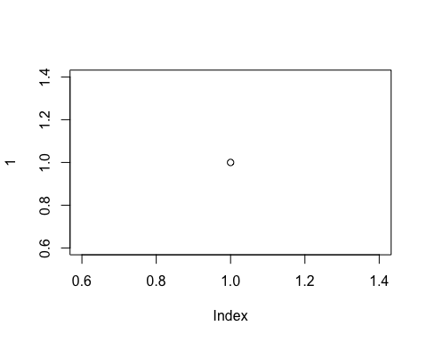
CAPTION HERE.
CAPTION HERE
x
1

Discussion

Supplementary Material
CAPTION HERE.

