Software Specification Requirements

Library Menagement Project

Name | Contact
Ivana Brankovic | ivana.brankovic@eng.it
Bozidar Grabovcic | bozidar.grabovcic@eng.it
Aleksandar Stojmenovic | aleksandar.stojmenovic@eng.it
Marko Petrovic | marko.petrovic@eng.it
Vukasin Simic | vukasin.simic@eng.it
Zoran Kovacevic | zoran.kovacevic@eng.it

Table of Contents
1. Introduction 3
1.1. Purpose 3
2. External Interface Requirements 3
2.1. User Interfaces 3
2.2. Hardware Interfaces 3
2.3. Hardware Interfaces 3
2.4. Communication Interfaces 4
3. Nonfunctional requirements 4
3.1. Performance Requirements 4
3.2. Safety Requirements 6

1. INTRODUCTION

This section gives a scope description and overview of everything included in this Software Specification Requirements. The most common architecture pattern is the layered architecture pattern, otherwise known as the n-tier architecture pattern. This pattern is the de facto standard for most Java EE applications and therefore is widely known by most architects, designers, and developers. Also, the purpose for this document is described and application functionality with realized plan is provided.

1.1 PURPOSE

A software requirements specification (SRS) is a comprehensive description of the intended purpose and environment for software under development. The SRS fully describes what the software will do and how it will be expected to perform. An SRS minimizes the time and effort required by developers to achieve desired goals and also minimizes the development cost. A good SRS defines how an application will interact with system hardware, other programs and human users in a wide variety of real-world situations.

2. EXTERNAL INTERFACE REQUIREMENTS

2.1 USER INTERFACES
- Front-end software: Asp.NET
- Back-end software: C#, MS SQL
2.2 HARDWARE INTERFACES
- Windows.
- A browser which supports CGI, HTML & Javascript.

2.3 SOFTWARE INTERFACES
Following are the software used for the Library Management online application. <<Include the software details as per your project

Software used | Description
Operating system | We have chosen Windows operating system for its best support and user-friendliness.
Database | To save the flight records, passengers records we have chosen MS SQL database.
Asp.NET | To implement the project we have chosen Asp.NET language for its more interactive support.

2.4 COMMUNICATION INTERFACES
This project supports all types of web browsers. We are using simple electronic forms for the book details, member info etc.

3. NONFUNCTIONAL REQUIREMENTS

3.1 PERFORMANCE REQUIREMENTS
The steps involved to perform the implementation of Library Management database are as listed below.
A) E-R DIAGRAM
The E-R Diagram constitutes a technique for representing the logical structure of a database in a pictorial manner. This analysis is then used to organize data as a relation, normalizing relation and finally obtaining a relation database.
- ENTITIES: Which specify distinct real-world items in an application.
- PROPERTIES/ATTRIBUTES: Which specify properties of an entity and relationships.
- RELATIONSHIPS: Which connect entities and represent meaningful dependencies between them.

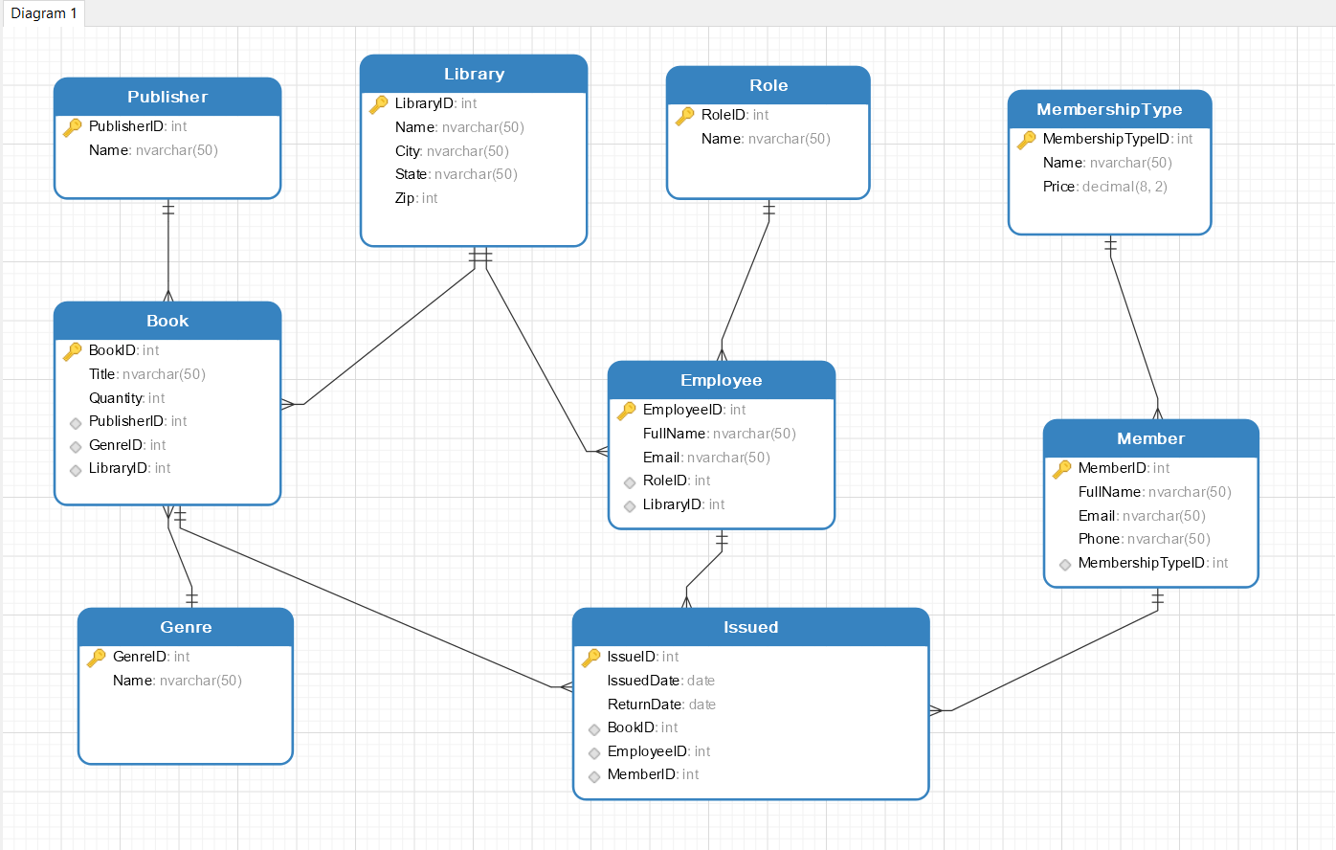
Picture 1. E-R diagram

The result of the search will be viewed either in a list view, depending on what criteria included in the search.

The result of the search will be viewed in a list view, depending on what criteria is included in the search. User can search by: year, author, title etc.

B) NORMALIZATION:

The basic objective of normalization is to reduce redundancy which means that information is to be stored only once. Storing information several times leads to wastage of storage space and increase in the total size of the data stored.
If a database is not properly designed it can give rise to modification anomalies. Modification anomalies arise when data is added to, changed or deleted from a database table. Similarly, in traditional databases as well as improperly designed relational databases, data redundancy can be a problem. These can be eliminated by normalizing a database.
Normalization is the process of breaking down a table into smaller tables. So that each table deals with a single theme. There are three different kinds of modifications of anomalies and formulated the first, second and third normal forms (3NF) is considered sufficient for most practical purposes. It should be considered only after a thorough analysis and complete understanding of its implications.

3.2 SAFETY REQUIREMENTS
If there is extensive damage to a wide portion of the database due to catastrophic failure, such as a disk crash, the recovery method restores a past copy of the database that was backed up to archival storage (typically tape) and reconstructs a more current state by reapplying or redoing the operations of committed transactions from the backed up log, up to the time of failure.

3.3 USE CASE DIAGRAM

2.4 Use Case Diagram

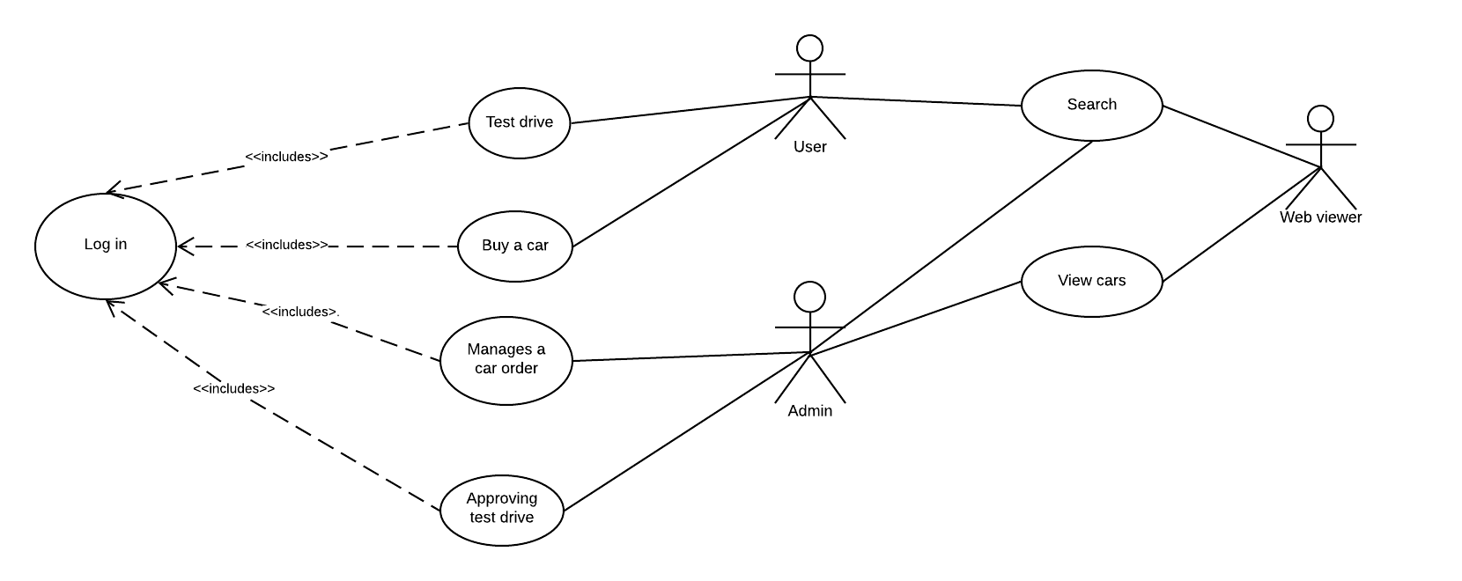
Picture 1. Use case diagram

Our use case diagram describes privileges that user and administrator have. We also have web -viewer without any privileges but certain options when he/she navigates to our web site.
In order to have these privileges pre conditions for both admin and user are to be logged in.
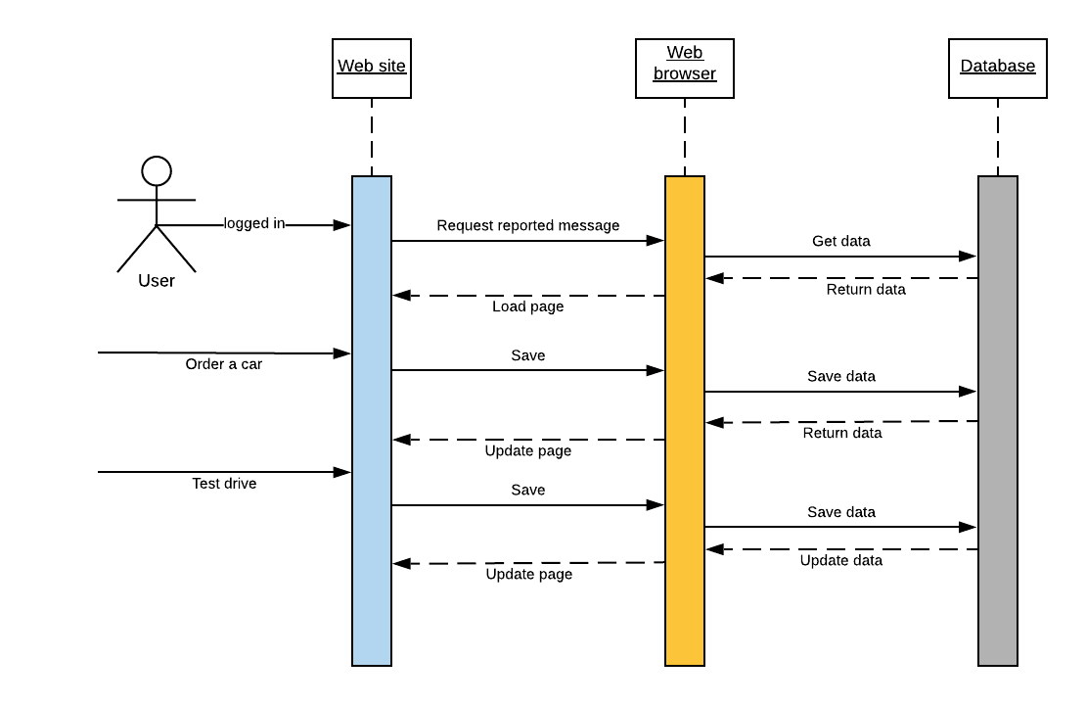

2.5 Sequence diagram

2. Sequence diagram User

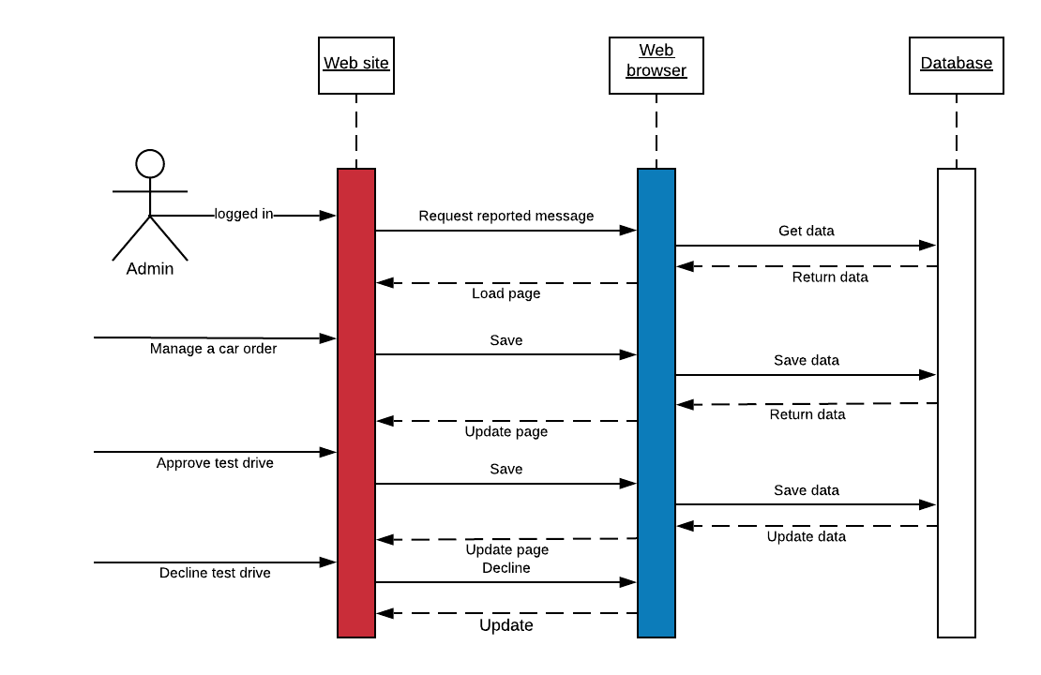
Picture 3 Sequence diagram Admin

3. Database details

In order to create database we will open Microsoft Server Management Studio and use right click on databases and select option new database. We named it ‘autoplatz’.
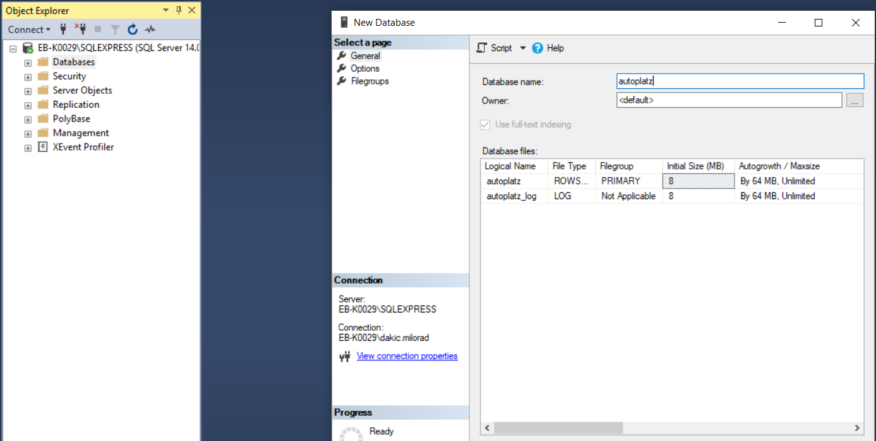
Picture 4. Creating database
After that we have to go Visual Studio Code and create POCO classes and open in package management console type the following commands:
Enable-Migrations, Add-Migration, update-database. This way ASP.NET will generate tables in our database with all fields, constrains.

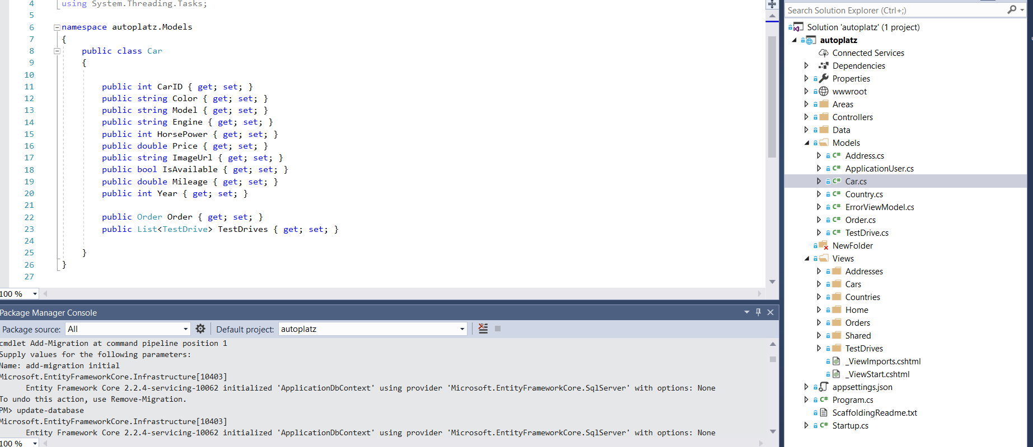
Picture 5. POCO classes and migration

Finally we go to our database and refresh it in order to see all details.
On folder database diagrams we can create new diagram from existing database. Select all tables and create all relations between them.

References

(1) IEEE Software Engineering Standards Committee, “IEEE Std 830-1998, IEEE Recommended Practice for Software Requirements Specifications”, October 20, 1998.

(2) Brian Larson, Delivering Business Intelligence with Microsoft SQL Server 2016, Fourth Edition,2016 p.180

