TABLE OF CONTENTS
OVERVIEW 1
- Purpose
- Scope

DEFINITIONS/GLOSSARY 1

TIMELINE 2

REQUIREMENTS 3
- Functional
- Non-functional

USE CASES 4
- Actors
- Brief Use Case Descriptions
- Detailed Use Case Descriptions
- Use Case Diagrams

LAYOUT 13
- Site Map
- UI

SYSTEM DESIGN 16
- Architecture
- Technologies

DATA DESIGN 17
- Objects (detailed descriptions)
- Tables
- Relationships (UML)
- Methods (UML)

OVERVIEW:

Intro

This software design document will describe the design of a basic online barter system. This document includes both narrative and graphical descriptions of the elements of the barter system.

Purpose

The purpose of the Barter Application is to facilitate the exchange of books between two parties without the use of currency.

Scope

Proof of concept for a basic application that enables the creation of a trade between two users. This document includes the layout for the first iteration of this application as well as diagrams for data models that we will be using in the application. Using this application, members will be able to do the following:

- Search for compatible trades nearby
- Create and negotiate a trade with another user
- Create and edit a profile that includes what they have to offer and what they are searching for

The proof of concept website will include a basic, but attractive layout and page design. The website will initially be deployed to Azure for demonstration purposes. Should this be released to the broader public, a Terms of Service document that prohibits illegal or illicit transactions will be drafted and published on the site.

DEFINITIONS/GLOSSARY

- Trader: Individual or Business with a trading account.
- Wants: Collection of books desired by a Trader.
- Haves: Collection of books owned and up for trade by a Trader.
- Barter: Exchange of books in lieu of legal tender. Used interchangeably with transaction.

TIMELINE

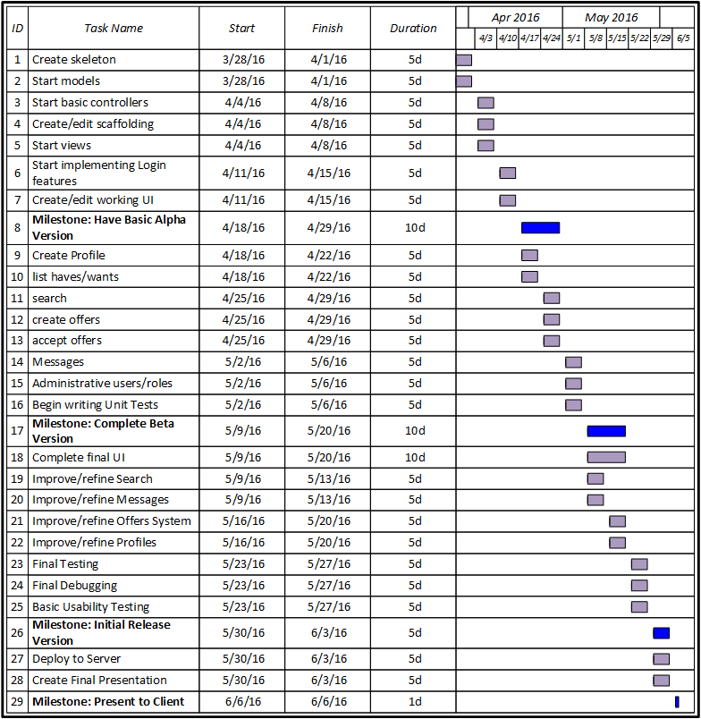

REQUIREMENTS

Functional

- User will be able to create, edit and maintain a profile, including their Haves and Wants.
- System will authenticate and authorize users based on account credentials.
- User will be able to search for nearby Traders and offered items.
- Users will be able to create and negotiate barters with other Traders.
- Users will be able to confirm or cancel a finalized transaction.
- Users will be required to submit feedback and ratings for completed and confirmed transactions.
- Users may file complaints about other users or transactions that violate the law and/or terms of service.
- Site administrators will be able to view and respond to user complaints, and temporarily or permanently ban users in response to violations.

Non-functional

- Clean user interface
- Mobile responsive
- Will be supported by most popular modern browsers (Chrome, Firefox, Safari, Opera, Internet Explorer (most recent version))

USE CASES

Actors

- Trader (or Non-Administrative User): A Trader is a generic public user that uses the system to conduct barter transactions.
- Administrative User: An Administrative User is a user responsible for overseeing and maintaining the system and user accounts.

Brief use case descriptions

Trader Use Cases:

Use Case | Description
Create Profile | User enters personal data such as desired username and location information.
Update Profile | User views personal data and changes information as desired.
List Wants | User enters books for which the user would like to barter.
List Haves | User enters books the user would like to offer in a barter transaction.
Create Barter (Transaction) | User discovers that a second user’s “want” matches the first user’s “have” or vice versa, selects the relevant goods and services in the profiles, and initializes a transaction request by pressing a “Barter” button (which is only enabled once transaction goods and services are selected).
Cancel/Void Barter (Transaction) | User selects a cancel/void option on the barter transaction page, enters reason for cancellation, and confirms the transaction cancellation.
Complete Barter (Transaction) | User views barter transaction request details and selects a “Transaction Completed” option upon completion of the exchange of goods or services.
Rate Transaction | After completing a transaction, the user is prompted to rate the completed transaction on a scale of 1 to 5.
Browse Profiles | User views a list of all profiles.
Filter Profiles | User selects profile filters on the browse profile page and views profiles conforming to the selected filters.
Browse Wants | User views a list of all goods and services desired by other users.
Filter Wants | User selects desired “wants” filters on the “Browse Wants” page and views “wants” conforming to the selected filters.
Browse Haves | User views a list of all goods and services on offer.
Filter Haves | User selects desired “haves” filters on the “Browse Haves” page and views goods and services on offer that conform to the selected filters.
Search Profiles | User enters search term and views a list of all matching profiles.
Search Wants | User enters search term and views a list of all matching goods and services desired by other users.
Search Haves | User enters search term and views a list of all matching goods and services others are offering for barter.
Report User | User notices another user’s profile that may violate the terms of service, selects the “report user” option on the other user’s profile page, and enters additional information about the type of violation before submitting the report to an administrator for review.
Report Barter (Transaction) | User selects a “report transaction” option on the barter transaction page, enters additional information about violation type, and submits the report for review after encountering a possible violation of the terms of service during the course of a transaction.
View History | User views a list of the user’s own past and pending barter transactions.
View Ratings | User views a list of the barter transaction ratings given by all users for a particular user.
Create Message | User selects the “Send Message” option on a user profile page and composes a message to another user in a message composition form which may be sent or saved as a draft.
Send Message | User selects the option to submit a completed message composition form.
View Received Messages | User views a list of received messages, each of which has an option to view the full message and message details.
View Message | User views the full message and relevant details of a specific message.
View Sent Messages | User views a list of sent messages, each of which has an option to view the full message and message details.
Delete Message | User selects a message to delete, then submits and confirms deletion request.
Save Message | User selects a “Save” option on the message composition form page.

Administrator Use Cases:

Edit User Profile | Admin user views non-admin user profile data and updates information as desired.
View/Browse Users | Admin user views list of non-admin user profiles.
Filter Users | Admin user selects desired non-admin user filters on the “View/Browse Users” page and views a list of only the user profiles conforming to the selected filters.
Search Users | Admin user enters search term in a search form, submits the form, and views a result set of users matching the search term.
Ban User (Time-Limited) | Admin user selects a “Ban User (Time-Limited)” option on a non-admin user’s profile page, enters the ban time frame, and enters the reason for the ban.
Ban User (Forever) | Admin user selects a “Ban User (Forever)” option on a non-admin user’s profile page and enters the reason for the ban.
View Reports | Admin user views list of unreviewed reports.
Review Report | Admin user selects a report not marked as reviewed, reviews the report details, and selects an appropriate action from a list of options.
View Archived Reports | Admin user views a list of reports that have already been reviewed and dealt with.
Filter Archived Reports | Admin user selects filters and views a list of reviewed reports that conform to the selected filters.
Review Barter Details | Admin user selects a barter transaction and views the transaction details.
Create New Admin | Admin user enters new admin user information.
Edit Admin | Admin user views existing admin user profile and updates information as desired.
Edit/Update Transaction | Admin user views a transaction in progress between two users, edits the desired fields, and saves the changes.

Detailed Use Case Diagrams

Create Profile Detailed User Case Description:

Use case name: | Create profile.
Triggering event: | Trader wishes to start using the barter application.
Brief description: | Trader enters personal data such as desired username and location information.
Actor(s): | Trader
Related use case(s): | This use case includes the “list haves” and “list wants” use cases.
Stakeholder(s): | Both Traders
Precondition(s): | Trader must be willing to divulge basic personal information.  Trader must have goods and/or services to offer other users as well as goods and/or services that the user desires.
Postcondition(s): | Trader profile must be successfully created.  Trader profile information (including initial wants and haves) must be accurate and saved to the database.
Flow of activities: | Actor (Trader) |  | System
Flow of activities: | 1. Trader selects a “Create Profile” option and enters necessary profile information into profile creation form (including initial wants and haves).  2. Trader submits profile creation form. |  | 1.1 System validates trader input.  1.2 System checks that the trader does not already have a profile.  2.1 System creates a Trader object that contains the entered trader input.
Exception condition(s): | 1.1 Information entered by trader is not valid.  1.2 Trader already has a profile.

Create Barter (Transaction) Detailed Use Case Description:

Use case name: | Create barter transaction.
Triggering event: | Trader discovers that a book on offer matches one of the trader’s “wants” or the trader discovers a book another trader wants that matches something that the trader is offering.
Brief description: | Trader selects the books that the trader is offering and for which the trader is bartering from the appropriate profiles before pressing a “Barter” button (which is only enabled once transaction goods and services are selected).
Actor(s): | Non-Business or Business Trader,a different Non-Business or Business Trader
Stakeholder(s): | Trader (x2)
Precondition(s): | Traders must have books on offer.  Users must have desired books listed.  One user must havebooks on offer that match up with the other user’s desired books.  “Wants” and “Haves” listing information must be correct and up-to-date.
Postcondition(s): | Barter transaction request must be successfully completed and sent to the second party.
Flow of activities: | Actor (Trader) | System
Flow of activities: | 1. Trader selects the goods and/or services that will be involved in the transaction.  2. Trader enters the rest of the barter transaction information and submits transaction request. | 1.1 System sends the trader to a barter transaction creation form.  1.2 System prompts trader to enter additional information necessary for successful barter transaction (e.g. transaction location, transaction time)  2.1 System validates trader input.  2.2 System sends transaction request to the second party involved in the barter transaction.
Exception condition(s): | 1.1 Trader internet connection drops out before the user can access the transaction creation form.  2.1 Trader input is invalid.  2.2 Second party listings inaccurate or out-of-date.  2.2 Second party no longer uses barter application.  2.2 Second party has decided to give up all modern conveniences and go live in a yurt in the forest.

Use Case Diagrams

Transaction Use Case Diagram:

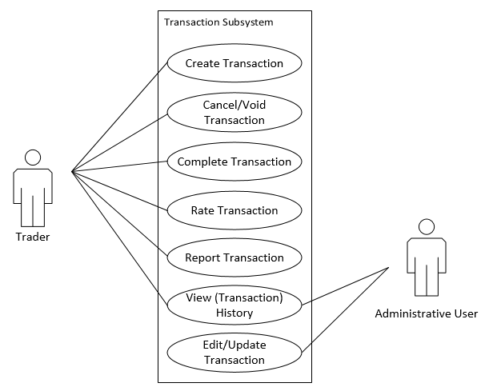

Messaging Use Case Diagram:

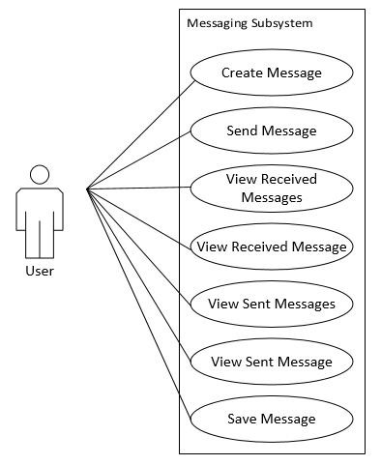

User Profile Use Case Diagram:

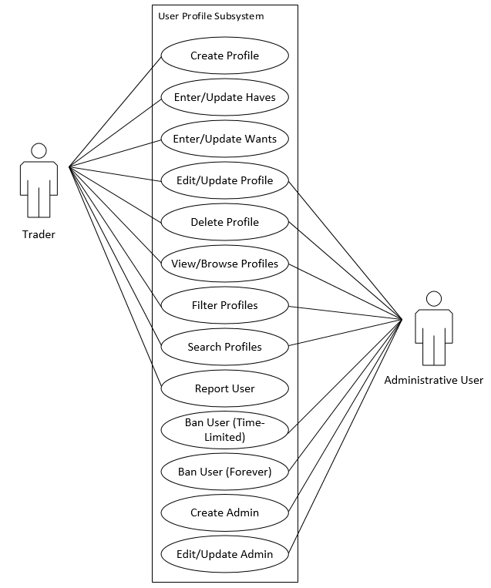

LAYOUT

Site Map
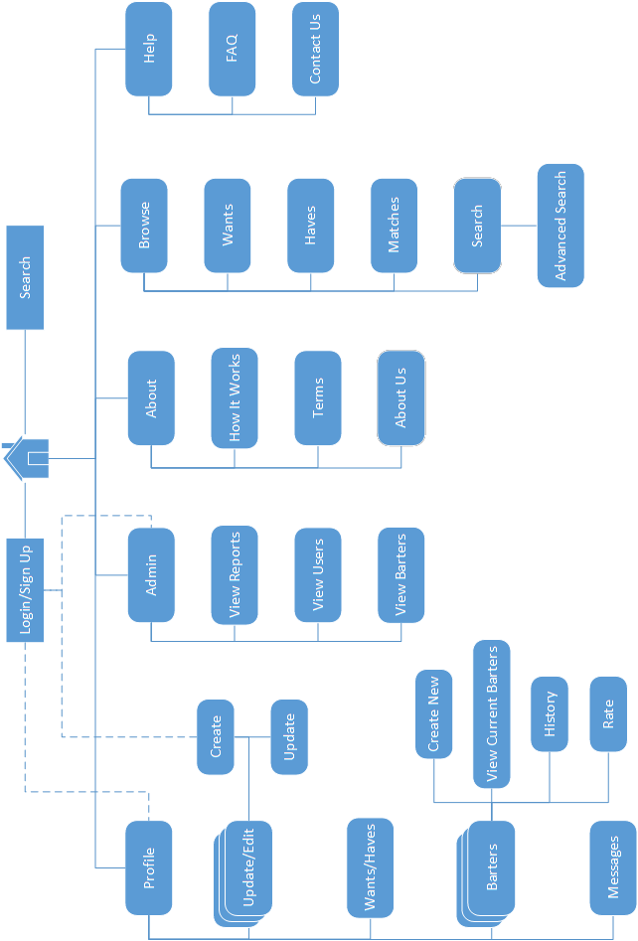

User Interface

Basic Profile View (Desktop):
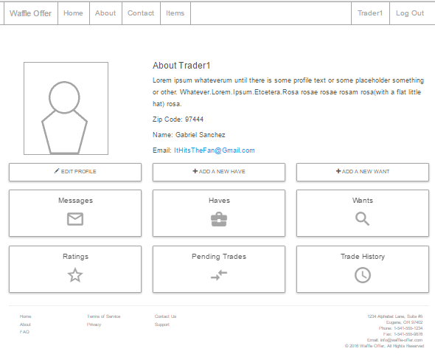

Barter and Browse Pages (Mobile):

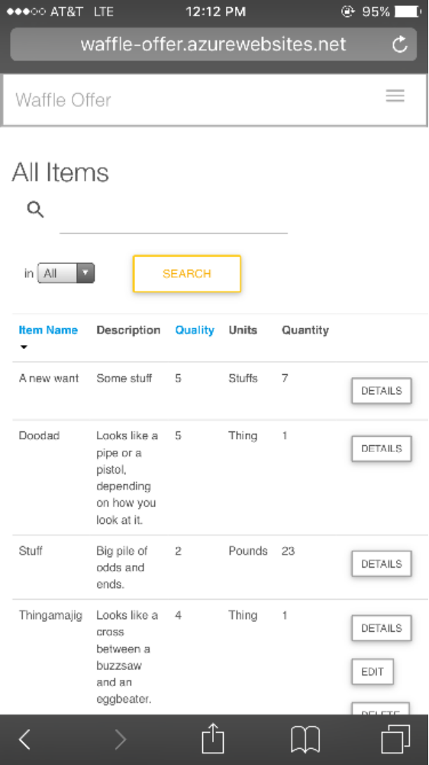
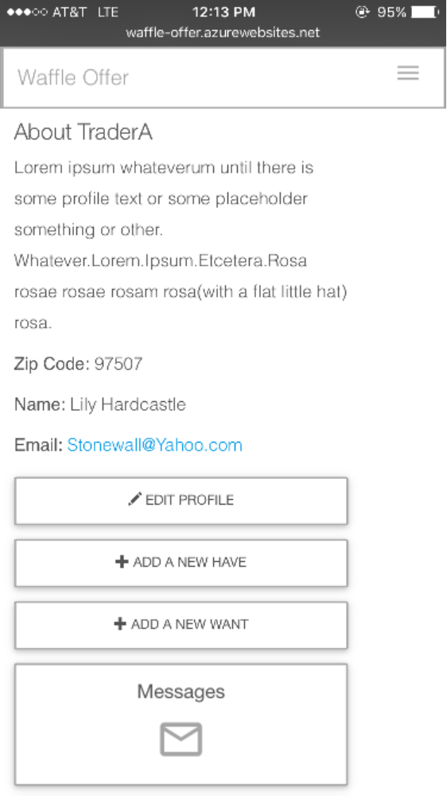

SYSTEM DESIGN

Architecture (Physical System)

The system will be designed as a responsive website that will specifically target mobile devices (smartphones, tablets). It will expand gracefully from a mobile layout to a tablet layout and, if necessary, a desktop layout.

Technologies

- Programming Languages:
The web application will be created using standard web technologies such as HTML5 and CSS as well as C# and ASP.NET MVC.

- IDE (Interactive Development Environment):
The web application will be developed using Visual Studio Ultimate 2013. It is an IDE that we are familiar with and have been using to develop our projects for class assignments at LCC.

- Version Control:
Version control will be done on Git via GitHub. Each developer will take a branch to develop and test a section of the code, and the team will review the branch before changes are merged into the master branch.

- Unit Testing:
To keep the workflow consistent between production and testing, unit testing will be done with Visual Studio 2013. Controller methods will be tested for viability and stability to catch potential errors as soon as possible in the development process.

- Deployment:
The web application will be deployed to and managed on Microsoft’s Azure cloud service during development.

DATA DESIGN

Objects:

Item
An Item describes a book, possessed or desired.
- Title: The book's title.
- Description: Book’s description.
- Author: Book's author.
- Quality: Numeric description (1-5) of item quality.
- Images: List of images of Item supplied.

Message
Messages can reply to other messages, and be replied to.
- ParentMessage: The message this message is responding to.
- ChildMessage: The Message that is responding to this one.

Trade
A Trade describes an accepted offer and a promise by both parties to complete the trade.
- FinalOffer: Accepted and agreed-upon offer.
- DateFinished: Date and Time Trade created.
- SenderConfirmed: Whether the Sender (on FinalOffer) has verified the Trade.
- SenderCancelled: Whether the Sender has opted to cancel the Trade.
- ReceiverConfirmed: Whether the Recipient has verified the Trade.
- ReceiverCancelled: Whether the Recipient has opted to cancel the Trade.
- SenderFeedback: Feedback from Sender.
- ReceiverFeedback: Feedback from Recipient.

Trader
The Trader class describes any trading member of the website. The class stores detailed data about the user.
- Wants: List of Items describing collection of books that the Trader wants to trade for.
- Haves: List of Items describing collection of books that the Trader can offer.
- Trades: List of Trades that the Trader has completed.
- ProfileText: HTML-formatted text displayed in the Trader’s profile.
- <decimal> GetRating(): Calculate aggregate rating based on the ratings on all Trades performed by the Trader.

AppUser : IdentityUser
The User class is the base class for all account-using users of the application. User inherits most of its important functionality and properties from the IdentityUser class.
- ProfilePicture: Image url for displaying the user’s profile picture and messaging avatar.
- Messages: List of BasicMessages written, sent, or received by the User.
- Wants: List of Items describing collection of books that the Trader wants to trade for.
- Haves: List of Items describing collection of books that the Trader can offer.
- Trades: List of Trades that the Trader has completed.
- ProfileText: HTML-formatted text displayed in the Trader’s profile.

Relationships (UML)
