Multiple Regression

José Pedro Conceição,Kiko Sánchez , Eloi Cirera

March 25, 2019

Table of Contents

## Executive Summary

The first Objective was accurately Predicting Sales Volume, this has not been fully achieved because of the small data set provided to the team, we did train some models and made some predictions,however, they accurate and the errors are big, but it was the best information value we could extract from this sample. Predicting the sales of new Products using a reduced sample won’t be accurate, besides being statistically unsound. We found out that what actually predicts success in volume are both, however the best predictor for successe comes from service reviews with an importance of 100% according to a random forest algorithm, followed by a a 50% importance of 4 star reviews.  
 Why 4 star reviews and not other reviews ? Well because they had to be taken out of our model training, they had levels of relationship with our predictor (Volume) so high that they were biasing the whole model, making the predictions even more unreliable.For example the 5 star review had a perfect correlation with the Volume, this means that the volume would grow at the same rate as a the 5 star reviews increased, which does not translate into reality. Nonetheless here are our final predictions.

|  |  |  |
| --- | --- | --- |
| Number | Volume | Profit |
| Game Console | 1735.3872 | 347.07744 |
| Game Console | 1735.3872 | 312.36970 |
| Tablet | 1319.6391 | 118.76752 |
| Tablet | 1211.3776 | 109.02398 |
| NoteBook | 877.6156 | 87.76156 |

## Technical Report

### Pre-process

We always start by assesing the importance of each variable, we achieve this by doing a correlation matrix and training a simple model, followed by a varImp(), which will give us in percentage the importance of the variable for the model’s prediction.(We need to first use a correlation matrix to see the correlation values, and take out anything that migh bias our model, otherwise the “biased”, features will just appear at the top of the varImp() output).  
 We created a function to dummyfy the variables and to check if there was any NA values (in any attribute), and if they exist, remove them, I also included a function that removes outliers, and a function to subset the data into different product types.

### Process functions

#### Pre-process

PPfunction <- function(data) {  
   
 N <- dummyVars(" ~ .", data = data)  
   
 N <- data.frame(predict(N, newdata = data))  
   
 N <- N[,colSums(is.na(N)) == 0]   
   
 N   
}

#### Remove Outliers

RmOut <- function(D,V)  
  
 {  
   
 Out <- boxplot(D$V ,plot = FALSE)$out  
 K <- D[-which(D$V %in% Out),]  
 K  
   
}

#### Sub-set by product types

SubSetDataProductTypes <- function(data,p,p1 = 0,p2 = 0 , p3 = 0 , p4 = 0)  
  
 {  
 if ( p1 == 0 && p2 == 0 && p3 == 0 && p4 == 0)  
 {  
 Nsub <- subset(data, data$ProductType == p)  
   
 return(Nsub)  
 }  
 else if (p2 == 0 && p3 == 0 && p4 == 0){  
 Nsub <- subset(data, data$ProductType == p)  
   
 Nsub2 <-subset(data, data$ProductType == p1)  
   
 Nsub2 <- rbind(Nsub,Nsub2)  
   
 return(Nsub2)  
 }  
 else if (p3 == 0 && p4 == 0)   
 {  
   
 Nsub <- subset(data, data$ProductType == p)  
   
 Nsub2 <-subset(data, data$ProductType == p1)  
   
 Nsub3 <- subset(data,data$ProductType == p2)  
   
 Nsub3 <- rbind(Nsub,Nsub2,Nsub3)  
   
 return(Nsub3)  
   
 }  
   
 else if (p4 == 0){  
 Nsub <- subset(data, data$ProductType == p)  
   
 Nsub2 <-subset(data, data$ProductType == p1)  
   
 Nsub3 <- subset(data,data$ProductType == p2)  
   
 Nsub4 <- subeset(data,data$ProductType == p3)  
   
 Nsub4 <- rbind(Nsub,Nsub2,Nsub3,Nsub4)  
   
 return(Nsub4)  
 }  
   
 else{  
   
 Nsub <- subset(data, data$ProductType == p)  
   
 Nsub2 <-subset(data, data$ProductType == p1)  
   
 Nsub3 <- subset(data,data$ProductType == p2)  
   
 Nsub4 <- subeset(data,data$ProductType == p3)  
   
 Nsub5 <- subset(data,data$ProductType == p4)  
   
 Nsub5 <- rbind(Nsub,Nsub2,Nsub3,Nsub4,Nsub5)  
   
 return(Nsub5)  
 }   
}  
  
#### I know it's not the most pretty or effective way to do this, but it works.

### Correlation Matrix :

EP <- PPfunction(EP)  
EP <- RmOut(EP,Volume)  
  
corr_all<-cor(EP)  
  
  
  
corrplot:: corrplot(corr_all,type="upper",tl.pos="td",method="circle",tl.cex = 0.5,tl.col='black',diag=FALSE)

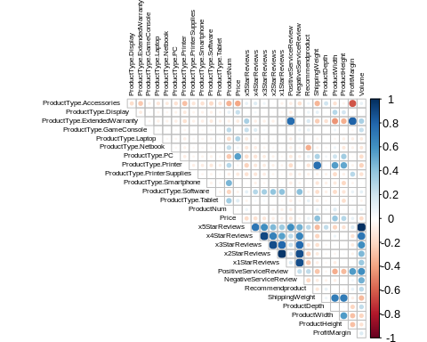

This information does not differ from the module 1’s counterpart, it’s obvius because we are using the same data set.

We trained a random forest followed by the use of varImp() function that assess the importance of each variables (without the ones we took out by looking at the correlation matrix). But first we need to create Test and Training sets, we also came up with a simple function to automate the processs.

#### Train and Test Set function

TrainAndTestSets <- function(label,p,data,seed){  
 set.seed(seed)  
   
 inTrain <- createDataPartition(y= label, p = p , list = FALSE)  
 training <- data[inTrain,]  
 testing <- data[-inTrain,]  
   
   
 list(trainingSet=training,testingSet = testing)  
   
}

EP <- EP[,c(1,2,3,4,5,6,7,8,9,10,11,12,13,14,16,18,20,21,22,23,24,25,26,27,28)]  
  
List <- TrainAndTestSets(EP$Volume,0.75,EP,123)

fitcontrol <- trainControl(method = "repeatedcv", repeats = 4)  
  
 Model <- train(Volume~., data = EP,method = "rf", trcontrol = fitcontrol , tunelenght = 5  
 , preProcess = c("center", "scale"),importance=T)   
   
 varImp(Model)

## rf variable importance  
##   
## only 20 most important variables shown (out of 24)  
##   
## Overall  
## PositiveServiceReview 100.000  
## x4StarReviews 46.607  
## ProductWidth 11.786  
## ShippingWeight 10.171  
## Price 9.865  
## x2StarReviews 9.387  
## ProductType.ExtendedWarranty 8.821  
## ProductType.Printer 7.122  
## ProfitMargin 6.530  
## ProductDepth 6.083  
## ProductType.Tablet 6.030  
## ProductType.Software 5.748  
## ProductHeight 4.535  
## ProductType.GameConsole 3.915  
## Recommendproduct 3.785  
## ProductType.Accessories 3.465  
## ProductType.Smartphone 3.014  
## ProductType.PC 2.530  
## ProductType.Display 2.499  
## NegativeServiceReview 2.344

So the only variables with a significant impact are only PostiveServiceReview and x4StarReviews.

## Models and Predictions

### Training Function

I created a function that trains every different model, by user specification

EP <- read.csv( file ="/home/zordo/Documents/Ubiqum/R-M2Task3/data/Epa.csv" , header = TRUE , sep = ',')  
  
EP <- EP[,c(1,5,9,18)]  
  
EP <- PPfunction(EP)  
  
EP <- RmOut(EP)  
  
List <- TrainAndTestSets(EP$Volume,0.75,EP,123)  
  
  
#### Random Forest ####  
ModelRandomForest <- TrainingFunction("rf",Volume~.,List$trainingSet,5)  
  
PredictionRandomForest <- predict(ModelRandomForest,List$testingSet)  
  
TestResultsRF <- postResample(PredictionRandomForest,List$testingSet$Volume)  
  
#### SVM ####  
  
svm.model <- TrainingFunction("svm",Volume~.,List$trainingSet,5,10000000,0.0000001)   
  
svm.pred <- predict(svm.model,List$testingSet)  
  
TestResultsSVM <- postResample(svm.pred,List$testingSet$Volume)  
  
  
#### knn ####  
  
 KNN <- TrainingFunction("knn",Volume~.,List$trainingSet,30)  
  
KnnPrediction <- predict(KNN,List$testingSet)  
  
TestResultsKNN <-postResample(KnnPrediction,List$testingSet$Volume)  
  
####  
  
  
AllTestResults <- cbind(TestResultsKNN,TestResultsRF,TestResultsSVM)  
  
AllTestResults

## TestResultsKNN TestResultsRF TestResultsSVM  
## RMSE 429.1288137 271.9646084 788.7251446  
## Rsquared 0.6828584 0.8447768 0.2698622  
## MAE 250.9259259 156.6409058 553.4143148

And then did another one t train the three models at the same time with a for loop

TrainAll3Models <- function (formula,data)  
 {  
  
 Model <- vector(mode="list", length=length(methods))  
  
 methods <- c("rf","svm","knn")  
   
 for(i in 1:length(methods))  
 {   
   
 Model[[i]] <- TrainingFunction(methods[i],formula,data,5)  
  
   
  
 }  
 Model  
}

I didn’t use this function that much since the mentors showed us another way of training without any function, and it’s much easier and cleaner.

a <- c("Volume ~ x4StarReviews","Volume ~.","Volume ~ PositiveServiceReview")  
b <- c("lm","rf", "knn","svmLinear")  
compare_var_mod <- c()  
  
for ( i in a) {  
 for (j in b) {  
   
 model <- train(formula(i), data = List$trainingSet, method = b,trainControl=trainControl(method = "repeatedcv", repeats = 4))  
   
 pred <- predict(model, newdata = List$testingSet)  
   
 pred_metric <- postResample(List$testingSet$Volume, pred)  
   
 compare_var_mod <- cbind(compare_var_mod , pred_metric)  
   
 }  
   
}  
 compare_var_mod

## pred_metric pred_metric pred_metric pred_metric pred_metric  
## RMSE 459.4407974 459.4407974 459.4407974 459.4407974 482.8296811  
## Rsquared 0.5286655 0.5286655 0.5286655 0.5286655 0.5398693  
## MAE 338.0400480 338.0400480 338.0400480 338.0400480 254.6791507  
## pred_metric pred_metric pred_metric pred_metric pred_metric  
## RMSE 482.8296811 482.8296811 482.8296811 568.6757233 568.6757233  
## Rsquared 0.5398693 0.5398693 0.5398693 0.2851607 0.2851607  
## MAE 254.6791507 254.6791507 254.6791507 436.9034926 436.9034926  
## pred_metric pred_metric  
## RMSE 568.6757233 568.6757233  
## Rsquared 0.2851607 0.2851607  
## MAE 436.9034926 436.9034926

names_var <- c()  
for (i in a) {  
 for(j in b) {  
 names_var <- append(names_var,paste(i,j))  
 }  
}  
  
  
names_var

## [1] "Volume ~ x4StarReviews lm"   
## [2] "Volume ~ x4StarReviews rf"   
## [3] "Volume ~ x4StarReviews knn"   
## [4] "Volume ~ x4StarReviews svmLinear"   
## [5] "Volume ~. lm"   
## [6] "Volume ~. rf"   
## [7] "Volume ~. knn"   
## [8] "Volume ~. svmLinear"   
## [9] "Volume ~ PositiveServiceReview lm"   
## [10] "Volume ~ PositiveServiceReview rf"   
## [11] "Volume ~ PositiveServiceReview knn"   
## [12] "Volume ~ PositiveServiceReview svmLinear"

colnames(compare_var_mod) <- names_var  
  
compare_var_mod

## Volume ~ x4StarReviews lm Volume ~ x4StarReviews rf  
## RMSE 459.4407974 459.4407974  
## Rsquared 0.5286655 0.5286655  
## MAE 338.0400480 338.0400480  
## Volume ~ x4StarReviews knn Volume ~ x4StarReviews svmLinear  
## RMSE 459.4407974 459.4407974  
## Rsquared 0.5286655 0.5286655  
## MAE 338.0400480 338.0400480  
## Volume ~. lm Volume ~. rf Volume ~. knn Volume ~. svmLinear  
## RMSE 482.8296811 482.8296811 482.8296811 482.8296811  
## Rsquared 0.5398693 0.5398693 0.5398693 0.5398693  
## MAE 254.6791507 254.6791507 254.6791507 254.6791507  
## Volume ~ PositiveServiceReview lm  
## RMSE 568.6757233  
## Rsquared 0.2851607  
## MAE 436.9034926  
## Volume ~ PositiveServiceReview rf  
## RMSE 568.6757233  
## Rsquared 0.2851607  
## MAE 436.9034926  
## Volume ~ PositiveServiceReview knn  
## RMSE 568.6757233  
## Rsquared 0.2851607  
## MAE 436.9034926  
## Volume ~ PositiveServiceReview svmLinear  
## RMSE 568.6757233  
## Rsquared 0.2851607  
## MAE 436.9034926

compare_var_mod_melt <- melt(compare_var_mod, varnames = c("metric", "model"))  
compare_var_mod_melt <- as.data.frame(compare_var_mod_melt)  
compare_var_mod_melt

## metric model value  
## 1 RMSE Volume ~ x4StarReviews lm 459.4407974  
## 2 Rsquared Volume ~ x4StarReviews lm 0.5286655  
## 3 MAE Volume ~ x4StarReviews lm 338.0400480  
## 4 RMSE Volume ~ x4StarReviews rf 459.4407974  
## 5 Rsquared Volume ~ x4StarReviews rf 0.5286655  
## 6 MAE Volume ~ x4StarReviews rf 338.0400480  
## 7 RMSE Volume ~ x4StarReviews knn 459.4407974  
## 8 Rsquared Volume ~ x4StarReviews knn 0.5286655  
## 9 MAE Volume ~ x4StarReviews knn 338.0400480  
## 10 RMSE Volume ~ x4StarReviews svmLinear 459.4407974  
## 11 Rsquared Volume ~ x4StarReviews svmLinear 0.5286655  
## 12 MAE Volume ~ x4StarReviews svmLinear 338.0400480  
## 13 RMSE Volume ~. lm 482.8296811  
## 14 Rsquared Volume ~. lm 0.5398693  
## 15 MAE Volume ~. lm 254.6791507  
## 16 RMSE Volume ~. rf 482.8296811  
## 17 Rsquared Volume ~. rf 0.5398693  
## 18 MAE Volume ~. rf 254.6791507  
## 19 RMSE Volume ~. knn 482.8296811  
## 20 Rsquared Volume ~. knn 0.5398693  
## 21 MAE Volume ~. knn 254.6791507  
## 22 RMSE Volume ~. svmLinear 482.8296811  
## 23 Rsquared Volume ~. svmLinear 0.5398693  
## 24 MAE Volume ~. svmLinear 254.6791507  
## 25 RMSE Volume ~ PositiveServiceReview lm 568.6757233  
## 26 Rsquared Volume ~ PositiveServiceReview lm 0.2851607  
## 27 MAE Volume ~ PositiveServiceReview lm 436.9034926  
## 28 RMSE Volume ~ PositiveServiceReview rf 568.6757233  
## 29 Rsquared Volume ~ PositiveServiceReview rf 0.2851607  
## 30 MAE Volume ~ PositiveServiceReview rf 436.9034926  
## 31 RMSE Volume ~ PositiveServiceReview knn 568.6757233  
## 32 Rsquared Volume ~ PositiveServiceReview knn 0.2851607  
## 33 MAE Volume ~ PositiveServiceReview knn 436.9034926  
## 34 RMSE Volume ~ PositiveServiceReview svmLinear 568.6757233  
## 35 Rsquared Volume ~ PositiveServiceReview svmLinear 0.2851607  
## 36 MAE Volume ~ PositiveServiceReview svmLinear 436.9034926

ggplot(compare_var_mod_melt, aes(x=model,y=value)) + geom_col() + facet_grid(metric~., scales="free") +theme(axis.text=element_text(size=3),  
 axis.title=element_text(size=14,face="bold"))

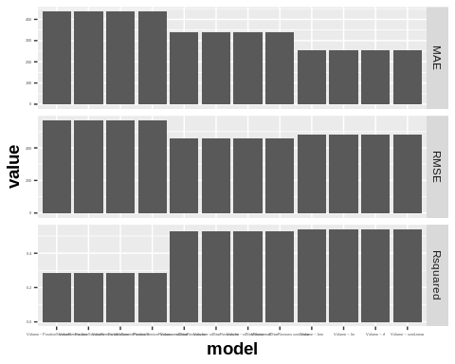 I only used RF, and KNN because from past results the SVM did not look like a good fit.

### Error Analysis

ABSrf <- (List$testingSet$Volume - PredictionRandomForest)  
  
RLTrf <- (ABSrf / List$testingSet$Volume)  
  
ABSsvm <- (List$testingSet$Volume - svm.pred)  
  
RLTsvm <- (ABSsvm / List$testingSet$Volume)  
  
  
  
Absknn <- (List$testingSet$Volume - KnnPrediction)  
  
RLTknn <- (Absknn / List$testingSet$Volume)  
 #abline(0, 0) # the horizon  
  
  
Lol <- cbind(List$testingSet,ABSrf)

Random Forest Residuals

ggplot(Lol,  
 aes(Lol$Volume,ABSrf))+  
 geom_point(color="red")+  
 geom_smooth()

## `geom_smooth()` using method = 'loess' and formula 'y ~ x'

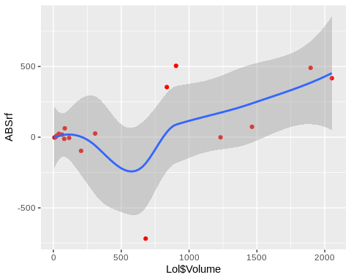

ggplot(Lol,  
 aes(Lol$Volume,RLTrf))+  
 geom_point(color="red")+  
 geom_smooth()

## `geom_smooth()` using method = 'loess' and formula 'y ~ x'

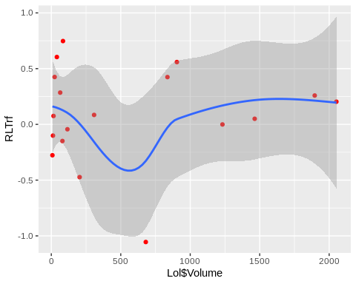 Svm Residuals

ggplot(Lol,  
 aes(Lol$Volume,ABSsvm))+  
 geom_point(color="red")+  
 geom_smooth()

## `geom_smooth()` using method = 'loess' and formula 'y ~ x'

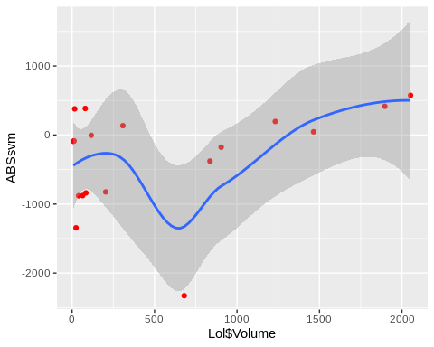

ggplot(Lol,  
 aes(Lol$Volume,RLTsvm))+  
 geom_point(color="red")+  
 geom_smooth()

## `geom_smooth()` using method = 'loess' and formula 'y ~ x'

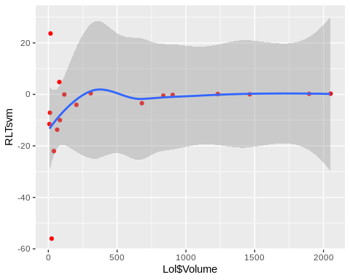

ggplot(Lol,  
 aes(Lol$Volume,Absknn))+  
 geom_point(color="red")+  
 geom_smooth()

## `geom_smooth()` using method = 'loess' and formula 'y ~ x'

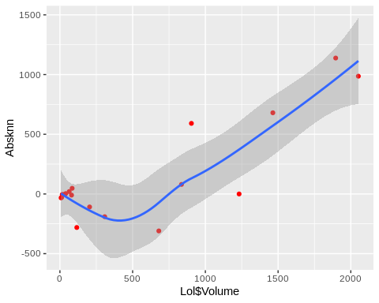

ggplot(Lol,  
 aes(Lol$Volume,RLTknn))+  
 geom_point(color="red")+  
 geom_smooth()

## `geom_smooth()` using method = 'loess' and formula 'y ~ x'

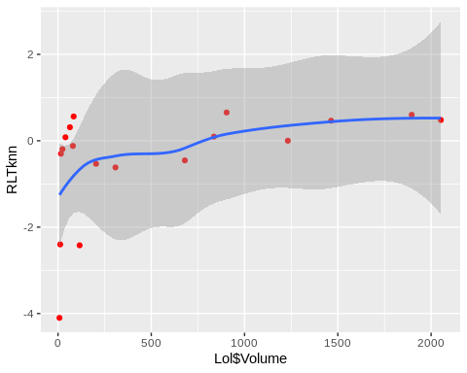

Let’s now apply the current models into the new product list and make a top 5 for most probably sold products in volume.

### Prediction

The random forest was the one who gave us the best results, with both variables (ProductServiceReview,x4StarReviews).

NP <- read.csv(file = "/home/zordo/Documents/Ubiqum/R-M2Task3/data/Npa.csv", header = TRUE , sep =',')  
  
NP <- PPfunction(NP)  
  
NewProductsVolume <- predict(ModelRandomForest,NP)  
  
NP$Volume<-NewProductsVolume

We got the volume, now we need to calculate the profit, to see which products types we should invest on.

**Profit = profit margin * Volume**

Profit <- NP$ProfitMargin * NP$Volume  
  
 NP <- cbind(NP,Profit)   
  
   
Top5 <- top_n(NP, 5, Profit)  
   
Top5 <- cbind (Top5,sort(Top5$Profit))  
   
Top5

## ProductType.Accessories ProductType.Display ProductType.ExtendedWarranty  
## 1 0 0 0  
## 2 0 0 0  
## 3 0 0 0  
## 4 0 0 0  
## 5 0 0 0  
## ProductType.GameConsole ProductType.Laptop ProductType.Netbook  
## 1 0 0 1  
## 2 0 0 0  
## 3 0 0 0  
## 4 1 0 0  
## 5 1 0 0  
## ProductType.PC ProductType.Printer ProductType.PrinterSupplies  
## 1 0 0 0  
## 2 0 0 0  
## 3 0 0 0  
## 4 0 0 0  
## 5 0 0 0  
## ProductType.Smartphone ProductType.Software ProductType.Tablet  
## 1 0 0 0  
## 2 0 0 1  
## 3 0 0 1  
## 4 0 0 0  
## 5 0 0 0  
## ProductNum Price x5StarReviews x4StarReviews x3StarReviews  
## 1 180 329.00 312 112 28  
## 2 186 629.00 296 66 30  
## 3 187 199.00 943 437 224  
## 4 199 249.99 462 97 25  
## 5 307 425.00 1525 252 99  
## x2StarReviews x1StarReviews PositiveServiceReview NegativeServiceReview  
## 1 31 47 28 16  
## 2 21 36 28 9  
## 3 160 247 90 23  
## 4 17 58 32 12  
## 5 56 45 59 13  
## Recommendproduct BestSellersRank ShippingWeight ProductDepth  
## 1 0.7 2699 4.6 10.17  
## 2 0.8 34 3.0 7.31  
## 3 0.8 1 0.9 5.40  
## 4 0.8 115 8.4 6.20  
## 5 0.9 215 20.0 8.50  
## ProductWidth ProductHeight ProfitMargin Volume Profit  
## 1 7.28 0.95 0.09 1386.986 124.8287  
## 2 9.50 0.37 0.10 1371.081 137.1081  
## 3 7.60 0.40 0.20 1835.990 367.1979  
## 4 13.20 13.20 0.09 1513.556 136.2200  
## 5 6.00 1.75 0.18 1843.867 331.8960  
## sort(Top5$Profit)  
## 1 124.8287  
## 2 136.2200  
## 3 137.1081  
## 4 331.8960  
## 5 367.1979

Our top 5 most profitable product types are

|  |  |  |
| --- | --- | --- |
| Number | Volume | Profit |
| Game Console | 1735.3872 | 347.07744 |
| Game Console | 1735.3872 | 312.36970 |
| Tablet | 1319.6391 | 118.76752 |
| Tablet | 1211.3776 | 109.02398 |
| NoteBook | 877.6156 | 87.76156 |

## Conclusion

All three models used are non-parametric, but before explaining what a non-parametric model is, I would like to explain what parametric models are. Parametric models are algorithms that simplify the function to a known form, and no matter how much data that’s fed to the algorithm, the model won’t change the quantity of parameters needed.All you need to know for predicting a future data balue from the current state of the model are his parameters,EG : Linear regression with on variable, you have two parameters (coefficient and intercept).Knowing this parameters will enable you to predict new values. In a mathematical way :   
**Yi = B0 + B1X1 + B2X2 + … + ei** Non-parametric models do not make any fixed assumptions about the form of the mapping, they are free to learn from the training data. The parameters are usually said to be infinite in dimension and so can express the characteristics in data much better than parametric models. E.g : KNN, makes predictions based on the k most similar training patterns for a new data instance. The method does not assume anything about the form of the mapping function other than patterns that are close are likely have a similar output variable. In mathematical form **Yi=F(xi) + ei** Where F can be any function,the data will decide what the function looks like.It will not provide the analytical expression but it will give you its graph given your data set. I find this picture very helpfull in understanding how both types of models work, summing up in easy non- technical language, parametric models follow an equation while non-parametric models follow the data. One of the requirements to use a non-parametric model is to have a big set of data, we have 80 rows, 78 after cutting outliers and only 60 of them are for training.This is not a big set of data at all, I think it actually couldn’t be any smaller than this. Also they are good methods when we don’t have any prior knowledge and not worry about choosing the right features. So using this models is not efficient at all, if we are using algorithms that “follow the data” and we have almost no data, it’s obvious why this approach is not efficient and why the errors are so big.