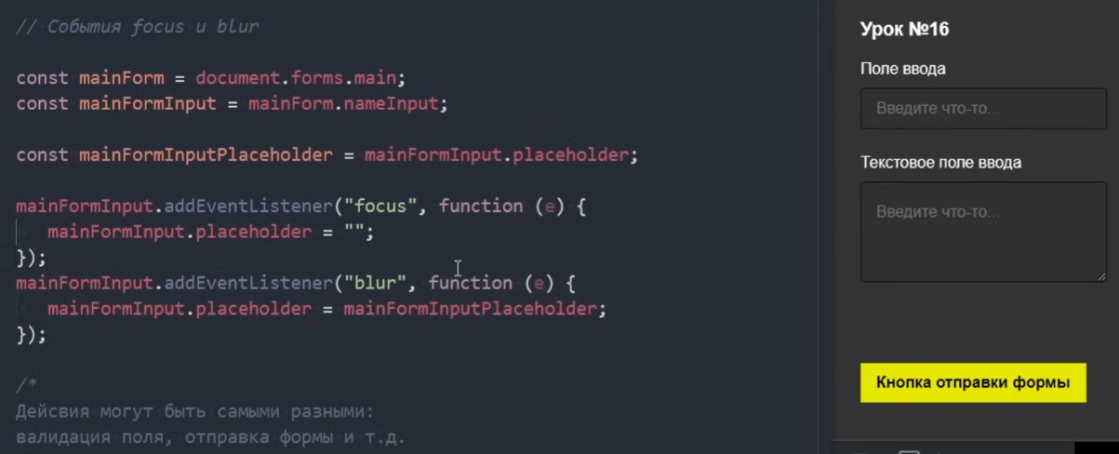

<https://www.youtube.com/watch?v=OtJkXuqyjkk&list=PLM6XATa8CAG7DDIBjNVd78Fv5Ueo930IV&index=19>

