IMPLEMENTATION OF MEDICAL IMAGE FUSION USING DWT PROCESS ON FPGA BOARD

ABSTRACT:

The Image fusion is a data fusion technology which keeps images as main research contents. It refers to the techniques that integrate multi-images of the same scene from multiple image sensor data or integrate multi images of the same scene at different times from one image sensor.. Wavelet Transform has good time-frequency characteristics. It was applied successfully in image processing field. Nevertheless, its excellent characteristic in one-dimension can’t be extended to two dimensions or multi-dimension simply. Separable wavelet which was spanning by one-dimensional wavelet has limited directivity.

The experiments show that the method could extract useful information from source images to fused images so that clear images are obtained.

Now-a-days, almost all areas of medical diagnosis are impacted by the digital image processing. When an image is processed for visual interpretation, the human eye is the judge of how well a particular method works. Clinical application demanding Radiotherapy plan, for instance, often benefits from the complementary information in images of different modalities.Formedicaldiagnosis, Computed Tomography (CT) provides the best information on denser tissue with less distortion. Magnetic Resonance Image (MRI) provides better information on soft tissue   
with more distortion.

With more available multimodality medical images in clinical applications, the idea of combining images from different modalities become very important and medical image fusion has emerged as a new promising research field. The experiments show that the method could extract useful information from source images to fused images so that clear images are obtained. In this paper, a hardware implementation of a image fusion system is proposed. Here MATLAB is used to convert images into pixel-format files and to observe simulation results. To implement this paper XPS & VB are needed. In XPS, first select hardware & software components then by adding source and header files & convertinginto bit streams and download into FPGA, to obtain fused image. The input image can also be recovered by combining of fused image and the other input image.

.

.

SIT ELECTRONICS AND TELECOMMUNICATION ENGINEERING 2018-19   
 1

IMPLEMENTATION OF MEDICAL IMAGE FUSION USING DWT PROCESS ON FPGA BOARD

CONTENTS

CHAPTER NO. TITLE PAGE

NO.

1 INTRODUCTION 5

1.1 MOTIVATION 7

1.2 OBJECTIVE 7

2 LITERATURE SURVEY 8

3 STATE OF ART 13

4 DESIGN AND DRAWING 15

4.1 BLOCK DIAGRAM 16

4.2 SYSTEM ACHITECTURE 17

4.3 CIRCUIT DIAGRAM 19

4.4 PCB LAYOUT 20

5 MANUFACTURING 21

5.1 SOFTWARE REQUIREMENTS 22

5.2 HARDWARE REQUIREMENTS 22

6 METHODOLOGY AND WORKING 30

6.1 ADVANTAGES 32

6.2 APPLICATIONS 32

7 CONCLUSION 33

7.1 FUTURE WORK 34

8 REFERENCES 35

SIT ELECTRONICS AND TELECOMMUNICATION ENGINEERING 2018-19   
 2

IMPLEMENTATION OF MEDICAL IMAGE FUSION USING DWT PROCESS ON FPGA BOARD

LIST OF FIGURES

Sr No. Figure No. List Of Figures Page No.

1 4.1 Block Diagram 16

2 4.2 System Architecture 17

3 4.3 Circuit Diagram 19

4 4.4 PCB Layout 20

5 5.2.1 Alcohol Sensor 22

6 5.2.2 Temperature Sensor 24

7 5.2.3 IR Sensor 25

8 5.2.4 Eye blink using Camera 26

9 5.2.5 GSM 800 27

10 5.2.6 Buzzer 28

SIT ELECTRONICS AND TELECOMMUNICATION ENGINEERING 2018-19   
 3

IMPLEMENTATION OF MEDICAL IMAGE FUSION USING DWT PROCESS ON FPGA BOARD

LIST OF TABLES

Sr No. List Of Tables Page No.

1 State Of Art 14

SIT ELECTRONICS AND TELECOMMUNICATION ENGINEERING 2018-19   
 4

IMPLEMENTATION OF MEDICAL IMAGE FUSION USING DWT PROCESS ON FPGA BOARD

CHAPTER NO.:-1

INTRODUCTION

SIT ELECTRONICS AND TELECOMMUNICATION ENGINEERING 2018-19   
 5

IMPLEMENTATION OF MEDICAL IMAGE FUSION USING DWT PROCESS ON FPGA BOARD

INTRODUCTION :

Image fusion is the process of combining relevant information from two or more images into a single image. Then the resultant image has more information than input images. It’s being used for medical applications, so as to get a better image. Due to the increasing number of high-resolution images are available along with sensor technology development, image fusion is still important and easy method to interpret theimage data obtaining a more suitable image for avariety of applications, such as visual interpretation, satellite, , digital classification & war-field

The main objective of medical imaging is to obtain a high resolution image with as much details as possible for the sake of diagnosis. MRI and CT imaging are of main concern for diagnostic purposes. Both techniques give special sophisticated characteristics of the organ to be imaged. So, it is expected that fusion of MRI and CT images of the same organ would result in an integrated image of much more information installed under the surface of the road such as loop detectors. However, in this system, finding the traffic sensors in every roads process is impossible, since the traffic sensors are installed in main highways only.

The fusion process should preserve all relevant information of the input imagery in the composite image (pattern conservation) The fusion scheme should not introduce any artifacts or   
inconsistencies which would distract the human observer or following processing stages .The fusion process should be shift and rotational invariant, i.e. the fusion result should not   
depend on the location or orientation of an object the input imagery .In case of image sequence fusion arises the additional problem of temporal stability and consistency of the fused image sequence.

Wavelet transform fusion is defined as considering the wavelet transforms of the two registered input images together with the fusion rule. Then, the inverse wavelet transform is computed, and the fused image is reconstructed. In the pixel-level image fusion the fused images provided all relevant information present in original images without any inconsistencies

SIT ELECTRONICS AND TELECOMMUNICATION ENGINEERING 2018-19   
 6

IMPLEMENTATION OF MEDICAL IMAGE FUSION USING DWT PROCESS ON FPGA BOARD

1.1 Motivation :

When an image is processed for visual interpretation, the human eye is the judge of how well a particular method works. Clinical application demanding Radiotherapy plan, for instance, often benefits from the complementary information in images of different modalities.

For medical diagnosis, Computed Tomography (CT) provides the best information on denser tissue with less distortion. Magnetic Resonance Image (MRI) provides better information on soft tissue with more distortion.

With more available multimodality medical images in clinical applications, the idea of combining images from different modalities become very important and medical image fusion has emerged as a new promising research field. The experiments show that the method could extract useful information from source images to fused images so that clear images are obtained. In this paper, a hardware implementation of a image fusion

* 1. Objective :
* Objective of the project is the hardware realization, which is based on FPGA technology to provide a fast, compact, and low-power solution for image fusion.
* The main objective of medical imaging is to obtain a high resolution image
* Using multi-resolution technique different frequencies would be analyzed with different resolutions due to the Wavelet Transform
* To increase the signal to-noise ratio of the resultant image with simple averaging technique
* To reduce the spatial distortion

SIT ELECTRONICS AND TELECOMMUNICATION ENGINEERING 2018-19   
 7

IMPLEMENTATION OF MEDICAL IMAGE FUSION USING DWT PROCESS ON FPGA BOARD

CHAPTER NO.:-2

LITERATURE SURVEY

SIT ELECTRONICS AND TELECOMMUNICATION ENGINEERING 2018-19   
 8

IMPLEMENTATION OF MEDICAL IMAGE FUSION USING DWT PROCESS ON FPGA BOARD

2.1 A smart vehicle for accident prevention using wireless black box and eye blink sensing technology along with seat belt controlled ignition system :

The accidents and the accident injuries in the world is increasing in our day today life so   
there must be good and efficient control for the safety of human life violation of traffic rules   
drunk driving, careless driving are some causes of road accidents as we know we cannot stop the   
accidents but we can reduce the accidents by some precautionary measures. Road accident is   
most unwanted thing to happen to a road user, though they happen quite often. The most   
unfortunate thing is that we don't learn from our mi stakes on road. Most of the road users are   
quite weil aware of the general rules and safety measures while using roads but it is only the   
laxity on part of road users, which cause accidents and crashes. Most of the fatal accidents occur   
due to over speeding.

It is a natural psyche of humans to excel. But when we are sharing the road with other   
users we will always want to take a control. Increase in speed multiplies the risk of accident and   
severity of injury during accident. A vehicle moving on high speed will have greater impact   
during the crash and hence will cause more lllJurles. some deaths also happen due to the lack of   
immediate first aid. Another problem is that the lack of information about the vehicle position. To   
solve the major problem several methods have been adopted but most of them are largely   
ineffective or manually operated and depend on the user's ability to be alert when using them. As   
such, an smart security to humans and alert and reporting system is needed which can inform a   
driver if any parameters are going wrong and also to the police to inform about the violation of   
laws occur. The smart vehicle system consisting of mainly 3 parts, black box, eye blink sensor,   
seatbelt controlled ignition system.

These systems provides a good and securable driving for the driver .In this project we are   
controlling the speed, seat belt, do Of, obstacle detection, whole security of the vehicle. Proposed   
method resolves the problems faced by the existing systems. In this project the vehicle is partially   
controlled by various sensors .There is a vehicle black box it will store the data of various sensors   
which measure various performance of the vehicle and also sends information to various

SIT ELECTRONICS AND TELECOMMUNICATION ENGINEERING 2018-19

9

IMPLEMENTATION OF MEDICAL IMAGE FUSION USING DWT PROCESS ON FPGA BOARD

authorities about the vehicle position to get immediate first aid. When any abnormalities from the   
threshold value occur the microcontroller sends message to the desired positions and immediate   
first aid and other facilities are available. This system is weil suitable in all type of vehicles.   
which contain a black box system which will store the values of the various parameters of the   
vehicles.

2.2 Automatic road accident detection techniques :

Statistics show that the leading cause of death by injury is road traffic accidents. A survey   
report by World Health Organization highlights that every year more than 30,000 people in   
Pakistan are died due to road traffic accidents [1]. There are number of causes for which an   
accident can occur, some of them are; lack of training institutes, use of mobile phone while   
driving, unskilled drivers, driving while intoxicated, bad road condition, overloading, and poor   
traffic management. However, most of the time it has been observed that the deaths occured in   
the road accident are due to the late arrival of the ambulance to the accident spot.

Although in most cases the injury is not severe and we could save the affected lives,   
however, due to late arrival of the rescue team, the injuries turn fatal. In this survey paper, we   
briefly review selected road accident detection techniques and propose a solution. In these   
techniques, a system is used that can automatically detect an accident in appreciably less amount   
of time and sends the basic information about the accident to the emergency center. These   
techniques use smartphone, GSM and GPS, VANET and mobile applications. In smartphone-  
based accident detection, the Internet services provided by a cellular network operator are used   
to send the information in case of road accident. The geographical location of the accident spot   
is identified by the GPS system.

2.3 Wireless Vehicle Alert and Collision Prevention System Design using LPC2148   
 Microcontroller :

For any system or device considered in today’s environment needs to be provided with   
security system. This security system can be with respect to providing an alert system or   
indication of usage of secured system. Various security systems include home automation where   
security is provided for controlling the home appliances, security to the valuables; detection of

SIT ELECTRONICS AND TELECOMMUNICATION ENGINEERING 2018-19

10

IMPLEMENTATION OF MEDICAL IMAGE FUSION USING DWT PROCESS ON FPGA BOARD

theft. The other type of security system includes security for vehicles. The proposed paper deals with the detection of vehicle accident and sending the SMS to mobile. Now days the vehicle accident rate has been increasing as compared to previous decade. The accident rate has increased by 54%. This system minimizes the action time after an accident. This paper deals with such system to detect possible collision and prevent it.

Now-a-days the vehicle accident rate has been increasing as compared to previous   
decade. The accident rate has increased by 54%. This system minimizes the action time after an   
accident. This paper deals with such system to detect possible collision and prevent it. The paper   
presents an efficient implementation of security system for the moving vehicles using SMS alert   
system. The system uses microcontroller which makes it unique comparative to the other   
systems. The components used in the proposed work are related with detecting the accident,   
saving the phone numbers, sending the SMS. The major component is the LPC2148   
microcontroller which performs all the operations related to controlling the embedded system   
circuit. The security for the vehicles is provided in terms of detection of accident system   
enclosed with the components is fit inside the vehicle for accident detection done using vibration   
sensor. This detection is sent in the form of an SMS alert to mobile using GSM.

2.4 Driver Knowledge and Attitudes on Animal Vehicle Collisions in Northern Tanzania :

Roads are a major cause of wildlife mortality by animal-vehicle-collisions (AVCs). We   
monitored the patterns and frequency of AVCs on two sections of a major highway in Northern   
Tanzania and compared these patterns to the knowledge and perceptions of drivers who   
frequently use the roads. While actual field survey showed that more birds were killed by AVCs,   
mammals were perceived by the drivers to be the most common AVC. Drivers were indifferent to   
whether AVCs were a major problem on the road, and 67% strongly felt that AVCs were mainly   
accidental, either due to high vehicle speed or poor visibility at night. There was a negative   
correlation between the likelihood of a species being hit by vehicles and its average body mass.   
Only 35% of drivers said they had attended an educational program related to the impact of roads   
on wildlife. This study highlights a need for collaborative efforts between the wildlife

SIT ELECTRONICS AND TELECOMMUNICATION ENGINEERING 2018-19   
 11

IMPLEMENTATION OF MEDICAL IMAGE FUSION USING DWT PROCESS ON FPGA BOARD

conservation and road departments to educate road users on the importance of driving responsibly and exercising due care for wildlife and human safety. This should be coupled with effective mitigation measures to reduce the extent of AVCs.

SIT ELECTRONICS AND TELECOMMUNICATION ENGINEERING 2018-19   
 12

IMPLEMENTATION OF MEDICAL IMAGE FUSION USING DWT PROCESS ON FPGA BOARD

CHAPTER NO.: - 3

STATE OF ART

SIT ELECTRONICS AND TELECOMMUNICATION ENGINEERING 2018-19   
 13

IMPLEMENTATION OF MEDICAL IMAGE FUSION USING DWT PROCESS ON FPGA BOARD

STATE OF ART :

|  |  |  |  |  |
| --- | --- | --- | --- | --- |
| TITLE OF PROJECT | ISSUE DISCUSSED | OUTCOMES | METHODOLOGY | SCOPE |

|  |  |  |  |  |
| --- | --- | --- | --- | --- |
|  |  |  |  |  |

STATE OF ART :

|  |  |  |  |  |
| --- | --- | --- | --- | --- |
| TITLE OF PROJECT | ISSUE DISCUSSED | OUTCOMES | METHODOLOGY | SCOPE |

|  |  |  |  |  |
| --- | --- | --- | --- | --- |
| IMPLEMENTATION OF MEDICAL IMAGE FUSION USING DWT PROCESS ON FPGA BOARD | BETTER DIAGNOSIS OF THE DIASEASE FROM THE IMAGE ITSELF | DIASEASES COULD BE DIAGONSED MORE ACCURATELY | USING FPGA BOARD IMAGES FUSED | HIGH RESOLUTION IMAGE LEADS TO ACCURATE INFOMATION |

Table No. 3.1 State Of Art

IMPLEMENTATION OF MEDICAL IMAGE FUSION USING DWT PROCESS ON FPGA BOARD

CHAPTER NO:-4

DESIGN AND DRAWING

SIT ELECTRONICS AND TELECOMMUNICATION ENGINEERING 2018-19   
 15

IMPLEMENTATION OF MEDICAL IMAGE FUSION USING DWT PROCESS ON FPGA BOARD

DIAGRAMS :

4.1 Block Diagram

Figure 4.1 Block diagram

SIT ELECTRONICS AND TELECOMMUNICATION ENGINEERING 2018-19   
 16

IMPLEMENTATION OF MEDICAL IMAGE FUSION USING DWT PROCESS ON FPGA BOARD

4.2 System Architectures :

Figure 4.2 System Architecture

A hi-sensitivity alcohol sensor is built into the transmission shift knob, which is able to detect the presence of alcohol in the perspiration of the driver’s palm as he or she attempts to start driving. When the alcohol-level detected is above the pre-determined threshold, the system automatically locks the transmission, immobilizing the car. A “drunk-driving” voice alert is also issued via the car navigation system.

SIT ELECTRONICS AND TELECOMMUNICATION ENGINEERING 2018-19   
 17

IMPLEMENTATION OF MEDICAL IMAGE FUSION USING DWT PROCESS ON FPGA BOARD

Additional alcohol odor sensors are also incorporated into the driver’s and passenger   
seats to detect the presence of alcohol in the air inside the vehicle cabin. When alcohol is   
detected, the system issues both a voice alert and a message alert on the navigation system   
monitor.

By constantly monitoring the operational behavior of the vehicle (e.g. sensing if the vehicle is drifting out of its driving lane), the system can identify signs of inattentiveness or distraction in the driver. When the system detects such behavior, voice and message alerts are issued via the navigation system. The seatbelt alert mechanism is also activated, tightening around the driver to gain immediate attention.

SIT ELECTRONICS AND TELECOMMUNICATION ENGINEERING 2018-19   
 18

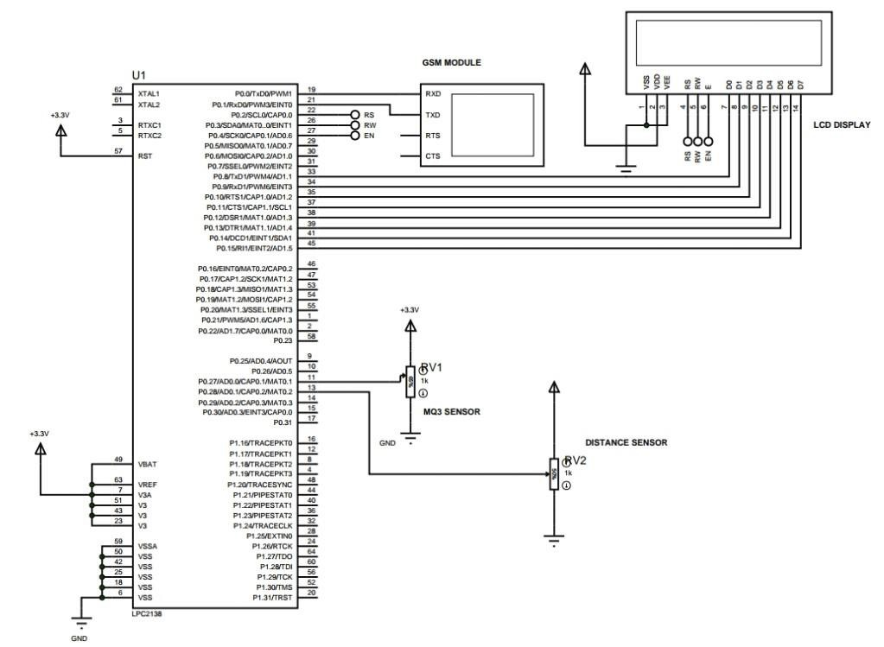

IMPLEMENTATION OF MEDICAL IMAGE FUSION USING DWT PROCESS ON FPGA BOARD

4.3 Circuit Diagram :

Figure No.4.3 Circuit Diagram

SIT ELECTRONICS AND TELECOMMUNICATION ENGINEERING 2018-19   
 19

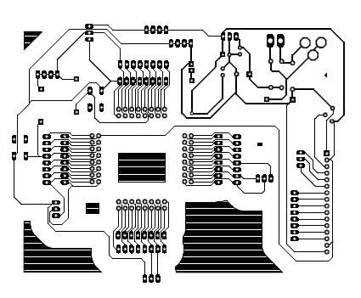

IMPLEMENTATION OF MEDICAL IMAGE FUSION USING DWT PROCESS ON FPGA BOARD

4.4 PCB Layout :

Figure No.4.4 PCB Layout

SIT ELECTRONICS AND TELECOMMUNICATION ENGINEERING 2018-19   
 20

IMPLEMENTATION OF MEDICAL IMAGE FUSION USING DWT PROCESS ON FPGA BOARD

CHAPTER NO.:-5

MANUFACTURING

SIT ELECTRONICS AND TELECOMMUNICATION ENGINEERING 2018-19   
 21

IMPLEMENTATION OF MEDICAL IMAGE FUSION USING DWT PROCESS ON FPGA BOARD

5.1 SOFTWARE REQUIREMENTS:

* Xilinx ISE 10.1i
* MATLAB
* Xilinx Platform Studio
* Visual Studio

5.2 HARDWARE REQUIREMENTS :

5.2.1 FPGA BOARD :

Figure 5.2.1 FPGA BOARD

It is used as part of the breathalyzers or breath testers for the detection of ethanol in   
human breath. A little tube is placed inside the sensor. This tube is a heating system that is made   
of aluminum oxide and tin dioxide and inside of it there are heater coils, which practically   
produce the heat. The analog gas sensor- MQ3 is suitable for alcohol detecting, this sensor can   
be used in a breath analyzer. It has a high sensitivity to alcohol and small sensitivity to benzene.

SIT ELECTRONICS AND TELECOMMUNICATION ENGINEERING 2018-19

22

IMPLEMENTATION OF MEDICAL IMAGE FUSION USING DWT PROCESS ON FPGA BOARD

The sensitivity can be adjusted by the potentiometer sensitive material of MQ3 gas sensor is SnO2, which with lower conductivity in clean air.

When the target alcohol gas exist, the sensors conductivity is higher along with the gas concentration rising, use of simple electro circuit, convert change of conductivity to correspond output signal of gas concentration. MQ-3 gas sensor has high sensitivity to Alcohol, and has good resistance to disturb of gasoline, smoke and vapor. It has fine sensitivity range around 2 meters. The sensor could be used to detect alcohol with different concentration; it is with low cost and suitable for different application.

➢ The Features:

➢ Size : 20x20 mm

➢ Requires 5 volt of power supply

➢ Pin specification: 1-Output, 2-Gnd, 3-VCC ➢ Analog Interference

➢ High sensitivity to alcohol ➢ Faster response time

➢ Highly stable, long life and low in cost

5.2.2 Temperature sensor :

This LM35 is a temperature sensor which measures temperature more accurately. This   
generates a higher output voltage than thermocouple and may not require that the output voltage   
be amplified. In this system temperature sensor is used to check engines temperature, if it is   
overheated, it indicates through alarm. The operating temperature range is from -55 to +150   
degrees centigrade. It has three pins-2 pins for the power supply and one for analog output. The   
output pin provides an analog voltage output that is linearly proportional to the centigrade   
temperature. Pin 2 gives an output of 1mv per 0.1 degree centigrade. So to get the degree value   
in Celsius, all that must be done is to take the voltage output and divide it by 10. This gives the   
value degrees in Celsius.

SIT ELECTRONICS AND TELECOMMUNICATION ENGINEERING 2018-19   
 23

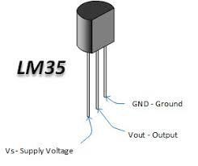

IMPLEMENTATION OF MEDICAL IMAGE FUSION USING DWT PROCESS ON FPGA BOARD

Figure 5.2.2 Temperature sensor

The LM35 string is a detailed IC temperature sensor, as their result voltage can be directly proportional temperature in Celsius (centigrade). The sensor was shown in Figure 3. Therefore leverage comes LM35 around direct temperature sensors aligned ° Kelvin, as the user seriously isn’t needed to take away a continuous voltage through its result to get helpful Centigrade scaling. The particular LM35, doesn’t demand virtually any outer calibration or maybe cutting down on to produce common a precision of ± ¼° C to room temperature and ± ¾° C for an aggregate -55° C to 150° C temperature range. Economic cost is normally guaranteed by clipping and adjustment in the measure of the wafer.

This low output impedance LM35 linear output and exact adjustment without touching   
help to interface to peruse first as well as management hardware particularly simple. It can be   
utilized with individual strength products, as well as with negative supplies. Subsequent to just it   
called 60 mu of its offer, which has low self-warming, under 0.1 C in the stationary   
environments. The LM35 is appraised to work in a scope of -55 to +150 C° temperature, while   
the LM35C is expected for ° -40 to +110 C range (-10° with more prominent exactness). The   
LM35 arrangement is accessible bundled in water/air proof compartments transistor A-46, while   
the LM35C, LM35CA and LM35D are additionally accessible in the plastic TO-92 bundle   
transistor. The LM35D is likewise vain-power in a surface mount bundle 8-lead little blueprint   
plastic bundle and A-220.

SIT ELECTRONICS AND TELECOMMUNICATION ENGINEERING 2018-19   
 24

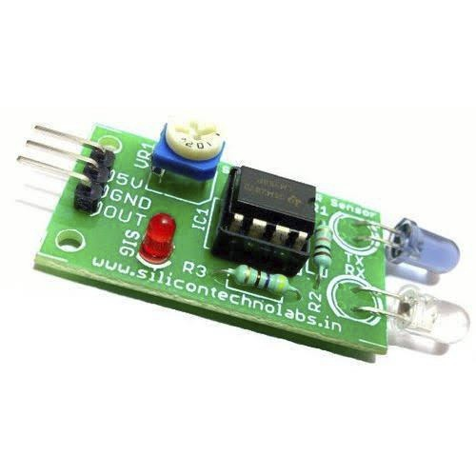

IMPLEMENTATION OF MEDICAL IMAGE FUSION USING DWT PROCESS ON FPGA BOARD

5.2.3 Seat belt using IR sensor :

For detection of proper seat is put on or not, for this purpose used IR sensor (for seat belt   
buckle detection) and encoder wheel for counting pulses of sensing how much length is pulling   
of seat belt. An output of these both sensors is given to the Arduino. Arduino decides the seat   
belt is properly attached or not. If both sensor outputs are properly so microcontroller decides   
the seat belt is properly attached otherwise seat belt alert sound continuously ringing. Seat belt   
is one of the primary safety feature used in vehicle to avoid major injuries to the driver driving   
the vehicle.

Figure 5.2.3 IR Sensor

Even after the government norm that is wearing of seat belt is mandatory, accidental   
injuries increase due to negligence of occupants in vehicle of wearing seat belt. If seat belt is not   
buckled correctly than the chances of accidental injuries increase. To avoid these, different   
companies found variety of seat belt systems such as passive seat belt system, automatic seat   
belt system, seat belt warning system and so on. So, in this project we have proposed better seat   
belt system than the present ones. This system comprises of sensor, micro controller and locking   
mechanism in wheel and seat belt. In this system vehicle propels only when seat belt and door   
are locked properly. According to our estimation this system can decrease fatality up to 70- 80%   
in comparison to present system.

SIT ELECTRONICS AND TELECOMMUNICATION ENGINEERING 2018-19   
 25

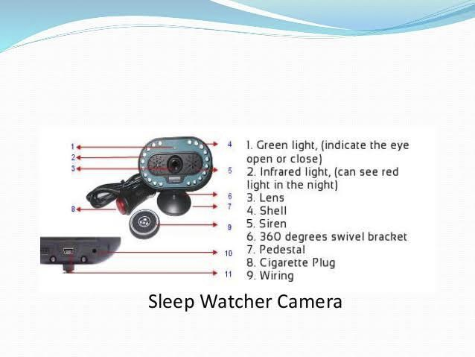

IMPLEMENTATION OF MEDICAL IMAGE FUSION USING DWT PROCESS ON FPGA BOARD

5.2.4 Eye blink using camera :

camera module that is to be used by the driver for Eye blink detection. The different blink events which differ from normal blinking of eye using cumulative index (CI) & Mutual index(MI) which is obtained at receiver of camera in terms of Current & voltage and plotted on graph. The signal can be smoothened using above graph to avoid unnecessary blinking event other than effective blinking event.

Figure 5.2.4 Eye blink using Camera

It is necessary in our working to find the blinking of eye, since it is used to drive the device and to operate events. So blink detection has to be done, for which we can avail readily available blink detectors in market (Catalog No. 9008 of Enable devices) or we can incorporate it with a special instruction written in image processing that, if there is no pupil found for the certain period of pre-determined i.e. time greater than the human eye blinking time then consider an event called “blink”, for which the set of operations will be followed. Here, in this case we need to set time as 1 second or above it, as “blink event” is different from “normal eye blinking”. We need to perform testing for only blink event estimation, and not to find normal eye blinking.

SIT ELECTRONICS AND TELECOMMUNICATION ENGINEERING 2018-19   
 26

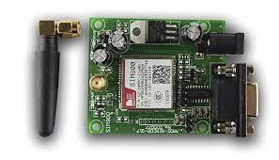

IMPLEMENTATION OF MEDICAL IMAGE FUSION USING DWT PROCESS ON FPGA BOARD

5.2.5 GSM 800:

Figure 5.2.5 GSM 800

In this paper GSM helps in controlling the DC motor, stepper motor, Temperature sensor and solid state relay by messaging schemes. This scheme helps in reducing the need of manual systems which are time consuming and not efficiency for usage. But the proposed system is fully automatic and can function without any manual interruption. Hence this automatic system is more efficient and less expensive and more convenient to use from were ever possible. Hence can be preferred mode of communication for controlling purpose.

GPS helps in both tracking and navigation purpose. Tracking systems is used to keep track of the vehicle without the intervention of the driver. But a navigation system guides the driver to reach the destination without any disruptions. Both tracking and navigation uses the same architecture. As a accident occurs the tracking stem detects the accident prone vehicle and a message is sent to the rescue team through a call or SMS.

SIT ELECTRONICS AND TELECOMMUNICATION ENGINEERING 2018-19   
 27

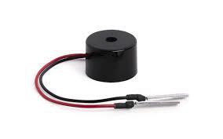

IMPLEMENTATION OF MEDICAL IMAGE FUSION USING DWT PROCESS ON FPGA BOARD

5.2.6 Buzzer:

Figure 5.2.6 Buzzer

A buzzer or beeper is a signaling device, usually electronic, typically used in   
automobiles, household appliances such as a microwave oven, or game shows. It most   
commonly consists of a number of switches or sensors connected to a control unit that   
determines if and which button was pushed or a preset time has lapsed, and usually illuminates a   
light on the appropriate button or control panel, and sounds a warning in the form of a   
continuous or intermittent buzzing or beeping sound. Initially this device was based on an   
electromechanical system which was identical to an electric bell without the metal gong   
(which makes the ringing noise). Often these units were anchored to a wall or ceiling and used   
the ceiling or wall as a sounding board.

Another implementation with some AC-connected devices was to implement a circuit to make the AC current into a noise loud enough to drive a loudspeaker and hook this circuit up to a cheap 8-ohm speaker. Nowadays, it is more popular to use a ceramic- based piezoelectric sounder like a Son alert which makes a high- pitched tone. Usually these were hooked up to "driver" circuits which varied the pitch of the sound or pulsed the sound.

SIT ELECTRONICS AND TELECOMMUNICATION ENGINEERING 2018-19   
 28

IMPLEMENTATION OF MEDICAL IMAGE FUSION USING DWT PROCESS ON FPGA BOARD

The circuit is designed to control the buzzer. The buzzer ON and OFF is controlled by   
the pair of switching transistors (BC 547). The buzzer is in the Q2 transistor collector terminal.   
When high pulse signal is given to base of the Q1 transistors, the transistor is conducting and   
close the collector and emitter terminal so zero signals is given to base of the Q2   
transistor. Hence Q2 transistor and buzzer is turned OFF state. When low pulse is given to base   
of transistor Q1 transistor, the transistor is turned OFF. Now 12v is given to base of Q2   
transistor so the transistor is conducting and buzzer is energized and produces the sound signal.

SIT ELECTRONICS AND TELECOMMUNICATION ENGINEERING 2018-19

29

IMPLEMENTATION OF MEDICAL IMAGE FUSION USING DWT PROCESS ON FPGA BOARD

CHAPTER NO:- 6

METHODOLOGY AND WORKING

SIT ELECTRONICS AND TELECOMMUNICATION ENGINEERING 2018-19   
 30

IMPLEMENTATION OF MEDICAL IMAGE FUSION USING DWT PROCESS ON FPGA BOARD

Methodology and Working:

We propose a new method in which the vehicular body will be equipped/embedded with   
sensors all around it which would sense the impact in the accident, and then will send the   
readings to the MCU which will process the readings and in case if the readings are above the   
predefined threshold values it will set up an alarm which would run for 10 seconds to avoid   
sending SMS to the services in case of any false accident or if the driver is safe. In case if the   
alarm not switched off would send a Text message containing the current whereabouts of the   
vehicle along with its registration number and the owner’s name to the nearest medical service   
Centre along with to the two numbers provided by the Vehicle owner to be contacted in case of   
any emergency. Hence by this method the victim is relieved from contacting the medical   
services or to his near and dear ones on his own when he is not in the condition to do so. B.   
Some new ideas.

• The victim is relieved from the manual labour required in contacting his near and dear ones and medical services on his own.

• The victim does not have to be dependent on the passengers passing by.

• As it is difficult to track an individual's where about after an accident, by this method this scenario will be minimized.

• Fuel efficiency will also increase as through the GPS driver will be aware of the correct coordinates and the path to take for the destination

• It will be easy to provide the victim with the quick medical aid even in hilly areas, national highways or in remote areas where it is very difficult to locate an accident spot.

SIT ELECTRONICS AND TELECOMMUNICATION ENGINEERING 2018-19   
 31

IOT BASED ACCIDENT PREVENTION, DETECTION AND POSITION TRACKING SYSTEM

6.1 Advantages:

➢ This method of analyzing or detecting the presence of alcohol in breath is relatively a   
 quick analysis as compared to other techniques.

➢ The sensors used in this project are smaller in size, not so bulky, hence can be   
 carried.

➢ The project based on this technology is self-sufficient within itself and thus can be   
 used as a safety system for any vehicle and the human being driving it by preventing   
 the accidents to occur.

➢ The system isn’t police dependent.

6.2 Applications:

➢ Automotive and transport vehicles.

➢ Security, remote monitoring and transportation and logistics.

➢ This system also can be interfaced with vehicle alerting system.

SIT ELECTRONICS AND TELECOMMUNICATION ENGINEERING 2018-19   
 32

IMPLEMENTATION OF MEDICAL IMAGE FUSION USING DWT PROCESS ON FPGA BOARD

CHAPTER NO. 7

CONCLUSION

SIT ELECTRONICS AND TELECOMMUNICATION ENGINEERING 2018-19   
 33

IMPLEMENTATION OF MEDICAL IMAGE FUSION USING DWT PROCESS ON FPGA BOARD

CONCLUSION:

In order to evaluate the results and compare these methods two quantitative assessment criteria Information Entropy and Root Mean Square Error were employed. Experimental results indicated that there are no considerable differences between these two methods in performance. The fusions have been implemented for medical images and remote sensing images. It is hoped that the techniques can be extended for colored   
images and for fusion of multiple sensor images with memory constraints

7.1 Future Work:

So far, it has been implemented that the system can collect data successfully from sensors and communicates with web server. In near future, the system can be improved by using more sensors to detect accident with more accuracy and more different way of accident detection. This system will try to communicate at least three nearest hospitals if any major accident occurs and show the shortest path to reach the accident spot. Moreover, the system will integrate with other system. For example, an insurance company can use the project database to inquiry about an accident and provide money to the owner in time. In Bangladesh, traffic jam is very popular word. If people use this system, the system can collect traffic data and notify the driver about traffic and find out a way which has less traffic jam.

SIT ELECTRONICS AND TELECOMMUNICATION ENGINEERING 2018-19   
 34

IMPLEMENTATION OF MEDICAL IMAGE FUSION USING DWT PROCESS ON FPGA BOARD

CHAPTER NO. 8

REFERENCES

SIT ELECTRONICS AND TELECOMMUNICATION ENGINEERING 2018-19   
 35

IMPLEMENTATION OF MEDICAL IMAGE FUSION USING DWT PROCESS ON FPGA BOARD

References :

1] A. Goshtaby and S. Nikolov, “Image fusion: Advances in the state of the art,” Inf. Fusion, vol. 8, no. 2, pp. 114–118, Apr. 2007.

[2] T. Stathaki, Image Fusion: Algorithms and Applications. New York:Academic, 2008.

[3] R. S. Blum and Z. Liu, Eds., Multi-Sensor Image Fusion and Its Applications(Special Series on Signal Processing and Communications).New York: Taylor & Francis, 2006.

[4] C. Pohl and J. L. van Genderen, “Multisensor image fusion in remote sensing: Concepts, methods and applications,” Int. J. Remote Sens., vol. 19,no. 5, pp. 823–854, 1998.

[5] V. Tsagaris, V. Anastassopoulos, and G. Lampropoulos, “Fusion of hyperspectral data using segmented PCT for enhanced color representation,” IEEE Trans. Geosci. Remote Sens., vol. 43, no. 10, pp. 2365–2375,Oct. 2005. [6] N. Jacobson,

[6] "GSM/GPRS/GPS Shield (B), Arduino Shield Based on SIM808", Waveshare.com, 2017.   
[Online]. Available: [http://www.waveshare.com/gsm-gprs-gps-shield-b.htm.](http://www.waveshare.com/gsm-gprs-gps-shield-b.htm./) [Accessed: 02-  
Aug- 2017]

[7] Available: [https://opencircuit.nl/ProductInfo/1000061/I2C-LCD-interface.pdf.](https://opencircuit.nl/productinfo/1000061/i2c-lcd-interface.pdf./) [Accessed: 02-  
Aug- 2017]

[8] S. Module, S. Arduino. and . If the module does not vibrate, "SW420", Bdspeedytech.com,   
2017.[Online].Available:[http://bdspeedytech.com/index.php?route=product/product&product_id](http://bdspeedytech.com/index.php?route=product/product&product_id/)   
=1388&search=sw+420. [Accessed: 02- Aug- 2017] 38

SIT ELECTRONICS AND TELECOMMUNICATION ENGINEERING 2018-19   
 36