

**MANAGEMENT SUMMARY**

**of**

**Combined System Development Services for**

**Self-Certification System**

**of the Buildings Department**

**Version 1.0**

**Dec 2022**

© The Government of the Hong Kong Special Administrative Region

The contents of this document remain the property of and may not be reproduced in whole or in part without the express permission of the HKSAR

| **Distribution** | |
| --- | --- |
| Copy No. | Holder |
| 1 | Buildings Department (BD) |
| 2 | Master Concept (Hong Kong) Limited |

|  |  |  |  |  |  |
| --- | --- | --- | --- | --- | --- |
| **Amendment History** | | | | | |
| Change Number | Revision Description | Section Affected on Respective Version | Revision / Version Number | Date | Approval Reference |
| 1 | Initial version | N/A | 0.1 | 18.11.2022 |  |
| 2 | First Release | N/A | 1.0 | 21.12.12022 |  |
|  |  |  |  |  |  |
|  |  |  |  |  |  |
|  |  |  |  |  |  |
|  |  |  |  |  |  |
|  |  |  |  |  |  |
|  |  |  |  |  |  |
|  |  |  |  |  |  |
|  |  |  |  |  |  |
|  |  |  |  |  |  |
|  |  |  |  |  |  |
|  |  |  |  |  |  |

**TABLE OF CONTENT**

**1. MANAGEMENT SUMMARY** **2**

**1.1. APPROVAL SOUGHT** **2**

**1.2. SYSTEM OBJECTIVES** **2**

**1.3. BACKGROUND** **4**

1.3.1 CURRENT SYSTEM DESCRIPTION 4

**1.4. PROPOSED SYSTEM** **5**

1.4.1. SYSTEM OVERVIEW 5

1.4.2. SYSTEM FUNCTION 6

1.4.3. TECHNICAL SYSTEM ARCHITECTURE 12

**1.5. RESOURCE IMPLICATIONS** **15**

**1.6. COSTS AND BENEFITS** **16**

1.6.1. COSTS 16

1.6.2. BENEFITS 18

**1.7. IMPLEMENTATION PLAN** **19**

# MANAGEMENT SUMMARY

## APPROVAL SOUGHT

The Management Summary aims to provide a summary of the System Analysis & Design report (SA&D) for the Project of Self-Certification System (SCS). It serves to seek approval for the acceptance of the recommendations identified in this SA&D Report so as to proceed to the next stage of the project, i.e. System Implementation & Integration (SI&I).

## SYSTEM OBJECTIVES

The main objectives of the system are to design and develop the Self-Certification System (SCS) to:

1. certifying the compliance of building safety requirements to the licensing authority (LA)/BD. The proposed system for SCS will need to support the above workflow and has the following functions:
   1. handle new applications for EP and CCC registration and issue certificates and notice;
   2. handle alteration applications of registered EP and CCC referred from the LA;
   3. record inspection results of the applications;
   4. handle the AP/RSE Certification Submissions;
   5. search and capture the building and structural safety requirements imposed and records of certificates and notices issued for the applications;
   6. provide an audit system for verification of full compliance of building and structural safety requirements certified under the applications and handle the selected audit cases;
   7. provide a centralised data repository of the application supporting documents submitted by the applicants, in which information of pre-accepted proprietary temporary structures or standard design of temporary structures can be accessible to the licensing authority;
   8. establish and implement system interface and data exchange mechanism with Building Condition Information System (BCIS) of BD for compiling of management statistics and reports of the applications;
2. to investigate and understand the operation of the existing operation;
3. to enable the e-submission process in fulfilling and undertaking the building safety requirements by building professionals (AP/RSE Certification Submissions) under the SCS for various licensing regimes which includes EP and CCC;
4. to build-in an auditing tool for the AP/RSE Certification Submissions to verify the compliance of building safety requirements imposed in the applications and monitor the performance of building professionals;
5. to develop a data repository of the pre-acceptance system for reusable temporary structures for a TPPEL;
6. to collect and implement new user requirements and enhancements;
7. to develop new functions, features, webpages and update system interfaces as identified during the User Requirement Collection session of SA&D;
8. to enable “iAM Smart” as an alternative channel to login SCS;
9. to handover SCS and provide training to the internal users of BD and other relevant government departments and AP/RSE;
10. to carry out SA&D and implement the findings and recommendations of the SA&D of the system (including, but not limited to, the requirements as specified by BD during SA&D and SI&I);
11. to co-ordinate and take the lead to monitor the installation, configuration, functional test and reliability test of delivered hardware, software, vendor services, Government Cloud Infrastructure Services (GCIS) services and Internet Mail Exchange (IMX) service provides SMTP Connection Service (SMTPX);
12. to identify the web pages or web elements in SCS that require necessary amendments for conformance with Web Content Accessibility Guidelines (WCAG) 2.1 Level AA Standard and the relevant guidelines for mobile friendly design as listed in Section 6 of this work assignment for details;
13. to make necessary amendments on the web pages or web elements identified in item n above, according to the guidelines specified in WCAG 2.1 Level AA Standard and the relevant guidelines for mobile friendly design;
14. to provide support to User acceptance testing (UAT);
15. to carry out the physical system design, develop programs, test and install the production system and disaster recovery (DR) system and proceed to live implementation;
16. to specify and prepare relevant documents for the procurement of software, hardware, hosting services and related facilities / services for the implementation of the new system if applicable;
17. to work with an independent auditor to carry out their Security Risk Assessment and Audit (SRAA) and follow up the issues and implement the recommendations mentioned in the Security Risk Assessment Report; and
18. to work with an independent auditor to carry out their Privacy Impact Assessment (PIA) and Privacy Compliance Audit (PCA) exercise and implement the recommendations from PIA and PCA Reports.
19. At the end of the SA&D and SI&I services, the proposed system (including hardware, software, hosting and procedures documentation) should be ready for use by BD.

The main objectives of SM&S are:

1. to support the users, maintain SCS and ensure reliable and satisfactory operations to meet the service level requirements and fulfil the security compliance;
2. to carry out minor enhancements;
3. c. to initiate meeting to collect user requirements on implementation of new enhancements and requests;
4. to maintain the system to the pre-defined service levels stated in the system maintenance plan and carry out performance tuning if needed;
5. to troubleshoot any anomaly observed in the system and provide remediation;
6. to maintain and update the system documentation to reflect the latest production system;
7. to continuously update/upgrade SCS with the latest patches and security updates of software (e.g. RDBMS, OS etc.), hardware and appliance;
8. to perform ad-hoc and periodic updates on the contents;
9. to maintain and update the system documentation to reflect the latest production system;
10. to take lead, manage and work with all service providers and other vendors to assure the system meeting the service level requirement;
11. to conduct regular user training sessions at BD premises; and
12. to provide all kinds of assistance in relation to the maintenance and support of the live running of SCS.

## BACKGROUND

The proposed project aims at developing the system for SCS for various licensing regimes which includes the registration of non-purpose built educational premises (EP) and child care centre (CCC), etc., and the pre-acceptance system of the reusable temporary structures for a temporary places of public entertainment licence (TPPEL) which have been included in the Action Plan 2019-20 under the "Be the Smart Regulator" Programme launched by the Efficiency Office to support Government’s commitment to enhance Hong Kong’s overall business licensing environment. Hence this supports the “licence/registration applications processed” under Head 82 Buildings Department in the Controlling Officer’s Report.

### CURRENT SYSTEM DESCRIPTION

Being one of the skeleton government departments in different types of licensing regimes in Hong Kong, Buildings Department (BD) is responsible to provide expert advice on building and structural safety matters for issuance of license. In addition to formulate building safety requirements to the LA for incorporating into the Letter of Requirement (LoR) for obtaining a license, BD is required to undertake the full compliance checks which involve both document checks and site checks for various licensing regimes such as Educational Premises (EP), Child Care Centre (CCC), Places of Amusement (PA), and amusement game centre (AGC).

**Registration for non-purpose built educational premises and child care centre**

Regarding the licensing regime for EP, at present, an application for registration of EP in premises not designed and constructed for the purposes of a school should be accompanied by three certificates issued by the Director of Buildings (DB) under section 12(1)(a), (b) and (ca) of the Education Ordinance (Cap. 279) (EO) and a notice issued by the Building Authority (BA) under section 12(1)(d) of the same Ordinance. Similarly, an application for registration of CCC should be accompanied by certificates issued by the DB under section 7(1)(b) of the Child Care Services Ordinance (Cap. 243) (CCSO).

In applying for the requisite certificates and notice for EP registration, applicants have to submit the application form together with 4 copies of premises layout plans showing the layout of the premises directly to BD for processing. Upon receipt of the applications, BD will, based on the proposed layout plan, conduct desktop study and site inspection to ascertain the suitability of the premises for use as EP. If the premises are found suitable from building safety perspective, the requisite certificates and notice will be issued to the applicant. Otherwise, a LoR listing out all the building safety requirements will be issued to the applicant and copied to the Education Bureau (EDB) for their rectification. Upon receipt of notification from the applicant for the completion of building safety requirements, BD will carry out compliance checks. When all the imposed building safety requirements are complied with, BD will endorse 4 sets of plans and issue the requisite certificates and notice, to the applicant.

Regarding applications for CCC registration, BD will process the referrals from the Social Welfare Department (SWD) similar to those for EP registration, except BD will provide input to SWD direct for incorporation into the LoR.

In addition, applicants may carry out alteration work in registered EP and CCC to cope with their operational needs, 4 sets of the alteration plans will be submitted to the LA for seeking BD’s comments as necessary. In general, BD will process the referrals similar to new registration applications.

**Temporary Places of Public Entertainment License (TPPEL)**

Also, BD is responsible to offer building safety comments to FEHD in respect of a TPPEL application. In support of each application, the applicant is required to submit the proposed layout plans, information of proprietary temporary structures or standard design of temporary structures, structural justifications (only required when certain dimensional requirements have exceeded), etc. for BD's comment regardless of whether or not such temporary structures have been used in the same location under different applications. According to the past experience, same proprietary temporary structures or standard design of temporary structures often reuse for different events in the same locations. All supporting documents are also kept in the case paper files.

## PROPOSED SYSTEM

The proposed Self-Certification System (SCS) allows Buildings Department (BD) users to receive, process and manage the application for certificates and notice required under Education Ordinance (Cap.279) and Child Care Services Ordinance (Cap. 243) for the registration of non-purpose built Educational Premises (EP) and Child Care Centre (CCC) and to provide building safety comment to Education Bureau upon applications for conducting courses of non-local higher and professional education under NLHPE(R) Rules (Cap.493B) respectively in an effective and efficient manner.

The system also allows applicant/Authorized Person (AP)/Registered Structure Engineer (RSE) or users in Social Welfare Department (SWD) and Education Bureau (EDB*) to submit application forms and electronic documents to BD through internet/intranet in order to speed up the registration process.

Furthermore, the system is a single repository to store all applications and supporting documents that can facilitate BD users to find documents easily.

* Including Joint Office for Kindergartens and Child Care Centres (JOKCCC) of Education Bureau

### SYSTEM OVERVIEW

The SCS would interact with other systems from BD and external third parties as illustrated below:

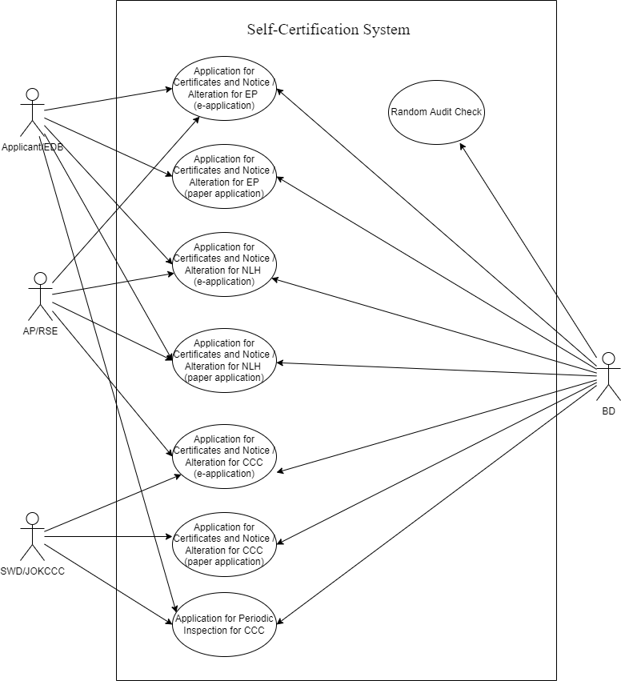

### SYSTEM FUNCTION

The proposed system will cover the following major function areas:

|  |  |
| --- | --- |
| Business Function | Description |
| Application for Certificates and Notice / Alteration for EP  (e-application) | The process is to allow applicant to apply e-certificates/ e-notice for EP through internet in which application/AP/RSE can submit digital signed documents to BD and BD to issue digital signed documents to EDB/Applicant/AP/RSE. |
| Application for Certificates and Notice / Alteration for EP  (paper application) | The process is to allow applicant to apply certificates/ notice for EP by post. |
| Application for Certificates / Alteration for CCC  (e-application) | The process is to allow applicant/SWD/EDB(JOKCCC) to apply –e-certificates for CCC through internet/intranet in which application/AP/RSE can submit digital signed documents to BD and BD to issue digital signed document to SWD/EDB(JOKCCC)/Applicant/AP/RSE. |
| Application for Certificates / Alteration for CCC  (paper application) | The process is to allow applicant/SWD/EDB(JOKCCC) to apply certificates for CCC by post. |
| Random Audit Check | The process is to allow BD users to perform random audit check of the completed applications. |
| Application for Approval /Alteration for use of the premises for conducting course under the Non-Local-Higher and Professional Education (Regulation) Ordinance [NLHPE(R)O]  (e-application) | The process is to allow applicant/ EDB to seek BD’s comment on approval for use of the premises for conducting course under the NLHPE(R)O through internet/intranet in which applicant/AP/RSE can submit digital signed documents to BD and BD to issue digital signed documents to EDB/Applicant/AP/RSE. |
| Application for Approval/ Alteration for use of the premises for conducting course under the NLHPE(R)O  (paper application) | The process is to allow applicant/ EDB to seek BD’s comment on approval for use of the premises for conducting course under the NLHPE(R)O by post. |
| Application for Structural inspection for CCC  (paper application) | The process is to allow applicant to apply periodic inspection for CCC by post. |
| Application for inclusion of Temporary Structures in the Pre-accepted Temporary Structure (PTS) Register for use under TPPE license | The process is to allow BD users to store PTS details, generate PTS register and assign register number for PTS. |

The following table describes system users who participate in the SCS.

|  |  |  |  |  |  |
| --- | --- | --- | --- | --- | --- |
| No. | User Role | Responsibilities | Branch/Division/Section/Unit | Staff Post/Rank | Stakeholder Group |
| 1 | Applicant | Submit application form to BD | N/A | N/A | N/A |
| 2 | AP/RSE | Ensure building safety that meets BD’s requirements | N/A | N/A | N/A |
| 3 | EDB User | Submit application form to BD for EP | N/A | N/A | N/A |
| 4 | SWD/EDB(JOKCCC) User | Submit application form to BD for CCC | N/A | N/A | N/A |
| 5 | Registry | Data input to SCS | LU | Registry | BD |
| 6 | SE | Provide comment via SSE to BS | LU | SE | BD |
| 7 | SSE | Provide comment | LU | SSE | BD |
| 8 | SO | Perform site inspection and prepare inspection report | LU | SO | BD |
| 9 | BS | Check Building Safety Requirement (BSR) | LU | BS | BD |
| 10 | TO | Obtain structural information and report to SE | LU | TO | BD |
| 11 | SBS | Endorse and approve application | LU | SBS | BD |
| 12 | CBS | Endorse objection cases | LU | CBS | BD |
| 13 | System Admin | Perform system administration of SCS | ITU/MC | System Admin | BD |
| 14 | User Admin | Perform user administration of SCS | LU/ITU/  EBD/SWD | User Admin | BD/EBD/SWD |

List Of Future Business Process

|  |  |
| --- | --- |
| Process ID | Business Process Title |
| BP-001 | Application for e-Certificates and e-Notice / Alteration for EP  (e-application) |
| BP-002 | Application for Certificates and Notice / Alteration for EP  (paper application) |
| BP-003 | Application for e-Certificates / Alteration for CCC  (e-application) |
| BP-004 | Application for Certificates / Alteration for CCC  (paper application) |
| BP-005 | Random Audit Check |
| BP-006 | Application for approval/ Alteration for use of the premises for conducting course under the NLHPE(R)O  (e-application) |
| BP-007 | Application for approval/ Alteration for use of the premises for conducting course under the NLHPE(R)O  (paper application) |
| BP-008 | Application for periodic inspection for CCC |
| BP-009 | Application for inclusion of Temporary Structures in the Pre-accepted Temporary Structure (PTS) Register for use under TPPE license |

List Of Functional Requirements

|  |  |  |  |
| --- | --- | --- | --- |
| **Req. ID** | **Requirement Name** | **Target Users** | **Priority** |
| General Requirement | | | |
| REQ-GR-01 | User Registration | Applicant/AP/RSE | NA |
| REQ-GR-02 | Login with Username & Password | Applicant/AP/RSE | NA |
| REQ-GR-03 | Registration and Login through iAM Smart | Applicant/AP/RSE | NA |
| REG-GR-04 | Change Password | Applicant/AP/RSE | NA |
| REG-GR-05 | Forget Password | Applicant/AP/RSE | NA |
| REG-GR-06 | Logout | Applicant/AP/RSE | NA |
| REQ-GR-07 | Single Sign On | BD Users/EDB User/ SWD User | H |
| REQ-GR-08 | Preview Document | All Users | H |
| REQ-GR-09 | Print Document | BD Users | H |
| REQ-GR-10 | Upload Document | BD Users/EDB User/SWD User/Applicant/AP/RSE | H |
| REQ-GR-11 | Management Statistics and Reports | BD Users | H |
| REQ-GR-12 | e-submission | Applicant/AP/RSE | H |
| REQ-GR-13 | e-processing | BD Users/EDB User/SWD User | H |
| REQ-GR-14 | e-tracking | All Users | H |
| REQ-GR-15 | Centralised data repository of the application supporting documents | BD Users/EDB User/SWD User/ | H |
| REQ-GR-16 | Search and Capture | BD Users/EDB User/SWD User/ | H |
| REQ-GR-17 | Handle new applications | BD Users/EDB User/SWD User/ | H |
| REQ-GR-18 | Handle alteration applications | BD Users/EDB User/SWD User/ | H |
| REQ-GR-19 | Handle Self Certification Submissions | BD Users | H |
| REQ-GR-20 | Handle Periodic Inspection for CCC | BD Users | H |
| REQ-GR-21 | Handle PTS for TPPE | BD Users | H |
| REQ-GR-22 | Data repository | BD Users | H |
| REQ-GR-23 | Easy retrieval of the records | BD Users | H |
| REQ-GR-24 | User and Delegation Administration | User Administrators of BD Users/EDB User/SWD User | H |
| REQ-GR-25 | Generate Application Number | Applicant | H |
| REQ-GR-26 | Withdraw Application | Applicant | H |
| Workflow Requirement | | | |
| REQ-WR-01 | Input Application Data | Registry | H |
| REQ-WR-02 | Create Structural Information Report | TO | H |
| REQ-WR-03 | Provide Comment via SSE | SE | H |
| REQ-WR-04 | Perform Site Inspection | SO | H |
| REQ-WR-05 | Building Safety Requirements Check | BS | H |
| REQ-WR-06 | Generate Reply Letter, e-Certificates and e-Notice | BS/SBS | H |
| REQ-WR-07 | Generate Letter of Requirement | BS/SBS | H |
| REQ-WR-08 | Endorse Application | SBS | H |
| REQ-WR-09 | Endorse Objection | CBS | H |
| REQ-WR-10 | AP/RSE Verification | Registry | H |
| REQ-WR-11 | Check Essential Documents | SO/BS | H |
| REQ-WR-12 | Digital Signing of Document | Applicant/AP/RSE/ BD Users | H |
| REQ-WR-13 | Random Audit Check | BD Users | H |
| REQ-WR-14 | Outstanding Application Alert | SO/TO/BS/SE/SSE/SBS | H |
| REQ-WR-15 | Input Application Form | Applicant | H |
| REQ-WR-16 | Input memo data | EDB/SWD | H |
| REQ-WR-17 | Search Case Information | BD Users | H |
| Form Requirement | | | |
| REQ-FRM-1 | Verify certificate against the copy from Hong Kong post and DigiSign | System | H |
| REQ-FRM-2 | Route form to corresponding user | System | H |
| REQ-FRM-3 | Encrypt restricted data in the form | System | H |
| REQ-FRM-4 | Submit public form via online | System | H |
| REQ-FRM-5 | Extract data from form | System | H |
| REQ-FRM-6 | Store the extracted data in the database | System | H |
| REQ-FRM-7 | Search function for all record | System | H |
| REQ-FRM-8 | Auto-reply to acknowledge receiving the form | System | H |
| REQ-FRM-9 | Maintenance function of the form | System | H |
| REQ-FRM-10 | Resubmit the form data | System | H |
| REQ-FRM-11 | Update of the disclaimer of the forms | System | H |
| REQ-FRM-12 | Handle eform and Hardcopy form | System | H |
| From Processing Requirement | | | |
| REQ-PRO-1 | Verify CRM certification record | BD Users/EDB User/SWD User | H |
| REQ-PRO-2 | Reassign Case to other officer | BD Users/EDB User/SWD User | H |
| REQ-PRO-3 | Form status query | BD Users/EDB User/SWD User | H |
| REQ-PRO-4 | Automatically Bring up Outstanding Cases | BD Users/EDB User/SWD User | H |
| REQ-PRO-5 | To Do List | BD Users/EDB User/SWD User | H |
| REQ-PRO-6 | Case History Summary | BD Users/EDB User/SWD User | H |
| REQ-PRO-7 | Mark Notes and remark for internal use. | BD Users/EDB User/SWD User | H |
| REQ-PRO-8 | Re-direct to BCIS for case checking | BD Users | H |
| REQ-PRO-9 | Handle upload soft-copy | BD Users/EDB User/SWD User | H |
| REQ-PRO-10 | Export outstanding case | BD Users/EDB User/SWD User | H |
| REQ-PRO-11 | Handle referral Case | BD Users/EDB User/SWD User | H |

### TECHNICAL SYSTEM ARCHITECTURE

SCS is a web-based application system that allows public user i.e., applicant / Authorized Person (AP) / Registered Structure Engineer (RSE) to submit and digitally sign application form, layout plans or other documents in order to apply license of non-purpose-built Educational Premises (EP) or Child Care Centre (CCC).

Also, the system allows back-end Buildings Department (BD) / Education Bureau (EDB) / Social Welfare Department (SWD) officers to process the licensing application through workflow.

The system is made up of 4 main components – SCS-WEB, SCS-ADMIN, SCS-WEB-BACKEND and SCS-ADMIN-BACKEND. The SCS-WEB is a web application to handle public users to submit and digitally sign documents. The SCS-ADMIN is a web application to handle BD officers to process the licensing application and issue certificates or other documents to public users and EDB/SWD users. The SCS-WEB-BACKEND is a set of standalone applications that maintains system data synchronisation with backend. The SCS-ADMIN-BACKEND is a set of standalone applications that maintains system data synchronisation with database and other systems such as BCIS.

To maintain data integrity, the system is interfaced with other BD systems including:

1. BCIS

Data for licensing case management

1. MWMS 2.0

Data for AP/RSE information

1. ESH

Data for licensing case for AP/RSE

1. ERKS

Data for released documents such as certificate/notice

1. BRAVO

Hyperlink to check building records

1. BDGIS

Data for area code and team mapping

1. BD Website

Data for Pre-accepted Temporary Structure (PTS)

Moreover, the system utilizes digital signature to provide authentication, integrity and non-repudiation of documents that are submitted to the system. The document signing can use certificates from Hong Kong Post/DigiSign or mobile app i.e. iAM Smart.

The SCS employs a hybrid deployment solution for servicing public users and internal users.

The SCS-WEB and SCS-WEB-BACKEND will be deployed in Government Cloud Platform, namely GCIS, which is managed by OGCIO. By leveraging modern cloud technologies, the system is deployed in Virtual Machines of Infrastructure-as-a-Service (IaaS) in both Production Sites (active-standby) i.e., Production Site 1 and Production Site 2, that can provide high availability. For UAT and development, the system is deployed in Testing environment in GCIS.

The SCS-ADMIN and SCS-ADMIN-BACKEND will be deployed in BD premises. The system will be also deployed in Virtual Machines that can easily scale up in order to provide high availability and scalability. To avoid single point of failure, the system will be deployed in at least two Virtual Machines for Web (API) Server, SCS-ADMIN, SCS-ADMIN-BACKEND and Database Server in different physical hardware.

It is digital alternatives to reduce paper consumption. The SCS is enabled user to online submission and signing process. It provides a healthy, sustainable, environmentally friendly alternative.

The following diagram shows a high-level system architecture and deployments of SCS.

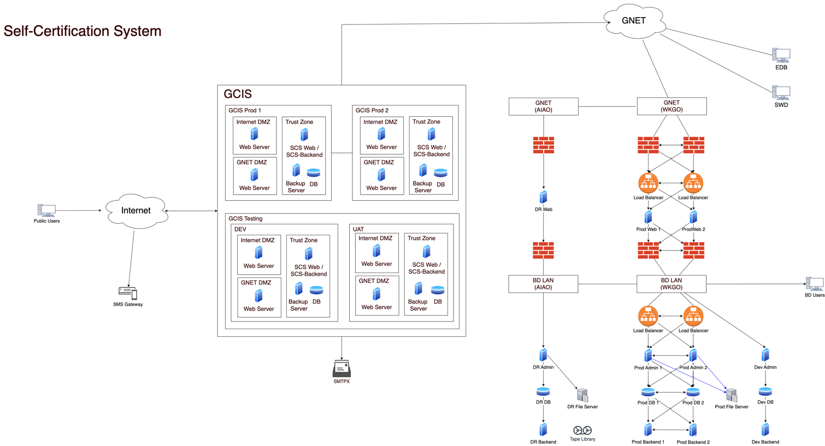

The networking of the system consists of three locations:

1. GCIS
2. West Kowloon Government Office (WKGO)
3. AIA Office (AIAO)

In GCIS, there are two external networks, one is Internet connection for public users and the other is GNET connection for data synchronisation with servers in WKGO. For internet connection, the network shared 10Gbps bandwidth for all tenants in GCIS. For GNET connection, it is 150Mbps in WKGO for shared applications.

For connection between WKGO and AIAO, it is connecting with Multi-point Metro-Ethernet. There are two service providers and two separate sets of network equipment to maintain high availability. The network bandwidth in WKGO is 2Gbps and the network bandwidth in AIAO is 500Mbps.

A logical network diagram for is shown below.



## RESOURCE IMPLICATIONS

**The staff resources of MCL for this project is summarised as below:**

|  |  |  |  |  |  |
| --- | --- | --- | --- | --- | --- |
| Stage | PM | SA | AP1 | NS | Total |
| Stage 0 – Project initiation | 36 | 80 | 60 | 20 | 196 |
| Stage 1 – System Analysis & Design | 56 | 120 | 240 | 30 | 446 |
| Stage 2 – System Implementation & Integration  And  Stage 3 – Documentation & Nursing | 20 | 40 | 60 | 18 | 128 |
| Total | 112 | 240 | 360 | 68 | 780 |

|  |  |
| --- | --- |
|  | From Project Initiation to completion of System nursing |
| System Analyst | At least 2 working days per week resident in BD office |
| Analyst Programmer | At least 2 working days per week resident in BD office |

Remarks:

PM - Project Manager

SA - Systems Analyst

AP - Analyst Programmer

NS - Senior Network System Engineeror Network Specialist

## COSTS AND BENEFITS

### COSTS

This section provides the cost estimation for SCS implementation based on the proposed system architecture.

The estimated hardware/software cost is as attached below.

Hardware Cost

|  |  |  |  |  |
| --- | --- | --- | --- | --- |
| Item | Description - One-off Cost | Qty | Unit Price | (HK$) |
| H1 | Tier-1 Firewall for Production Site | 2 | 43,457 | 86,914 |
| H2 | Tier-1 Firewall for DR Site | 1 | 43,457 | 43,457 |
| H3 | Tier-2 Firewall for Production Site | 2 | 69,264 | 138,528 |
| H4 | Tier-2 Firewall for DR Site | 1 | 33,000 | 33,000 |
| H5 | Network Switch for Production Site (DMZ) | 2 | 20,000 | 40,000 |
| H6 | Network Switch for DR Site (DMZ) | 1 | 18,000 | 18,000 |
| H7 | Network Switch for Production Site (Internal) | 2 | 36,000 | 72,000 |
| H8 | Network Switch for DR Site (Internal) | 1 | 33,000 | 33,000 |
| H9 | VM Host Server for Production Site (DMZ) | 2 | 57,550 | 115,100 |
| H10 | VM Host Server for DR Site (DMZ) | 1 | 57,550 | 57,550 |
| H11 | VM Host Server for Production Site (Internal) | 2 | 61,000 | 122,000 |
| H12 | VM Host Server for DR Site (Internal) | 1 | 91,000 | 91,000 |
| H13 | Tap Library for DR Site (offline) | 1 | 104,000 | 104,000 |
| H14 | Backup server for Production Site | 1 | 88,000 | 88,000 |
| H15 | Backup server for DR Site | 1 | 81,600 | 81,600 |
| H16 | SAN Storage for Production Site  (16TB usable capacity) | 1 | 333,000 | 333,000 |
| H17 | SAN Storage for DR Site  (16TB usable capacity) | 1 | 333,000 | 333,000 |
| H18 | KVM for Production Site | 1 | 13,990 | 13,990 |
| H19 | KVM for DR Site | 1 | 13,990 | 13,990 |
| H20 | UPS for Production Site | 2 | 23,780 | 47,560 |
| H21 | UPS for DR Site | 1 | 23,780 | 23,780 |
|  |  |  | Sub-Total | 1,889,469 |

The above one-off hardware cost includes the cost for 3-year warranty.

Software Cost

|  |  |  |  |  |
| --- | --- | --- | --- | --- |
| Item | Description - One-off Cost | Qty | Unit Price | (HK$) |
| S1 | MS Windows Server | 15 | 7,280 | 109,200 |
| S2 | MS SQL Server | 6 | 24,410 | 146,460 |
| S3 | Symantec SEP License | 24 | 352 | 8,448 |
| S4 | Kiwi Log Servers | 2 | 3,730 | 7,460 |
| S5 | VMware vSphere 7 | 8 | 14,900 | 119,200 |
| S6 | VMware vCenter Server 7 | 1 | 76,000 | 76,000 |
| S7 | VMware vSphere 7 Essentials Plus Kit | 1 | 56,000 | 56,000 |
| S8 | Veeam | 3 | 46,365 | 139,095 |
|  |  |  | Sub-Total | 661,863 |

The above one-off software cost includes the cost for 3-year maintenance/subscription.

Total Cost

|  |  |  |
| --- | --- | --- |
| **Item** | **Description** | **One-off Cost (HK$)** |
| 1 | Hardware Cost | 1,889,469 |
| 2 | Software Cost | 661,863 |
| 3 | Installation Cost for the hardware and software | 460,000 |
|  | **Total** | **3,011,332** |

### BENEFITS

TANGIBLE BENEFITS

There is no tangible benefits resulted by the development of the SCS since it is a digital transformation of existing site-inspection practice.

INTANGIBLE BENEFITS

|  |  |
| --- | --- |
| Benefits | Description |
| Streamline business operation | The current operation relies on paper processing that leads to longer processing time for public users to apply EP/CCC licensing application. The system can help public users and BD users to process the licensing application in an effective and efficient way. |
| Environment friendly | The current operation requires a large amount of paper including application form, layout plan, inspection reports…etc. The system can help to reduce paper consumption. |
| Enhance communication between BD and users | The system helps to enhance the communication between BD and users as the system provides better communication such as SMS or Email notifications. |

.

## IMPLEMENTATION PLAN

The detailed implementation project plan is attached below.

|  |  |  |  |
| --- | --- | --- | --- |
| Milestone | Start Date | End Date | Deliverables |
| 1. Project initiation | 16/2/2022 | 31/12/2022 | (1) Project initiation document; |
| 2. Definition of problems | 28/3/2022 | 6/9/2022 | (2) Current environment description;  (3) Requirement specifications; |
| 3. Selection of feasible options | 10/9/2022 | 15/10/2022 | (4) System specifications;  (5) Selected technical system option including technical system architecture, cloud hosting solutions, hardware, software and system design of SCS;  (6) Presentation on the proposed system: |
| 4. System analysis & design | 16/10/2022 | 31/12/2022 | (7) SA&D report; |
| 5. Physical design | **25/10/2022** | 16/1/2023 | (8) Physical data design;  (9) Process data interface;  (10) Data catalogue;  (11) Program specification;  (12) Performance optimization report; |
| 6. Site preparation and cabling | 25/7/2022 | 31/8/2022 | (13) Site specification;  (14) Accepted site; |
| 7. Procurement & installation of hardware and software | 1/12/2022 | 19/4/2023 | (15) Procurement plan;  (16) Procurement specification and/or procurement list;  (17) Hardware and software installed and checked; |
| 8. Program development | 1/9/2022 | 29/3/2023 | (18) Program codes, software modules;  (19) Job control procedures; |
| 9. Unit test | 1/9/2022 | 19/5/2023 | (20) Unit test cases and results;  (21) Plan for testing by Persons With Disabilities (PWD) groups;  (22) W3C WCAG 2.1 AA conformance checking and rectification report; |
| 10. System integration and test | 1/9/2022 | 19/5/2023 | (23) System installation plan;  (24) System installation report;  (25) System test plan, specifications and results;  (26) Software modules in integration; |
| 11. User acceptance | 22/5/2023 | 3/8/2023 | (27) Acceptance test plan, specifications and results;  (28) “Passing tests” S/W modules; |
| 12. Disaster recovery drill and Load Test | 4/8/2023 | 23/8/2023 | (29) Disaster recovery drill test report;  (30) Load Test report; |
| 13. Prepare system documentation | 17/7/2023 | **23/8/2023** | (31) Application operation manual;  (32) Computer operation procedures manual;  (33) Data manual;  (34) Program manual;  (35) System maintenance plan;  (36) System manual;  (37) User procedures manual;  (38) Security incident handling procedure;  (39) a DR plan;  (40) Data Conversion Plan & Result, and Rollout plan; |
| 14. Training | 17/7/2023 | **23/8/2023** | (41) Training plan;  (42) Training manual;  (43) Training courses;  (44) Trained users; |
| 15. System production | 17/7/2023 | 24/8/2023 | (45) Computer systems in production use; |
| 16. Nursing | 25/8/2023 | 24/11/2023 | (46) System nursing & maintenance;  (47) Hand-over plan;  (48) System Maintenance Report; and |
| 17. Project closure | 24/11/2023 | 24/11/2023 | (49) Project evaluation report. |

SM&S

|  |  |  |  |
| --- | --- | --- | --- |
| Milestone | Start Date | End Date | Deliverables |
| 1. System Maintenance & Support (SM&S) | 25/11/2023 | 24/11/2024 |  |
| 1. Production Rollout (2) - System interface with the electronic record-keeping system (ERKS) | 1/6/2024 | 1/9/2024 |  |

<End-of-Document>