STATISTICAL PROCESS CONTROL (SPC)
AND CONTROL CHARTS FOR QUALITY ASSURANCE
IN TEXTILE MANUFACTURING
A project report on monitoring yarn tensile-strength stability in automated textile looms
Submitted by: ______________________________
Programme / Department: ______________________________
Institution: ______________________________
Academic Year: 2026–2027
Tools: Microsoft Excel and R
Important data note: This report demonstrates the full method using a clearly labelled synthetic dataset. Replace it with actual factory measurements before claiming plant-level findings.

ABSTRACT
Textile manufacturers must maintain consistent yarn tensile strength to reduce yarn breakage, fabric defects, loom stoppages, rework and customer complaints. This project presents a practical Statistical Process Control (SPC) framework for monitoring tensile-strength measurements from an automated textile production process. The method combines subgroup-based X-bar and R control charts with a tabular Cumulative Sum (CUSUM) chart. Excel is used for accessible data entry, subgroup summaries and visual reporting, while R provides a reproducible workflow for calculations and chart generation.
A demonstration dataset containing 25 rational subgroups of five observations each (125 readings) was created for method validation. The illustrative data include a shift in the process mean in later subgroups to show how control charts can reveal a sustained change that may be missed by reviewing individual measurements. The X-bar chart evaluates changes in the subgroup mean, the R chart evaluates within-subgroup variation, and CUSUM accumulates small deviations from a target or baseline. Control limits are calculated using standard constants for subgroup size five.
The report provides a research problem, objectives, literature context, methodology, formulas, implementation steps, illustrative results, limitations, an implementation plan and references. Because the dataset is synthetic, numerical findings are pedagogical and are not evidence about a real textile plant. The proposed contribution is a low-cost, reproducible SPC workflow that can be adopted by small and medium-sized textile units and later evaluated using real production data.

Keywords
Statistical process control; textile manufacturing; yarn tensile strength; X-bar chart; R chart; CUSUM; quality assurance; process stability; Excel; R.

Report roadmap
The report progresses from the production-quality problem to statistical foundations, data design, chart construction, interpretation, deployment and future research. Supporting files include the raw sample dataset, subgroup statistics workbook and R analysis script.

1. INTRODUCTION

1.1 Background
Textile production depends on stable interactions among yarn properties, machine settings, environmental conditions, operator practices and material handling. Tensile strength is a critical yarn characteristic because yarn must withstand the stresses imposed during winding, warping, sizing, weaving and subsequent handling. Excessively low strength can increase breakage and downtime; excessive variation can create inconsistent performance even when the average appears acceptable.
Traditional quality inspection often relies on periodic testing and pass/fail decisions. Such inspection can detect defects after they occur but may not reveal when the process began to change. Statistical Process Control uses time-ordered process data to distinguish routine variation from signals that warrant investigation. Control charts are therefore intended as process-monitoring tools, not merely as end-of-line inspection.

1.2 Problem statement
A textile unit may collect tensile-strength measurements but lack a consistent, statistically justified method to detect shifts in process average and changes in short-term variability. Manual review can overlook gradual changes, and a single specification threshold does not describe whether a process is stable over time. The project addresses this gap by designing an accessible workflow using X-bar, R and CUSUM charts.

1.3 Rationale
Excel is widely available and familiar to production teams. R provides transparent, repeatable calculations and publication-quality plots without requiring commercial statistical software. Combining the two tools can make SPC more practical for an academic prototype or a small factory pilot.

1.4 Scope
- Quality characteristic: yarn tensile strength, measured in newtons (N).
- Sampling design: five readings per subgroup, collected at regular intervals in the intended live deployment.
- Charts: X-bar and R for subgroup mean and dispersion; tabular CUSUM for small sustained mean shifts.
- Tools: Microsoft Excel for operational use and R for reproducibility.
- Demonstration only: synthetic observations are used in this report; no factory or customer data are represented.

2. AIM, OBJECTIVES AND RESEARCH QUESTIONS

2.1 Aim
To design and demonstrate a practical SPC framework using X-bar, R and CUSUM control charts to monitor the stability of yarn tensile strength in automated textile manufacturing.

2.2 Objectives
- Explain how common-cause and special-cause variation affect yarn quality.
- Create a structured subgroup data format suitable for repeated tensile-strength testing.
- Calculate X-bar and R control limits for subgroup size five.
- Use a CUSUM method to improve sensitivity to persistent, relatively small mean shifts.
- Implement the calculations in Excel and R so that results can be checked and reproduced.
- Develop an interpretation and response procedure for operators and quality engineers.
- Identify limitations and propose a validation plan using real production measurements.

2.3 Research questions
- How can X-bar and R charts help distinguish changes in the process mean from changes in within-subgroup variation?
- Can a CUSUM chart provide an earlier indication of a sustained small shift than a Shewhart chart alone?
- How can a low-cost Excel/R workflow be made repeatable and useful to textile quality teams?

2.4 Expected outcomes
The expected outputs are a documented sampling plan, a dataset template, formulas for control limits, three charting methods, a simple decision protocol, an Excel workbook, an R script and recommendations for pilot deployment. The project does not claim to prove that SPC reduces defects until a before-and-after evaluation is conducted on real production data.

2.5 Proposed contribution
The practical contribution is the integration of three complementary monitoring views in a single, auditable workflow: X-bar for shifts in average strength, R for short-term spread and CUSUM for accumulated evidence of a sustained mean shift. The value lies in clear operational interpretation and repeatability rather than in inventing a new statistical control-chart formula.

3. LITERATURE REVIEW AND CONCEPTUAL FOUNDATION

3.1 Statistical Process Control
SPC is a collection of statistical methods used to understand, monitor and improve processes. Shewhart control charts compare time-ordered statistics with a centre line and statistically derived control limits. A point beyond a limit is evidence that the process may be affected by a special cause; it is a signal to investigate, not automatic proof of a particular cause.

3.2 X-bar and R charts
When measurements are collected in small subgroups, an X-bar chart monitors subgroup averages and an R chart monitors subgroup ranges. The paired approach is important: an average chart can be difficult to interpret if within-subgroup dispersion is changing. For subgroup size n = 5, standard constants are A2 = 0.577, D3 = 0 and D4 = 2.114. These constants should be selected from an authoritative SPC table for the chosen subgroup size.

3.3 CUSUM charts
CUSUM charts accumulate deviations from a target or reference mean. Because information is accumulated across successive observations, CUSUM can be more sensitive than a Shewhart chart to sustained small shifts. Its performance depends on design parameters, including the reference value k and decision interval h, which should reflect the shift size of practical interest and the desired false-alarm rate.

3.4 SPC in manufacturing and textiles
Manufacturing SPC applications commonly monitor dimensions, strength, weight, temperature, defects and other repeatable characteristics. In textiles, strength and uniformity influence downstream performance. The same general principles apply, but a useful deployment must account for changes in yarn count, fibre blend, supplier lot, machine, spindle, humidity, shift and test method. Pooling unlike process conditions can create misleading limits.

3.5 Research gap and project position
For a rapid, low-cost project, the practical gap is not the absence of control-chart theory; it is the need for an understandable implementation that links data collection, chart signals and a documented response. This report provides a demonstrator and a plan for validation. It should be described as an applied implementation study, not as proof of a novel algorithm.

3.6 Conceptual framework
Production process → rational subgroup sampling → data validation → X-bar/R analysis → CUSUM monitoring → signal review → root-cause investigation → corrective action → continued monitoring. The feedback loop is essential: charts only create value when signals lead to disciplined investigation and learning.

4. METHODOLOGY

4.1 Research design
The project uses a quantitative, applied-methodology design. A reproducible demonstration dataset is analysed to show the calculations and interpretation workflow. A later industrial pilot should use prospective measurements from a single, reasonably homogeneous process stream.

4.2 Characteristic and measurement unit
The response variable is tensile strength in newtons (N). In a real study, the test procedure, specimen conditioning, gauge length, pulling speed, instrument calibration, sample identification and test operator should be documented. Results from incompatible test methods should not be combined.

4.3 Sampling plan
The proposed starting design is five consecutive or near-consecutive specimens per subgroup at a fixed sampling interval, such as once per production hour or once per defined lot. The final frequency must be selected with the plant quality team based on process speed, risk, test cost and how quickly a shift could cause unacceptable output. Subgroups should be rational: observations within a subgroup should represent short-term variation, while subgroups are separated enough to reveal changes over time.

4.4 Data fields
- Timestamp and subgroup identifier.
- Machine/loom, line, shift, operator and yarn lot identifiers.
- Yarn specification, count and fibre blend where applicable.
- Specimen number and tensile-strength result in N.
- Instrument ID, calibration status and test-method version.
- Notes for stoppages, maintenance, changeovers or unusual events.

4.5 Data preparation
Check units, duplicate identifiers, missing values, impossible readings and transcription errors before computing limits. Do not silently delete unusual values: verify the measurement first and retain an audit trail. Special-cause observations should be investigated and removed from baseline estimation only when an assignable cause is documented and the exclusion is justified. Otherwise, limits may be manipulated to make a process look stable.

4.6 Demonstration dataset
The supplied sample contains 25 subgroups and five measurements per subgroup (125 values). It is synthetic and seeded for reproducibility. Later subgroup means were generated with an illustrative upward shift to show how the charts behave. These data are appropriate for demonstrating code and report structure, not for making operational decisions.

5. STATISTICAL METHODS AND FORMULAS

5.1 Subgroup statistics
For subgroup i with n = 5 measurements xᵢⱼ, the subgroup mean is x̄ᵢ = (Σⱼ xᵢⱼ)/n. The subgroup range is Rᵢ = max(xᵢⱼ) − min(xᵢⱼ). The grand mean is x̄̄ = (Σᵢ x̄ᵢ)/m and the average range is R̄ = (Σᵢ Rᵢ)/m, where m is the number of subgroups.

5.2 X-bar chart limits
UCLₓ̄ = x̄̄ + A₂R̄; centre line CLₓ̄ = x̄̄; LCLₓ̄ = x̄̄ − A₂R̄. For n = 5, A₂ = 0.577. The limits describe expected process behaviour under the chart assumptions; they are not customer specification limits.

5.3 R chart limits
UCLᵣ = D₄R̄; centre line CLᵣ = R̄; LCLᵣ = D₃R̄. For n = 5, D₃ = 0 and D₄ = 2.114. The R chart should be reviewed first because changing dispersion can affect the interpretation of the X-bar chart.

5.4 CUSUM design
For a two-sided tabular CUSUM on subgroup means, define C⁺ᵢ = max[0, C⁺ᵢ₋₁ + (x̄ᵢ − μ₀) − k] and C⁻ᵢ = max[0, C⁻ᵢ₋₁ − (x̄ᵢ − μ₀) − k]. A signal occurs when either cumulative statistic exceeds decision interval h. In the demonstrator, μ₀ is the baseline grand mean, k = 0.5σ̂ and h = 5σ̂. For subgroup size five, σ̂ can be estimated as R̄/d₂ with d₂ = 2.326. These are demonstration settings; a real deployment should choose a target μ₀ and parameters based on engineering requirements.

5.5 Control limits versus specification limits
Control limits estimate process behaviour; specification limits express product requirements set by design or customers. A stable process can still fail specifications, and a process can temporarily meet specifications while remaining statistically unstable. Capability indices such as Cp and Cpk should be calculated only after stability and distributional assumptions are assessed.

6. IMPLEMENTATION IN MICROSOFT EXCEL

6.1 Workbook structure
The supplied workbook includes a Raw Data sheet with subgroup, specimen and tensile-strength columns, and a Subgroup Stats sheet with subgroup means, ranges and control-limit reference columns. It also contains line charts for visual exploration. The workbook is a starter template; a production version should include timestamps, machine identifiers, validation lists and protected formulas.

6.2 Recommended formulas
- Subgroup mean: =AVERAGE(range_of_five_readings)
- Subgroup range: =MAX(range_of_five_readings)-MIN(range_of_five_readings)
- Grand mean: =AVERAGE(all_subgroup_means)
- Average range: =AVERAGE(all_subgroup_ranges)
- X-bar UCL/LCL: =GrandMean + 0.577*AverageRange and =GrandMean - 0.577*AverageRange
- R UCL/LCL: =2.114*AverageRange and =0*AverageRange

6.3 Chart construction
- Enter validated readings in a consistent, time-ordered format.
- Create one row per subgroup with the mean and range.
- Add constant columns for centre line, UCL and LCL so the reference lines appear on the chart.
- Insert line charts with subgroup sequence on the horizontal axis and statistic on the vertical axis.
- Use distinct line styles for the centre line and control limits; label units and chart date range.
- Review chart signals alongside machine, shift, lot and maintenance records.

6.4 Operational safeguards
Keep raw measurements immutable and perform calculations in separate columns or sheets. Record formula versions and control-limit approval dates. Do not recalculate limits after every new point; establish a baseline period, review stability, then freeze approved limits for routine monitoring. Rebaseline only after a documented process change or a formal review.

6.5 Excel limitations
Excel is accessible but can be vulnerable to accidental formula edits, inconsistent copy/paste, missing audit trails and manual refresh errors. A controlled template, protected cells, version control and periodic verification against R reduce these risks.

7. IMPLEMENTATION IN R

7.1 Reproducible workflow
The supplied file spc_analysis.R reads the CSV, validates required columns, computes subgroup means and ranges, calculates control limits, exports a statistics table and creates X-bar, R and CUSUM charts. R is useful because the same script can be rerun whenever a new approved dataset is supplied.

7.2 Running the script
- Install R and an editor such as RStudio or VS Code with R support.
- Place spc_analysis.R and yarn_tensile_strength_sample_data.csv in the same working directory.
- Install the required packages with install.packages(c('readr','dplyr','ggplot2')).
- Run the script from that directory.
- Review the console output and generated files: subgroup_control_chart_statistics_from_R.csv, cusum_results.csv, xbar_control_chart.png, r_control_chart.png and cusum_control_chart.png.

7.3 Reproducibility and versioning
Record the R version, package versions, data extraction date and script version for each analysis. Keep the original input file and generated outputs together. For a formal study, add a README, code comments, a data dictionary and a record of any exclusions. This enables a reviewer to reconstruct the results.

7.4 Suggested extension
A future version could read data from a plant database, create a daily PDF summary, send alerts when a chart rule is triggered and show filters for machine, shift or yarn lot. Alerts should identify the affected subgroup and link to the underlying observations rather than simply stating that quality is bad.

7.5 Verification
Before operational use, verify the R calculations against hand calculations for a small subset and compare R results with the Excel workbook. Confirm that subgroup size is consistently five, constants match that subgroup size, and all chart axes and units are labelled. A script that runs successfully is not necessarily a statistically valid monitoring system.

8. RESULTS: ILLUSTRATIVE DEMONSTRATION

8.1 Descriptive summary
The demonstration dataset contains 125 measurements in 25 subgroups. The observed measurement range is 30.188 N to 34.599 N. The overall mean is 32.388 N. These values describe only the synthetic sample.

8.2 X-bar chart interpretation
Using the standard X-bar/R method, the demonstration grand mean is 32.388 N, the average range is 1.549 N, and the X-bar limits are approximately 31.494 N and 33.282 N. The later subgroups were intentionally generated with a higher mean. The chart should therefore be inspected for an upward shift, long runs on one side of the centre line, or points outside the control limits.
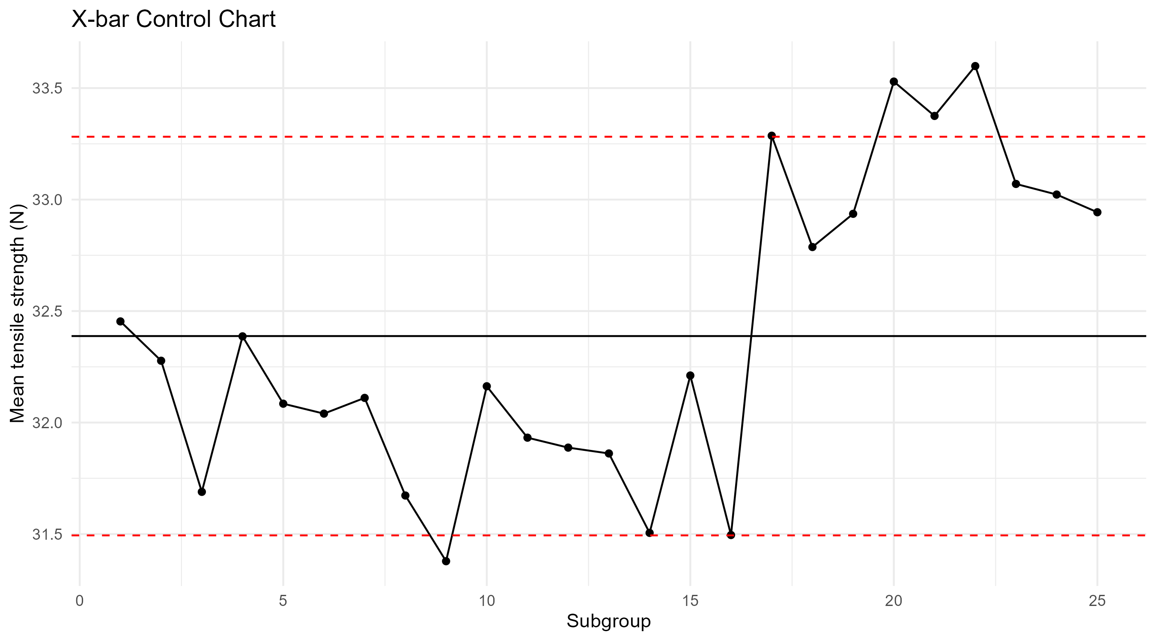

8.3 R chart interpretation
The R-chart centre line is 1.549 N, with an upper control limit of 3.275 N and a lower control limit of 0.000 N. The R chart asks whether short-term spread is consistent. If dispersion changes, the team should investigate material, testing, machine or sampling causes before relying on the X-bar interpretation.
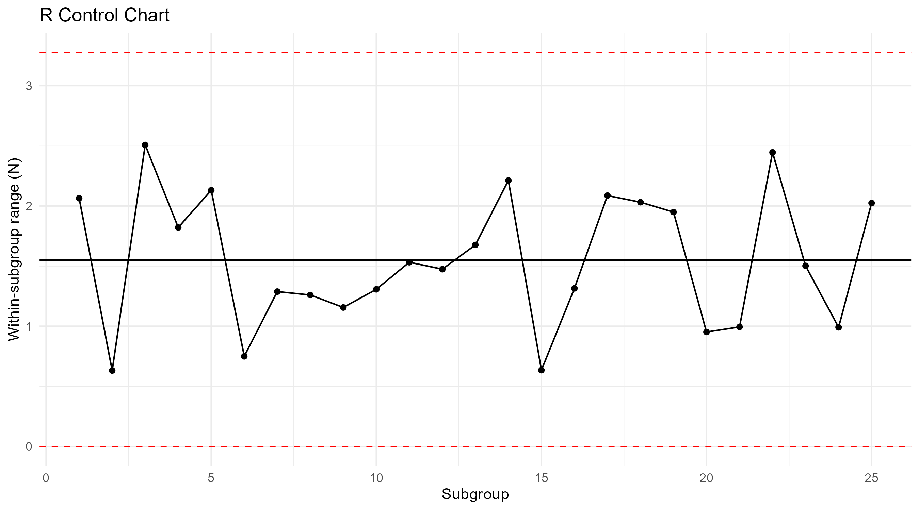

8.4 CUSUM interpretation
The CUSUM chart accumulates departures from the baseline and can make a persistent moderate shift more visible than a single-point threshold. In the provided script, CUSUM is computed on subgroup means with a reference value of half the estimated standard deviation and a decision interval of five standard deviations. The exact signal subgroup should be taken from the generated cusum_results.csv output and reported after running the script in the intended environment.
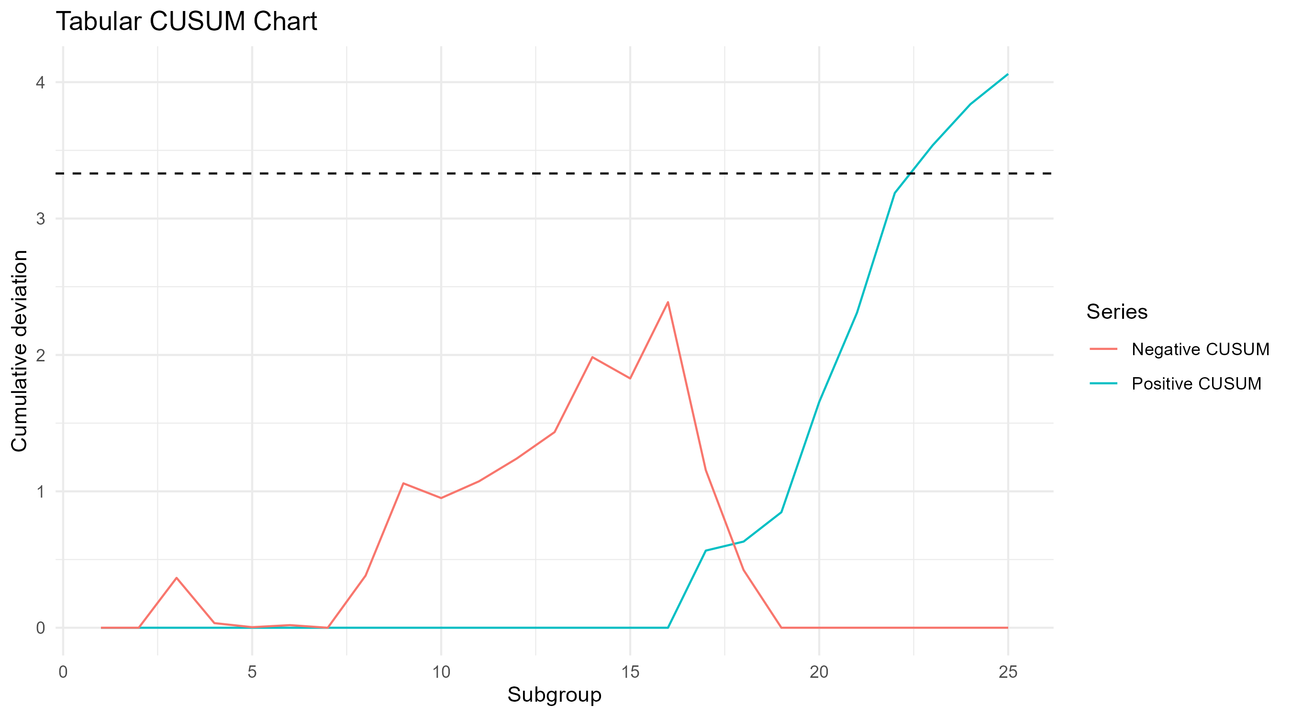

8.5 Key caution
No claim about defect reduction, real loom performance, savings or plant capability can be made from synthetic data. The purpose of this results section is to show how a valid analysis should be presented and interpreted.

9. DISCUSSION

9.1 Why use three charts?
The charts answer different questions. The X-bar chart monitors the process average. The R chart monitors within-subgroup variability. CUSUM accumulates small deviations and may detect sustained shifts sooner. Using them together provides more diagnostic information than a single chart, but it also requires a documented signal policy to avoid overreacting to random noise.

9.2 Practical interpretation in a textile unit
An upward mean shift is not automatically an improvement: it may indicate a changed yarn lot, test calibration drift, a different yarn count or an intentional setting change. A downward shift may indicate weaker yarn, a testing issue or a process condition. A widening range may suggest inconsistent material, machine wear, poor environmental control, sampling differences or measurement-system variation. Investigation should be evidence-led.

9.3 Signal response protocol
- Confirm the signal and check data entry, instrument status and test method.
- Identify the affected machine, shift, yarn lot and production time window.
- Contain potentially affected output according to the plant’s quality procedure; do not assume every signal means product is defective.
- Review maintenance, machine settings, material certificates, environmental conditions and operator notes.
- Document the likely cause and corrective action, including the person responsible and completion date.
- Collect follow-up subgroups and confirm whether the process returned to stable behaviour.
- Update the baseline only through an approved change-control process.

9.4 Human factors
Charts should support, not punish, operators. A process signal is a prompt for joint investigation, not a performance score. Clear training, easy-to-read displays and consistent escalation rules improve adoption.

9.5 Management implications
A pilot can establish whether the measurement system and sampling frequency are practical. If effective, SPC can help prioritize investigation, reduce reliance on reactive inspection and build a traceable quality history. Any financial benefit must be measured rather than assumed.

10. LIMITATIONS, RISKS AND VALIDATION PLAN

10.1 Limitations
- Synthetic dataset: findings do not represent a real factory or actual product performance.
- Small demonstration size: 25 subgroups are sufficient to show a workflow but may be inadequate for a stable baseline in a real process.
- Distribution and independence: standard control-chart interpretation relies on assumptions that should be checked in real data.
- Measurement system: gauge calibration, operator technique and specimen conditioning may contribute to observed variation.
- Process heterogeneity: combining machines, yarn types or operating conditions may create misleading limits.
- CUSUM settings: k and h are illustrative and must be selected based on the shift of practical interest and acceptable false-alarm risk.

10.2 Validation plan
- Agree on the yarn specification and test method with the quality engineer.
- Run a measurement-system review and verify instrument calibration.
- Collect a prospective baseline from a homogeneous process stream with full traceability.
- Assess the baseline for special causes, autocorrelation and subgroup consistency.
- Set and approve control limits; document exclusions with evidence.
- Run the charts in shadow mode and compare signals with known production events.
- Train operators and define containment/escalation responsibilities.
- Evaluate outcomes over a pre-agreed period using defect rate, breakage rate, downtime and response time.

10.3 Evaluation metrics
Recommended measures include the proportion of chart signals investigated within the target time, time from process shift to detection, yarn breakage rate per production unit, nonconforming-lot rate, rework, downtime and false-alarm frequency. Use comparable production periods and account for changes in product mix and volume.

10.4 Ethical and operational considerations
Protect production data and supplier information, restrict access to raw records, and avoid using a statistical signal as the sole basis for disciplinary action. Any automated alert should include human review and a clear route to verify the measurement.

11. IMPLEMENTATION PLAN, RESOURCES AND DELIVERABLES

11.1 Rapid project schedule
A short academic implementation can be completed in approximately 7–10 working days if the scope remains limited to the demonstrator and report. A factory pilot will take longer because data collection and baseline validation require real operating time.
Stage | Activity | Output | Estimated time
1 | Confirm characteristic, objectives and assumptions | Approved scope | 0.5 day
2 | Prepare/validate dataset and data dictionary | CSV + data dictionary | 1 day
3 | Compute subgroup statistics and limits | Validated statistics | 1 day
4 | Create X-bar, R and CUSUM charts | Charts + outputs | 1–2 days
5 | Cross-check Excel and R calculations | Verification notes | 1 day
6 | Interpret results and define response rules | Results/discussion | 1 day
7 | Finalize report, references and presentation | Submission package | 2–3 days

11.2 Resources
- Computer with Microsoft Excel or compatible spreadsheet software.
- R and packages readr, dplyr and ggplot2.
- Tensile-strength testing instrument and trained operator for a real deployment.
- Access to machine, shift, yarn-lot and maintenance records for root-cause analysis.
- Quality engineer or faculty supervisor to review the sampling plan and statistical assumptions.

11.3 Deliverables
- 15-page project report.
- Synthetic demonstration dataset, explicitly labelled.
- Excel workbook with raw data, subgroup statistics and starter charts.
- R script to reproduce subgroup statistics, control limits and charts.
- Generated CSV summaries and a proposed validation/implementation plan.

11.4 Risk management
The primary delivery risks are insufficient real data, incorrect units, inconsistent subgrouping and overclaiming from a synthetic example. The mitigation is to label the demonstration honestly, verify formulas independently and state clearly what must be replaced or validated before a plant-level conclusion is made.

12. CONCLUSION AND FUTURE SCOPE

12.1 Conclusion
This project develops a practical framework for applying Statistical Process Control to yarn tensile-strength monitoring in textile manufacturing. X-bar and R charts provide complementary views of the process mean and within-subgroup variation, while a tabular CUSUM chart accumulates evidence of sustained shifts. Excel offers a familiar operational interface and R provides a reproducible analytical workflow.
The demonstration package shows how to structure measurements, calculate control limits, visualize process behaviour and define a response protocol. Its main value is the integrated workflow and supporting materials, which can be adapted for a real production line after the measurement method and baseline data have been validated.
The key limitation is that the data are synthetic. Consequently, the report makes no empirical claim about actual textile quality, defect reduction, process capability or financial savings. A defensible next step is a prospective pilot on one homogeneous process stream, with quality-engineer oversight and documented evaluation metrics.

12.2 Future scope
- Use real plant data across several weeks or months and evaluate chart performance against known process events.
- Compare Shewhart and CUSUM detection delay for shifts of practical importance.
- Add EWMA charts for alternative sensitivity to gradual drift.
- Integrate machine, yarn-lot, humidity and maintenance metadata for root-cause analysis.
- Build a Streamlit dashboard with filters, alerts and downloadable daily summaries.
- Evaluate process capability only after stability and assumptions are established.
- Conduct a before-and-after study to estimate changes in breakage, downtime, rework and quality cost.

12.3 Final recommendation
Present this as an applied SPC implementation project and be transparent that the example data are simulated. If the project is intended for a journal or conference submission, strengthen it with actual industrial data, a clear research contribution, a more complete comparison of chart methods, and formal review of the target venue’s scope and submission requirements.

REFERENCES AND APPENDIX

References (APA style)
Montgomery, D. C. (2020). Introduction to Statistical Quality Control (8th ed.). Wiley.
Shewhart, W. A. (1931). Economic Control of Quality of Manufactured Product. D. Van Nostrand Company.
Page, E. S. (1954). Continuous inspection schemes. Biometrika, 41(1/2), 100–115. https://doi.org/10.1093/biomet/41.1-2.100
Woodall, W. H. (2000). Controversies and contradictions in statistical process control. Journal of Quality Technology, 32(4), 341–350. https://doi.org/10.1080/00224065.2000.11980013
Ryan, T. P. (2011). Statistical Methods for Quality Improvement (3rd ed.). Wiley.
International Organization for Standardization. (2015). ISO 9001:2015 Quality management systems—Requirements. ISO.
International Organization for Standardization. (2019). ISO 22514-2:2017 Statistical methods in process management—Capability and performance—Part 2: Process capability and performance of time-dependent process models. ISO.

Appendix A: Deliverable files
- yarn_tensile_strength_sample_data.csv — 125 synthetic tensile-strength observations in 25 subgroups.
- SPC_Textile_Analysis.xlsx — raw data, subgroup statistics and starter line charts.
- spc_analysis.R — reproducible X-bar, R and CUSUM analysis script.
- subgroup_control_chart_statistics.csv — precomputed subgroup summaries and chart limits.

Appendix B: Suggested declaration
“The dataset used for the demonstration analysis was synthetically generated for educational purposes. The numerical results are not observations from an operating textile plant. Any industrial interpretation requires validation using actual measurements and an approved sampling plan.”

Appendix C: Submission checklist
- Replace student/institution placeholders on the cover page.
- Confirm the required citation style and reference details with the supervisor.
- Run the R script and verify that all charts and output files generate successfully.
- If real data are available, replace the synthetic CSV and rerun every result.
- Do not claim the project is published, accepted or industry-validated unless that is true.

