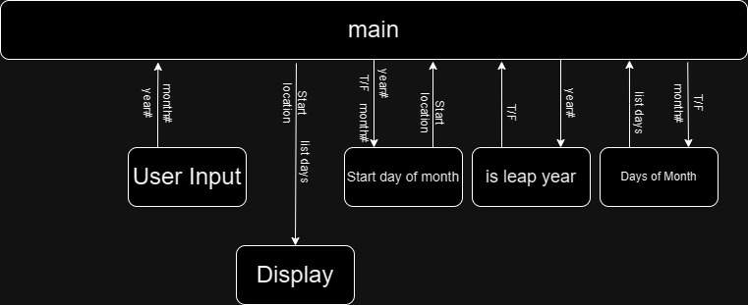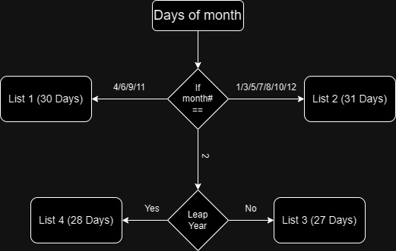

def display(start_location, list_of_days)

print(" Su Mo Tu We Th Fr Sa ")

count = 0

while count < start_location

list_display += " "

list_display += list_of_days

count += list_of_days.length()

while count < 42

list_display += " "

print(f" {list_display[0]} {list_display[1]} {list_display[2]} {list_display[3]} {list_display[4]} {list_display[5]} {list_display[6]} \n

> {list_display[7]} {list_display[8]} {list_display[9]} {list_display[10]} {list_display[11]} {list_display[12]} {list_display[13]} \n

> {list_display[14]} {list_display[15]} {list_display[16]} {list_display[17]} {list_display[18]} {list_display[19]} {list_display[20]} \n

> {list_display[21]} {list_display[22]} {list_display[23]} {list_display[24]} {list_display[25]} {list_display[26]} {list_display[27]} \n

> {list_display[28]} {list_display[29]} {list_display[30]} {list_display[31]} {list_display[32]} {list_display[33]} {list_display[34]} \n

> {list_display[35]} {list_display[36]} {list_display[37]} {list_display[38]} {list_display[39]} {list_display[40]} {list_display[41]} ")