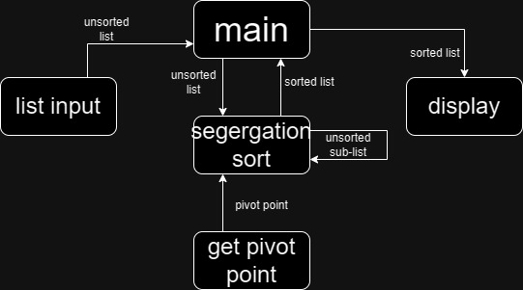

function segregation_sort(array, i_start, i_end)

if i_start < i_end

i_pivot = choose_pivot_index(array, i_start, i_end)

i_up = i_start

i_down = i_end

while i_up < i_down

while array[i_up] < array[i_pivot] and i_up < i_end

i_up = i_up + 1

while array[i_down] >= array[i_pivot] and i_down > i_start

i_down = i_down - 1

if i_up < i_down

swap(array[i_up], array[i_down])

swap(array[i_pivot], array[i_down])

segregation_sort(array, i_start, i_down - 1)

segregation_sort(array, i_down + 1, i_end)

function choose_pivot_index(array, i_start, i_end)

return (i_start + i_end) / 2