**PICK-AT-CHU DOCUMENTATION**

**INTRODUCTION**

Pick-at-chu is an intriguing and interactive web-based game developed for anime enthusiasts. Developed using HTML, CSS, and JavaScript, this game challenges players to guess the name or title of an anime based on a given description. The game is also has a “Who’s that Pokemon” game mode challenges the players to guess a pokemon from their pokedex entry. With its sleek and user-friendly design, Pick-at-chu delivers a smooth gaming experience that blends fun and learning for anime fans. We also use a Jikan Api for the unofficial MyAnimeList API. It scrapes the website to satisfy the need for a complete API - which is MyAnimeList lacks. We also used pokeapi.co this is where we got the pokemons descriptions where we used the /pokedex entry

**OUTPUT**



**-**The first Ui is where you can see the game titled Pick-At-Chu!  
 You can also enter your username and select a button if either you will select the play button Details or the How to Play

-In the Details after you click the Detail button it will show you the Details about the Game Pick-At-Chu

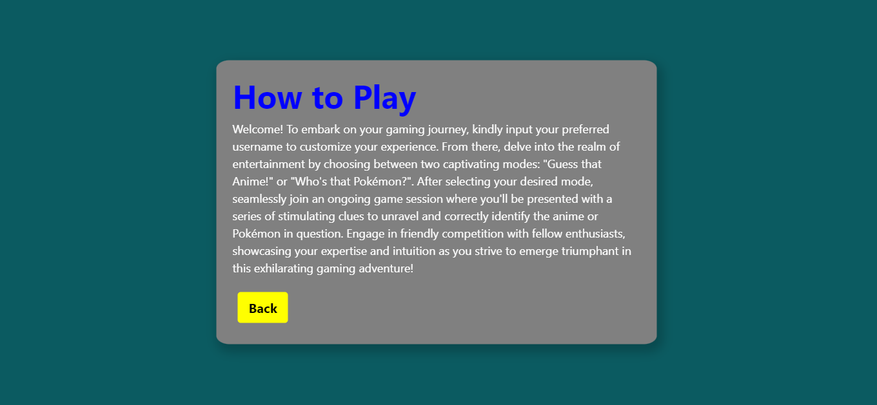

-In the how to play after you click the How to Play button it will show you the details how to play the game

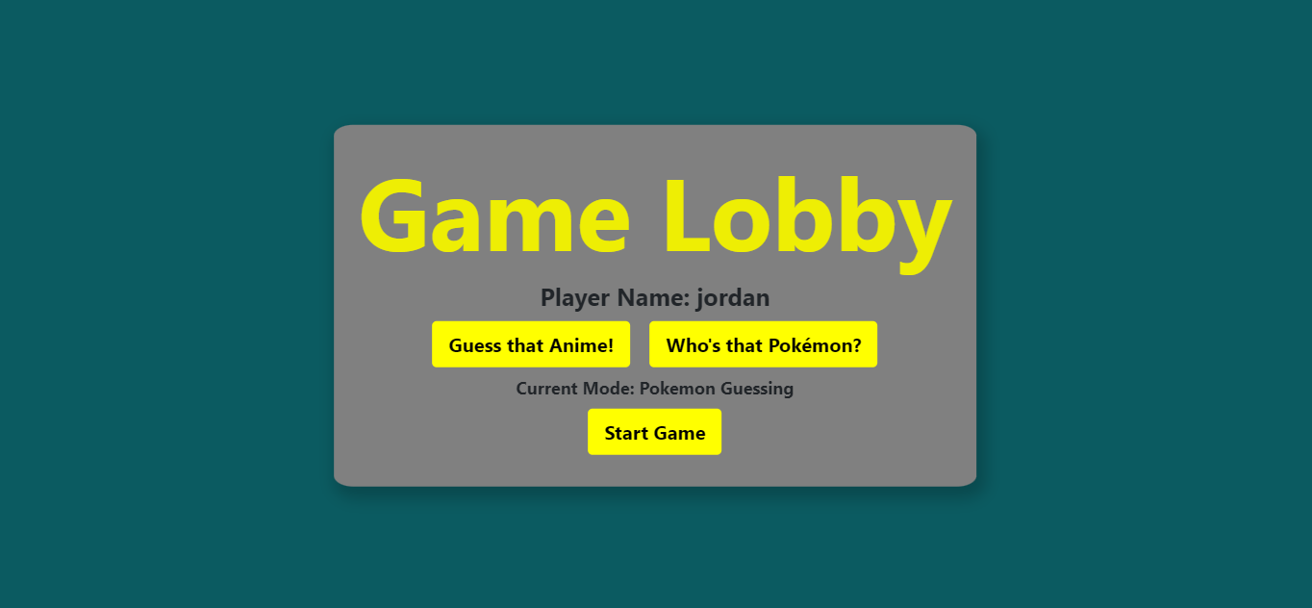-In the game lobby you can select which one you would like to play if it’s a Guess the Anime! Or Who’s that Pokemon and you can start the game

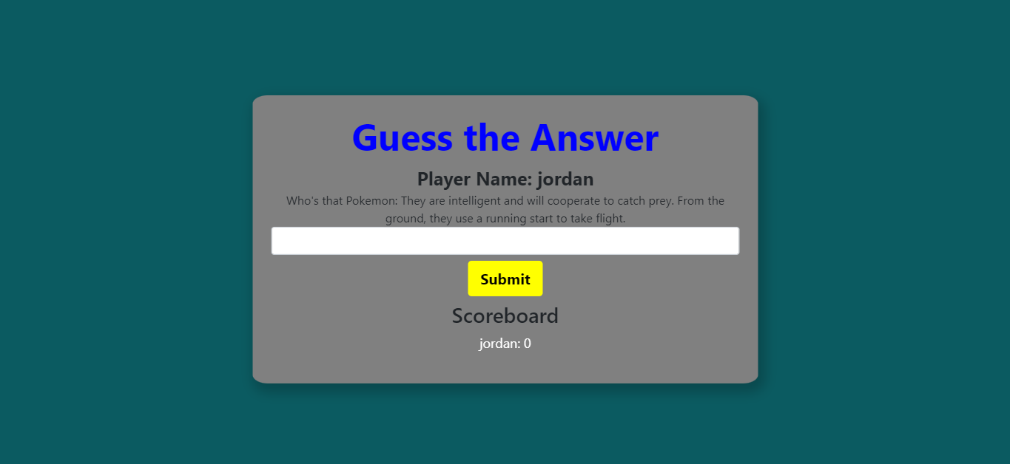

-After starting the game it will show you a random question which you need to answer and after you entered a answer click the submit and it will show you if you got the correct answer the scoreboard will update and add the score in your name

**CODE**

**HTML**

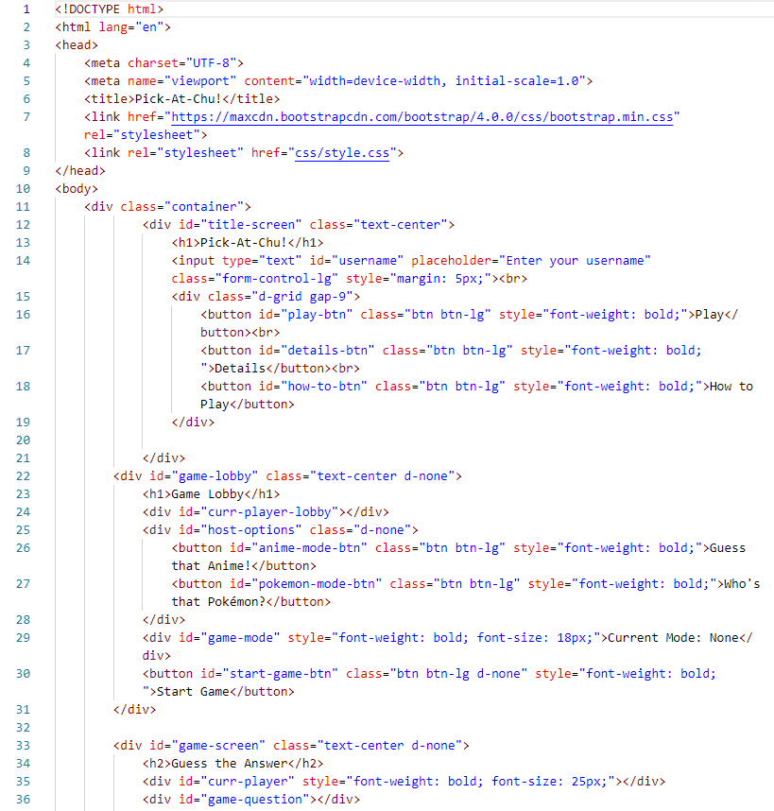

This initiates all the links needed from css to javascripts needed to run the webpage

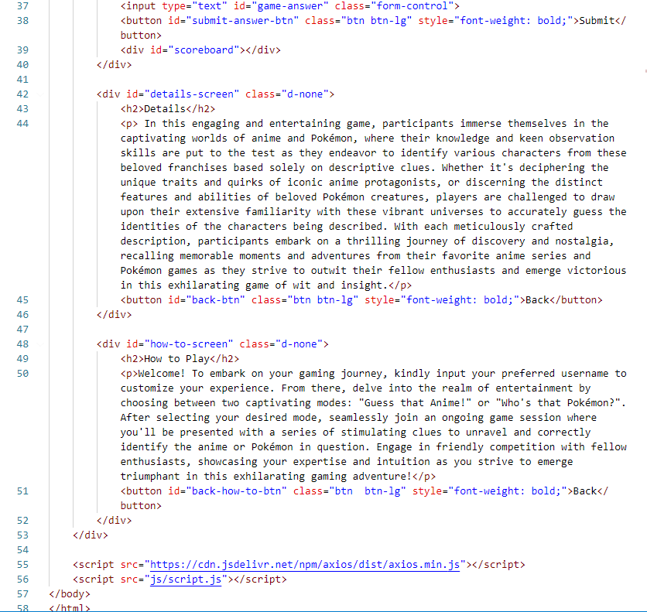

**CSS**

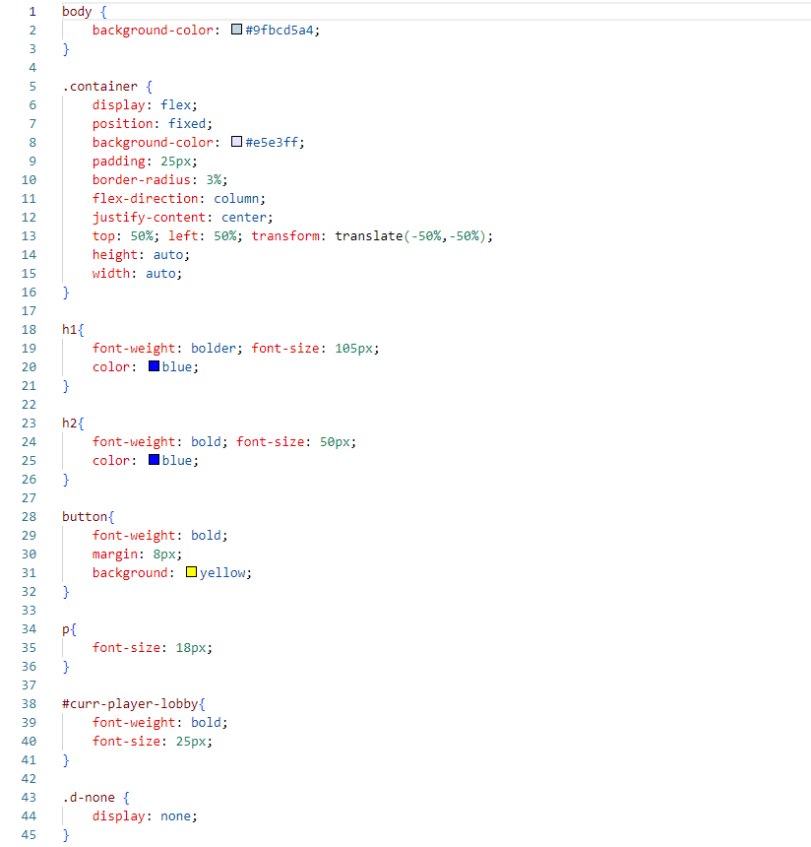

This file includes all css formatting in all webpages

**JAVA SCRIPT**

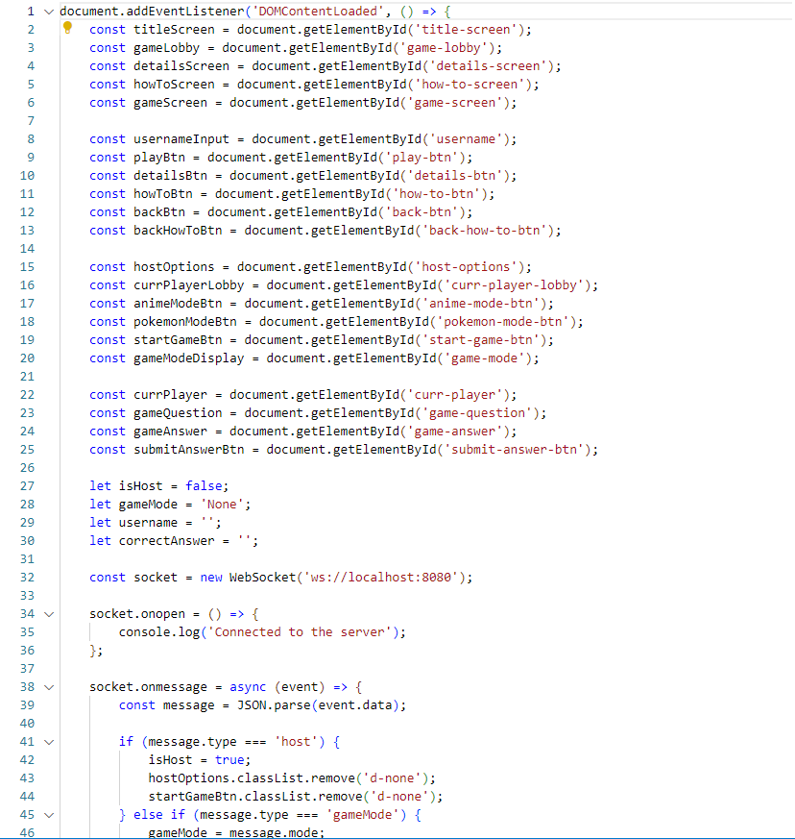

This java script file is mainly for handling animations in our website

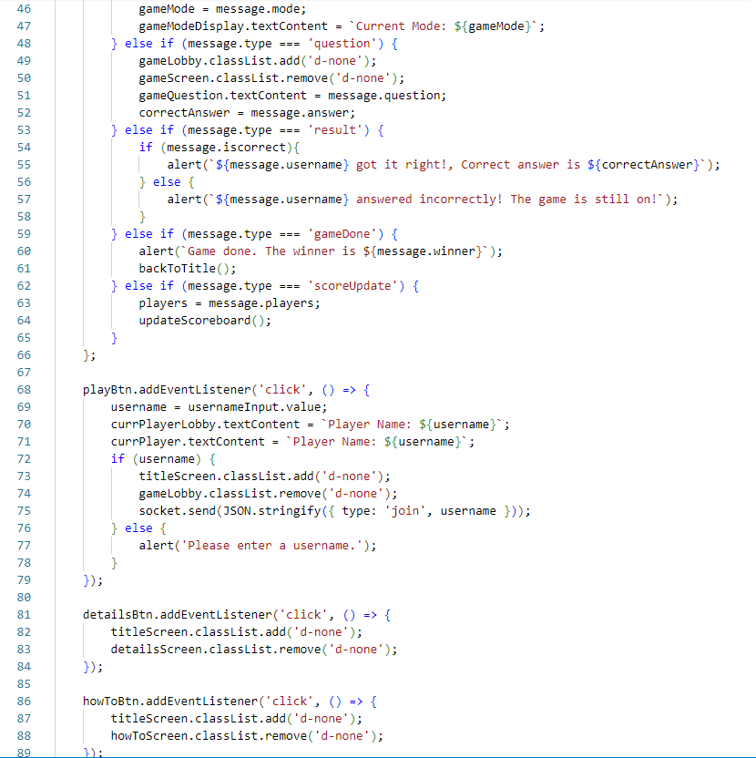

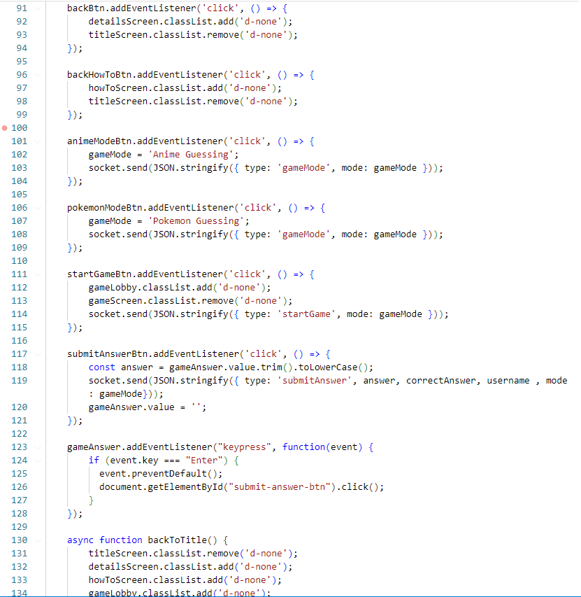

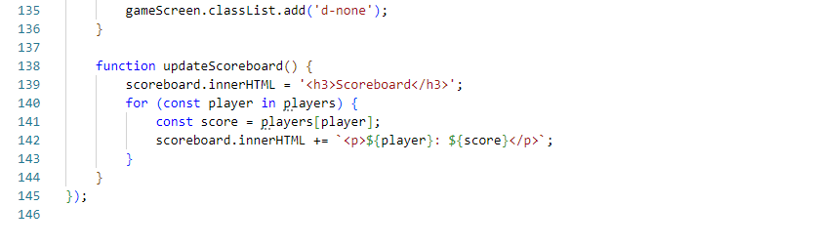

**SERVER.JS**

