Supplemental Information
Reconstructing the stochastic Waddington landscape of bone regeneration identifies CDK8 as a pan-non-union therapeutic target
Jie Zou, Bo Guo, Liang Ma, Weibo Zheng, Xiaoai Zhou, Meiyun Tan*
Department of Orthopedics, The Affiliated Hospital of Southwest Medical University, Luzhou 646000, Sichuan, China
Supplemental Figures
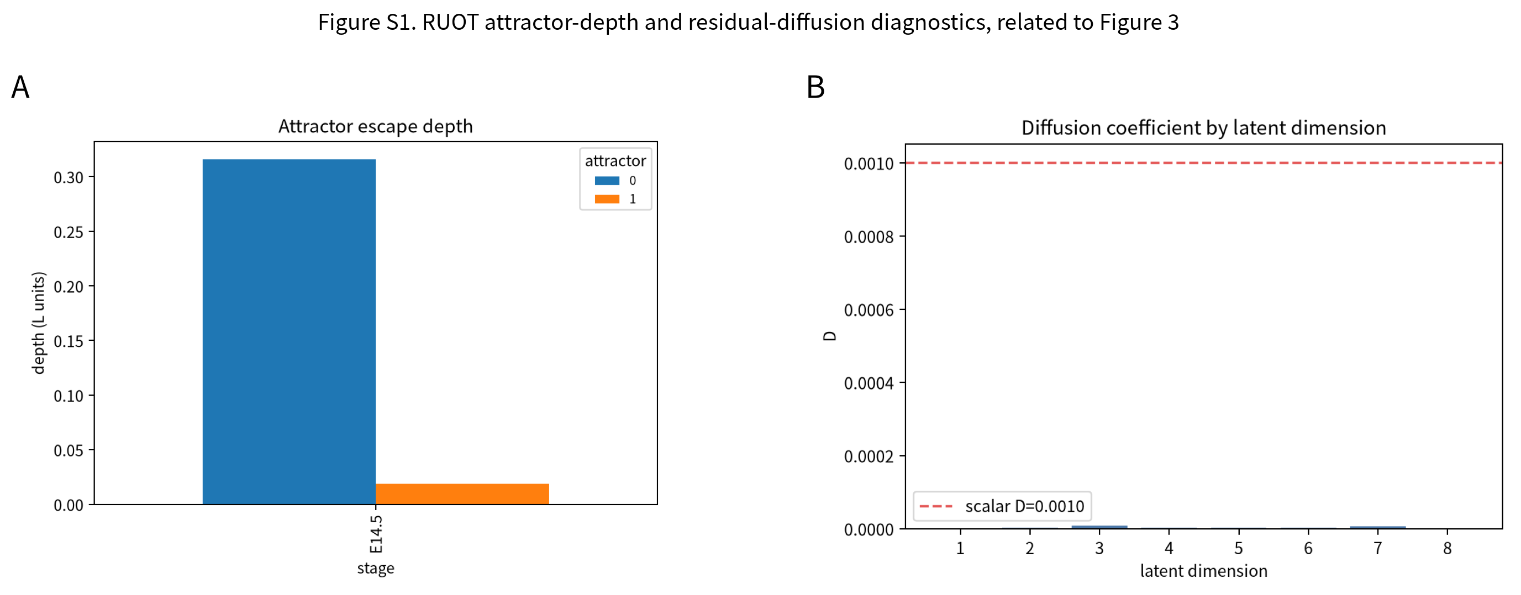
Figure S1. RUOT attractor-depth and residual-diffusion diagnostics, related to Figure 3. (A) Attractor escape depth (in potential L = −log p units) for the two E14.5 attractors, quantifying the deep chondrogenic basin (≈0.316) relative to the shallow fibrous basin (≈0.019). (B) Per-latent-dimension residual diffusion coefficient after joint drift/diffusion/growth fitting, compared with the fixed irreducible noise floor d = 0.001 (red dashed). Residual anisotropic diffusion is ~1×10⁻⁶–9×10⁻⁶, far below d, indicating that the drift field is well identified and that stochasticity is dominated by the explicitly modelled noise.
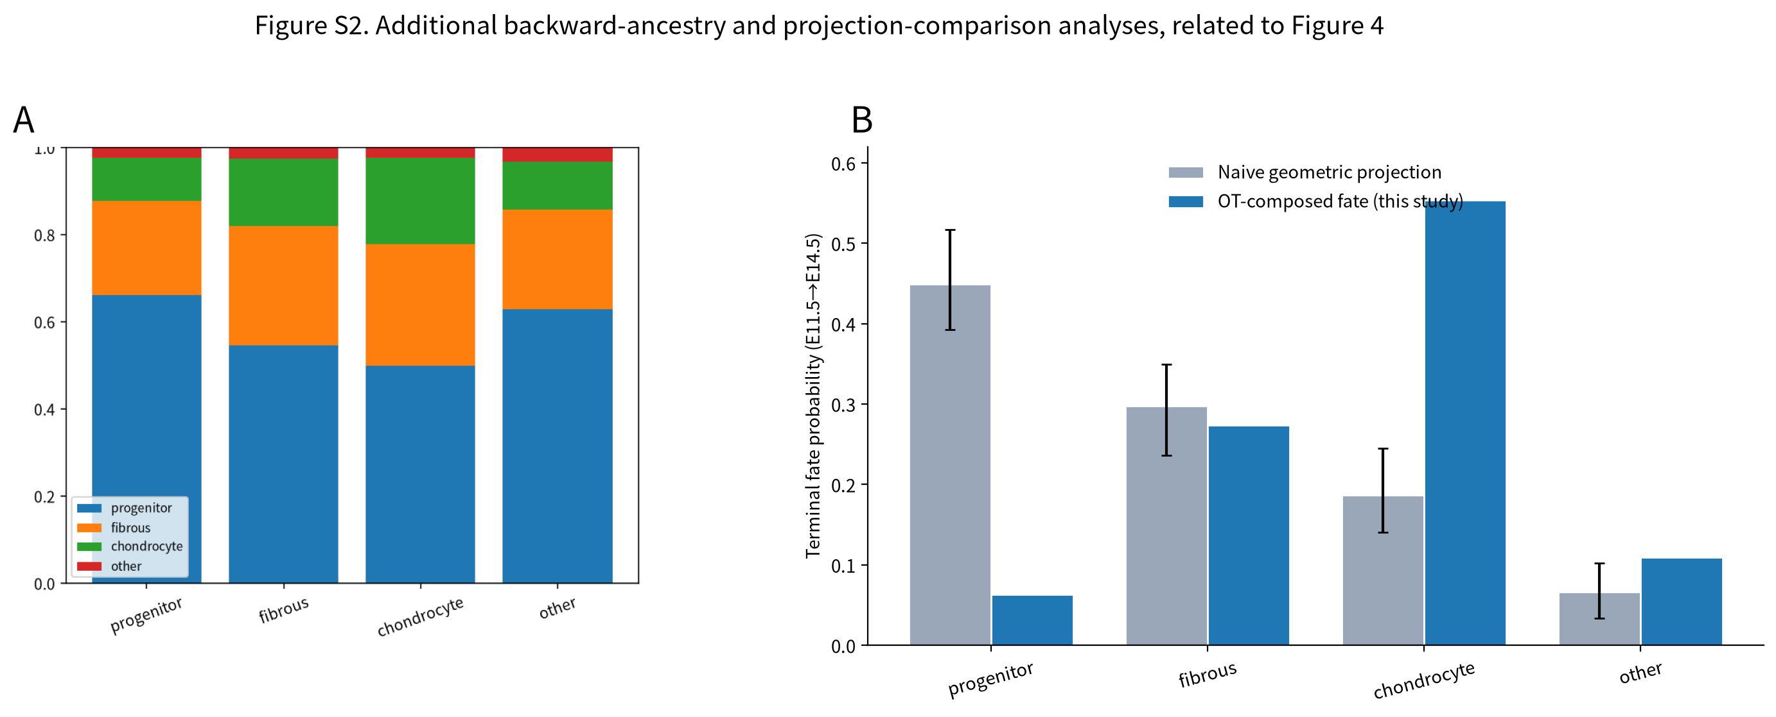
Figure S2. Additional backward-ancestry and projection-comparison analyses, related to Figure 4. (A) Backward ancestry shown as the E11.5 source composition within each E14.5 terminal state (stacked bars), a companion to the Figure 4E heat map and confirming that terminal chondrocytes draw from multiple early sources, including fibrous-like cells. (B) Terminal fate from E11.5 to E14.5 under naive geometric projection (grey, with bootstrap 95% confidence intervals) versus the entropic-OT-composed coupling (blue). Bare geometric projection inflates the progenitor fraction (≈0.45 vs ≈0.06) and underestimates chondrocyte commitment (≈0.19 vs ≈0.55), motivating lineage-module/attractor-probability mapping rather than direct geometric projection of adult cells.
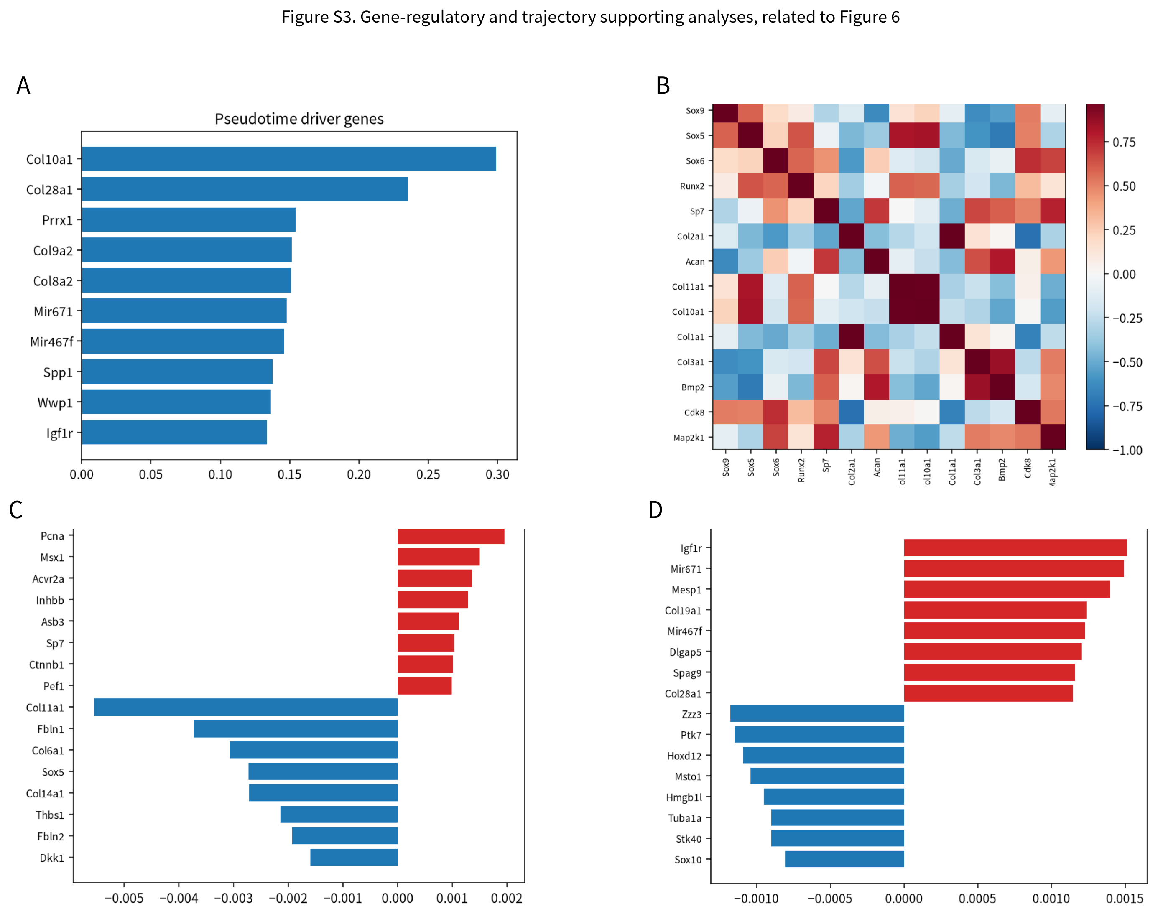
Figure S3. Gene-regulatory and trajectory supporting analyses, related to Figure 6. (A) Top pseudotime driver genes of endochondral progression. (B) Partial-correlation regulatory matrix after stage/cycle correction (red, positive co-variation; blue, negative). (C) Growth-related genes ranked by standardized association (red positive, blue negative). (D) Trajectory-critical genes ranked along the differentiation trajectory (red positive, blue negative). The directed gene-regulatory network and perturbation dose-response curves are shown in main Figure 6D–F.
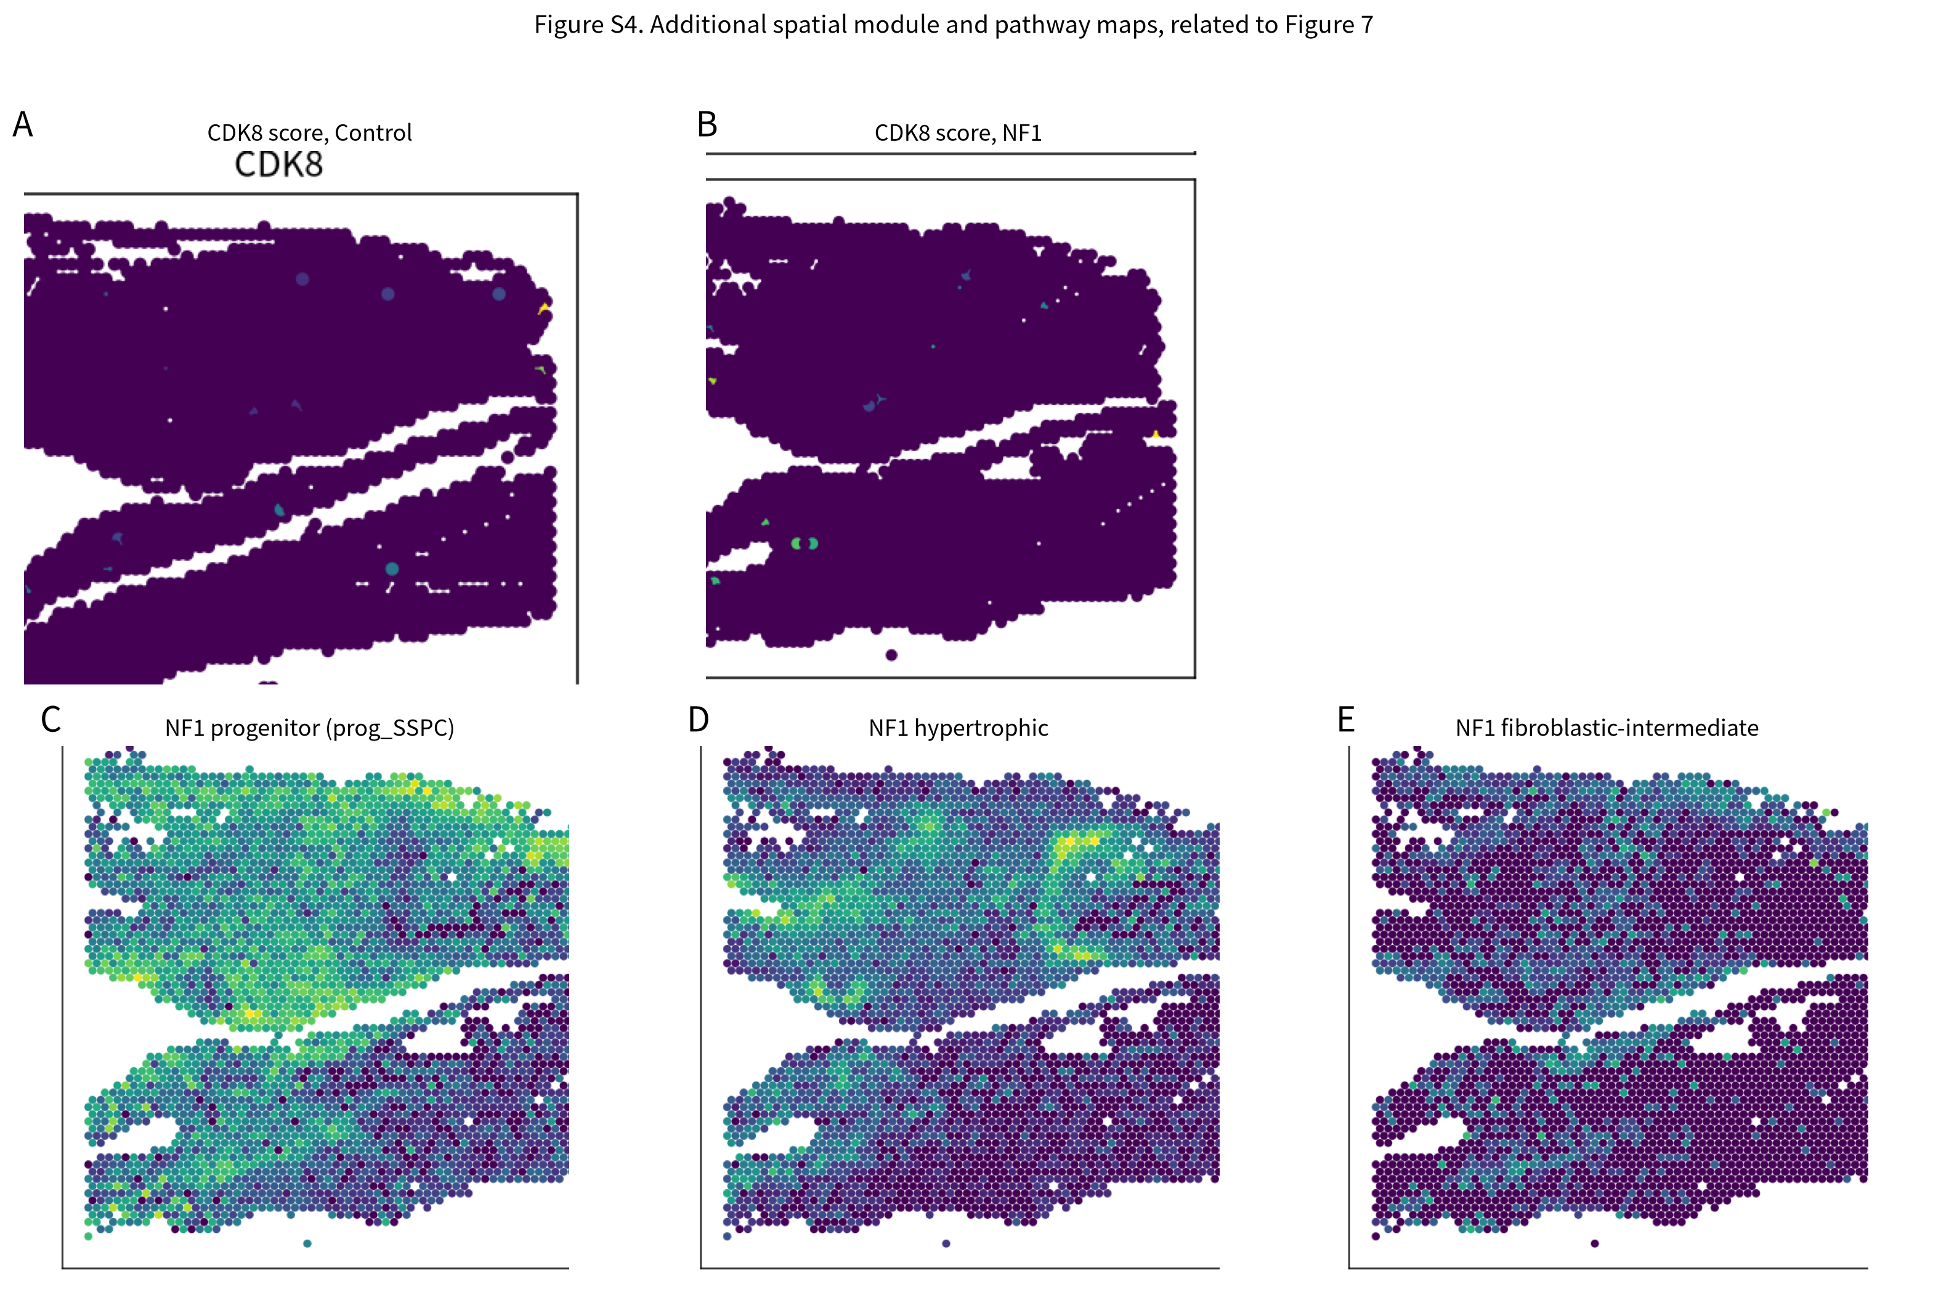
Figure S4. Additional spatial module and pathway maps, related to Figure 7. (A,B) CDK8 pathway score on the control (A) and NF1 (B) Visium sections, showing near-uniform low CDK8 spatial signal with no focal hotspot, consistent with CDK8 acting as a distributed lineage gate rather than a spatially localized cue. (C–E) NF1 section spatial scores for the progenitor/prog_SSPC (C), hypertrophic (D) and fibroblastic-intermediate (E) modules; the chondrogenic, fibrous and hypertrophic maps for both sections are shown in main Figure 7A.

Supplemental Tables
All supplemental tables are additionally provided as machine-readable CSV files in the Supplemental_Tables folder accompanying this document.
Table S1. Cell counts and state composition by developmental stage.
Table S2. Stage-resolved abundance trends (Spearman rho and significance) for each state.
Table S3. State marker statistics (expression fraction, average scaled expression and enrichment).
Table S4. Per-stage quality-control summary (detected genes, UMI counts, mitochondrial/ribosomal fractions, doublet scores).
Table S5. Forward fate probabilities (E11.5 start class to E14.5 terminal state) from the entropic OT coupling.
Table S6. Backward ancestry matrix (E14.5 terminal fate to E11.5 ancestor).
Table S7. Extended terminal fate from the probability layer, including hypertrophic and osteoblast states.
Table S8. Day-4/day-7 non-union block metrics by condition (commitment, arrest, terminal, fibrotic, fibroblastic-intermediate and proliferation fractions).
Table S8b. Integrated non-union blockage score at day 7 for WT-intact, ischemic and CD47-null conditions.
Table S9. Condition differential-expression signatures (ischemia and CD47-null versus intact) for lineage and target genes.
Table S10. ITPS multi-evidence target ranking and composite scores.
Table S11. Moran's I spatial autocorrelation for lineage modules and BMP/MAPK pathways (control and NF1).
Table S12. Fibrocartilaginous-junction statistics: junction counts, pathway z scores, enrichment and per-spot BMP–MAPK correlations.

