

UNIVERSITY OF ASIA PACIFIC
Object Oriented Programming II Lab: Visual and
Web Programming Lab
CSE – 310
ER Diagram and Schema
Dept. of CSE

Submitted To:
Md. Nahiyan Uddin
Lecturer,
Department of CSE
University of Asia Pacific
Submitted By :
Name: Ferdous Alam Naeem
Id: 18201035
Name: Ferdous Alam Naeem
Id: 18201035
Name: Ferdous Alam Naeem
Id: 18201035

E-R Diagram

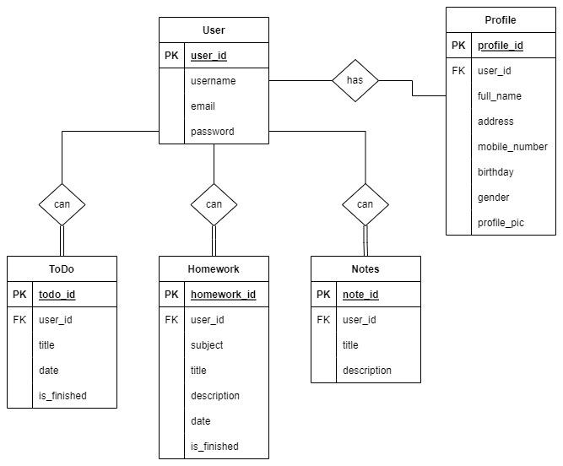

Schema

User(user_id, username, email, password)
Profile(profile_id, full_name, address, mobile_number, birthday, gender, profile_pic)
Notes(note_id, title, description)
Homework(homework_id, subject, title, description, date, is_finished)
ToDo(todo_id, title, date, is_finished)

