# DEX

Decentralized exchange

Cannot be shut down by the government

* For people in areas where access to crypto currency is restricted

User in charge of the finds not by a centralized exchange

* Vulnerability of the centralized exchange is not a concern
* DEX Hub can still have vulnerabilities

# Liquidity pools

Used to facilitate trading by DEXes

# BSC (to beat ETH)

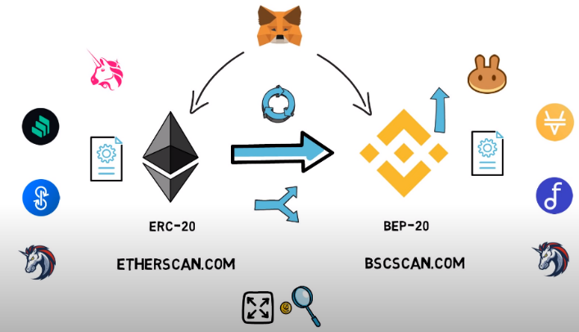

**CEDEFI**

* BSC is a fork of ETH, as with PCS being a fork of ETH
* resolves the issues of unusable high gas fees in ETH
* supports Smart Contracts from ETH

|  |  |
| --- | --- |
| **Benefits** | **Cost** |
| Low transaction fees | decentralisation |
| Fast transaction times | censorship resistant property |

## Reducing Block time & Gas Limit per block

Scalability Trilemma

## Sharding (at base layer)

* Cannot resolve the trilemma
* Splitting blockchain into multiple smaller chains (shards) – ETH 2.0 update
* Not able to process millions of transactions per sec without suffering from decentralization
* **ETH Layer 2.0** solutions **can resolve** without the sacrifices above

Top 21 holders of BNB become validators and take turns validating the blocks

Validators can encourage holders to stake with validator to earn from validation of transaction fees

**Changing Block Properties**

1. Reduced block time
2. Increase block gas limit
3. **Reduced Block time**

measure of the time it takes to produce a new block, or data file

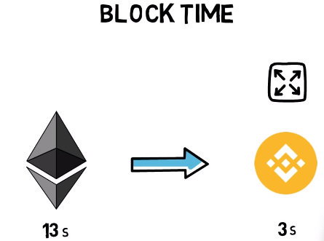

|  |  |
| --- | --- |
| **Benefits** | **Costs** |
| Higher transaction throughput | Store more data |
| Faster Confirmation Times | (if on ETH) more orphan Blocks, not enough time to propagate blocks across multiple geographic locations |

1. **Increased Block gas limit (how many transactions fit into one single block)**

Increasing block gas limit increases data produced by block chain makes it difficult for individual nodes using consumer grade hardware

# ETH 2.0

**Etherum scaling**

1. Scaling base layer
2. Scaling network to another layer : layer 2

## Etherum 2.0 scaling

Collective term of solutions for improving layer 1

Improve capabilities by handling the transactions off chain

1. TX speed
2. TX throughput, reduce gas fees

**Channels**

**Main issues:**  
Cannot be used to scale general purpose smart contracts, only application-specific

**Plasma**

Offload transactions to side chains

**Main issues:**

Long delay to withdraw money from layer 2  
Cannot scale general purpose smart contracts

**Sidechains**

Independent ETH compatible side chains

**Rollups**

**2 Types of rollups**

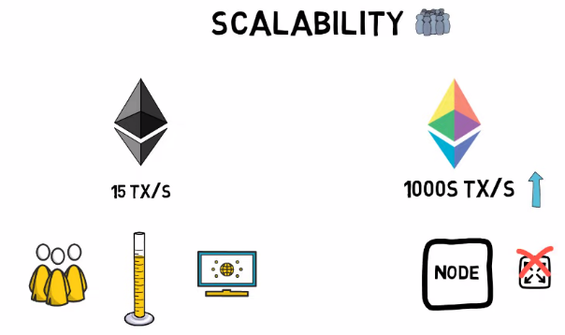

**Sharding + rollouts**

Current ETH chain becomes one of the shards

**Beacon Chain**coordinating a proof of stake system

**Randomly** assign stakers to validify a shard

**Docking**

Adding existing chain to new shards  
(marks end of proof of work)

**Roadmap**

## Smart contracts

* Trusted intermediary
* Fully automated, deterministic
* Obviates need for third party
  + Speed of transaction
  + Cost of transaction