# GeneCompare3X – Triple-Method DNA Similarity Analyzer

## Abstract

GeneCompare3X is a Python-based DNA sequence similarity analyzer that compares two sequences using three algorithms: Hamming Distance (adapted for unequal lengths), Jaro–Winkler Similarity, and the Smith–Waterman Local Alignment. The tool features an interactive Tkinter GUI that supports manual or CSV-based input and calculates similarity percentages instantly. The objective is to evaluate the strengths, limitations, and suitability of each algorithm for DNA comparison tasks.

## Introduction

DNA sequence comparison is a fundamental process in bioinformatics used to identify similarities and variations between genetic sequences. The GeneCompare3X project provides a simplified platform to study and compare different algorithmic approaches to this task, helping learners understand how algorithm selection affects speed, accuracy, and computational performance.

## Algorithms Implemented

### 1. Hamming Distance

The Hamming distance counts mismatched positions between two equal-length strings. This implementation extends Hamming Distance to handle unequal lengths by comparing characters up to the maximum length. Similarity is calculated as (1 - mismatches/length) * 100. Time Complexity: O(n), Space Complexity: O(1).

Strengths: Fast, simple, ideal for equal-length sequences.

Weaknesses: Not suitable for insertions/deletions (indels).

### 2. Jaro–Winkler Similarity

Jaro–Winkler measures similarity between two strings by matching characters within a fixed window, accounting for transpositions and prefix bonuses. It’s effective for detecting minor rearrangements and typographical errors. Time Complexity: O(n × m), Space Complexity: O(n + m).

Strengths: Good for short sequences with small differences.

Weaknesses: Not biologically informed; ignores gaps.

### 3. Smith–Waterman Algorithm

Smith–Waterman performs local sequence alignment using dynamic programming. It constructs a scoring matrix to find the optimal matching subsequence between two DNA strings. The similarity percentage is derived from the alignment score. Time Complexity: O(n × m), Space Complexity: O(n × m).

Strengths: Handles insertions, deletions, and mutations effectively.

Weaknesses: Slower for long sequences, higher memory usage.

## Comparative Analysis

The following table summarizes the properties and performance of the implemented algorithms:

|  |  |  |  |  |  |
| --- | --- | --- | --- | --- | --- |
| Algorithm | Handles Gaps | Speed | Accuracy | Memory Use | Best Use Case |
| Hamming Distance | No | Fast | Basic | Low | Equal-length sequences |
| Jaro–Winkler | Partial | Moderate | Moderate | Medium | Noisy short sequences |
| Smith–Waterman | Yes | Slow | High | High | Biological sequence alignment |

## GUI Overview

The GeneCompare3X interface is built using Tkinter. It provides fields for manual sequence input and CSV-based sequence selection. Buttons allow users to choose between Hamming, Jaro–Winkler, or Smith–Waterman algorithms, or run all simultaneously. Results are displayed as percentage similarity within a color-coded result box.

### Manual Input Interface

Manual input interface for entering two DNA sequences and selecting comparison algorithms.

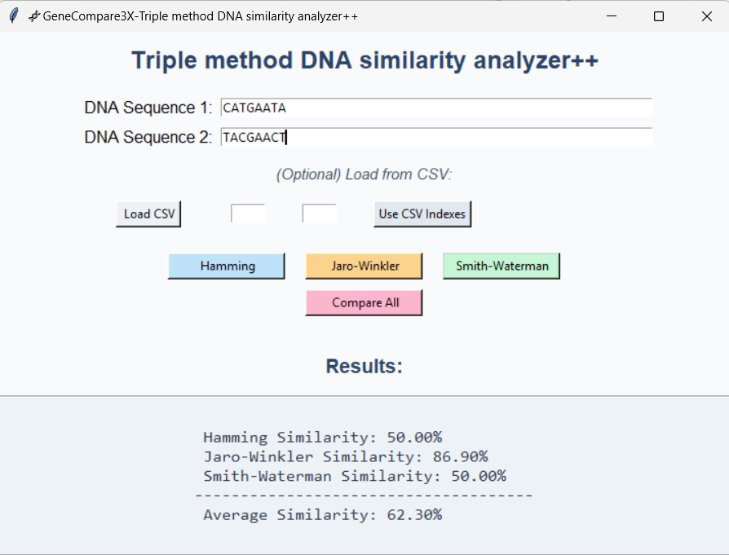

### CSV Selection Interface

CSV-based sequence selection and index input feature in the GeneCompare3X analyzer.

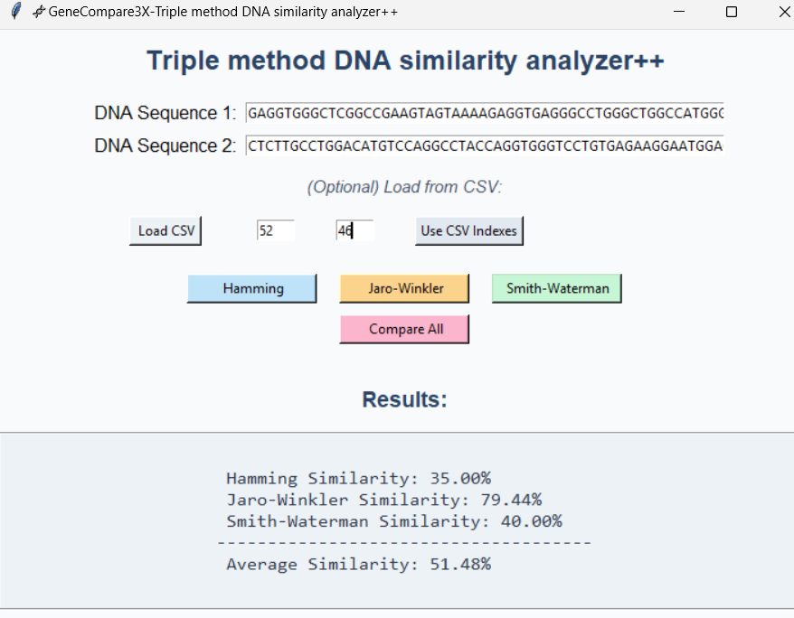

## Technologies Used

• Python 3.x

• Tkinter (for GUI)

• Pandas (for CSV handling)

• Jupyter Notebook or VS Code (for development)

## Observations and Conclusion

Among the three algorithms, Smith–Waterman provides the most biologically meaningful similarity measure by handling insertions, deletions, and local alignments accurately. However, it requires more computational resources. Hamming is the fastest but limited to equal-length sequences, while Jaro–Winkler balances speed and flexibility for short or noisy sequences. The combination of all three methods allows flexible, efficient, and accurate DNA comparison depending on data characteristics.