**PRACTICAL NO. 5**

Name: Zoya Ghachi

Roll no. : A1_B2_23

**Aim:** Implement Longest Common Subsequence (LCS) algorithm to find the length and LCS for DNA sequences.

**TASK-1:** Find the similarity between the given X and Y sequence.

X=AGCCCTAAGGGCTACCTAGCTT

Y= GACAGCCTACAAGCGTTAGCTTG

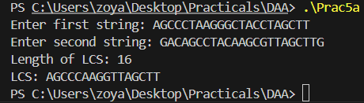

**TASK-2:** Find the longest repeating subsequence (LRS). Consider it as a variation of the longest common subsequence (LCS) problem.

Let the given string be S. You need to find the LRS within S. To use the LCS framework, you effectively compare S with itself. So, consider string1 = S and string2 = S.

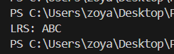

**LeetCode Assesment:**

<https://leetcode.com/problems/longest-common-subsequence/description/>

