**PRACTICAL NO. 7**

**Name :** Zoya Ghachi

**Roll No.:** A1_B2_23

**Aim:** Construction of OBST

**Problem Statement: Smart Library Search Optimization**

**Task 1:**

**Scenario:**

A university digital library system stores frequently accessed books using a binary search mechanism. The library admin wants to minimize the average search time for book lookups by arranging the book IDs optimally in a binary search tree.

Each book ID has a probability of being searched successfully and an associated probability for unsuccessful searches (when a book ID does not exist between two keys).

Your task is to determine the minimum expected cost of searching using an Optimal Binary Search Tree (OBST).

**Input Format**

First line: integer n — number of book IDs.

Second line: n integers representing the sorted book IDs (keys).

Third line: n real numbers — probabilities of successful searches (p[i]).

Fourth line: n+1 real numbers — probabilities of unsuccessful searches (q[i]).

Keys: 10 20 30 40

P[i]: 0.1 0.2 0.4 0.3

Q[i]: 0.05 0.1 0.05 0.05 0.14

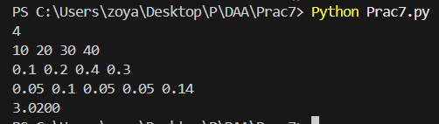

**Output Format**

Print the minimum expected cost of the Optimal Binary Search Tree, rounded to 4 decimal places.

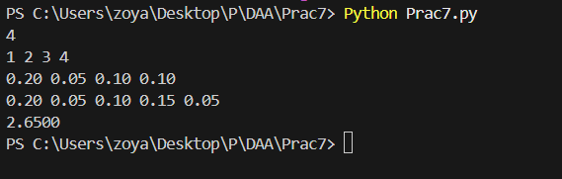

**Task 2:**   
<https://www.geeksforgeeks.org/problems/optimal-binary-search-tree2214/1>

