**class assignment 2**

***Programming Fundamentals***

15/OCT/2023

**Assignment 2**

**BSCS-I-B**

**Programming Fundamentals**

**Program 1:**

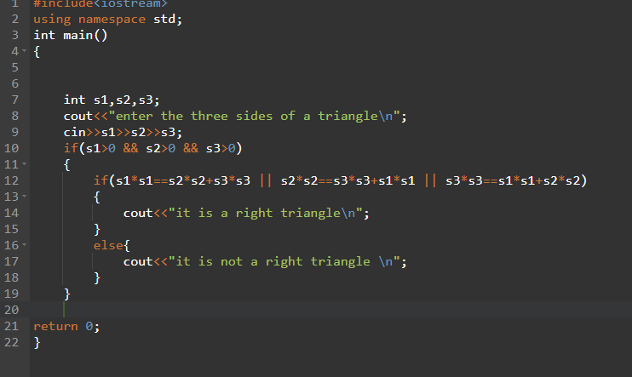

**Output:**

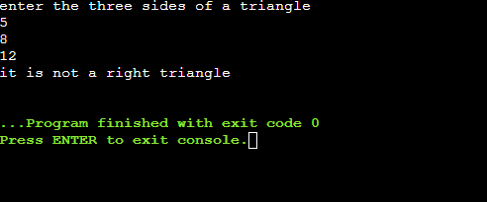

**Explanation:**

* First we will ask the user to enter the three side of a triangle.
* Then we will check if all three sides are greater than 0 using if statement.
* Now we will use if statement inside the outer if statement to check if the triangle satisfies the Pythagoras theorem.
* If the sides do satisfy the theorem then it is a right triangle otherwise it’s not a right triangle.

**Program 2:**

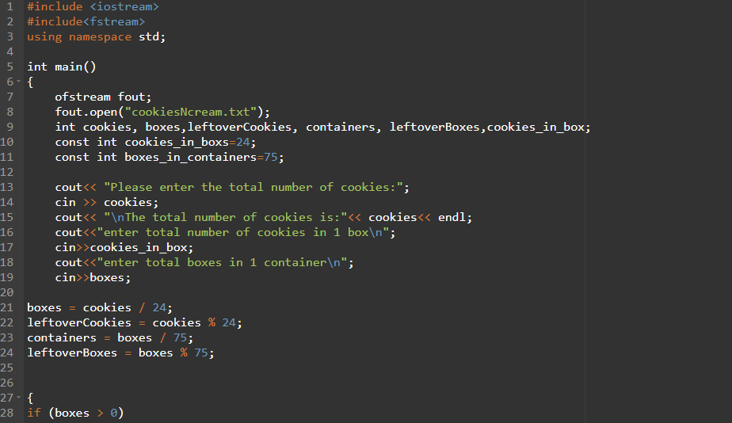

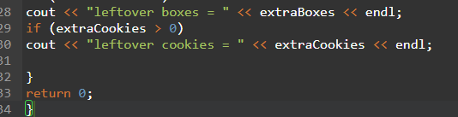

**Output:**

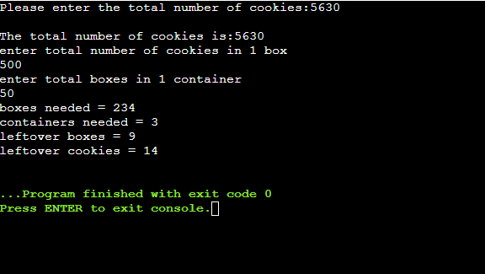

**File:**

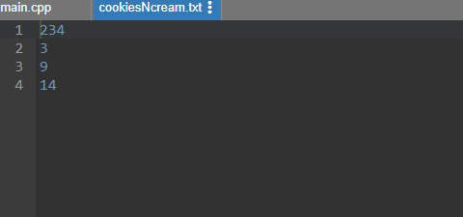

**Explanation:**

* First we will create a file or save data in an existing file like cookiesNcream.txt
* Now declare the constant values like cookies in boxes=24 and boxes in containers=75.
* Now ask the user to enter the total number of cookies, cookies in 1 box , total boxes in 1 container as required in the program.
* Now we will find the leftover cookies and leftover boxes by using the formula:

Leftover cookies=cookies%24

Leftover boxes = boxes%75

* Now we will use the if statement to see if the boxes, leftover cookies, containers and leftover boxes are > 0. If yes then display their number.
* Program ends.

**Program 3:**

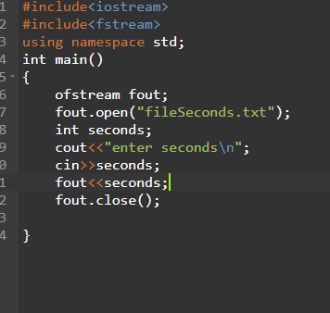

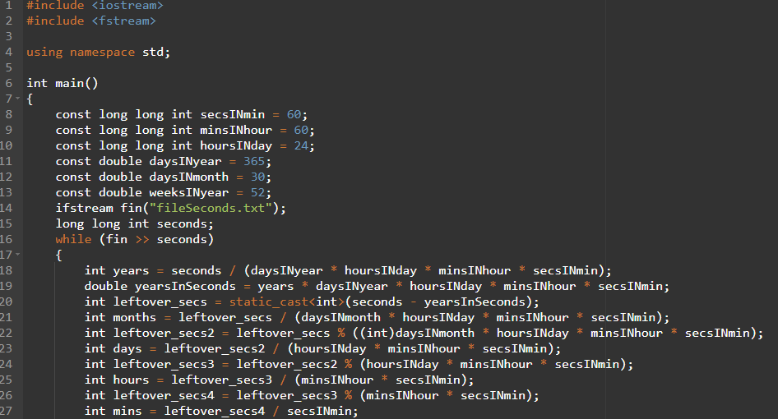

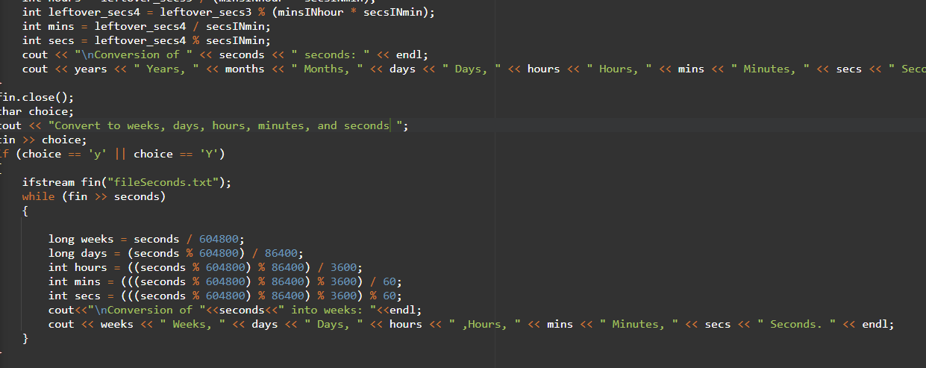

**Output:**

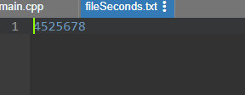

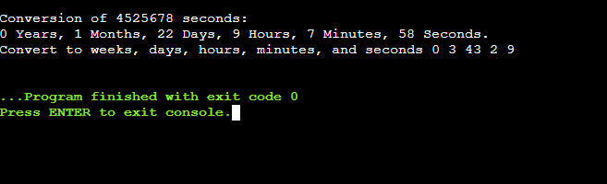

**Program 4:**

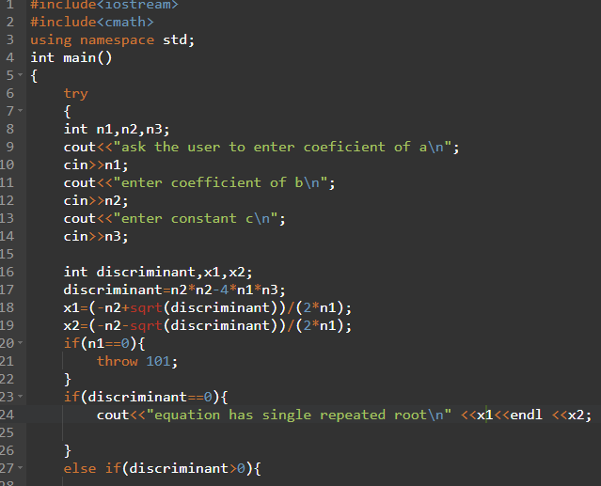

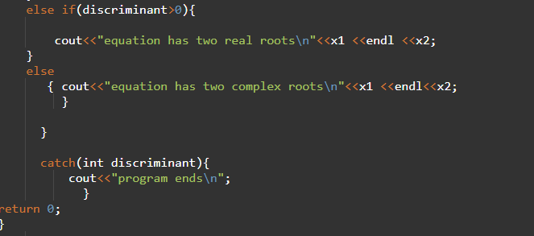

**Output:**

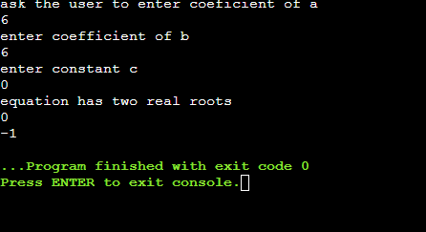

**Explanation:**

* First we will use the try exception to start the program.
* Now we will ask the user to enter the the coefficient of a, b and the constant c.
* Now we will write the formula of discriminant:
* Discriminant=b^2-4*a*c
* We will also write the quadratic formula to find the roots.
* Now we will use the if-else-if statement to check the type of root.
* We will use the throw exception in case the coefficient of a is 0.
* At last, we will use the catch exception to end the program.