**EXPERIMENT 1:**

**Structured Query Execution for Information Retrieval**

Zoya Momin

Department of Computer Engineering

M.H Saboo Siddik College of Engineering

Mumbai, India

zoya.221257.co@mhssce.ac.in

**1.**  **INTRODUCTION**

Information Retrieval (IR) focuses on obtaining relevant data from vast collections using query-based mechanisms. Structured queries like SQL provide precise control, whereas unstructured queries mirror natural language interactions. This experiment aims to explore structured queries, their execution, and performance evaluation while contrasting them with unstructured approaches.Applications include search engines, digital libraries, biomedical databases, and enterprise data systems. By combining structured queries with advanced IR techniques, systems can offer faster, more accurate, and context-aware search capabilities.

**QUERIES:**

**1. Creating PERSON table**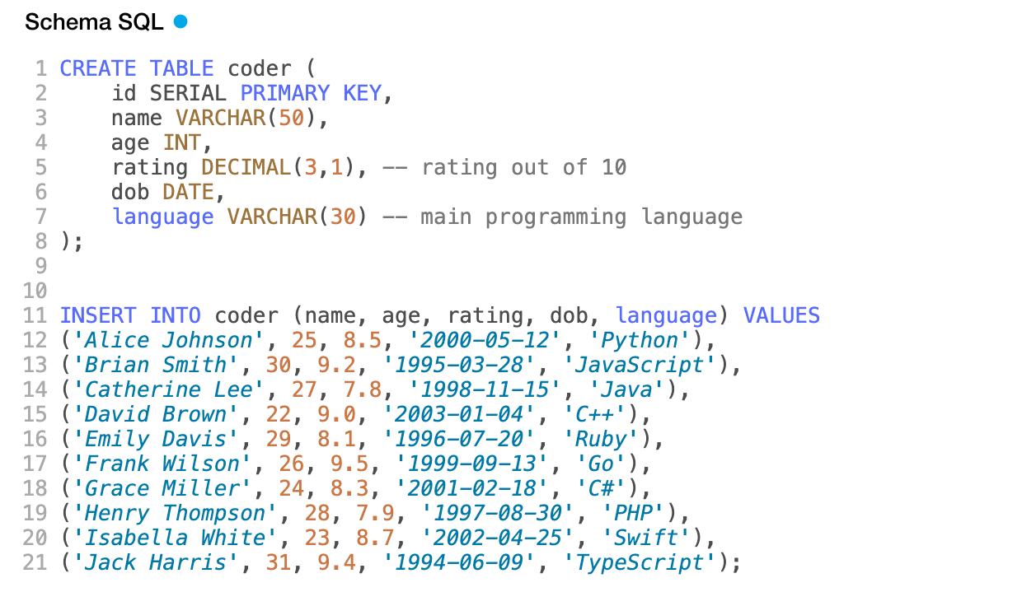

1. Retrieve all records from the "employees" table

**SELECT * FROM coder;**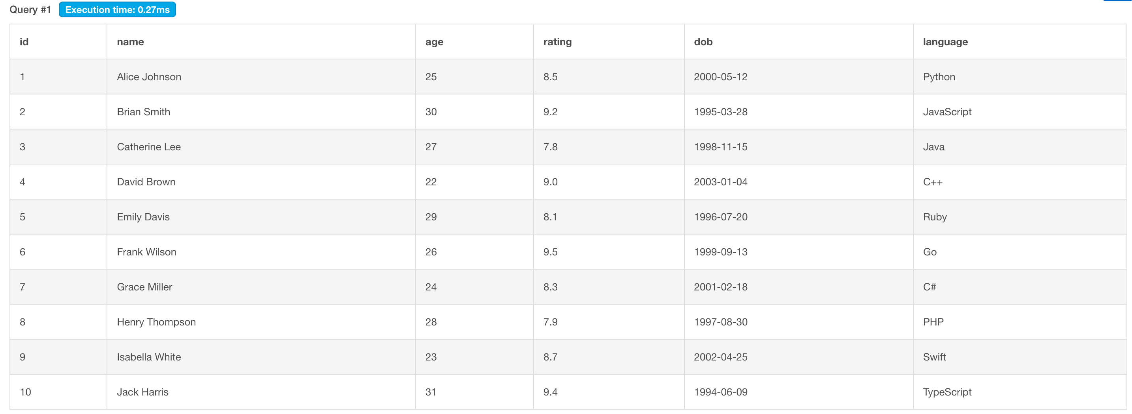

2. Retrieve names from coder where language is java

**SELECT name FROM coder WHERE language = “Python”;**

3. Retrieve the average age of the coder

**SELECT AVG(age) AS avg_age FROM coder;**

4. Sort coder by age in ascending order

**SELECT name, age FROM coder ORDER BY age ASC;**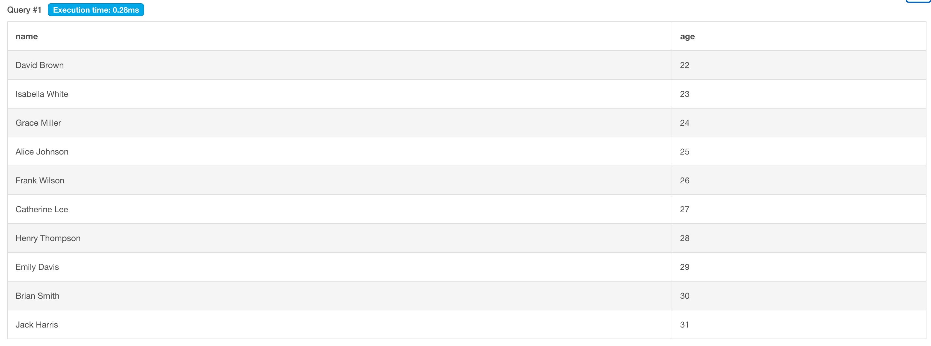

5. Retrieve total avg rating per language category.

**SELECT language, AVG(rating) AS avg_rating FROM coder GROUP BY language;**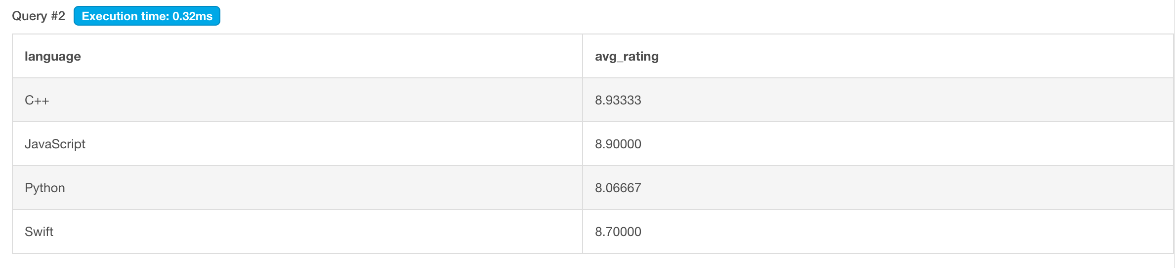

6. Retrieve coder names with rating above avg

**SELECT name FROM coder WHERE rating > (SELECT AVG(rating) FROM coder);**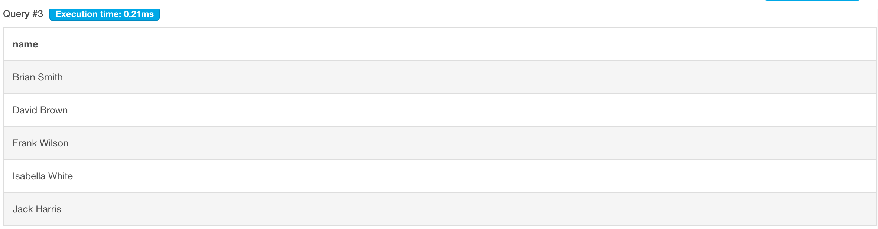

7. List coders who code in Python or Java

**SELECT name FROM coder WHERE language = ‘Python' UNION SELECT name FROM coder WHERE language = ‘Java';**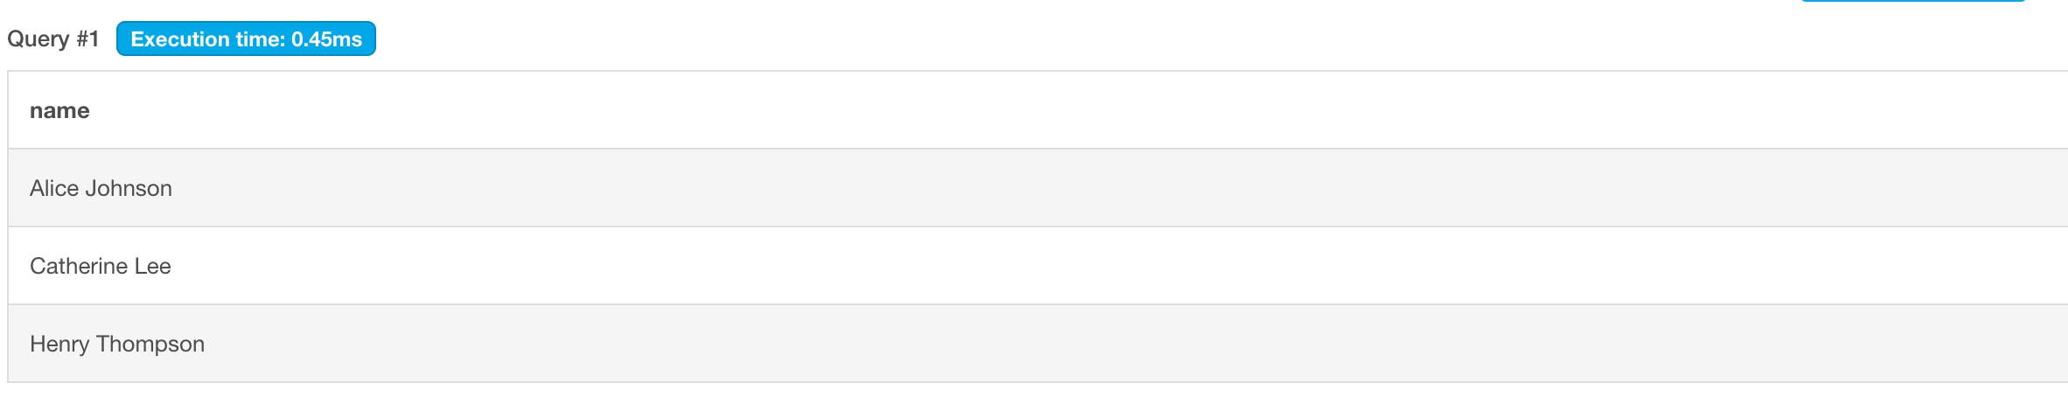

8. Coders born between Jan 1, 1998 and Jan 1, 2001

**SELECT name FROM coder WHERE dob BETWEEN "1998-01-01" AND “2001-01-01";**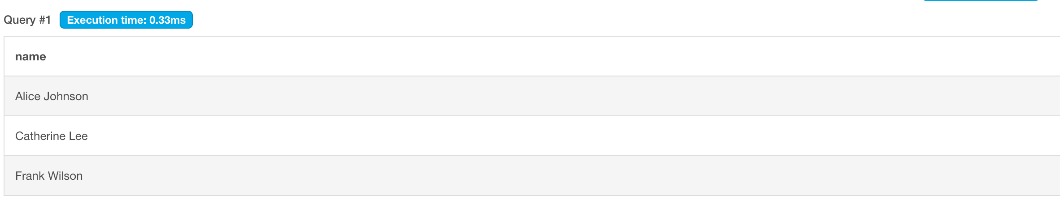

**Insert for join**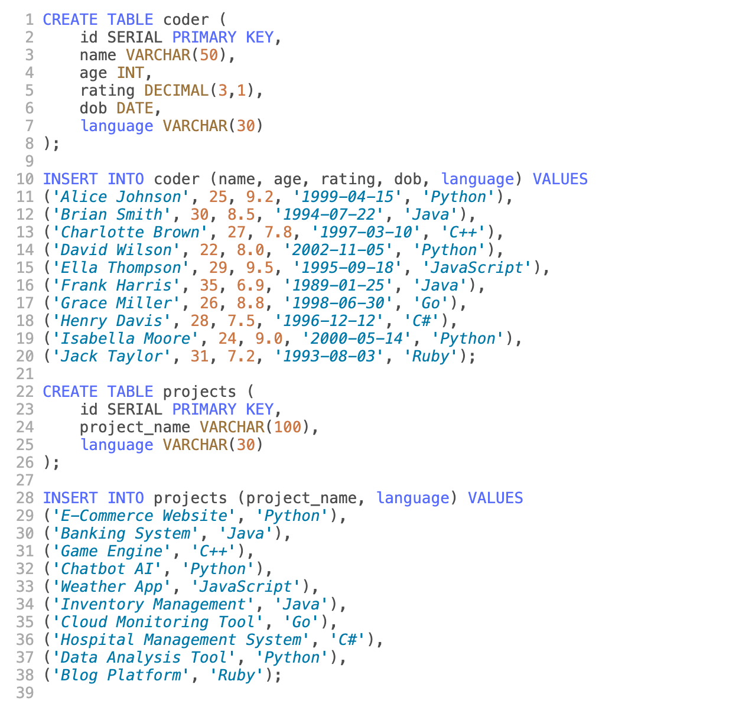

**9.** Coders working on language-specific projects

**SELECT c.name AS coder_name, p.project_name FROM coder c JOIN projects p ON c.language = p.language;**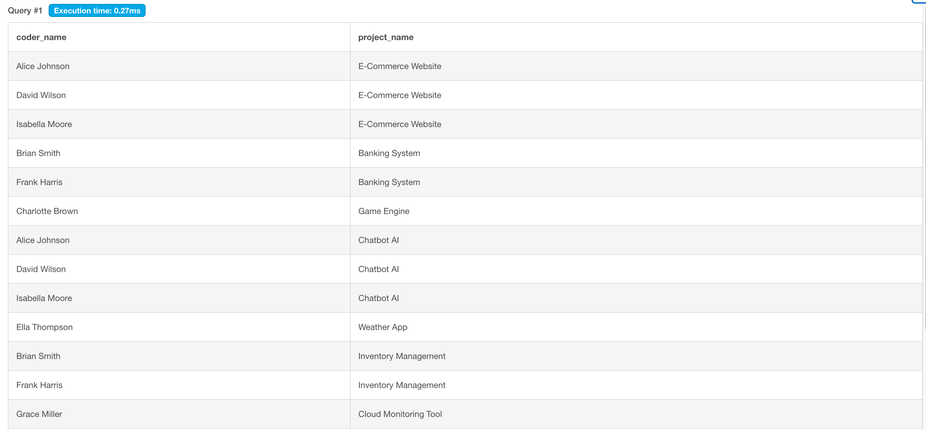

**2.**  **CONCLUSION**

This experiment bridges theoretical and practical understanding of structured query execution for information retrieval. Participants learned to convert real-world needs into SQL queries, evaluate their efficiency, and explore the contrast with unstructured, NLP-driven approaches. This foundational knowledge is essential for building efficient retrieval systems across various domains.