**EXPERIMENT 0: Mindmap on Data Visualisation**

Zoya Momin

Department of Computer Engineering

M.H Saboo Siddik College of Engineering

Mumbai, India

zoya.221257.co@mhssce.ac.in

**ABSTRACT**

Data visualisation transforms complex datasets into visual representations to facilitate understanding, trend identification, and decision-making. This document explores the types, applications, and tools used for data visualisation, emphasizing its pivotal role across industries such as healthcare, government, logistics, research, sports analytics, and business intelligence.

**1.**  **INTRODUCTION**

**1.1 Definition**

Data visualisation is defined as the graphical representation of data and information. By using visual elements like charts, graphs, and maps, it offers an accessible way to understand trends, outliers, and patterns in data. As data volume grows, visualisation becomes increasingly essential to extract insights and communicate findings effectively.

**1.2 Features**

1. Helps identify trends and patterns quickly
2. Simplifies complex data interpretation
3. Supports data-driven decision making
4. Enhances storytelling with data
5. Customisable for different audiences and needs
6. Integrates easily with data analytics tools

**2. MINDMAP**

The mind map visually organizes the concept of **Data Visualisation** into three main branches: types, applications, and tools. The *types* branch lists various visualisation methods, including histograms, box plots, KDE plots, bar charts, scatter charts, pie charts, donut charts, area charts, line charts, and column charts—each chosen to highlight comparisons, distributions, trends, or parts of a whole. The *applications* branch illustrates how data visualisation supports fields like healthcare, government policy, transportation and logistics, scientific research, sports analytics, and business intelligence, enabling better analysis and decision-making. Finally, the *tools* branch outlines popular software and libraries such as Tableau, Power BI, Google Data Studio, Python libraries (matplotlib, seaborn, bokeh, plotly, folium), R packages (ggplot2, Shiny), MATLAB, D3.js, and mapping tools like Google Maps API, which together make it possible to create both static and interactive visualisations tailored to different needs.

*Fig 1. Mind Map on Data Visualisation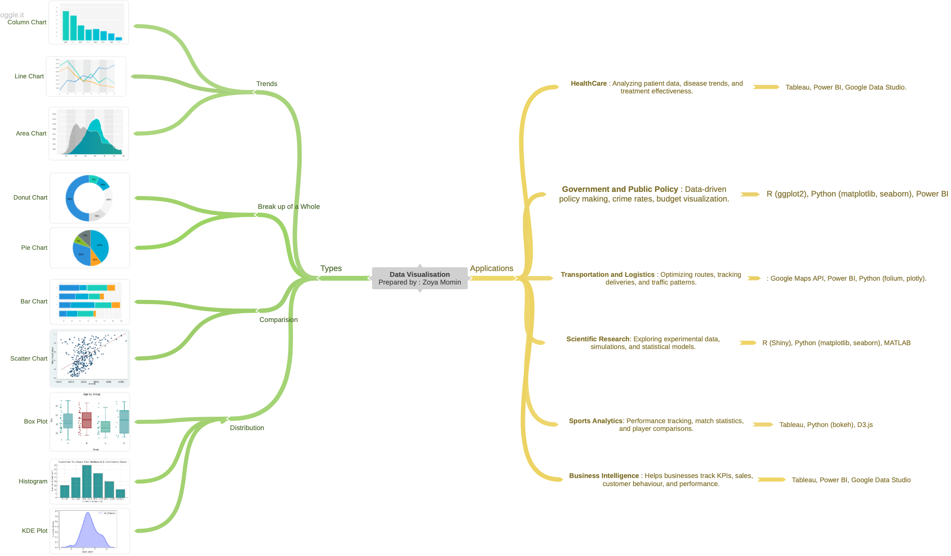*

**3. TOOLS USED FOR MIND-MAP**

**3.1 Tool Overview**

Coggle is an online tool designed for creating mind maps and flowcharts collaboratively. It helps users visually organize ideas, concepts, and information in a structured, branching format. Ideal for brainstorming, planning, and presenting complex topics in an intuitive visual way.

**3.2. Key Features:**

Coggle is an online mind mapping tool that helps users visually organize ideas and concepts through an intuitive, drag-and-drop interface. It supports real-time collaboration, allowing multiple users to work together simultaneously, and offers features like unlimited image uploads, auto-saving with revision history, and easy sharing or export in various formats.

**4. Conclusion**

Data visualisation is indispensable in today’s data-centric world. By converting raw data into meaningful visuals, it empowers users across industries to make informed decisions, communicate findings effectively, and uncover insights hidden within data. Tools and libraries have evolved to meet diverse visualisation needs, from simple charts to interactive dashboards and geographic mapping.

**4. REFERENCES**

[1] Tableau, "What is Data Visualisation?" [Online].

[https://www.tableau.com/visualisation/what-is-data-visualisation](https://www.tableau.com/visualization/what-is-data-visualization)

[2] GeeksforGeeks, "Data Visualisation and its Importance."

[https://www.geeksforgeeks.org/data-visualisation/data-visualisation-and-its-importance/](https://www.geeksforgeeks.org/data-visualization/data-visualization-and-its-importance/)