**EXPERIMENT 3:**

**To install and Configure MongoDB to create NoSQL Commands**

Zoya Momin

Department of Computer Engineering

M.H Saboo Siddik College of Engineering

Mumbai, India

zoya.221257.co@mhssce.ac.in

**I. INTRODUCTION**

MongoDB is a No SQL database. It is an open-source, cross-platform, document-oriented database written in C++. It provides high performance, high availability, and automatic scaling. MongoDB is available under General Public license for free, and it is also available under Commercial license from the manufacturer. MongoDB was designed to work with commodity servers. Now it is used by the company of all sizes, across all industry

**Step 1 : Install MongoDB**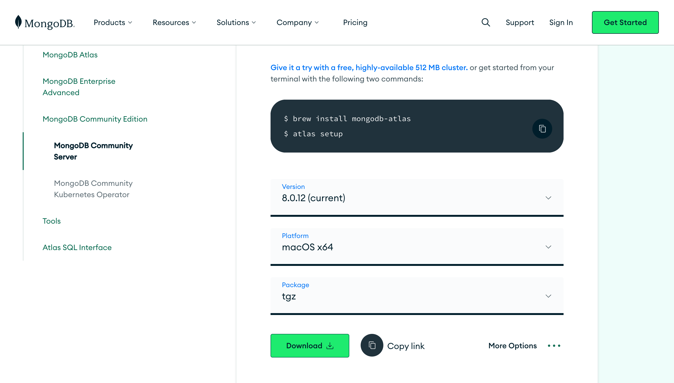

**Step 2 : Configure MongoDB on terminal**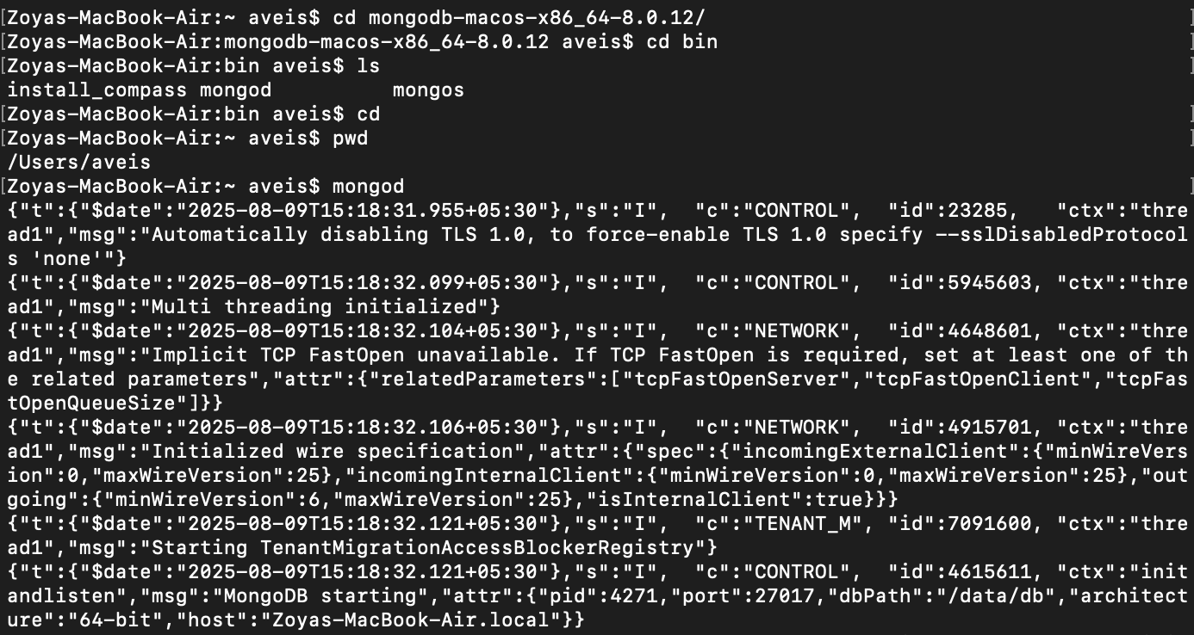

**Creating data directory.**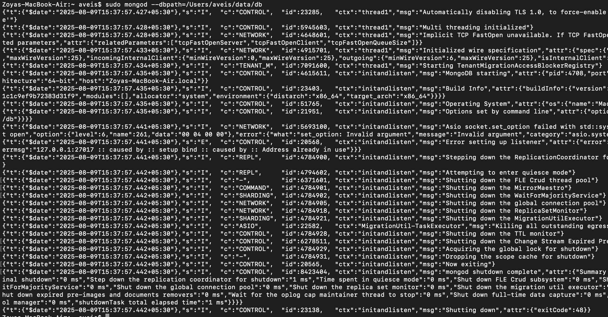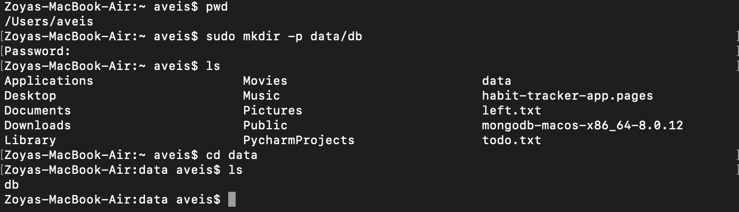

**Zoyas-MacBook-Air:~ aveis$ sudo mongod —dbpath=/Users/aveis/data/db**

**Zoyas-MacBook-Air:~ aveis$ mongosh**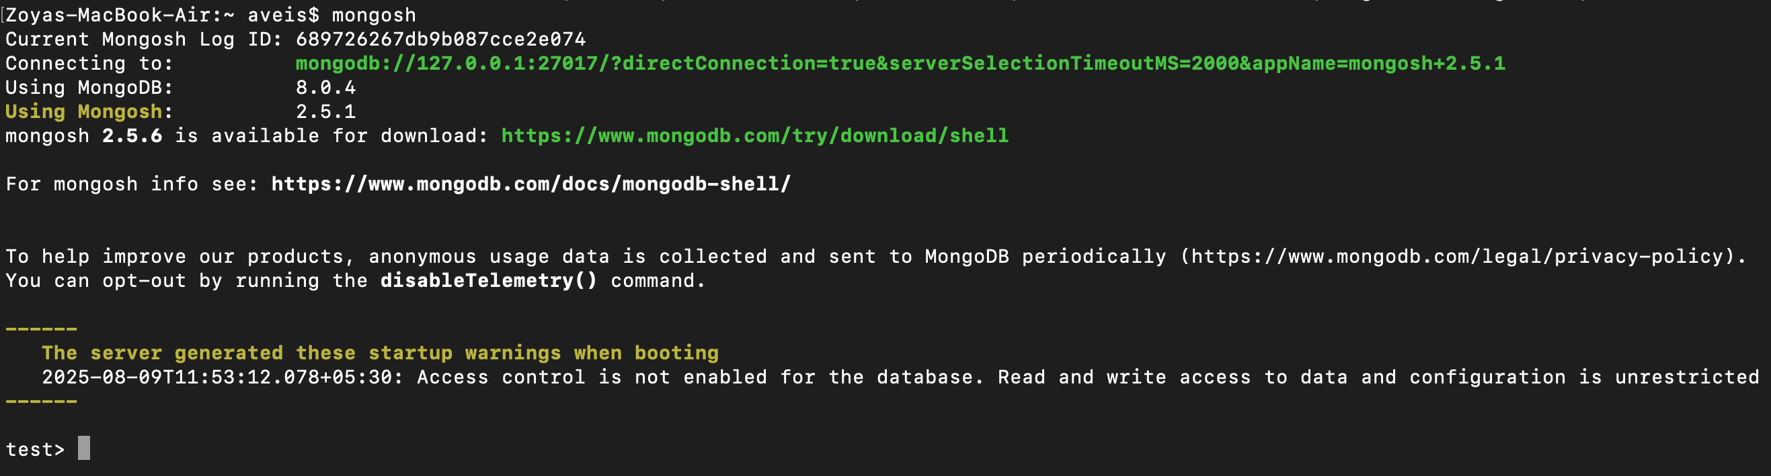

**db.help()**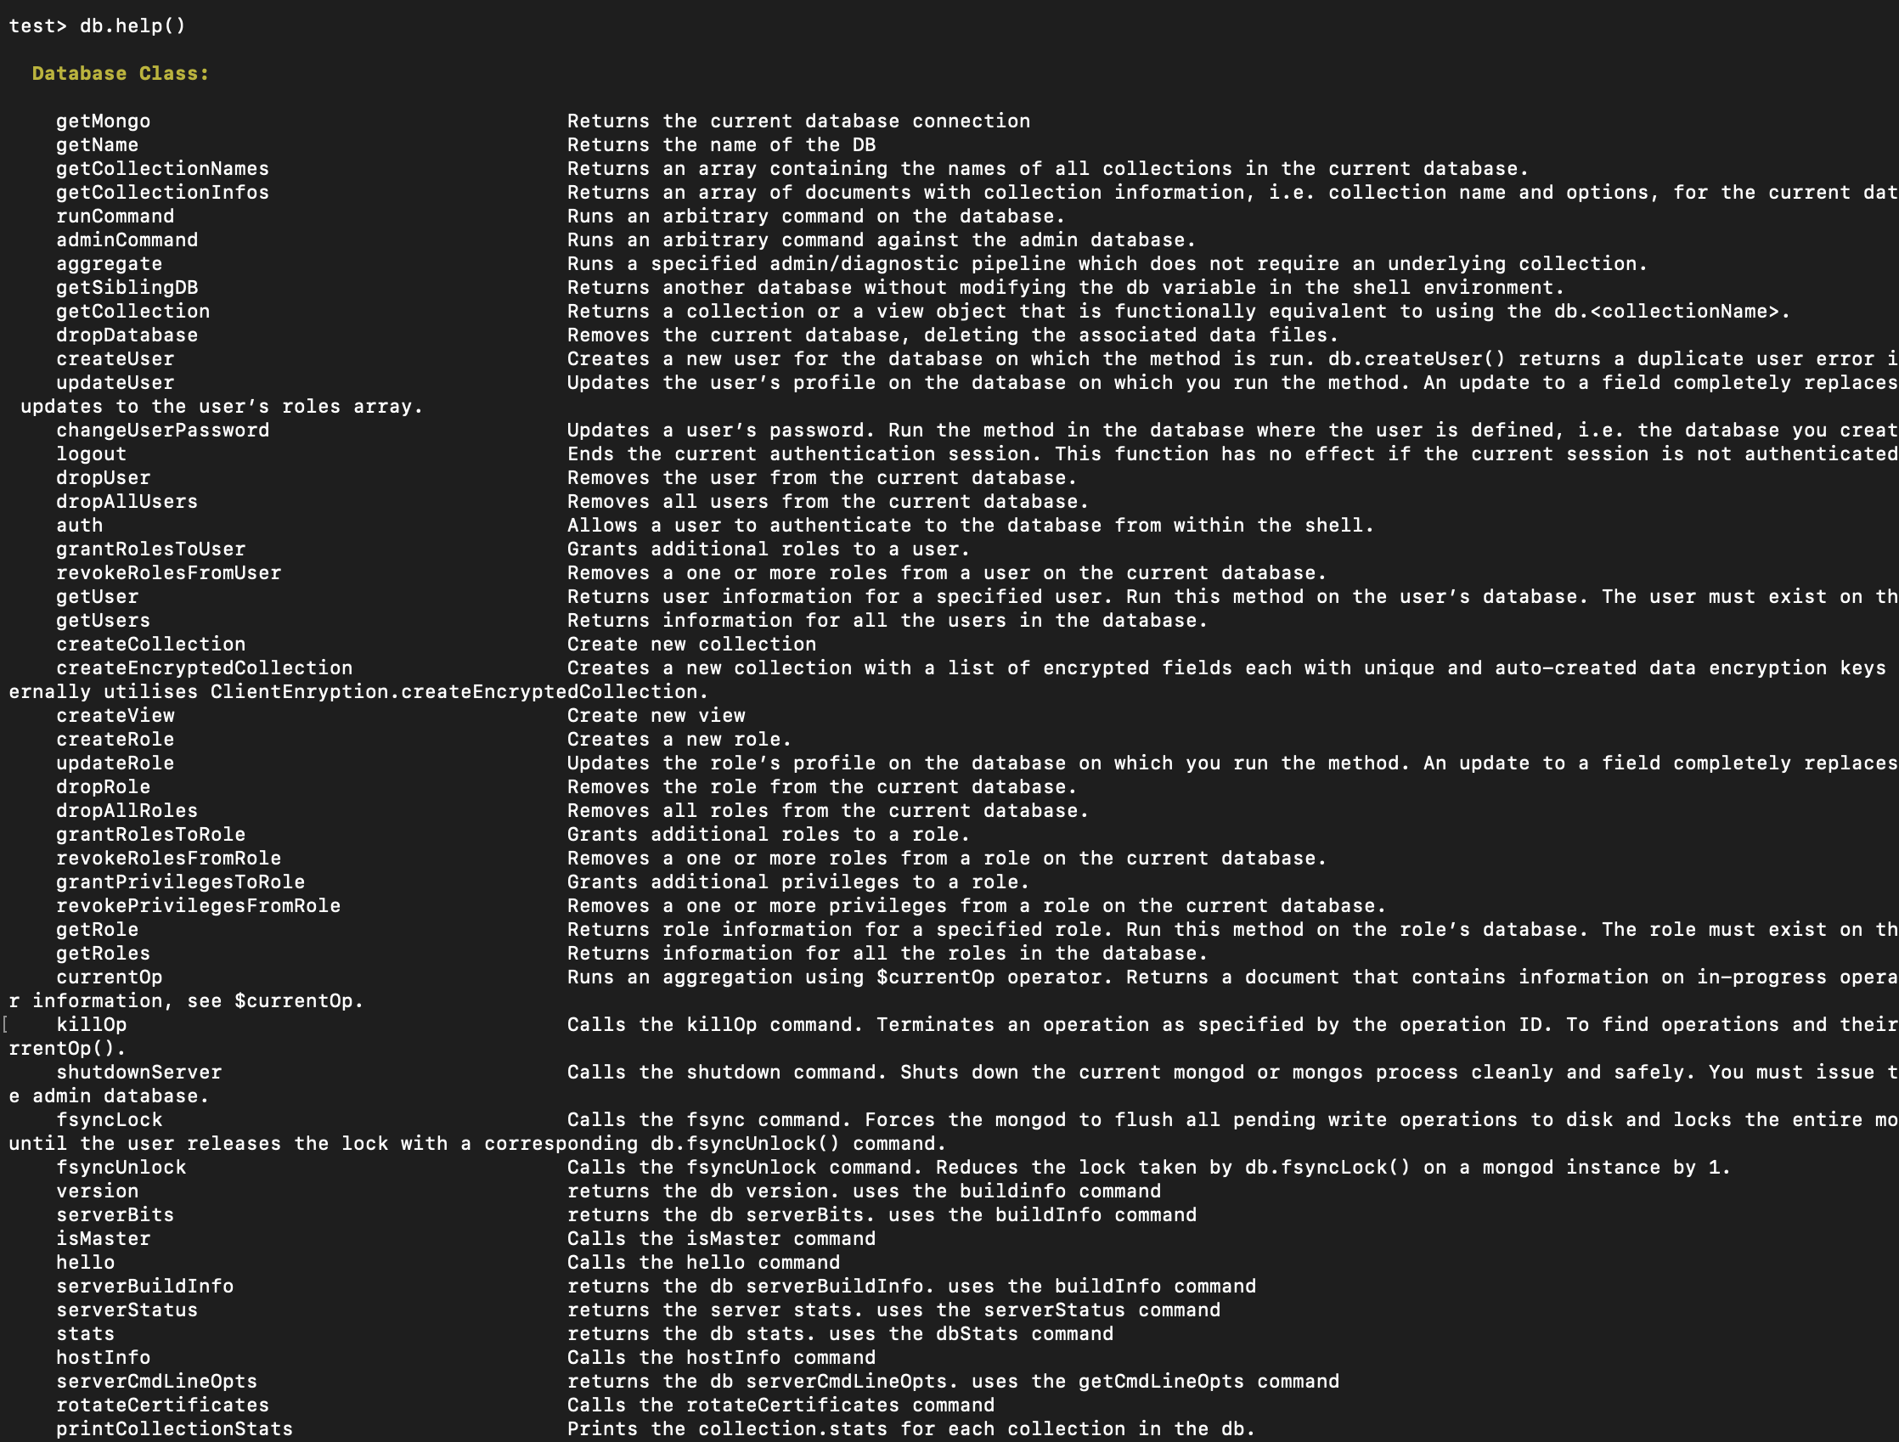

**db.stats()**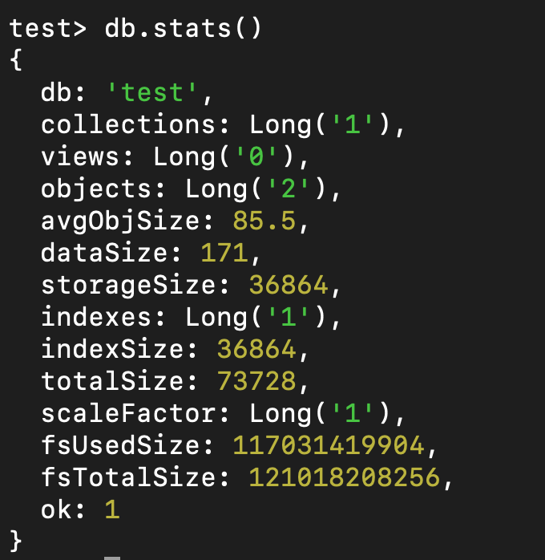

**use DATABASE :**

**db.version()**

**test> use ZOYA**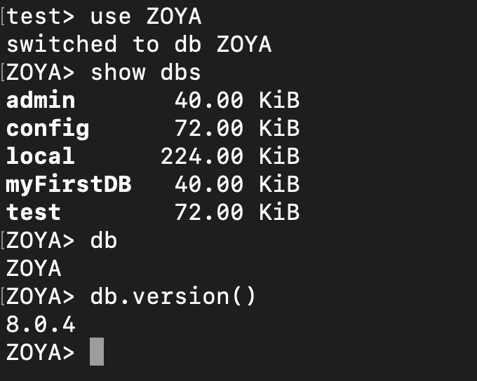

**Creation, Display and Deletion of collection:**

Create : ZOYA> db.createCollection(“hobbies")

Display : ZOYA> show collections

Delete : db.collection_name.drop()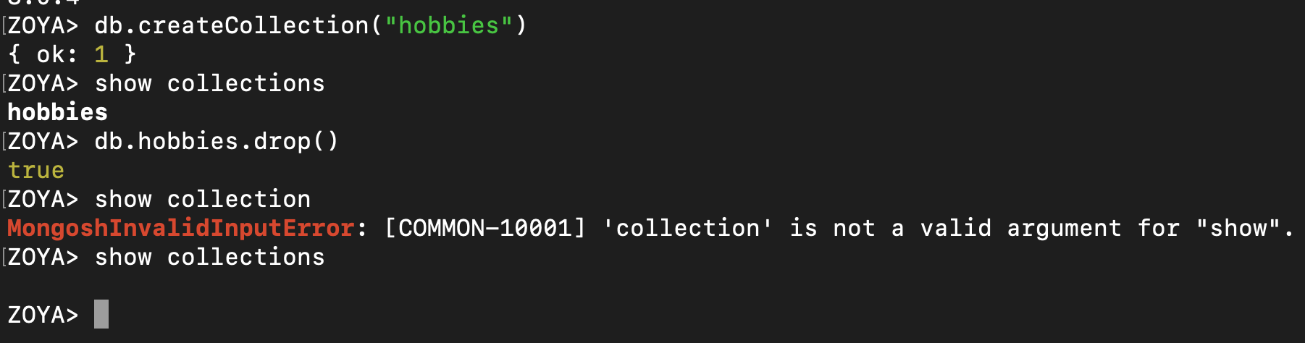

**Inserting into collection**

**db.hobbies.insert()**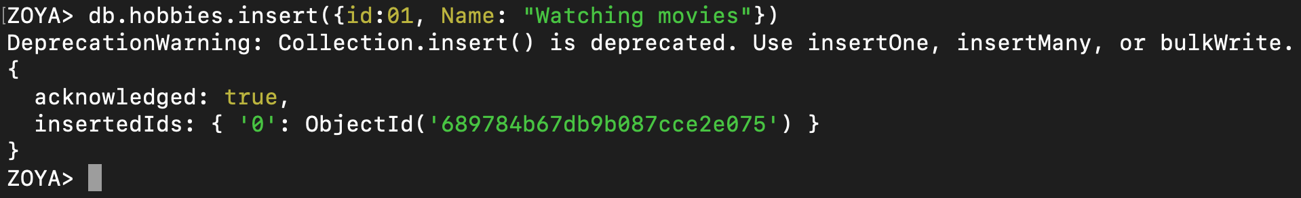

**Display the content of collection**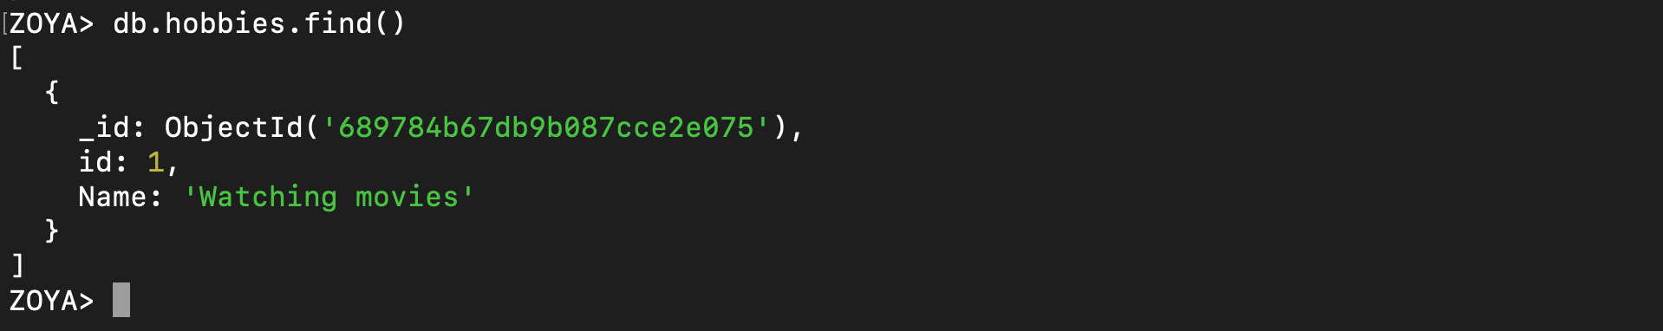

**Display the content of collection in pretty way**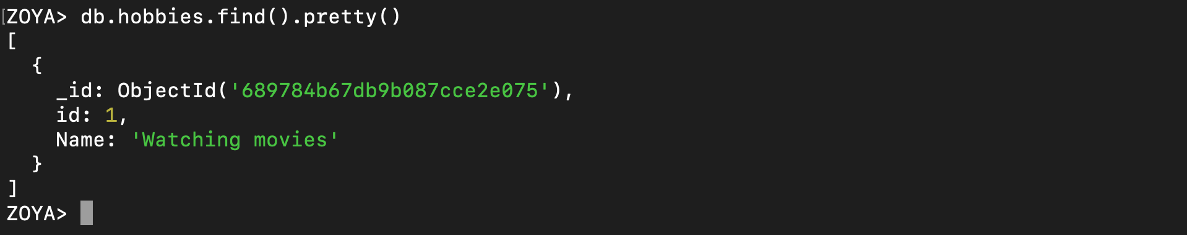

**Insert multiple key value records**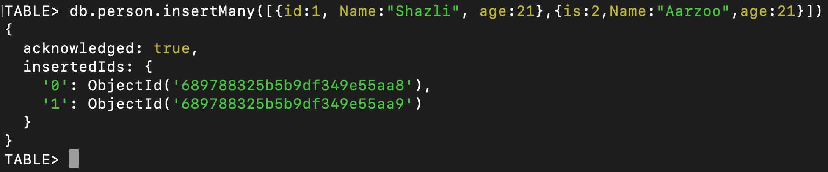

**Update a document in collection**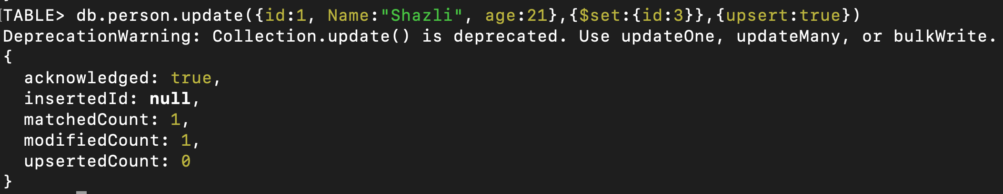

**Finding a specific document**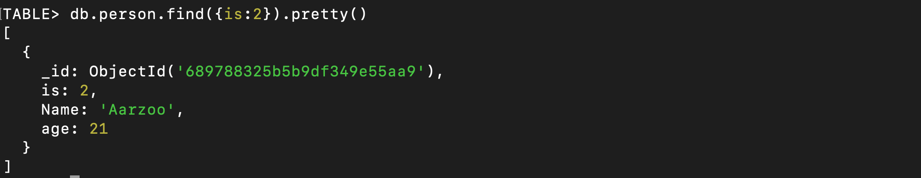

**Adding a new field using update**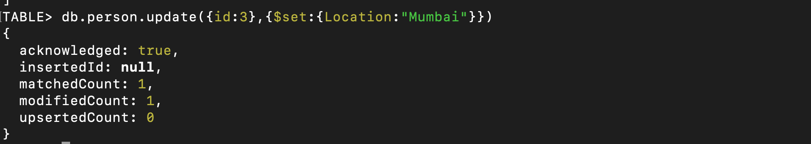

**Delete a field using update**

**Finding do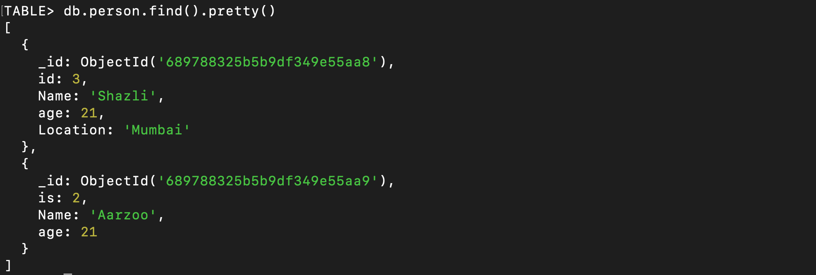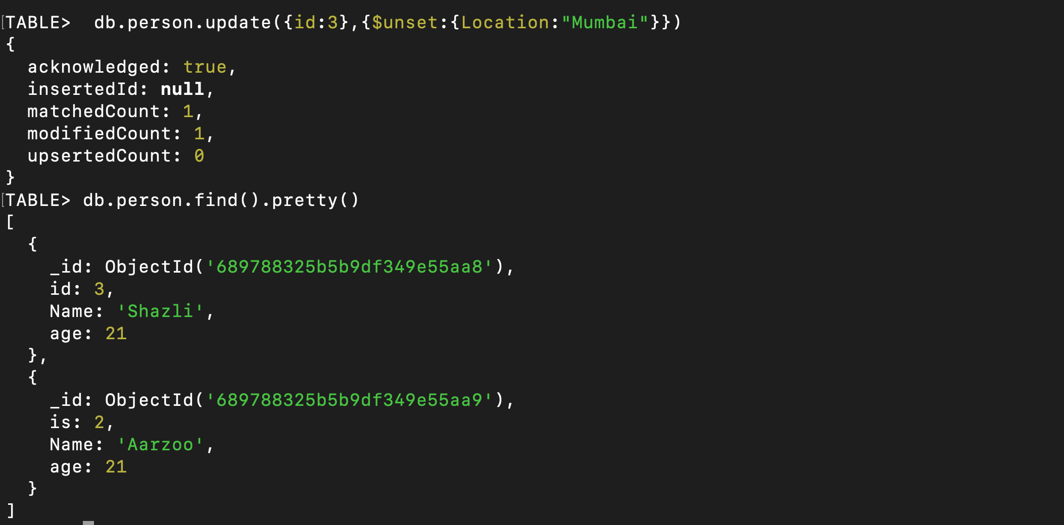cument using string match**

