Experiment No. 9: Demonstrate Web Data Scraping Using Power BI
Khan Inshiraah
Department of Computer Engineering
M.H Saboo Siddik College of
Engineering
Mumbai, India
inshiraah.232263.co@mhssce.ac.in

INTRODUCTION
In the modern data-driven environment, organizations increasingly rely on real-time and publicly available web data to support strategic decision-making. Web data scraping refers to the process of extracting structured information from websites for analysis, reporting, and visualization. With the exponential growth of online content such as financial statistics, population data, product prices, news articles, and social trends, web scraping has become a critical technique in business intelligence and analytics.
Power BI, a powerful business analytics tool developed by Microsoft, provides a built-in web connector feature that enables users to directly extract tabular data from HTML web pages without requiring advanced programming skills. Through the “Get Data → Web” functionality, users can connect to publicly available websites and retrieve structured datasets such as tables containing statistical, economic, or demographic information.
In this practical experiment, web data scraping was performed using Power BI Desktop by extracting structured population data from a publicly accessible online source. The extracted data was processed and refined using Power Query Editor, which serves as a data transformation engine within Power BI. Data cleaning operations such as removing unwanted columns, eliminating blank rows, renaming attributes, correcting data types, and converting percentage values were carried out to ensure analytical accuracy and consistency.
Following transformation, interactive visualizations were developed including bar charts, pie charts, treemaps, and summary cards. These visual representations allow users to interpret trends, compare distributions, and derive insights effectively. Additionally, Power BI supports manual and scheduled data refresh capabilities, enabling real-time analytics and automated updates.
This practical demonstrates the integration of web data acquisition, transformation, and visualization within a single analytics environment. It highlights the importance of web scraping in business intelligence, enabling organizations to convert unstructured online information into structured, decision-ready insights.

Steps:

Step 1: Open Power BI and Load Web Data
- Open Power BI Desktop.
- Click on Home > Get Data > Web.
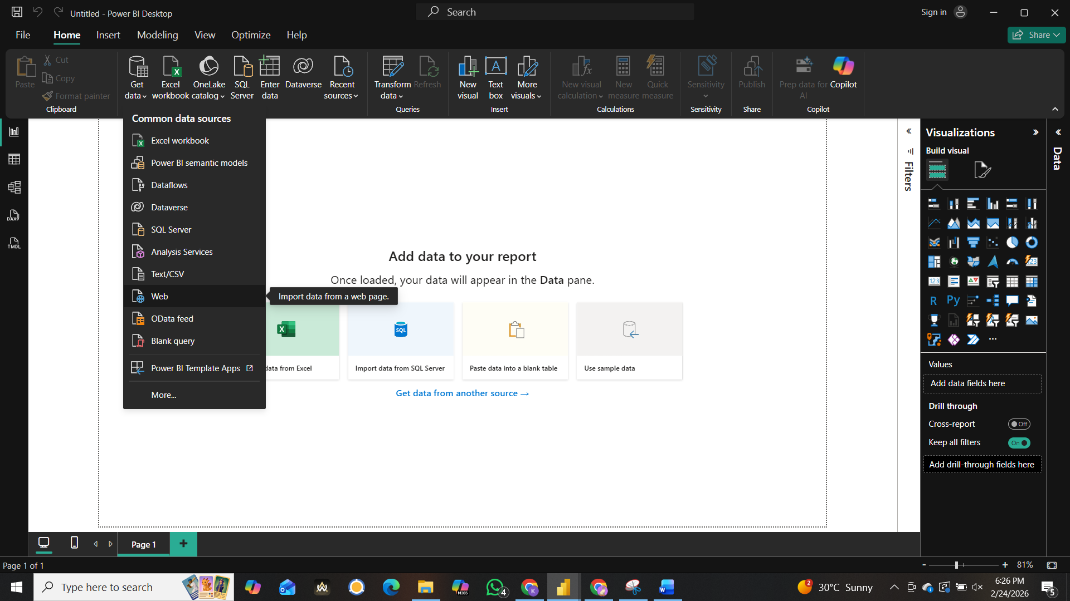

- Enter the URL of the webpage containing the data.
- Click OK to connect.
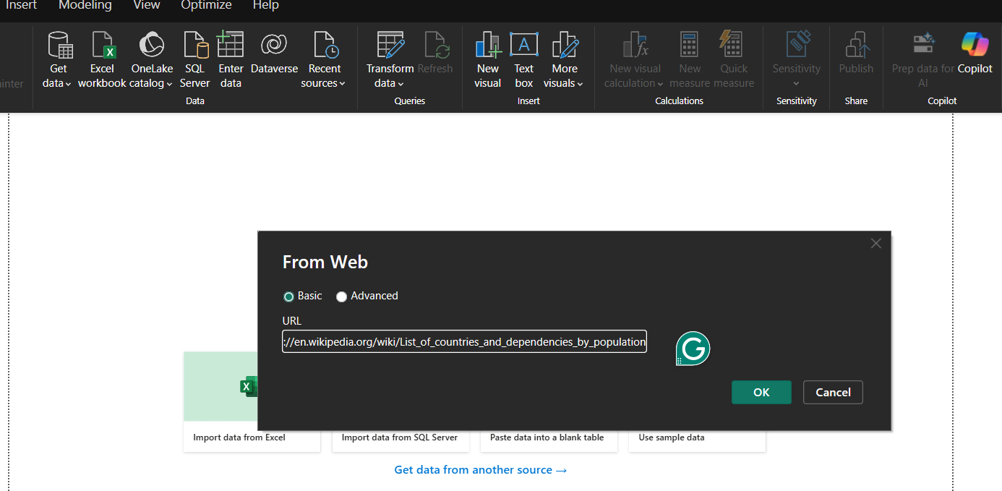

Step 2: Extract and Transform Data Using Power Query
- Select the table or list to extract data from.
- Use Power Query Editor to clean and filter the data.
- Rename columns, remove duplicates, and transform the dataset.
- Click Close & Apply to save changes.
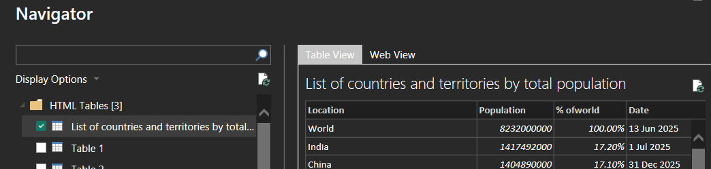

Step 3: Create Visualizations
- Select a chart type (e.g., bar chart, pie chart, line graph).
- Drag and drop data fields into visualization panels.
- Customize charts with filters, colors, and labels.
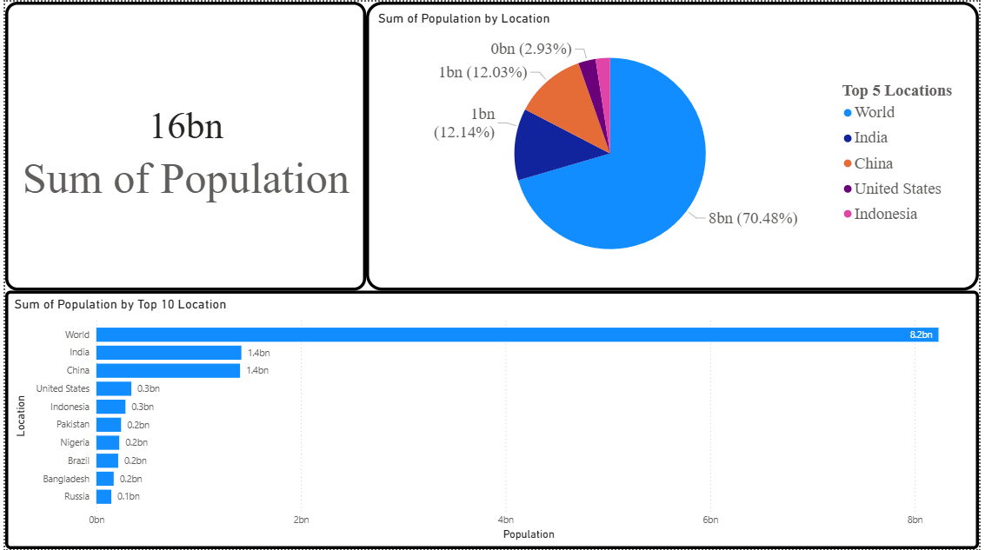

Step 4: Automate Data Refresh
- Go to Home > Refresh to update live data.
- Schedule automatic refresh to get real-time insights.
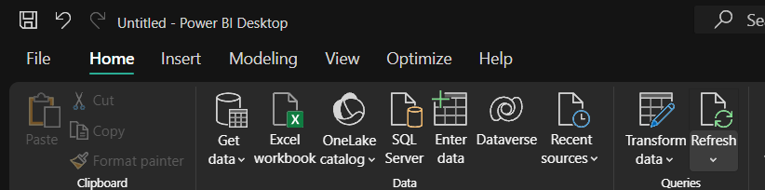

CONCLUSION
The practical successfully demonstrated the process of web data scraping and visualization using Power BI Desktop. By utilizing the built-in web connector feature, structured data was efficiently extracted from an online source and transformed into an analyzable dataset. The Power Query Editor played a critical role in ensuring data quality through cleaning and preprocessing operations such as removing redundant fields, handling missing values, correcting formatting inconsistencies, and converting textual numerical data into quantitative formats.
The creation of multiple visualizations, including bar charts, pie charts, treemaps, and summary cards, enabled comprehensive data interpretation. These visual tools facilitated comparative analysis, distribution evaluation, and identification of key trends within the dataset. Such graphical representations enhance clarity and support informed decision-making processes.
Furthermore, the ability to refresh and automate data updates ensures that analytics remain current and relevant. However, certain challenges such as website structural changes, dynamic content rendering, authentication restrictions, and data accuracy limitations must be considered when implementing web scraping solutions.
Overall, this experiment highlights the practical significance of web data scraping in modern business analytics. By integrating data extraction, transformation, and visualization within Power BI, organizations can efficiently transform publicly available web information into actionable insights, thereby strengthening strategic planning and competitive advantage.

