**PROJECT REPORT**

**ON**

**MODERN PORTFOLIO THEORY**

**PRESENTED BY**

**GROUP 8**

UNDER THE GUIDANCE OF

**DR. SHREYA BISWAS**

**COURSE CODE: FIN F313**

**COURSE TITLE: SECURITY ANALYSIS AND PORTFOLIO MANAGEMENT**



**BIRLA INSTITUTE OF TECHNOLOGY AND SCIENCE, PILANI**

**HYDERABAD CAMPUS**

GROUP 8

|  |  |  |
| --- | --- | --- |
| S.No | Name | ID |
| 1. | AKASH JAIN | 2021AAPS2049H |
| 2. | SHUBHAM GUPTA | 2021A8PS2953H |
| 3. | SHAILENDRA ALLAM | 2021A4PS2943H |
| 4. | ZOYAN KHOJA | 2021A4PS1979H |
| 5. | ASHISH PILLAI | 2021A2PS3219H |
| 6. | TASHVI ARGEKAR | 2021A4PS3083H |
| 7. | SAI AAKASH VOORA | 2021AAPS1532H |
| 8. | SAKETH EUNNY | 2021A4PS3106H |

9. **VANDANA KUMARI ( 2021A5PS1114H)** is withdrawing from the course and hence has not contributed in the project work.

TABLE OF CONTENTS:

|  |  |  |
| --- | --- | --- |
| S.No | Title | Page. No |
| 1. | Securities In Assessment | 4 |
| 2. | Modern Portfolio Theory | 5 |
| 3. | Domestic Portfolio Analysis | 6-9 |
| 4. | CAPM Analysis | 9-10 |
| 5. | International Portfolio Analysis | 11-15 |
| 6. | Interpretation of Results | 15-18 |
| 7. | References | 18 |

**SECURITIES IN ASSESSMENT**

1.**HAVELLS** - Havells is a well-known Indian electrical equipment manufacturer headquartered in Noida, India. Havells was founded in 1958 and is noted for producing a wide range of items such as electrical cables, wires, lighting, fans, and household appliances. The company is well-known in both domestic and international markets for its innovative and high-quality electrical solutions.

  2. **HDFC** - HDFC, or Housing Development Finance Corporation Limited, is a major Indian financial services firm. HDFC, which was founded in 1977, is well-known for its competence in housing finance, providing house loans and other associated services. It has expanded into a variety of financial areas, including banking, insurance, and asset management, and is now one of India's largest and most reputable financial companies..

3. **BSOFT** - Birlasoft is a global Indian IT services firm based in Noida, India. It is a subsidiary of the CK Birla Group that provides software and information technology solutions to a variety of industries, including banking, healthcare, and manufacturing. Birlasoft is well-known for its digital transformation and IT consulting services, which assist businesses in using technology for greater efficiency and competitiveness.

4**.IOC** - Indian Oil Corporation Limited (IOCL), based in New Delhi, is one of India's main state-owned oil and gas enterprises. IOCL, founded in 1964, is an important player in the refining, marketing, and distribution of petroleum products in India. It owns and manages a large network of refineries, pipelines, and fuel retail shops, making it a major participant in the country's energy sector

5.**CIPLA** - Cipla is a well-known Indian pharmaceutical firm based in Mumbai. Cipla, which was founded in 1935, is well-known for its contributions to the healthcare business, particularly in the creation and manufacture of a wide range of pharmaceutical goods, including generic pharmaceuticals and novel therapies. The organization is well-known for its global reach as well as its dedication to making healthcare more accessible and affordable.

6. **MARUTI** - Maruti Suzuki, headquartered in New Delhi, is a major Indian vehicle manufacturer. It is a division of Suzuki Motor Corporation, a Japanese carmaker, and is well-known in India for making a variety of well-liked and reasonably priced vehicles. Maruti Suzuki is well-known for its dependability and fuel efficiency and has a substantial market share in the Indian auto sector.

7. **SSE Composite** - The Shanghai Composite Index, or SSE Composite Index, is a prominent stock market benchmark in China. It monitors the performance of all companies listed on the Shanghai Stock Exchange, including A-shares and B-shares. The index is closely watched as an indicator of the Chinese stock market's general health and movements.

8. **SILVER METAL**

# **MODERN PORTFOLIO THEORY**

**Expected return of risky portfolio:** 𝐸(𝑟𝑝) = w1𝐸(𝑟1) + 𝑤2.𝐸(𝑟2)

**Risk of risky portfolio:** 𝜎𝑃 = (𝑤1 2𝜎1 2 + 𝑤2 22𝜎2 2 + 2𝑤1𝑤2𝜌12𝜎1𝜎2) 1/2

𝑤ℎ𝑒𝑟𝑒 **𝑤1+ 𝑤2= 1**

* 𝜎1 2: Covariance of Securities 1 and 2
* 𝜎1: Risk of Security 1
* 𝜎2: Risk of Security 2
* 𝑤1- weight of Security 1
* 𝑤1 −weight of Security 2
* 𝐸(𝑟1) - expected return of Security 1
* 𝐸(𝑟2) - expected return of Security 2

**Investor wishes to maximize utility:** 𝑀𝑎𝑥𝑖𝑚𝑖𝑧𝑒 𝑈 = 𝐸(𝑟𝑐) – (½)𝐴𝜎𝑐 2

y∗ = 𝐸(𝑟𝑝) −𝑟𝑓 𝐴𝜎𝑝 2 where

* 𝐸(𝑟𝑐)- Expected returns of complete portfolio
* 𝜎𝑐 – Risk of complete portfolio
* y∗ - Optimal Capital Allocation to Risky Part
* 𝑟𝑓 – Risk Free rate
* A – Index of risk-aversion for investor

Investor tangency between Indifference Curve (IC) and the Capital Allocation Line (CAL) is the optimal capital allocation.

**DOMESTIC PORTFOLIO ANALYSIS**

1.. MARKOVITZ INPUT LIST



2. VARIANCE- COVARIANCE MATRIX

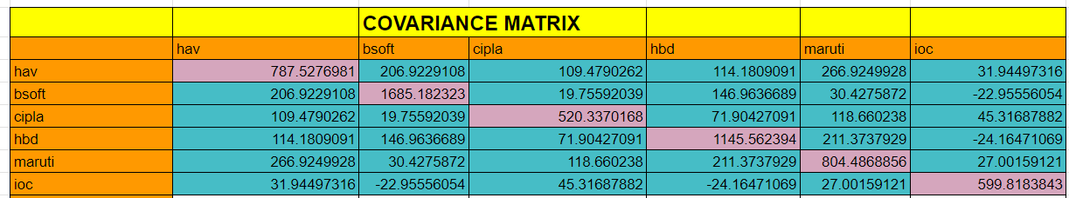

**MINIMUM VARIANCE PORTFOLIO**

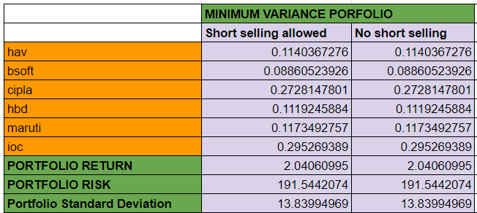

### **EFFICIENT PORTFOLIO FRONTIER**

The efficient portfolio frontier is a collection of portfolios that have the highest rate of return for each level of risk, or the lowest risk for each level of return.

#### **Short Selling is Allowed**

The efficient portfolio is the upward sloping part of the investment opportunity set originating from the minimum variance portfolio. It represents a set of optimal portfolios that offer the highest expected return for a given level of risk or the lowest risk for a given level of expected return.

Efficient frontier when short selling is allowed :

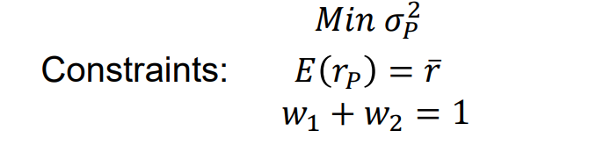

Using the solver function of Excel, we have found the maximum return for a given level of risk. We have plotted our findings as can be seen below:

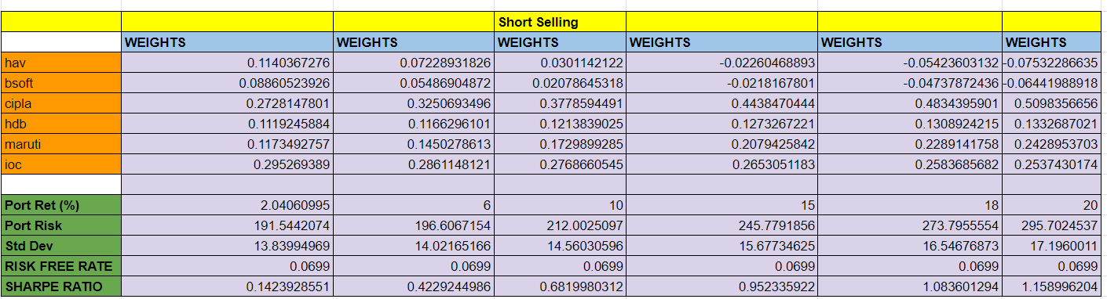

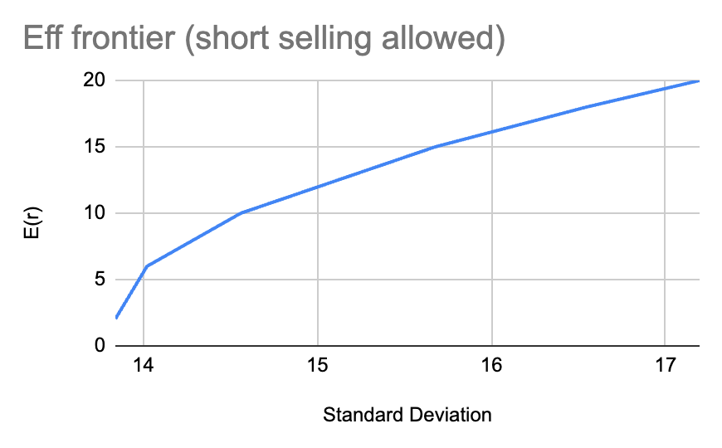

The efficient frontier is the upward-sloping part of the investment opportunity set originating from the minimum variance portfolio. When short selling is not allowed we have to make sure that individual weights are never negative .

#### **Short Selling is not allowed**

With short selling constraints, we must ensure that the individual weights are never negative and find the maximum return for a given level of risk up until close to a point beyond which returns can not be increased without short selling.

Efficient frontier when short selling is not allowed :

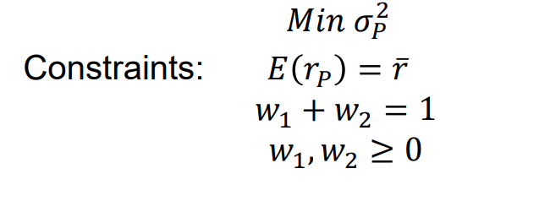

Using the solver function of Excel, we have found the maximum return for a given level of risk. We have plotted our findings as can be seen below:

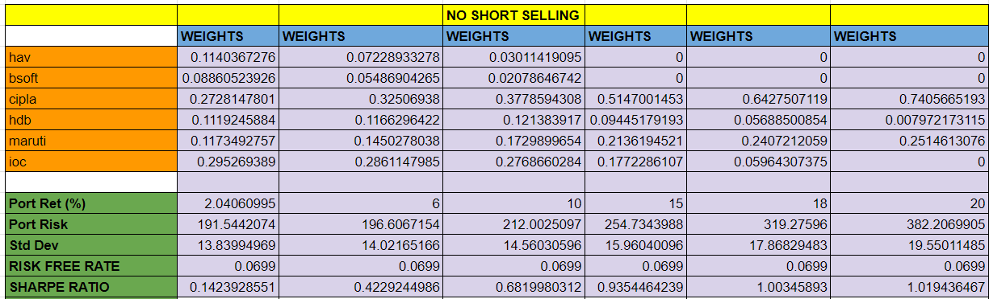

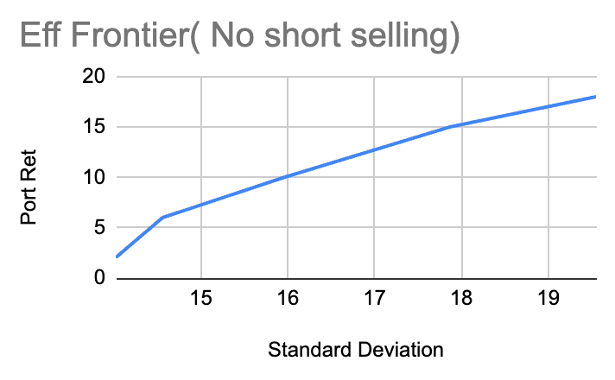

### **TANGENCY PORTFOLIO**

The tangency portfolio is the optimal portfolio of risky assets, known as the market portfolio. It represents the portfolio that offers the highest expected return for a given level of risk or the lowest risk for a given level of expected return when combined with a risk-free asset.

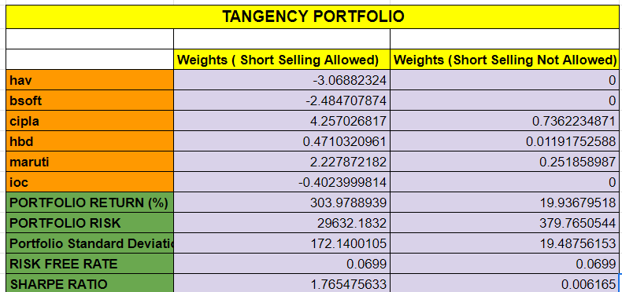

**Comparison of Weights with CAPM Weights:**

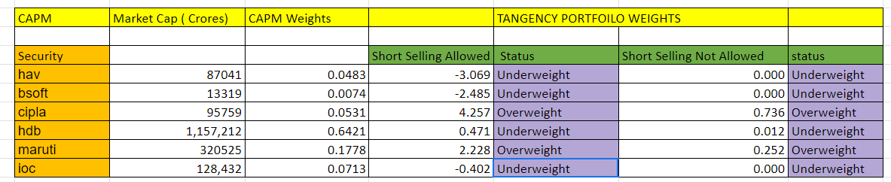

**Havells**

 CAPM Weight: 0.0483

Tangency Portfolio Weight (Short Selling Allowed): -3.069

Tangency Portfolio Weight (Short Selling Not Allowed): 0

Conclusion: The portfolio is underweight on Havells in the case of short selling allowed, suggesting a lower allocation.

It has zero weight in the case of short selling not allowed, indicating that it is not included in the portfolio.

**Birla Soft**

CAPM Weight: 0.0074

Tangency Portfolio Weight (Short Selling Allowed): -2.485 Tangency Portfolio Weight (Short Selling Not Allowed): 0

Conclusion: The portfolio is underweight on Havells in the case of short selling allowed, suggesting a lower allocation.

It has zero weight in the case of short selling not allowed, indicating that it is not included in the portfolio.

**CIPLA**

CAPM Weight: 0.0531

Tangency Portfolio Weight (Short Selling Allowed): 4.257

Tangency Portfolio Weight (Short Selling Not Allowed): 0.736

Conclusion: The active portfolio is overweight on CIPLA in both cases, stating a higher allocation than the CAPM weight.

**HDFC BANK**

CAPM Weight: 0.6421

Tangency Portfolio Weight (Short Selling Allowed): 0.471 Tangency Portfolio Weight (Short Selling Not Allowed): 0.012

Conclusion: The active portfolio is underweight on HDFCBANK in both cases, stating a lower allocation than the CAPM weight.

**MARUTI**

CAPM Weight: 0.1778

Tangency Portfolio Weight (Short Selling Allowed): 2.228

 Tangency Portfolio Weight (Short Selling Not Allowed): 0.252

Conclusion: The active portfolio is overweight on MARUTI in both cases, stating a higher allocation than the CAPM weight.

**IOCL**

CAPM Weight: 0.0713

Tangency Portfolio Weight (Short Selling Allowed): -0.402

 Tangency Portfolio Weight (Short Selling Not Allowed): 0

Conclusion: The portfolio is underweight on IOCL in the case of short selling allowed, suggesting a lower allocation.

It has zero weight in the case of short selling not allowed, indicating that it is not included in the portfolio.

## **INTERNATIONAL PORTFOLIO ANALYSIS**

### INPUT LIST



### VARIANCE COVARIANCE MATRIX

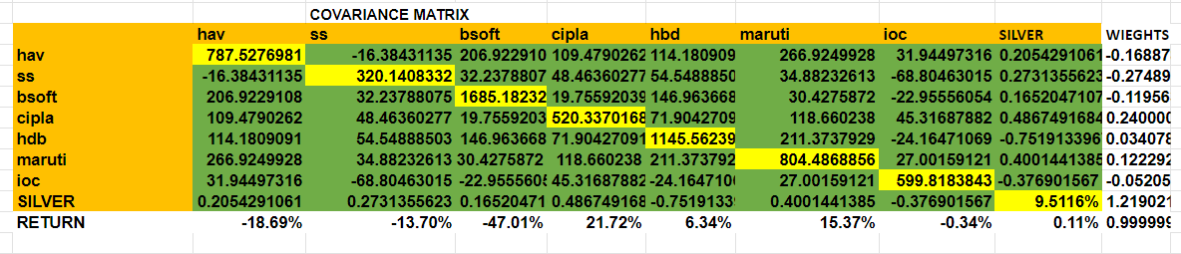

### MINIMUM VARIANCE PORTFOLIO

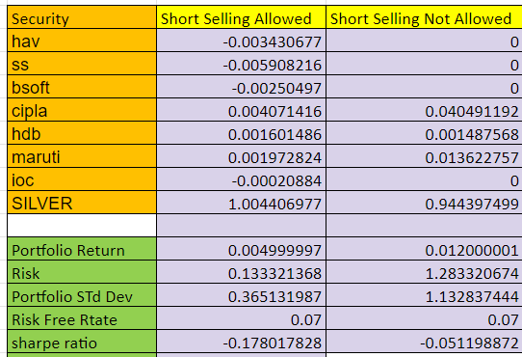

### **EFFICIENT PORTFOLIO FRONTIER**

The efficient portfolio frontier is a collection of portfolios that have the highest rate of return for each level of risk, or the lowest risk for each level of return.

#### **Short Selling is Allowed**

The efficient portfolio is the upward sloping part of the investment opportunity set originating from the minimum variance portfolio. It represents a set of optimal portfolios that offer the highest expected return for a given level of risk or the lowest risk for a given level of expected return.

Efficient frontier when short selling is allowed :



Using the solver function of Excel, we have found the maximum return for a given level of risk. We have plotted our findings as can be seen below:

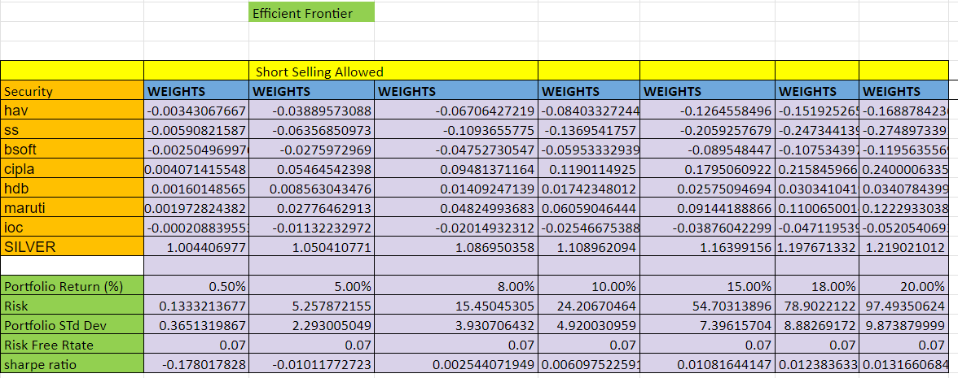

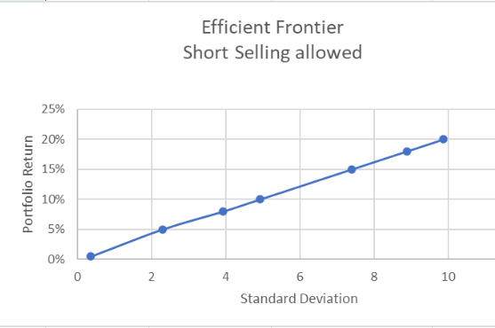

#### **Short Selling is not allowed**

With short selling constraints, we must ensure that the individual weights are never negative and find the maximum return for a given level of risk up until close to a point beyond which returns can not be increased without short selling.

Efficient frontier when short selling is not allowed :



Using the solver function of Excel, we have found the maximum return for a given level of risk. We have plotted our findings as can be seen below:

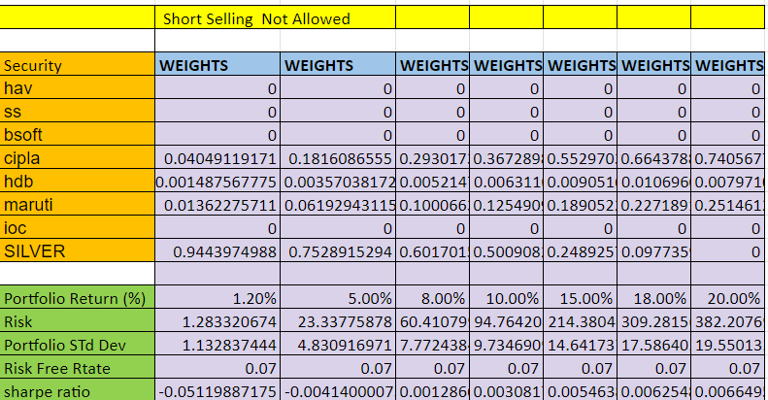

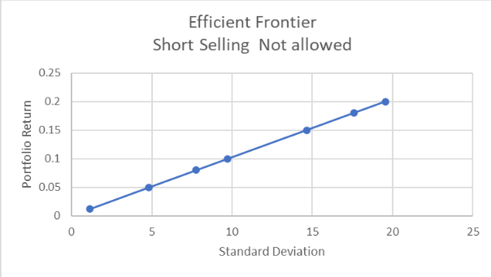

### **TANGENCY PORTFOLIO**

The tangency portfolio is the optimal portfolio of risky assets, known as the market portfolio. It represents the portfolio that offers the highest expected return for a given level of risk or the lowest risk for a given level of expected return when combined with a risk-free asset.

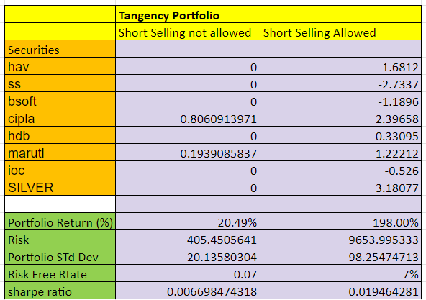

**COMPARISON OF DOMESTIC PORTFOLIO WITH INDEX:**

Portfolio A (short-selling not allowed):

Return –– 19.93679518

Risk — 19.4875615

Sharpe ratio —  0.635172

Portfolio B (short-selling allowed):

Return –– 303.9788939

Risk — 172.1400105

Sharpe ratio — 1.765475633

Index

Return — 2.715244027

Risk — 17.23408282

Sharpe ratio — -0.2483

**Comparision:**

Portfolio A outperformed index in returns but have higher risk and have a higher Sharpe ratio.

Portfolio B outperformed the index in returns but has a higher risk and a higher Sharpe ratio.

**Key points** — the Sharpe ratio of the index is negative, which implies that the return from the index is less than a risk-free asset and has higher risk, so people should invest in risk-free assets.

**Conclusion:**

If an investor wants to invest in any of these, he/she should choose a portfolio according to their A(risk tolerance), expected return, and risk to maximize their utility.

**Example–**

People willing to take more risk for higher returns should choose B .

**COMPARISON OF DOMESTIC PORTFOLIO WITH INTERNATIONAL PORTFOLIO**

**1) SHORT-SELLING NOT ALLOWED:**

A)  Domestic portfolio:

Return –– 19.93679518

Risk — 19.4875615

Sharpe ratio — 0.635172

B) International portfolio

Return –– 20.49

Risk — 20.135

Sharpe ratio — 0.66

**Comparision:**

Portfolio B outperformed A in returns but have higher risk and have a higher Sharpe ratio the Sharpe ratio is higher because of elimination of market risk( macroeconomic risk) because of addition of international security.

**Conclusion:**

If an investor wants to invest in any of these, he/she should choose a portfolio according to their A(risk tolerance), expected return, and risk to maximize their utility.

**2) SHORT-SELLING ALLOWED:**

A)  Domestic portfolio:

Return –– 303.9788939

Risk — 172.1400105

Sharpe ratio — 1.765475633

B) International portfolio

Return –– 198

Risk — 98.25

Sharpe ratio — 1.94

**Comparision:**

Portfolio A outperformed B in returns but have higher risk and have a higher Sharpe ratio the Sharpe ratio is higher because of elimination of market risk( macroeconomic risk) because of addition of international security.

**Conclusion:**

If an investor wants to invest in any of these, he/she should choose a portfolio according to their A(risk tolerance), expected return, and risk to maximize their utility.

**COMPARISON OF THE INDEX WITH INTERNATIONAL PORTFOLIO**

Portfolio A (short-selling not allowed):

Return –– 20.49

Risk — 20.135

Sharpe ratio — 0.66

Portfolio B (short-selling allowed):

Return –– 198

Risk — 98.25

Sharpe ratio — 1.94

Index

Return — 2.715244027

Risk — 17.23408282

Sharpe ratio — -0.2483

**Comparision:**

Portfolio A outperformed index in returns but have higher risk and have a higher Sharpe ratio.

Portfolio B outperformed the index in returns but has higher risk and a higher Sharpe ratio.

**Conclusion:**

If an investor wants to invest in any of these, he/she should choose a portfolio according to their A(risk tolerance), expected return, and risk to maximize their utility**.**

References:

* 1. https://finance.yahoo.com/
  2. https://[www.moneycontrol.com/](http://www.moneycontrol.com/)
  3. https://[www.nseindia.com/](http://www.nseindia.com/)
  4. https://[www.rbi.org.in/](http://www.rbi.org.in/)