**Faculty of Engineering**

**Course Name: Communication systems**

**Research Report Title: AM modulation**

|  |  |  |  |
| --- | --- | --- | --- |
| الدرجة من 5 | الرقم الجامعي | اسم الطالب | م |
|  | 23220165 | عبد العزيز محمد عبد العزيز | 1 |
|  | 23220106 | رضوى مؤنس محمد | 2 |
|  | 23220131 | سلمى محمد السيد | 3 |
|  | 23220146 | صلاح الدين عطيه سيد | 4 |
|  | 23220215 | محمد احمد صبرى | 5 |
|  | 23220103 | دعاء محمد على | 6 |

* **AM modulation (DSB-WC).**

We use this method of modulation to avoid regenerating the carrier signal at the receiver because it’s never going to be in frequency and phase synchronized with carrier at transmitter.

This can be done by sending the carrier signal with the modulated signal.

So, the output signal of the transmitter should be:

$$φ_{Am}=A_{c} \cos{ω_{c}t}+m\left(t\right)\cos{ω_{c}t}$$

Where:

* $ω_{c }$ is the angular frequency of the carrier.
* $A_{c}$ is the magnitude of the carrier.
* $m(t)$ is the message signal.

This project has three stages:

1. Modulation.
2. Demodulation.
3. White noise generation
4. **Modulation.**

We use switching modulator as shown in the figure:

The input is $A_{c}\cos{ω_{c}t} +m(t)$ with $A_{c}$ > m(t) so that the switching action of the diode is controlled by $A_{c}\cos{ω_{c}t}$.

The diode opens and shorts periodically with $\cos{ω_{c}t}$, in effect multiplying the input signal by $ω(t)$.

the bandpass filter is tuned to $ω_{c}$ suppresses all the other terms and producing the desired AM signal at the output.

$$V_{bb^{'}}=\left(A_{c}\cos{ω_{c}t} +m\left(t\right)\right)*ω(t)$$

$$= \left(A_{c}\cos{ω_{c}t} +m\left(t\right)\right)*[\frac{1}{2}+2/π(\cos{ω_{c}t}-\frac{1}{3\cos{{3ω}_{c}t}}+…)]$$

$$=\frac{A_{c}}{2}\cos{ω_{c}t}+\frac{2}{π}m\left(t\right)\cos{ω_{c}t}$$

$$+other termes suppressed by the filter$$

* Circuit diagram.

* We use a message signal with frequency 1kHz and amplitude is1v peak
* The frequency of the carrier is 20kHz and the amplitude is 2v peak

That makes the modulation index µ = 0.5 < 1, so the modulated signal will look as shown in the following figure:

And in this case, we can use the envelope detection method in demodulation.

We use an RC bandpass filter which use these equations:

$$f_{c_{LOW} }=\frac{1}{2πR_{3}C_{2}}$$

$$f_{c_{HIGH} }=\frac{1}{2πR_{2}C_{1}}$$

* Components
* Diode
* 50Ω res
* 7.5kΩ res
* 4.5k Ω res
* 100nF cap
* 1nF cap

1. **Demodulation.**

There are several methods we can use to demodulate the AM signal like coherent detection, rectifier detection and envelope detection.

In this project we use envelope detection.

During each positive cycle, the capacitor charges up to the peak voltage of the input signal and then decays slowly until the next positive cycle. The output voltage $V_{o}(t)$, thus, closely follows the envelope of the input.

The capacitor discharge between positive peaks causes a ripple signal of frequency $ω_{c}$, This ripple can be reduced by increasing the time constant RC so that the capacitor discharges very little between the positive peaks. Making RC too large, however, would make it impossible for the

capacitor voltage to follow the envelope.

In an envelope detector, the output of the detector follows the

envelope of the modulated signal. On the positive cycle of the input signal, the diode conducts, and the capacitor C charges up to the peak voltage of the input signal. As the input signal falls below this peak value, the diode is cut off, because the capacitor voltage (which is very nearly the peak voltage) is

greater than the input signal voltage, thus causing the diode to open.

The capacitor now discharges through the resistor R at a slow rate (with a time constant RC). During the next positive cycle, the same thing repeats.

The diode conducts again when the input signal becomes greater than the capacitor voltage. The capacitor again charges to the peak value of this (new) cycle. The capacitor discharges slowly during the cutoff period, thus

changing the capacitor voltage slightly.

The envelope-detector output is $V_{c}\left(t\right)= A_{c}+m(t)$ with a ripple of frequency $ω_{c}$.

The dc term $A_{c}$ can be blocked out by a capacitor or a

simple RC high-pass filter. The ripple may be reduced further by another lowpass RC filter.

* Circuit diagram.

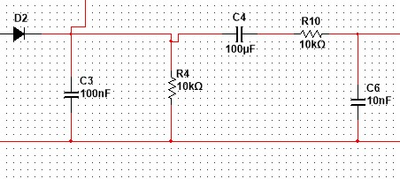

We use a 100µF capacitor as a dc block and a low pass filter to reduce the ripple.

The output signal will be as shown in the following figure:

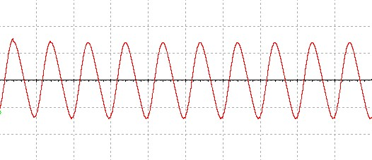

* Components.
* Diodes.
* 100nF cap
* 10nF cap
* 100µF cap
* 10KΩ Res

1. **White noise generation.**

White noise has a wide range of usage. It is widely used in Music Production. It is useful to obtain the impulse response of an electrical circuit. It is a part of Electronics engineering.

it has random frequency thus we can generate random numbers from white noise.

* Circuit diagram.

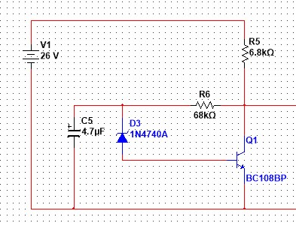

The transistor is getting the bias current through the 10V Zener diode which is placed in reverse bias with the transistor base. The 10V Zener diode is acting as a Noise source. Other two resistors are connected for current control. The 4.7uf Capacitor is working as a filter capacitor. The circuit needs high voltage to provide noise at the output. We provided 26V as the input voltage of the circuit.

The output of the circuit will be as shown in the following figure:

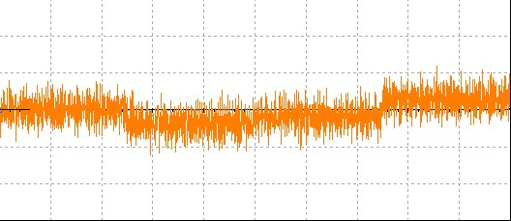

* Components
* 26V power supply
* 4.7µF cap
* 6.8kΩ res
* 68kΩ res
* Zener diode
* BC108BP transistor
* We can choose to add the noise or not in this project by using two switches, one of them when closed connects the modulation circuit to the demodulation circuit

directly.

* The other path is to add the modulated signal to the noise signal using an analog adder, and the resulted signal is connected to the demodulation circuit.

The analog adder:

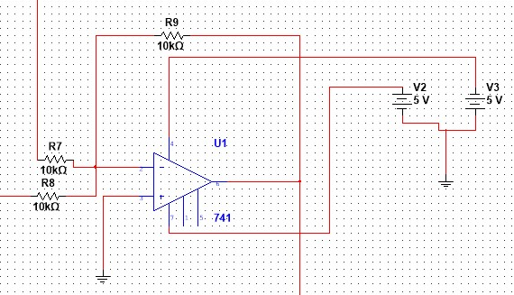

$$V_{o}= -\left[\frac{R_{9}}{R_{7}}* V_{1}+\frac{R_{9}}{R_{8}}* V_{2}\right]$$

$$∵ R_{9}= R_{7}= R_{8 }=10kΩ$$

$$∴ V_{o}= -\left[V_{1}+ V_{2}\right]$$

* **Full circuit diagram.**

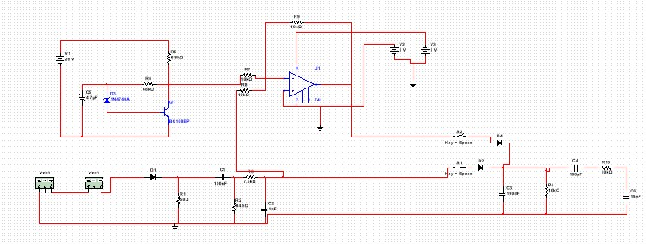

* **PCB design.**

