It has been designed as a panel meter and can be used in DC power supplies or anywhere else it is necessary to have an accurate indication of the voltage present. This IC incorporates in a 40 pin case all the circuitry necessary to convert an analogue signal to digital and can drive a series of four seven segment LED displays directly. The circuits built into the IC are an analogue to digital converter, a comparator, a clock, a decoder and a seven segment LED display driver. The circuit as it is described here can display any DC voltage in the range of 0-1999 Volts.

IC 7107:

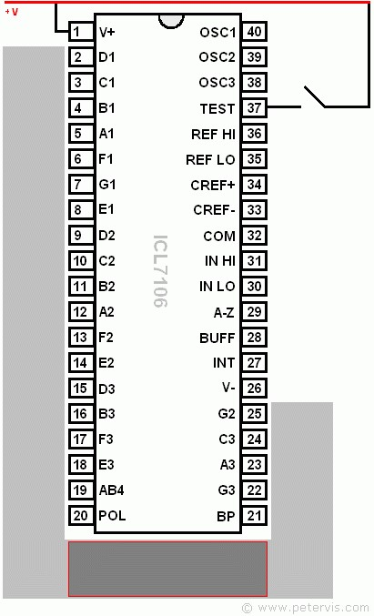

* Small size
* Easy construction • Low cost.
* Simple adjustment.
* Easy to read from a distance.
* Few external components.
* Great accuracy.
* It is not affected by noise.
* No need for a sample and hold circuit.
* It has a built-in clock.
* It has no need for high accuracy external components.

•

Component:

* Res 1MΩ, 470kΩ, 180kΩ, 22kΩ, 12kΩ,

560Ω and pot 20k.

* Caps 220nF, 47nF, (2)100nF, 100PF.
* Four 7 Segment

Circuit:

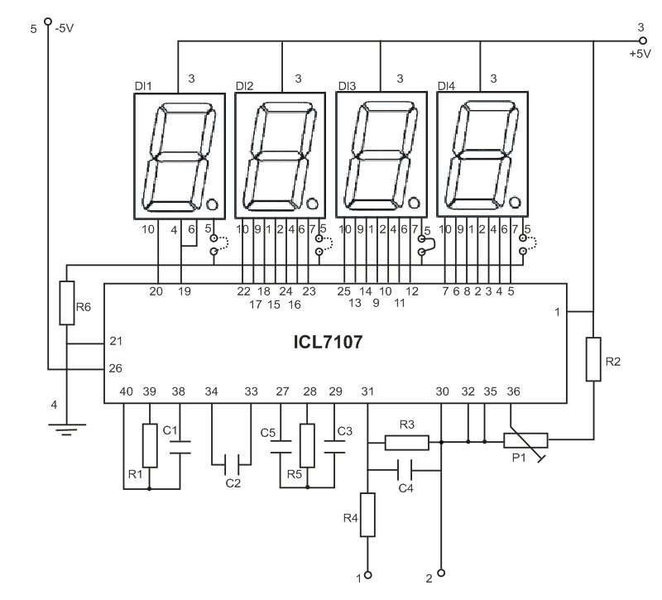

An Analogue to Digital Converter, (ADC from now on) is better known as a dual slope converter or integrating converter. This type of converter is generally preferred over other types as it offers accuracy, simplicity in design and a relative indifference to noise which makes it very reliable. The operation of the circuit is better understood if it is described in two stages. During the first stage and for a given period the input voltage is integrated, and in the output of the integrator at the end of this period, there is a voltage which is directly proportional to the input voltage. At the end of the preset period the integrator is fed with an internal reference voltage and the output of the circuit is gradually reduced until it reaches the level of the zero reference voltage. This second phase is known as the negative slope period and its duration depends on the output of the integrator in the first period. As the duration of the first operation is fixed and the length of the

second is variable it is possible to compare the two and this way the input voltage is in fact compared to the internal reference voltage and the result is coded and is send to the display. The voltage to be measured is applied across points 1 and 2 of the circuit and through the circuit R3, R4 and C4 is finally applied to pins 30 and 31 of the IC. These are the input of the IC as you can see from its diagram. (IN HIGH & IN LOW respectively). The resistor R1 together with C1 are used to set the frequency of the internal oscillator (clock) which is set at about 48 Hz. At this clock rate there are about three different readings per second. The capacitor C2 which is connected between pins 33 and 34 of the IC has been selected to compensate for the error caused by the internal reference voltage and also keeps the display steady. The capacitor C3 and the resistor R5 are together the circuit that does the integration of the input voltage and at the same time prevent any division of the input voltage making the circuit faster and more reliable as the possibility of error is greatly reduced. The capacitor C5 forces the instrument to display zero when there is no voltage at its input. The resistor R2 together with P1 are used to adjust the instrument during set-up so that it displays zero when the input is zero. The resistor R6 controls the current that is allowed to flow through the displays so that there is sufficient brightness without damaging them. The IC as we have already mentioned above is capable to drive four common anode LED displays. The three rightmost displays are connected so that they can display all the numbers from 0 to 9 while the first from the left can only display the number 1 and when the voltage is negative the «-« sign. The whole circuit operates from a symmetrical ρ 5 VDC supply which is applied at pins 1 (+5 V), 21 (0 V) and 26 (-5 V) of the IC.