

Faculty of Engineering

Course Name: electronic measurement
Research Report Title: Voltameter
Names: Abd El-Aziz mohamed
Salah Eldeen Atia Sayed
Abd El-Rahman omar shawky

Department: Communication

- Description:

Digital voltmeter that based on convert analog into digital with (ADC), The voltage to be measured is converted into a digital equivalent by the ADC inside the IC and then this digital equivalent is decoded to the seven-segment format and then displayed.
The ICL7107 is a CMOS device, and it is very sensitive to static electricity. So, avoid touching the IC pins with your bare hands.

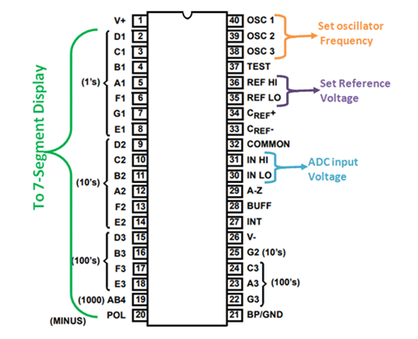

- the ICL7107 is:
- a high performance.
- low power.
- 3.5-digit analog to digital converter.
- simple adjustment and not affected by noise..
- The power dissipation is less than 10mW and the display stability is very high.

- The IC includes:
- internal circuitry for seven segment decoders.
- display drivers.
- reference voltage source as a comparator with the input.
- An oscillator as clock.

- Components:

- IC 7107
- Res 1MΩ, 470kΩ, 180kΩ, 22kΩ, 12kΩ and 560Ω
- pot 20k.
- Caps 220nF, 47nF, (2)100nF, 100PF.
- Four 7 Segment

- The 7-segment display is common anode and there are for display the result and one can display - or 1.

- The voltage to be measured is converted into a digital equivalent by the ADC inside the IC and then this digital equivalent is decoded to the seven-segment format and then displayed.

- For a fixed period, the voltage to be measured is integrated to obtain a ramp at the output of the integrator. Then a known reference voltage of opposite polarity is applied to the input of the integrator and allowed to ramp until the output of integrator becomes zero.

- The time taken for the negative slope to reach zero is measured in terms of the IC’s clock cycle and it will be proportional to the voltage under measurement. In simple words, the input voltage is compared to an internal reference voltage and the result is converted in a digital format.

- At pin 1 Vcc with resistance 22k with 20k pot to display zero when there is no input.

- From pin 2 to pin 25 common anode seven-segment connected, pin 21 connected with resistor 560 ohm to avoid damaging the seven-segment and connected with dot of second one.
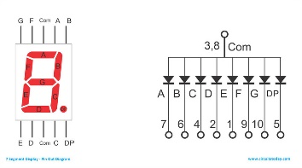
- At pin 38, 39 the resistor and Capacitor are used to set the frequency of IC’s internal clock.

- At pin 33, 34 capacitor neutralizes the fluctuations in the internal reference voltage and increases the stability of the display.

- At pin 30, 31 controls the range of the voltmeter (R4=1.2K gives 0-20V range, R4=12K gives 0-200V range).

- Circuit diagram:

