I’m Moussa

I’m Harry

I’m Jamie

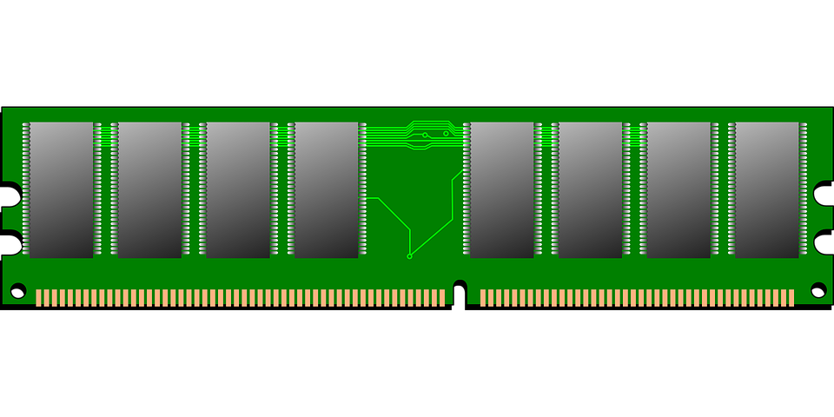



**0x9EF330**

**0x9E00BB**

**0x7DFF71**

**player2**





**player2**

**player1**

**player3**

player1 = player2



**0x9EF330**

**0x9E00BB**

**0x7DFF71**

**player3**

**player1**



**player2**

**player3**

**player1**

**0x9E00BB**

**0x9EF330**

**0x7DFF71**

player3 = player1

**player2**

**player3**

**0x9E00BB**

**0x7DFF71**

**0x9EF330**

**player1**

player2 = player3