# Module diagram

The overview of how the application is connected on the insides looks like the following diagram:

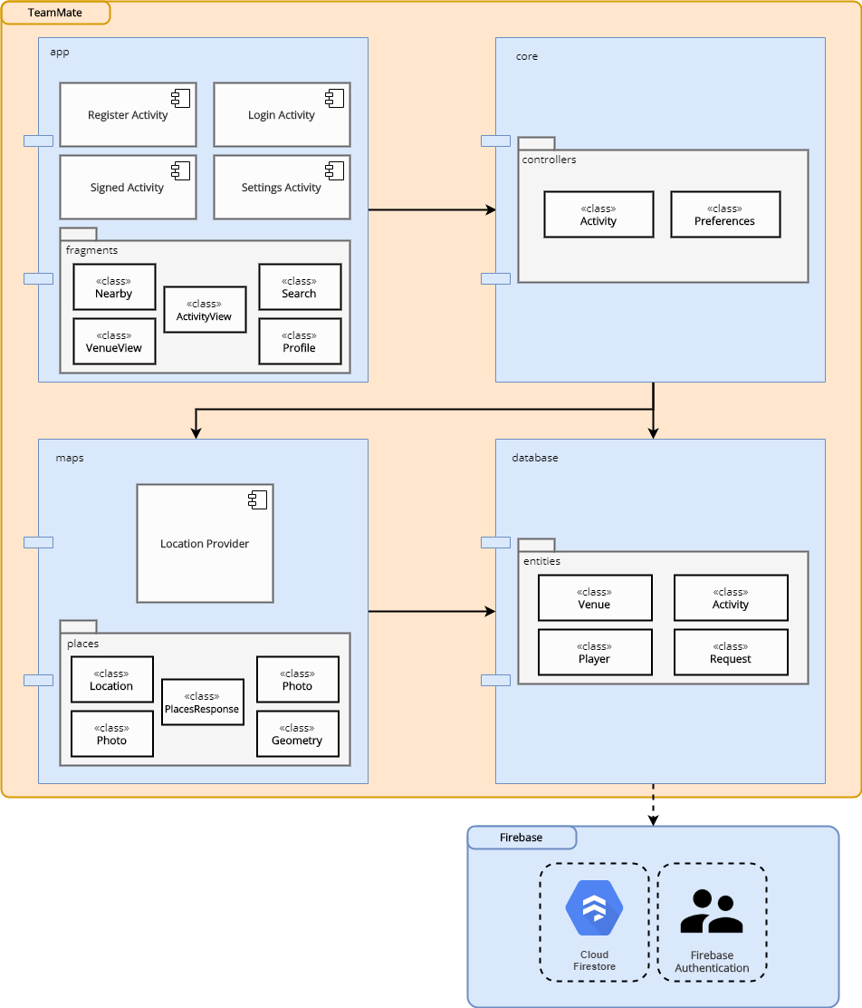

## app module

This is where the UI will be located. In it we can see that there are multiple activities:

* **Register Activity**: where the application will let the user sign up, either through his/her Google account or an email or password.
* **Login Activity**: where the user can log in with his/her already existing account.
* **Signed Activity**: when the user is already logged in, he/she will be able to use all the functionalities.
* **Settings Activity**: where the user can modify some data related to his/her account.

### Package fragments

This package contains all the fragments to be used in the signed activity. We opted for this kind of implementation in order to not repeat too much code, making it much more readable and easier to understand. The following image represents this:

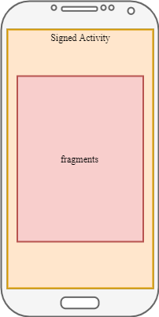

These fragments will switch when the user performs certain actions while using the app:

* **Nearby** will show the closest venues to the user. This is the screen that will come up first when the user is logged in.
* **VenueView** shows the details of certain venue.
* **ActivityView** shows the details of certain activity.
* **Search** will let the user search for venues.
* **Profile** shows info about the user that is logged in.

## maps module

This is where the application will get the location information. Using Google's location service, we can easily get the device location and, therefore, the venues that are close to him/her. See [this](https://github.com/AIR-FOI-HR/AIR19E1/wiki/05-Third-party-services) to know more.

### Package places

These are only some entities created to handle the response from Places SDK. See [this](https://github.com/AIR-FOI-HR/AIR19E1/wiki/05-Third-party-services) to know more.

## core module

This is where all internal logic will be handled. All the information gathered through the different views will be processed here, if possible.

## database module

This is where the application will communicate with Firestore. We will be using Cloud Firestore instead of Realtime Database because it provides better functionalities. See [this](https://github.com/AIR-FOI-HR/AIR19E1/wiki/05-Third-party-services) to know more.

### Package *entities*

All the entities related to the domain of the project are located here: Venue, Activity, Player and Request.