MAC OSx USERS:

To download and setup all necessary resources to run and generate the workflow output:

The gradle app:

1. Install Python version 2.7 or higher if you do not already have it

2. Install Phantomjs version 1.9.7 (DO NOT choose any other version)

3. Install Casperjs version 1.1 or higher

4. Clone/download the git repository https://github.com/spidasoftware/min/scripts/flowdocument

into the Applications folder.

5. Inside of Applications/flowdocument, drag or duplicate the SHELL file called "GenerateWorkflow" to your desktop.

6. Open up a terminal window and type "chmod u+x /Users/zpeugh/Desktop/GenerateWorkflow.command"

7. You can now put this GenerateWorkflow file anywhere you wish, and you will simply double-click on it to begin the app.

Google Docs Add-on:

2. Create a google drive if you do not already have one (You must be a member of the spidasoftware domain to find it).

3. Open a new document in google docs.

4. Click on the "Add-ons" tab, then "Get add-ons...".

5. Inside the web store, find the add-on titled "Document Workflow", and install it. Alternatively, go to https://chrome.google.com/webstore/detail/document-workflow/lhffgpnhgkohngaplfphaihbapakkchl

To run the app:

1. Go to the https://www.spidasoftware.com/projectManager/ page where you created your WorkFlow.

2. Note the exact syntax of the company name you log into to get to the flow. If you do not have to change companies, then the company name is 'SPIDA'.

3. Press download on your workflow, and note the name of the file that gets downloaded. For example, if the flow name was 'North Carolina Make Ready Process' then the file download name would be 'North-Carolina-Make-Ready-Process.flow'. You will need this in an upcoming step.

4. Double-click the GenerateWorkflow file from App-setup step 7.

5. Fill in Company and flow names, being careful with spelling.

6. Press "Generate Document"

7. The program will then go and gather all the proper resources and after between 1-10 minutes (depending on the size of the flow, but usually around 3-4).

8. Click "Open in Browser"

9. Click "Create Export Folder" then a folder called ExportToGoogleDrive will appear in your desktop.

10. Click "Go to Google Drive"

11. Inside of "My Drive" create a new folder for the workflow, and name it whatever you like. Do not name it something that is already in your MyDrive folder however. This name will be prompted later, so remember it.

12. Click into this folder and then open up the "ExportToGoogleDrive" folder on your desktop and drag the "Resources" folder into the newly created folder in your google drive.

13. This upload will take a while, because Google apparently has severely limited upload speed inside google drive.

14. Once the folder is uploaded fully, open up a new google doc, and use the previously installed google doc add-on to create the Event, Action, and Form document templates. When prompted for folder name, it is whatever you named it in step 11.

Troubleshooting:

*If there are missing forms or actions, it is likely that an internet slowdown or interruption caused a page not to load, and you can simply run the program again and see if that captures them all.

**You must have your downloaded .flow file in your /Users/"your username"/Downloads. If this is not your automatic download location, then simply move the downloaded file to that folder and try again.

WINDOWS USERS

To download and setup all necessary resources to run and generate the workflow output:

The gradle app:

0*. If you do not know how to install programming frameworks on Windows, then see the appended section titled in Troubleshooting.

1. Install Python version 2.7 or higher if you do not already have it. Here is a link <https://www.python.org/downloads/release/python-2710/>.

2. Install Phantomjs version 1.9.7 (DO NOT choose any other version). <https://repository-javaetmoi.forge.cloudbees.com/release/org/phantomjs/phantomjs/1.9.7/>

3. Install Casperjs version 1.1 or higher <http://casperjs.org/>.

4. Clone/download the git repository [https://github.com/spidasoftware/min/scripts/flowdocument into your desktop.](https://github.com/spidasoftware/min/scripts/flowdocument%20into%20your%20desktop.)

5. Inside of flowdocument, drag or duplicate the Windows Batch file called "GenerateWorkflow.bat" to your desktop or anywhere else convenient (NOT the SHELL version). You can now simply double-click on it to begin the app.

Google Docs Add-on:

2. Create a google drive if you do not already have one (You must be a member of the spidasoftware domain to find it).

3. Open a new document in google docs.

4. Click on the "Add-ons" tab, then "Get add-ons...".

5. Inside the web store, find the add-on titled "Document Workflow", and install it. Alternatively, go to https://chrome.google.com/webstore/detail/document-workflow/lhffgpnhgkohngaplfphaihbapakkchl

To run the app:

1. Go to the https://www.spidasoftware.com/projectManager/ page where you created your WorkFlow.

2. Note the exact syntax of the company name you log into to get to the flow. If you do not have to change companies, then the company name is 'SPIDA'.

3. Press download on your workflow, and note the name of the file that gets downloaded. For example, if the flow name was 'North Carolina Make Ready Process' then the file download name would be 'North-Carolina-Make-Ready-Process.flow'. You will need this in an upcoming step.

4. Double-click the GenerateWorkflow file from App-setup step 5.

5. Fill in Company and flow names, being careful with spelling.

6. Press "Generate Document"

7. The program will then go and gather all the proper resources and after between 1-10 minutes (depending on the size of the flow, but usually around 3-4).

8. Click "Open in Browser"

9. Click "Create Export Folder" then a folder called ExportToGoogleDrive will appear in your desktop.

10. Click "Go to Google Drive"

11. Inside of "My Drive" create a new folder for the workflow, and name it whatever you like. Do not name it something that is already in your MyDrive folder however. This name will be prompted later, so remember it.

12. Click into this folder and then open up the "ExportToGoogleDrive" folder on your desktop and drag the "Resources" folder into the newly created folder in your google drive.

13. This upload will take a while, because Google apparently has severely limited upload speed inside google drive.

14. Once the folder is uploaded fully, open up a new google doc, and use the previously installed google doc add-on to create the Event, Action, and Form document templates. When prompted for folder name, it is whatever you named it in step 11.

Troubleshooting:

*To install a programming framework:

Download the zip file of the language (java, python, phantomjs, casperjs). Take this folder and “extract all” directly into your into C:\ drive. Rename the folder to just the basename of the language, getting rid of any version numbers (as seen above). Now, once all of the downloaded zip files are renamed and in the C:\ drive, go to your Control panel and do the following:

Control Panel -> System & Security -> System

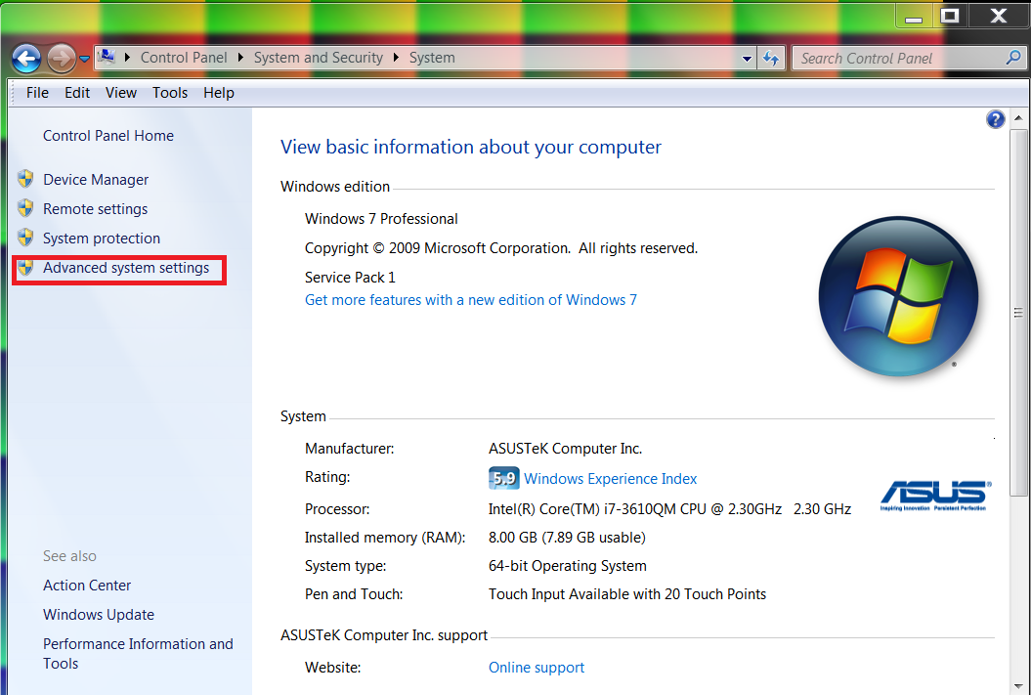

-> Advanced System Settings

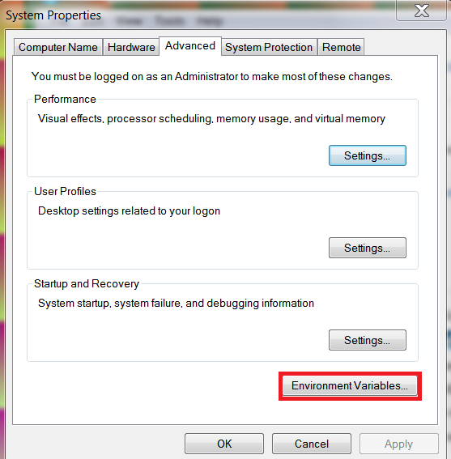

-> Environment Variables…

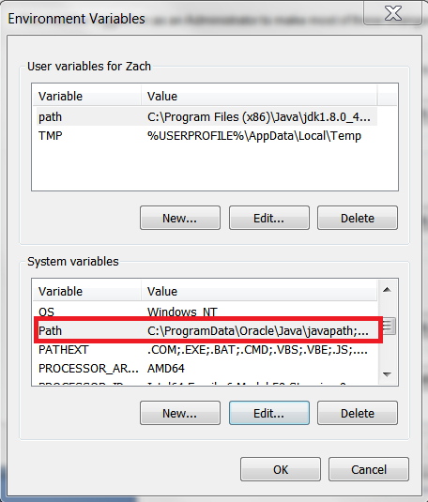

Choose your PATH System variable, and press edit.

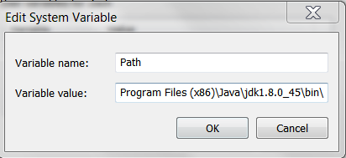

At the end of the variable value field, APPEND the absolute file path locations of the executables inside the downloaded casperjs/phantomjs/python folders. If you renamed them and extracted them into the C:\ drive as suggested, you should be able to copy and paste this to the end: Semicolons separate different file paths. Casperjs needs both the bin and batchbin paths or it will not work.

;C:\python\;C:\phantomjs\;C:\casperjs\bin\;C:\casperjs\batchbin\;

**If there are missing forms or actions, it is likely that an internet slowdown or interruption caused a page not to load, and you can simply run the program again and see if that captures them all.

***You must have your downloaded .flow file in your /Users/"your username"/Downloads. If this is not your automatic download location, then simply move the downloaded file to that folder and try again.