git init

git add .

git status

git commit -m "这里面写你的注释"

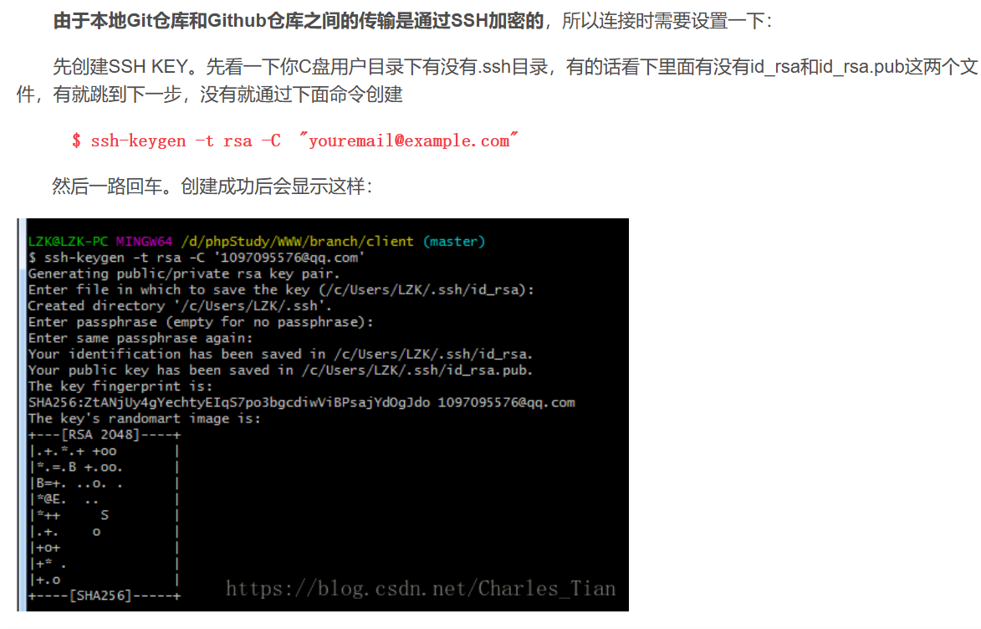

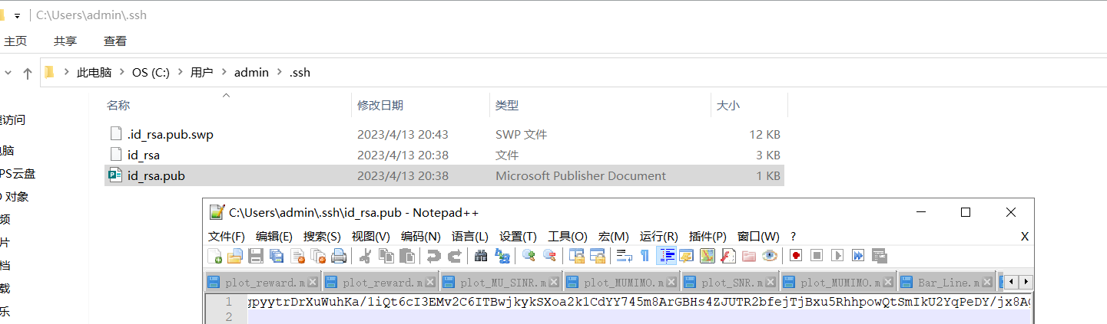

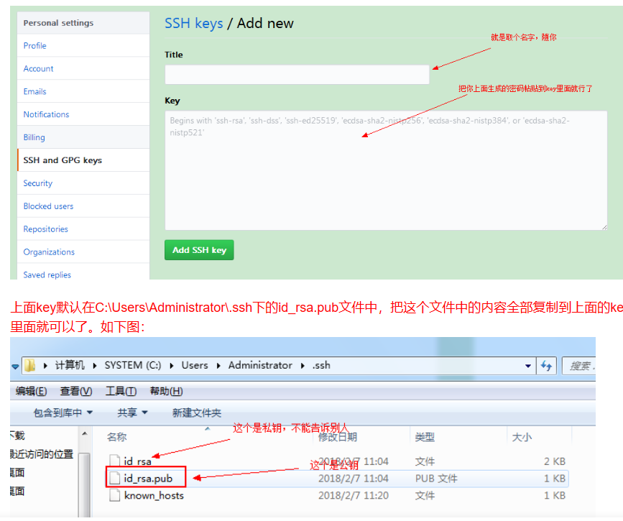

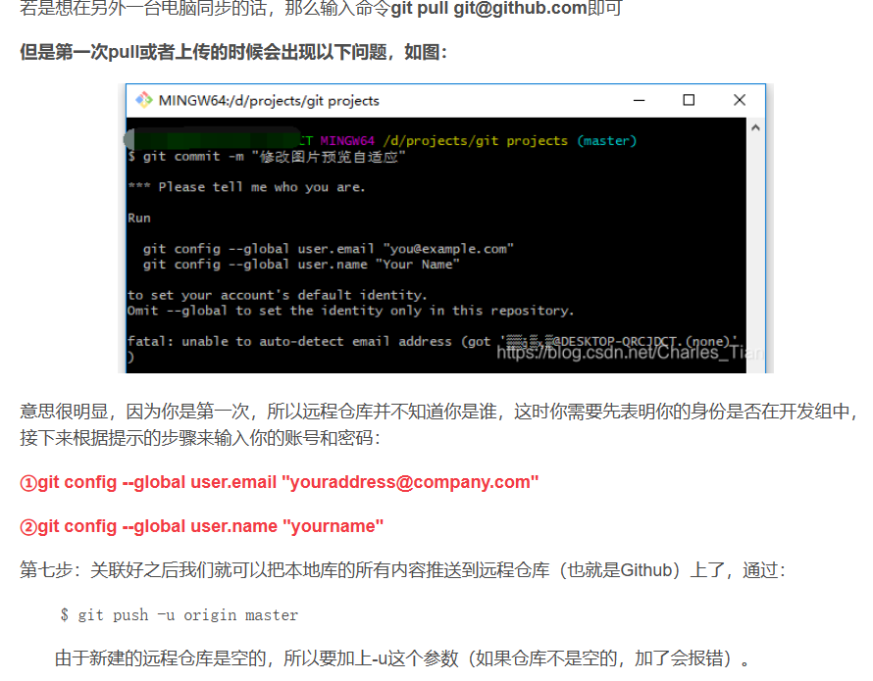

git remote add origin <https://github.com/Zr-wh/linux-kernel-research-notes-.git>

git config --global http.proxy 127.0.0.1:7890

git config --global https.proxy 127.0.0.1:7890

git pull https://github.com/Zr-wh/linux-kernel-research-notes-.git

git push origin master