VNC + ROS + MOVO

1. Download ubuntu 16.04 image with VNC-desktop

docker run -p 6080:80 -v /dev/shm:/dev/shm dorowu/ubuntu-desktop-lxde-vnc

Browse http://127.0.0.1:6080/

The VNC desktop should like this:

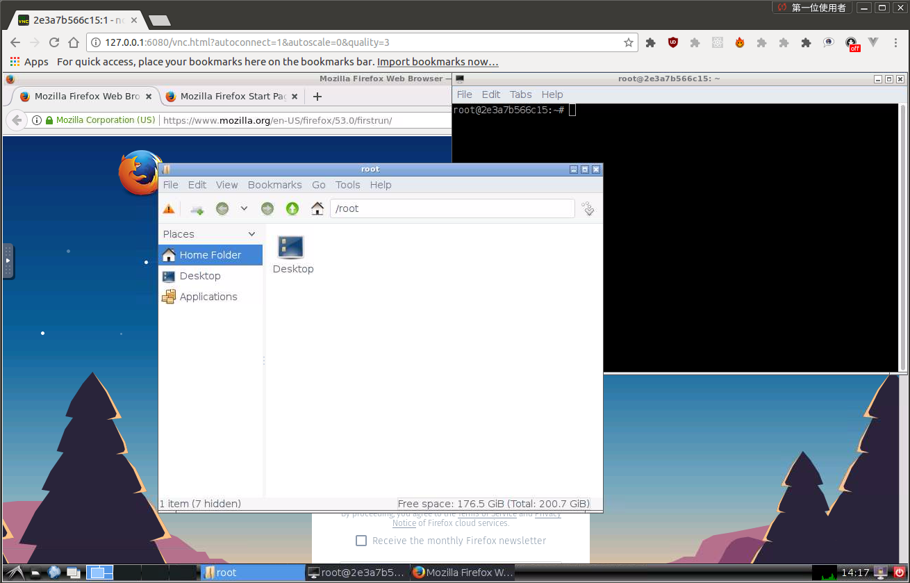

2. Install ROS-kinetic in container

Tutorial: http://wiki.ros.org/kinetic/Installation/Ubuntu

2.1 Setup your sources.list
sudo sh -c 'echo "deb http://packages.ros.org/ros/ubuntu $(lsb_release -sc) main" > /etc/apt/sources.list.d/ros-latest.list'

2.2 Set up your keys
sudo apt-key adv --keyserver 'hkp://keyserver.ubuntu.com:80' --recv-key C1CF6E31E6BADE8868B172B4F42ED6FBAB17C654

2.3 Installation

sudo apt update
sudo apt-get install ros-kinetic-desktop-full

2.4 Environment setup

echo "source /opt/ros/kinetic/setup.bash" >> ~/.bashrc
source ~/.bashrc

2.5 Install dependencies for building ROS packages

sudo apt install python-rosdep python-rosinstall python-rosinstall-generator python-wstool build-essential

2.6 Initialize rosdep

sudo apt install python-rosdep
sudo rosdep init
rosdep update

3. Pre-download models into gazebo

cd ~/.gazebo/
git clone https://github.com/osrf/gazebo_models.git models

4. Setup kinova-movo

Before starting with the tutotial, first create soft link between /home/root and /root:

ln -s /home/root /root

Tutorial: https://github.com/ALAN-NUS/kinova_movo

5. Commit the container to image

In the terminal of host system:
sudo docker commit ($the container ID) ($image name:$tag)
eg: sudo docker commit 6802a0b12f5f radoe/movo:v1

6. Generate new container with the image

sudo docker run -p 6080:80 -v /dev/shm:/dev/shm radoe/movo:v1

sudo docker run --network host --gpus all -v /dev/shm:/dev/shm radoe/movo:v1

