# 1：下载授权证书

<https://raw.githubusercontent.com/mock-server/mockserver/master/mockserver-core/src/main/resources/org/mockserver/socket/CertificateAuthorityCertificate.pem>

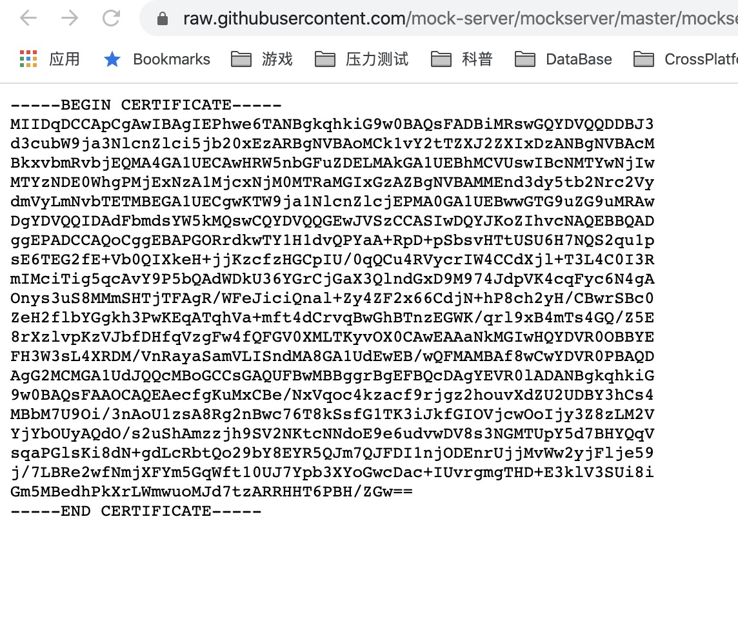

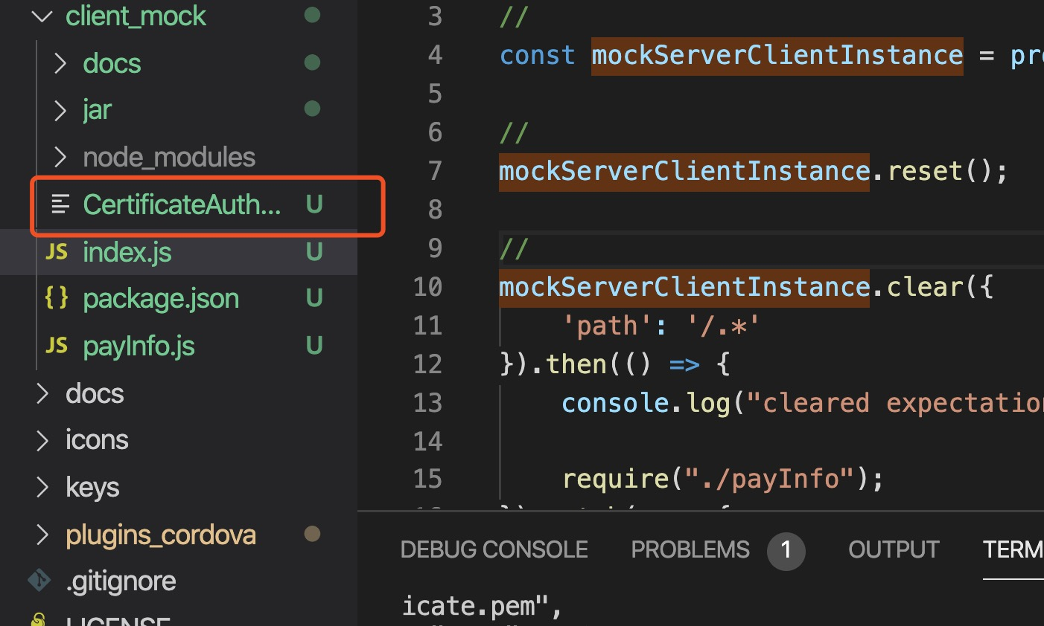

# 2：下载mockServer

<https://www.mock-server.com/where/downloads.html>

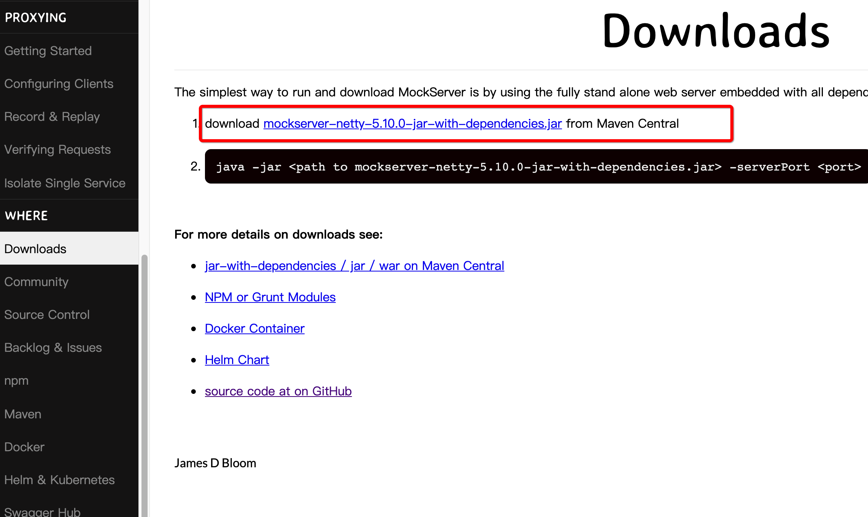

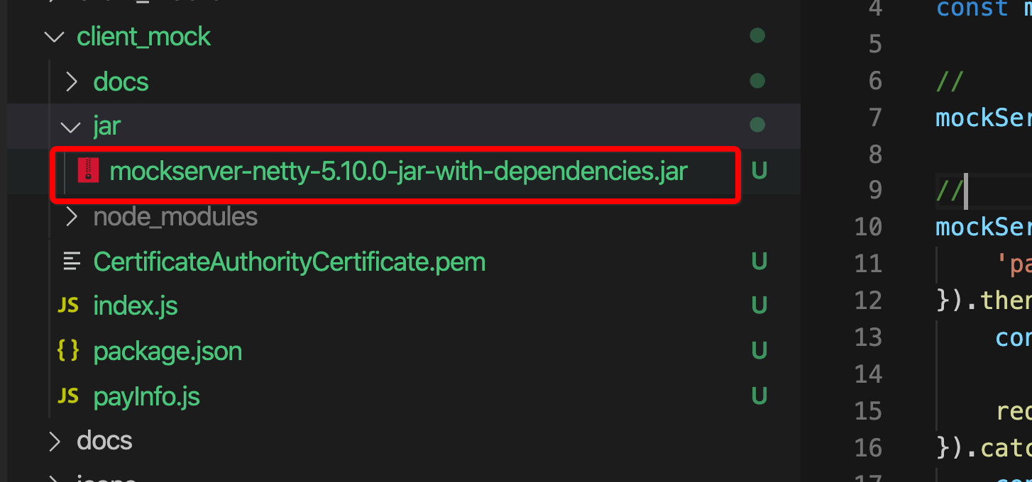

# 3：启动mockServer

Java -Dmockserver.enableCORSForAllResponses=true -jar \"./client_mock/jar/mockserver-netty-5.10.0-jar-with-dependencies.jar\" -serverPort 8080

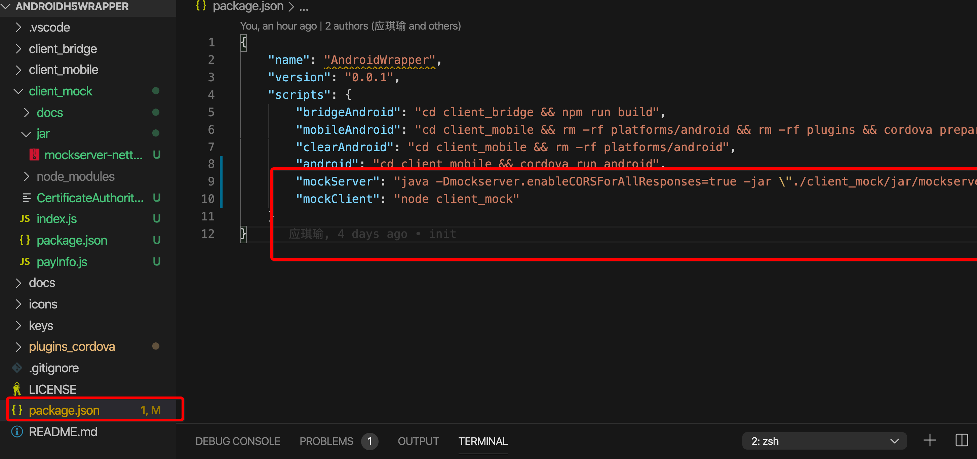

# 4：启动mockClient

## 1：安装依赖

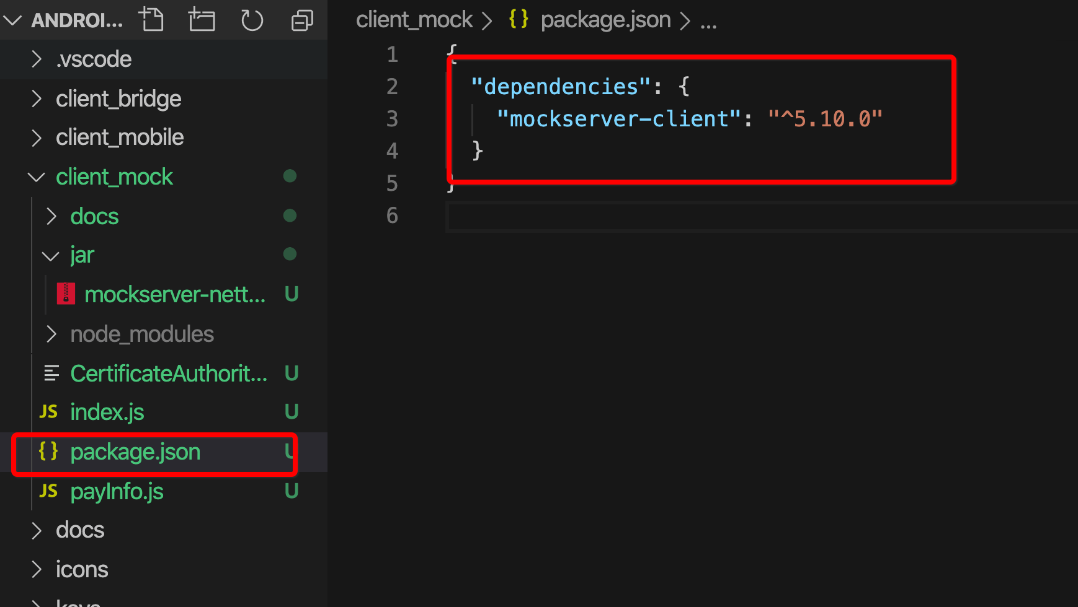

## 2：添加expectation

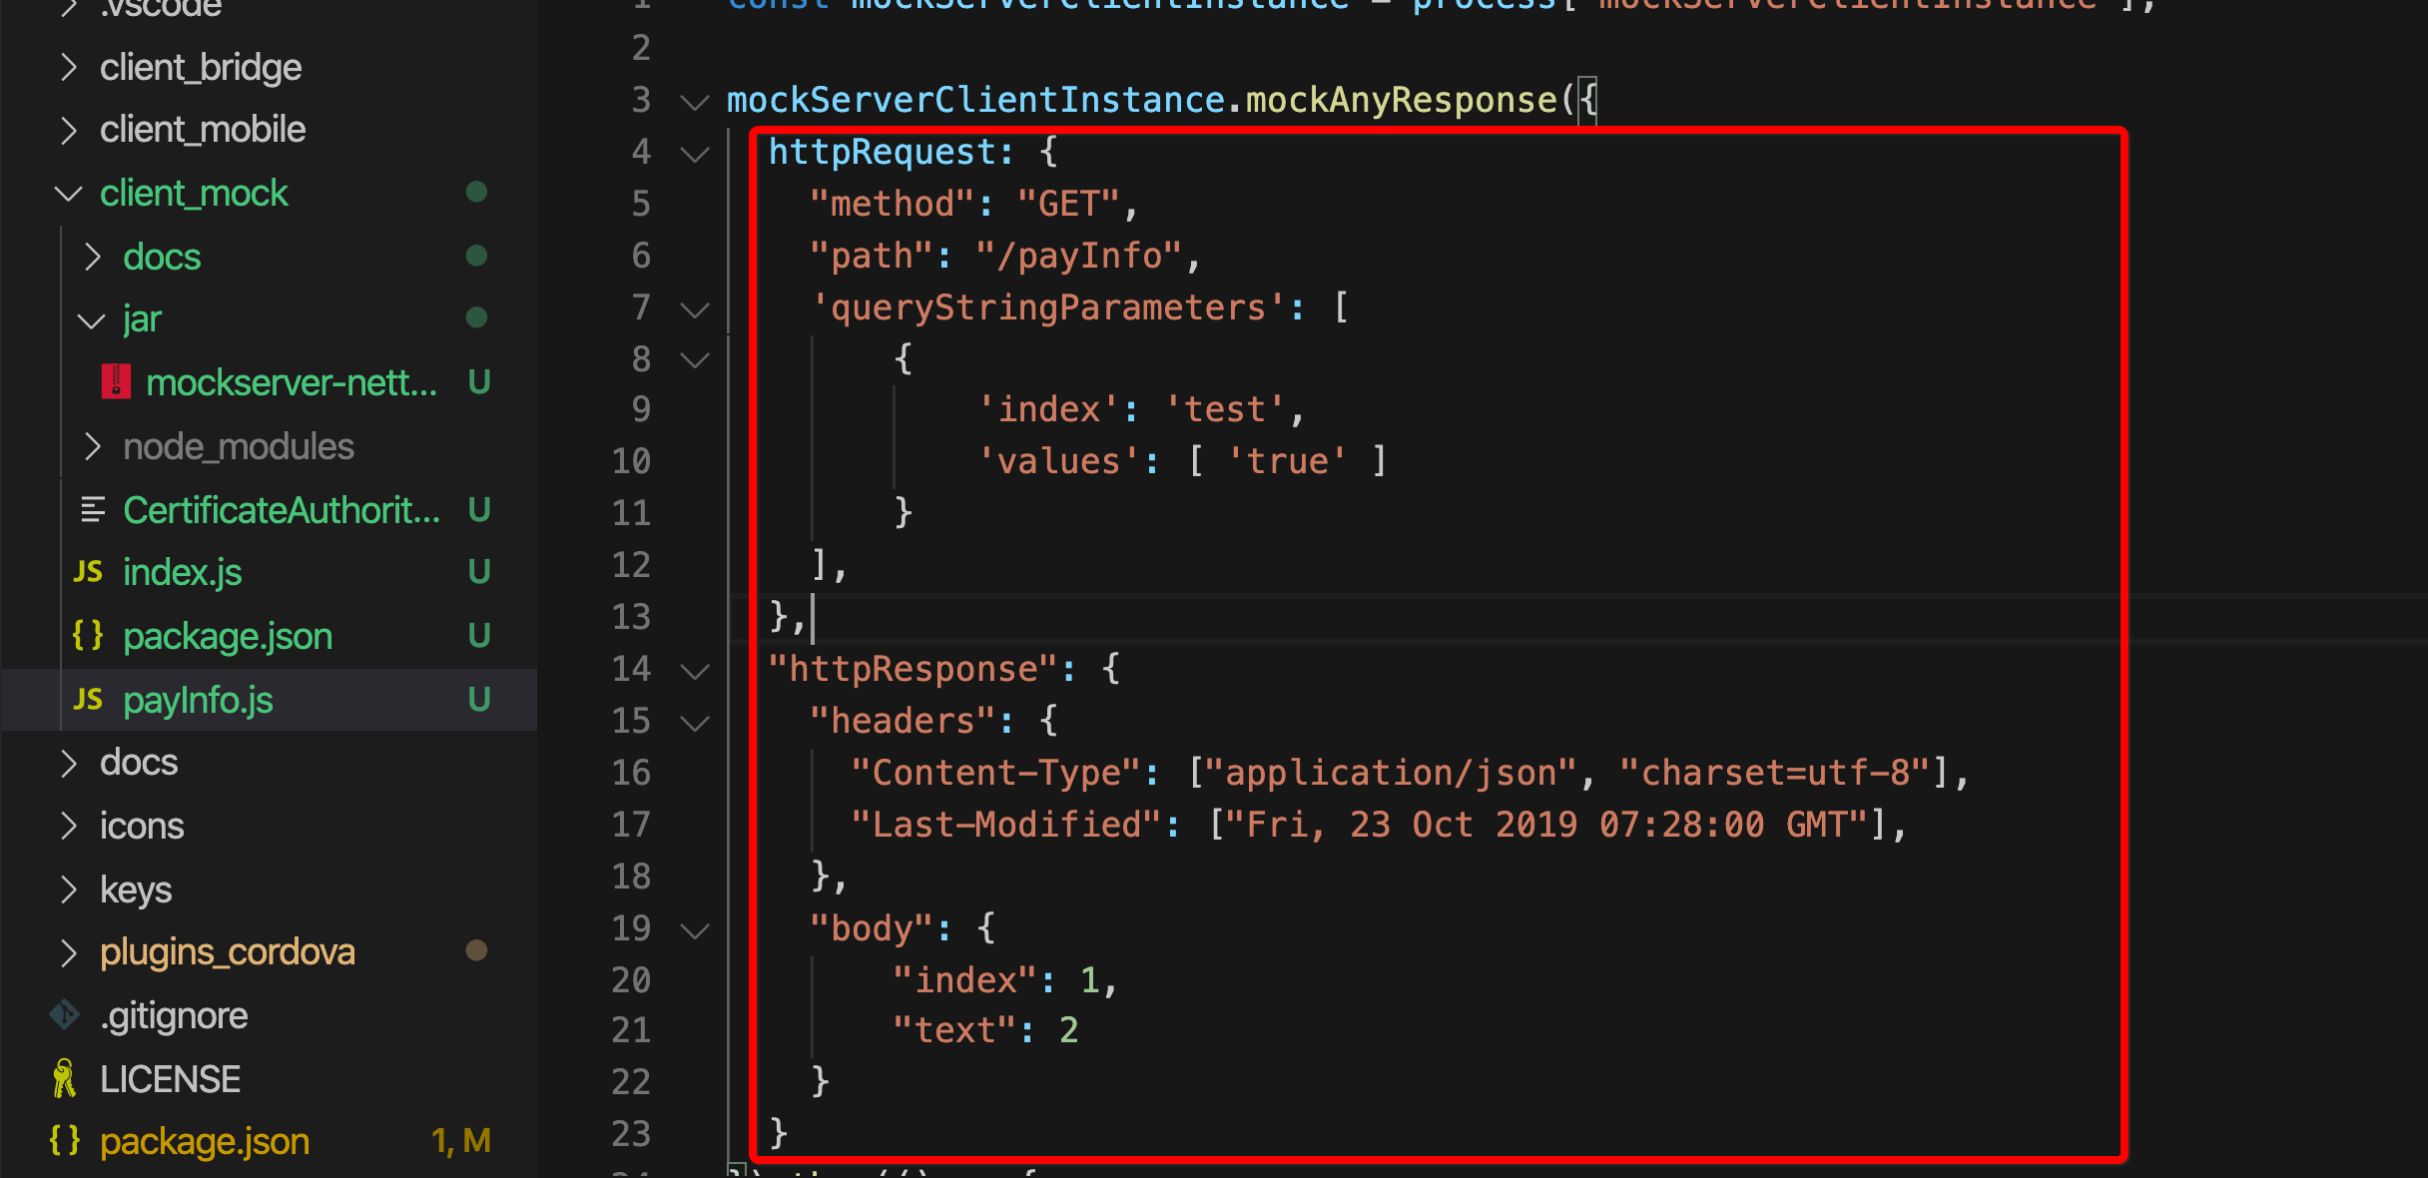

## 3：启动

