# 参数说明

## 1：三江开票

type = sanjiang

identifier = 身份证号码

# 1：扫一扫，身份证入口页面

/scan/:type

比如 <http://localhost/#/scan/sanjiang?code=xxxx>

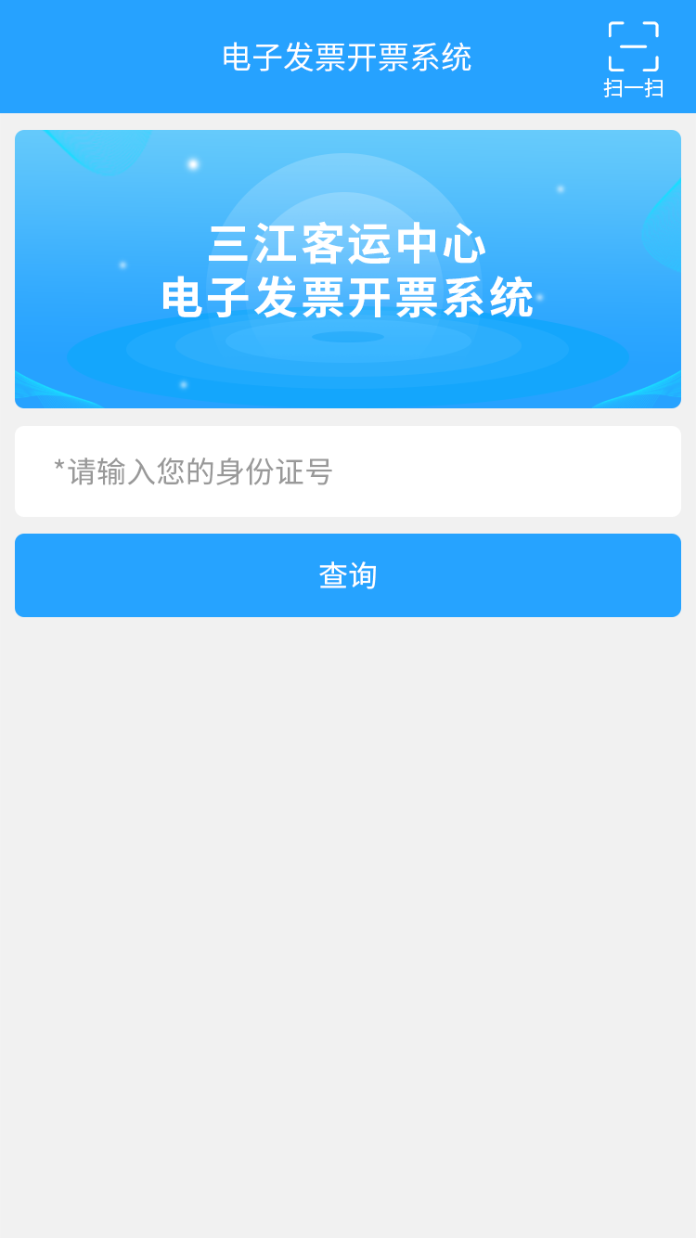

# 2：电子发票列表

/invoiceList/:type/:identifier

比如 <http://localhost/#/invoiceList/sanjiang/330902185412340125>

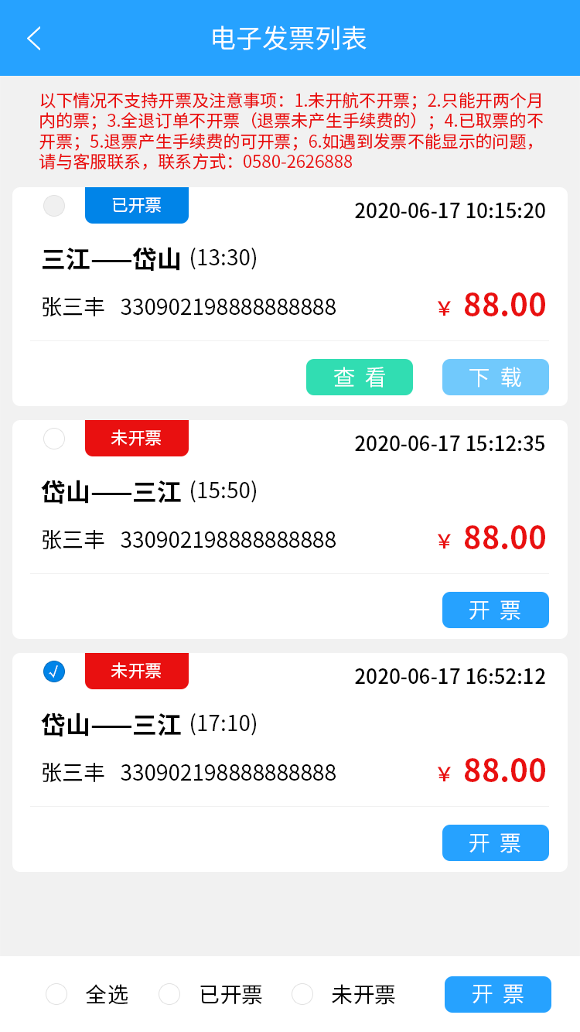

# 3：开票页面

/checkInvoice?code=xxxx&type=xxx&invoiceList=[发票信息]

其中invoiceList为一个JSON数组（需要转为字符串）

比如 ：[http://localhost/#/checkInvoice?code=111&type=sanjiang&invoiceList=%5B%7B%22IDNum%22%3A%22330921198606202031%22,%22canInvoice%22%3Atrue,%22date%22%3A%222018-12-06%22,%22endPort%22%3A%22gaoting%22,%22id%22%3A1,%22invoiceAmount%22%3A102,%22invoiceType%22%3A1,%22isInvoice%22%3Afalse,%22name%22%3A%22tom%22,%22phoneNum%22%3A%2213216800218%22,%22price%22%3A%22102%22,%22refundState%22%3A0,%22seatNum%22%3A%220%22,%22seatType%22%3A%225%3F%3F%3F%22,%22serialNum%22%3A%2220181206000002%22,%22shipName%22%3A%22%3F%3F%22,%22takeState%22%3A0,%22ticketType%22%3A%22%3F%3F%22,%22time%22%3A%2210%3A10%22,%22invoiceUrl%22%3A%22%22,%22ifSelected%22%3Atrue%7D%5D](http://localhost:8080/" \l "/checkInvoice?type=sanjiang&invoiceList=[{"IDNum":"330921198606202031","canInvoice":true,"date":"2018-12-06","endPort":"gaoting","id":1,"invoiceAmount":102,"invoiceType":1,"isInvoice":false,"name":"tom","phoneNum":"13216800218","price":"102","refundState":0,"seatNum":"0","seatType":"5???","serialNum":"20181206000002","shipName":"??","takeState":0,"ticketType":"??","time":"10:10","invoiceUrl":"","ifSelected":true}])

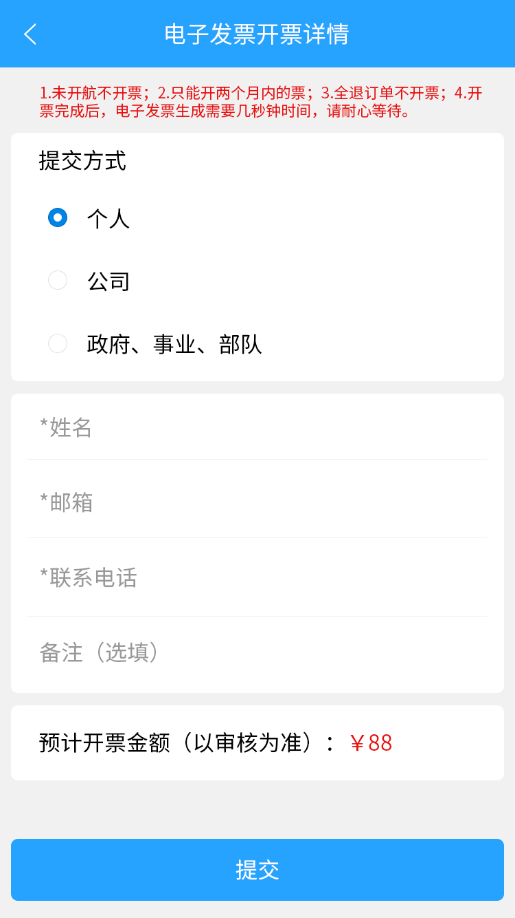

# 4：无法开票提醒页面

/routeCheckInvoiceResult? reason=xxxx

