**RESPONSE**

**Colors Mean Different Things to Different Cultures**

Colors have an extraordinary power to convey emotions and messages. While color symbolism can bridge cultural differences, it can also lead to misunderstandings if not approached with sensitivity.

For instance, red often symbolizes love and vitality in the U.S. and Western Europe however, it assumes distinct roles in other parts of the world. In former Eastern European Bloc countries, it might evoke memories of communism. In many Asian cultures, red often signifies luck, happiness, and longevity that adorn festive occasions. The Middle East may perceive it as a warning, reflecting danger with undertones of caution. In South Africa, red can take on a distressing role, symbolizing sacrifice and mourning.

Understanding the diversity of color symbolism can truly broaden our perspective and connect us to the complexity of our diverse world. McDonalds is one company consciously adjusting to cultures worldwide when it comes to **red** in their branding. **Notable Examples From the link below:** Columbia, India, Italy, Mainland China and Panama. <https://corporate.mcdonalds.com/corpmcd/our-company/where-we-operate.html>

In so many ways vibrant hues transform the way celebrations are adorned and enjoyed, demonstrating how colors are fundamental to cultures worldwide. In a world where designs have the potential to reach diverse audiences, understanding the cultural implications of color is imperative.

**SOURCES:**  
Richard Brooks. December 21, 2016. “Colours and their Meanings Around the World”. <https://www.k-international.com/blog/color-meanings-around-the-world/>

**What You See Isn’t What Your Brain Gets**

Negative space embraces the art of empty areas on a webpage evoking emotions and drawing attention to important content by guiding users and providing visual pauses. By removing excessive elements, designs appear polished and modern. Typography benefits considerably from negative space because well-spaced text is easier to read and comprehend, enhancing usability which contributes to better user engagement. Imagery can have a greater impact when surrounded by negative space signifying or enhancing its importance, isolation, or simplicity.

1. **Web Design Examples** of Negative Space: [**20 Best Websites Making Use Of Negative Space**](https://www.designmantic.com/blog/websites-using-negative-space/)
2. **Print Design Examples** of Negative Space

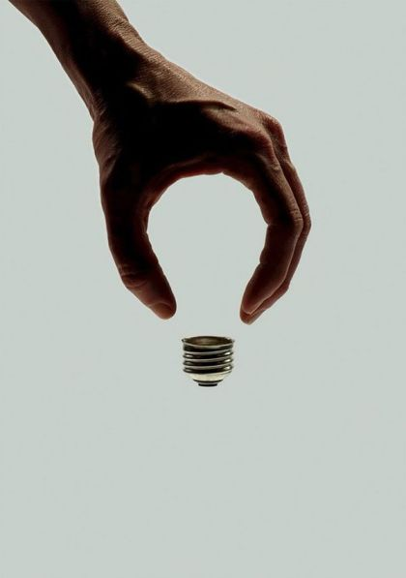

Incorporating negative space in responsive web design is important as users transition across devices, providing sufficient space ensures seamless adaptability without compromising aesthetics or functionality.

Negative space is more than just an aesthetic choice; it's a powerful design principle. It enhances user experience, guides attention, and communicates messages effectively.

SOURCES:   
Tubik. UX Planet. “Negative Space in UI Design: Tips and Best Practices”. [https://uxplanet.org/negative-space-in-ui-design-tips-and-best-practices](https://uxplanet.org/negative-space-in-ui-design-tips-and-best-practices-98311cb2ad16#:~:text=Basically%2C%20negative%20space%20%E2%80%94%20or%20white,on%20the%20page%20or%20screen).

**DISCUSSION RESPONSES**

**#1**

**Jessica Cheetham - Mod 1**

You had some insightful observations about how human perception and habits influence design choices. It made clear the importance of understanding user expectations and patterns when creating effective user-friendly designs.

Reiterating the coffee cup and ice cream examples were a nice lead in for explaining how our perception is influenced daily and highlights the familiar expectations we have when representing objects. Also, it made me realize these items are rarely depicted from another angle.

Also, your explanation of where people’s attention is drawn to when they scan webpages really reflected how strong human habit is and emphasized the significance of matching users' expectations. Overall, this post was insightful.

**#2**

**Holly McFarland - Module 1**Bottom of Form

Including an explanation about color psychology and its insights into how colors can significantly impact behaviors and moods added an interesting layer to this topic. Your suggestion of how this knowledge would assist web designers in creating more appealing websites was perceptive. If web designers took this approach to color their content would absolutely resonate with users.

Your personal experience about the Amazon search bar being relocated really illustrated the concept of ingrained habits and user expectations. This real-world example really showed how even minor changes in design can disrupt well-established user behavior patterns.

Overall, you did a nice job expanding on these topics and providing some thoughtful examples.

Bottom of Form

**#3**

**Ryan Church Module 1**

The discussion about how red and blue colors are processed differently by the eye is fascinating. Pointing out how individuals perceive this effect and the impact of computers and smartphones on our eyesight was interesting. I never would have thought mixing red, green, and blue would have such an influence on how we view websites and their 3D effect.

Your example of the expectations we have when viewing banking websites was a great way to illustrate the need for standardized design elements and consistent placement of key features like account logins.

The way you've broken down these topics and related them to real-world scenarios showcased a thoughtful approach to the topics discussed.

Bottom of Form

Bottom of Form