**GitHub Repository Link:**

<https://github.com/Zsa-who-wa/csd-340/tree/main>

**Screenshot: Starter Code HTML Validator Results**

**Screenshot: Starter Code HTML Validator Updated – Results**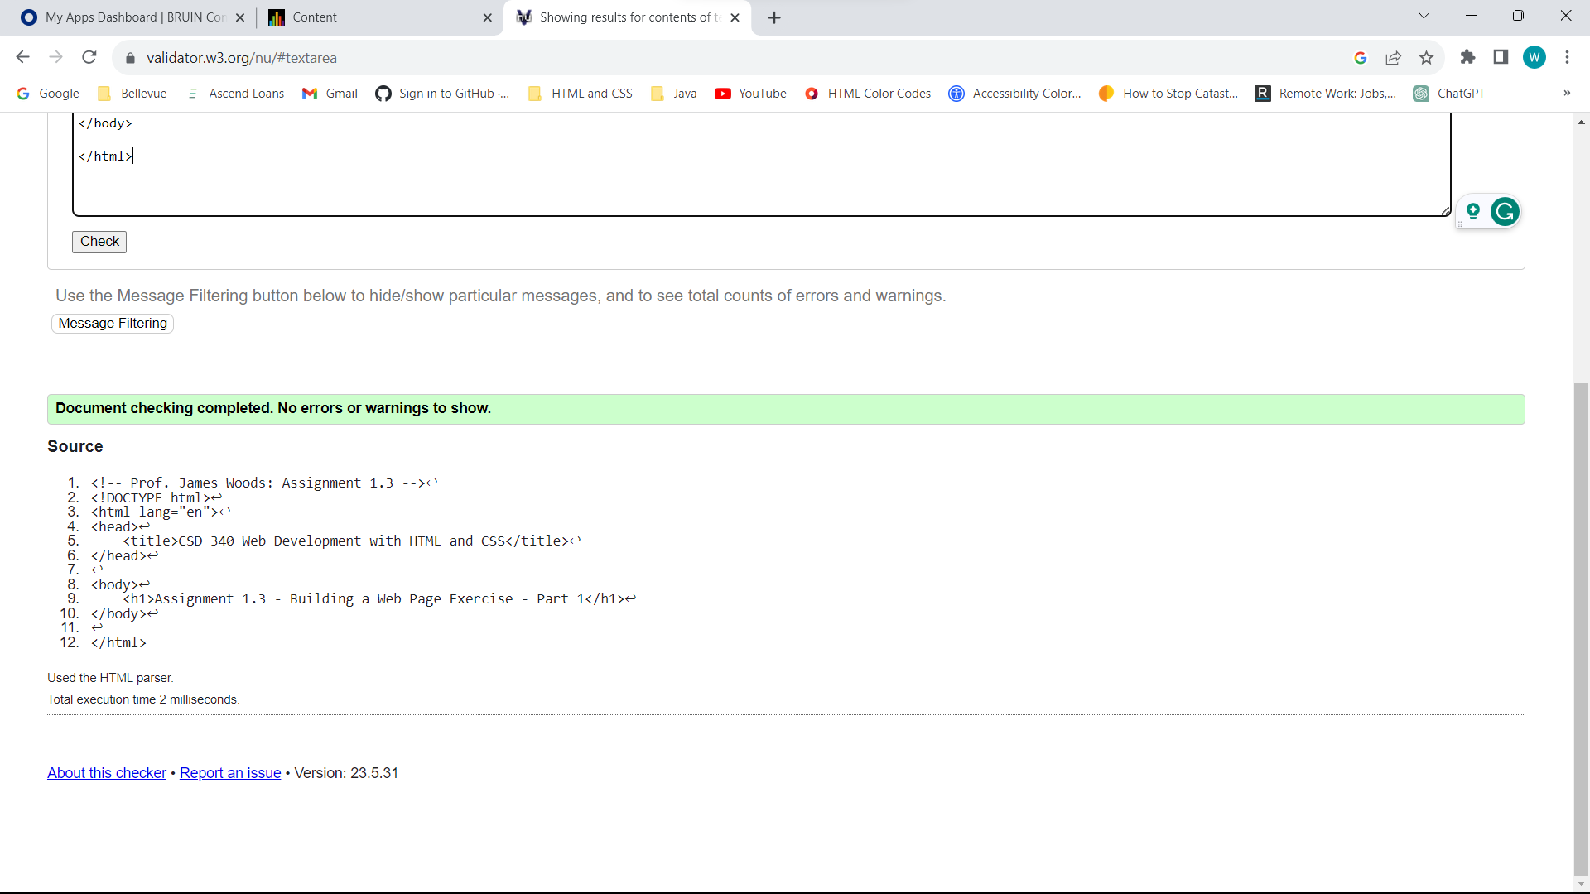

**Screenshot: Starter Code HTML Validator Added/Updated - Results**

**