TECHNICAL REPORT

Sensitivity Analysis of FEMA National Risk Index (NRI)
CIVE 202 - Civil Engineering Analysis II
Prepared for: Risk Averse, LLC
Prepared by: Abdi Aden
Date: 4/21/26

Executive Summary
This research will examine the risk assessment of natural disasters based on FEMA's National Risk Index (NRI) methodology and compare it with an alternative risk model developed using Python code. This will be done to understand the effect of redefinition on the outcome and uncover any biases in the risk calculation methods.
Two states, California and Alaska, were selected for the study based on their geographic diversity, population size, and economic development. The NRI model considers the factors of expected loss, social vulnerability, and community resilience, whereas the alternate model is based on hazard calculation along with normalized social factors.
The results demonstrate that the redefinition of risk greatly alters the high-risk areas identified by the models.
1. Introduction
Natural disasters present major risks to infrastructure, communities, and economic systems. To evaluate these risks, FEMA developed the National Risk Index (NRI), which combines hazard exposure with social and economic factors.
The NRI defines risk using:
- Expected Annual Loss (EAL)
- Social Vulnerability (SOVI)
- Community Resilience (RESL)
However, risk is not purely objective; it depends on how it is defined. This project performs a sensitivity analysis by comparing FEMA’s model to a custom model developed using Python.
The goal is to determine how different variable selections and weightings influence risk classification and potential bias.

2. Methods
2.1 Variables Selected
Variables were selected directly from the NRI dataset and SVI dataset.
NRI Variables:
- WFIR_RISKS (Wildfire risk)
- ERQK_RISKS (Earthquake risk)
- CWAV_RISKS (Cold wave risk)
Hazard Variables:
- AFREQ (frequency)
- EXPT (exposure)
- HLRP (historic loss ratio)
Social Variables:
- SOVI_SCORE (vulnerability)
- RESL_SCORE (resilience)

2.2 Risk Model Definition
The hazard component was calculated as:
Hazard = Frequency x Exposure x Historic Loss Ratio
The final custom risk model was:
Risk = 0.40(Hazard) + 0.45(SOVI) - 0.15(RESL)
This model:
- Includes hazard + social factors
- Uses weights to simulate real-world decision priorities
- Is scaled from 0–100 for comparison

2.3 Data Processing
The data was processed using Python:
- Merged datasets using STCNTY
- Removed duplicates
- Filled missing values using median
- Converted data types for consistency
- Normalized variables using MinMaxScaler

2.4 Visualization and Mapping
The following outputs were created:
- Choropleth maps using GeoPandas
- Bar charts comparing top and bottom counties
- Summary tables using groupby

3. Results and Discussion
3.1 Risk Comparison
The NRI model and custom model produced noticeably different results.
Figure 1 shows the spatial distribution of wildfire risk in California using both the FEMA National Risk Index (NRI) and the proposed risk model. The NRI model displays consistently high risk values across most regions, while the proposed model produces more variation and highlights specific high-risk areas. This demonstrates how different model structures can significantly impact spatial risk interpretation.
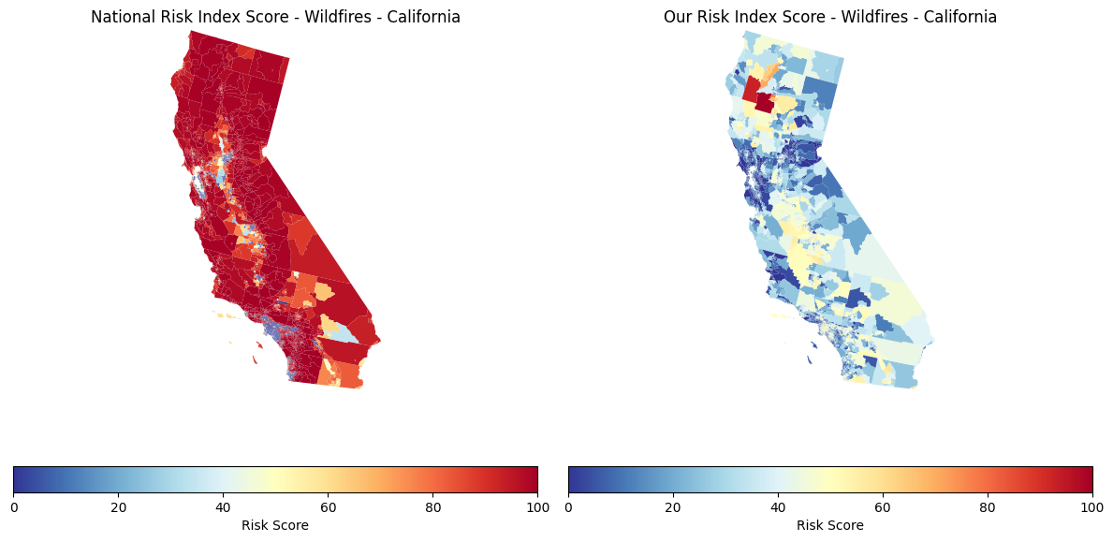
Figure 1: California Wildfire Risk Map (NRI vs Custom Model)

Key observation:
- NRI distributes risk more evenly
- Custom model shows more concentrated high-risk areas

3.1 Distribution Differences
Figure 2 illustrates the comparison between the high-risk counties and low-risk counties using both models. It is found that the NRI model gives higher values with less dispersion compared to the proposed model, which shows a greater range of risk values. Thus, the use of the proposed model enhances the difference between the counties.
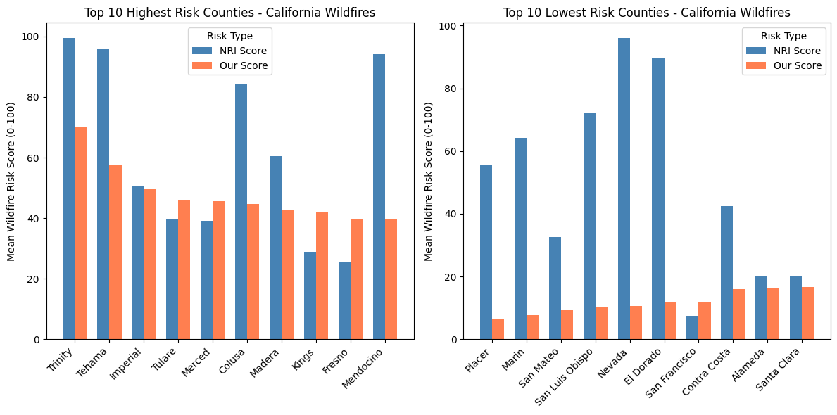
Figure 2: Bar Chart – Top/Bottom Risk Counties
Custom model produces more extreme values
- NRI smooths results due to social variables

3.3 California Earthquake Maps
Figure 3 illustrates the difference in earthquake risk distribution across California between the NRI model and the proposed model. The NRI model produces a more uniform distribution of risk, while the proposed model identifies more concentrated high-risk regions. This highlights how weighting and variable selection influence spatial outcomes.
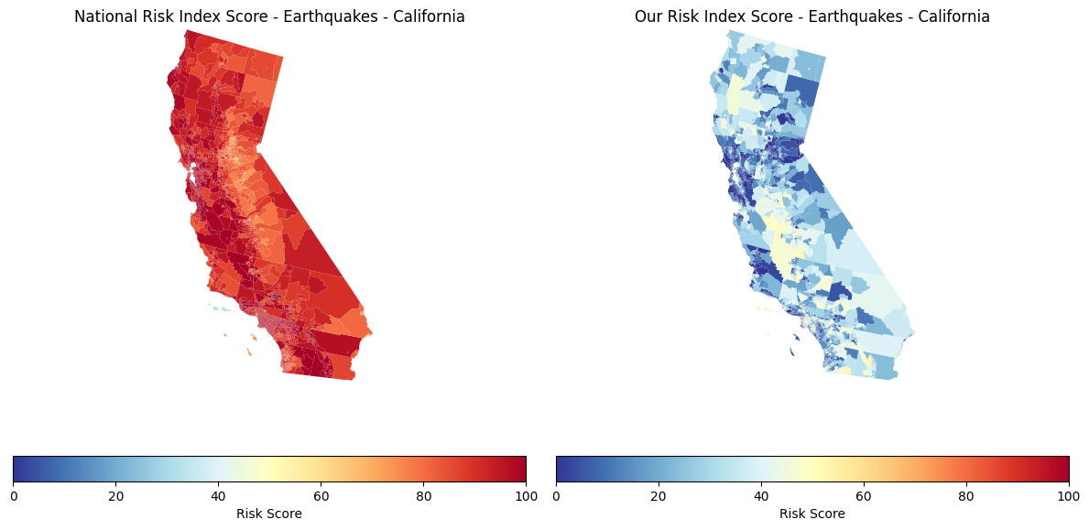
Figure 3: Comparison of NRI and Proposed Risk Model for Earthquake Risk in California (Census Tract Level)
Figure 4 presents a comparison of earthquake risk rankings across counties. The NRI model maintains consistently high scores, while the proposed model shows lower and more varied values. This difference suggests that the NRI model smooths results, whereas the proposed model highlights more extreme differences between counties.

3.4 California Earthquake Bar Charts
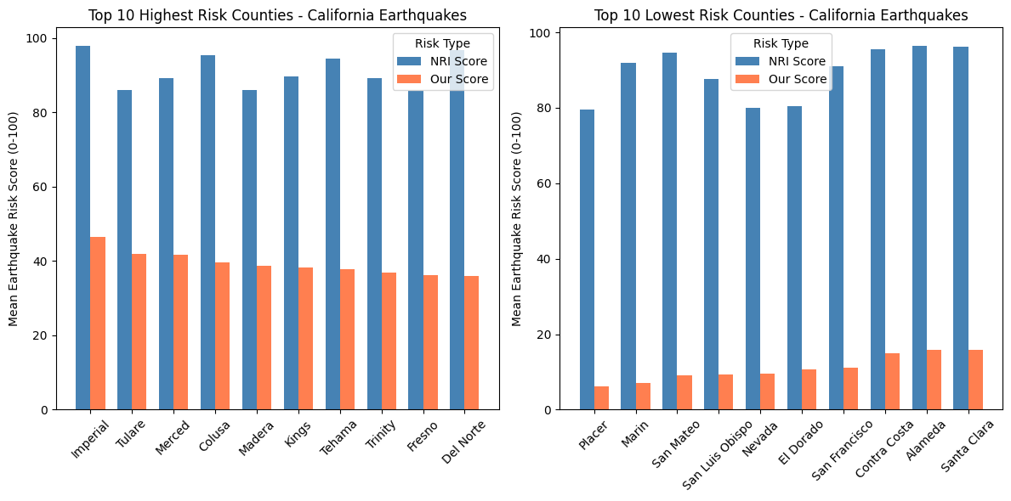
Figure 4: Top 10 Highest and Lowest Risk Counties for Earthquakes in California (NRI vs Proposed Model)

3.5 Alaska Case Study
Figure 5 shows the distribution of cold wave risk in Alaska. The NRI model displays higher risk values across northern regions, while the proposed model produces a more varied distribution. This demonstrates how hazard type and geographic characteristics influence risk outcomes differently across models.

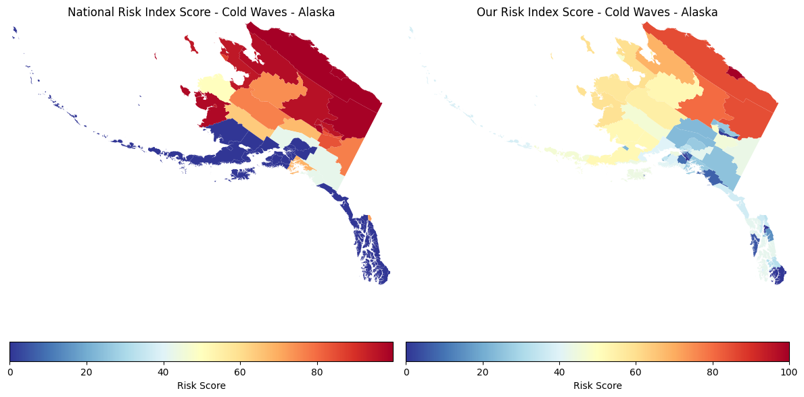
Figure 5: Comparison of NRI and Proposed Risk Model for Cold Wave Risk in Alaska

3.6 – Alaska Bar Charts
Figure 6 compares the highest and lowest cold wave risk counties in Alaska. Similar to previous results, the NRI model produces higher and more uniform values, while the proposed model introduces greater variation. This reinforces the idea that model design significantly affects risk classification.
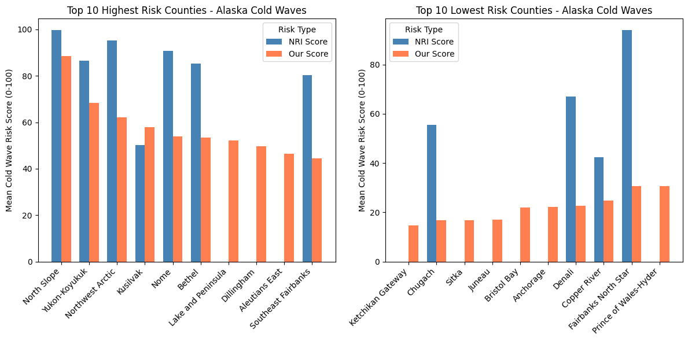
Figure 6: Top 10 Highest and Lowest Risk Counties for Cold Waves in Alaska (NRI vs Proposed Model)
- High-risk areas shift depending on model
- Shows sensitivity to hazard type and geography

Overall, the figures demonstrate that changing the definition of risk significantly impacts both the spatial distribution and ranking of high-risk areas. This has important implications for engineering decision-making, resource allocation, and disaster planning.

3.7 Key Insight
Changing the definition of risk:
- Changes rankings
- Changes spatial patterns
- Changes decision-making outcomes

3.8 Bias Analysis
Bias in Custom Model
- Ignores some social complexity
- Focuses more on hazard + exposure
Bias in NRI Model
- May overemphasize vulnerability
- Can inflate risk in certain areas

4. Conclusion
In this project, we have seen how risk models give rise to very diverse results. FEMA’s NRI risk model takes into account social and resilience aspects, whereas the customized model focuses on hazard-related risks.
We have learned from this analysis how important model design is for engineering. Even slight differences in variables or weightings can cause large variations in results.
Moreover, the choice of changing the risk model created and eliminated various forms of bias. The elimination of the impact of social vulnerability and resilience could lead to underestimation of risk by the customized risk model, particularly for socially vulnerable populations. However, this risk model eliminates socioeconomic bias, leading to a clearer analysis of hazard impacts.
5. References
- FEMA National Risk Index
- ATSDR Social Vulnerability Index
- CIVE 202 Course Materials

