TECHNICAL REPORT

Visualization and Simulation of Transportation Data using NHTS and NGSIM
CIVE 202 - Civil Engineering Analysis II
Spring 2026
Prepared for: Federal Highway Administration (FHWA)
Prepared by: Abdi Aden
Date: March 31, 2026

1. Introduction
Transportation systems play a critical role in supporting economic activity and daily life. To improve transportation planning and decision-making, the Federal Highway Administration (FHWA) collects large datasets such as the National Household Travel Survey (NHTS) and the Next Generation Simulation (NGSIM) dataset.
The objective of this project is to analyze transportation data using visualization techniques and to simulate vehicle-following behavior using the Intelligent Driver Model (IDM). This study focuses on identifying patterns in travel behavior, vehicle characteristics, and driver interactions. The results provide insights that can be used to improve traffic efficiency, safety, and infrastructure planning.
2. Methods
2.1 Description of Variables Selected and Justification
The variables used in this analysis were selected based on their ability to represent key transportation trends and driving behavior.
NHTS Variables
- travel_day
This variable represents the day of the week when trips occur. It was selected to analyze how travel demand varies across different days.
- vehicle_age
This variable represents the age of vehicles in years. It was selected to understand the condition and distribution of vehicles on the road, which can impact safety and emissions.
- vehicle_type
This variable categorizes different types of vehicles. It was selected to compare how vehicle characteristics differ across categories.
NGSIM Variables
- Time
Used to analyze changes in vehicle behavior over time.
- leader_speed and follower_speed
Selected to examine how vehicles interact in terms of speed.
- leader_acceleration and follower_acceleration
Used to analyze driver response and changes in motion.
- leader_position and follower_position
Used to track movement and calculate spacing between vehicles.
Derived Variable
- spacing = leader_position - follower_position
This variable represents the distance between vehicles and is critical for analyzing vehicle-following behavior.
Justification
These variables were selected because they provide both:
- Macro-level insights (travel patterns from NHTS)
- Micro-level insights (driver behavior from NGSIM)
This combination allows for a comprehensive understanding of transportation systems.
2.2 Description of How Each Plot Was Constructed
Each visualization was created using Python libraries including pandas, matplotlib, and seaborn.
Bar Chart (Travel Day vs Trips)
The number of trips for each day was calculated using value_counts() and sorted using sort_index(). A bar chart was then created using plot. Axis labels and a title were added for clarity.
Histogram (Vehicle Age Distribution)
A histogram was created using plt.hist() with multiple bins to group vehicle ages. This allows visualization of how frequently different age ranges occur.
Boxplot (Vehicle Age by Vehicle Type)
A boxplot was created using pandas boxplot() to compare vehicle age across categories. This plot displays median values, quartiles, and outliers.
Time-Series Plot (Speed vs Time)
A line plot was created using seaborn lineplot() to display leader and follower speeds over time. Two lines were plotted on the same graph for comparison.
Time-Series Plot (Acceleration vs Time)
Another line plot was created to compare leader and follower acceleration over time.
Spacing Plot (Distance vs Time)
A line plot was created using matplotlib to display the spacing between vehicles over time.
Simulation Plots (IDM Model)
The IDM model was implemented using a Python function that calculates acceleration based on speed, spacing, and relative velocity. The simulation iteratively updated follower speed and position.
The following comparisons were plotted:
- Actual vs simulated position
- Actual vs simulated speed
- Actual vs simulated acceleration
- Actual vs simulated spacing
All plots include proper titles, axis labels, and legends.
3. Results and Discussion
3.1 Key Findings from Each Plot
Travel Day (Bar Chart)
The number of trips varies across different days of the week, indicating that travel demand is not uniform. Certain days show higher activity, suggesting peak travel periods.
As shown in Figure 1, the bar chart displays the number of trips taken on each day of the week. The height of each bar represents the total trip count for that specific day.

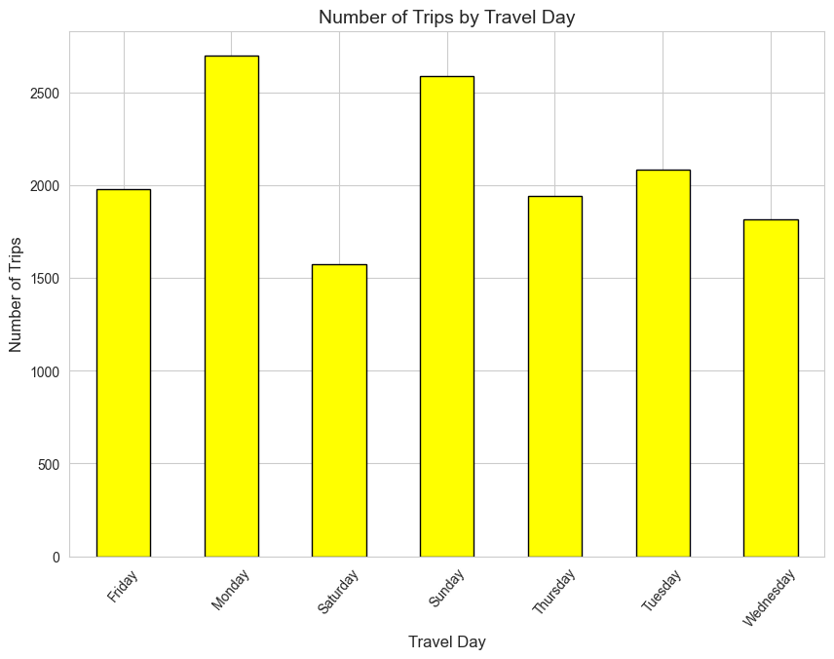
Figure 1: Number of Trips by Travel Day
The figure indicates that there is a difference in demand in various days, with some days having a higher number of trips than others. This implies that there is no equal distribution of transportation usage in a week. This is a significant aspect in transportation planning, as it helps in identifying peak days in transportation usage.
Vehicle Age (Histogram)
The distribution shows that most vehicles fall within a moderate age range. Very new and very old vehicles are less common, indicating a relatively stable but aging fleet.
As shown in Figure 2, the histogram illustrates the distribution of vehicle ages. The bars represent the frequency of vehicles within specific age ranges.
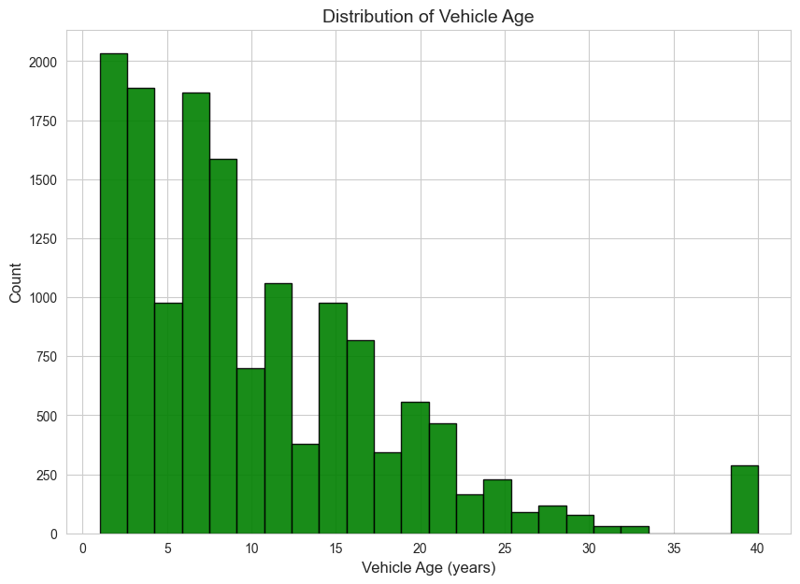
Figure 2: Distribution of Vehicle Age
It is obvious from the above figure that the majority of the vehicles are within the moderate age range, while the number of vehicles with low or high age is less. This shows that the vehicle population is aging but is still stable. The age of the vehicle is related to safety as well as pollution. The aged vehicle is the reason behind the increased pollution as well as accidents.
Vehicle Type (Boxplot)
Different vehicle types show variation in age distribution. Some vehicle types tend to be newer, while others are older, reflecting differences in usage patterns.
As shown in Figure 3, the boxplot compares vehicle age across different vehicle types. Each box represents the distribution of ages within a specific category.
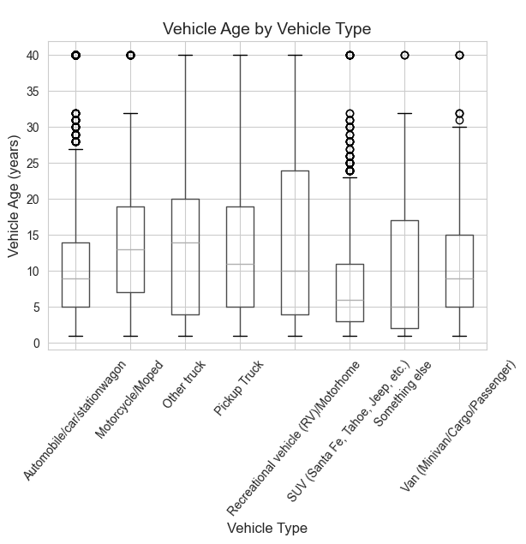
Figure 3: Vehicle Age by Vehicle Type
The figure illustrates differences in median age, variability, and outliers for various types of vehicles. Vehicles are newer in some types than in others, while they are older in some types than in others. This helps transportation engineers gain a sense of how different types of vehicles are used.
Speed Behavior (Time-Series)
The follower vehicle closely tracks the leader’s speed but with slight delays. This demonstrates reactive driving behavior and response time.
As shown in Figure 4, the time-series plot compares leader and follower speeds over time. Two lines represent how each vehicle’s speed changes.
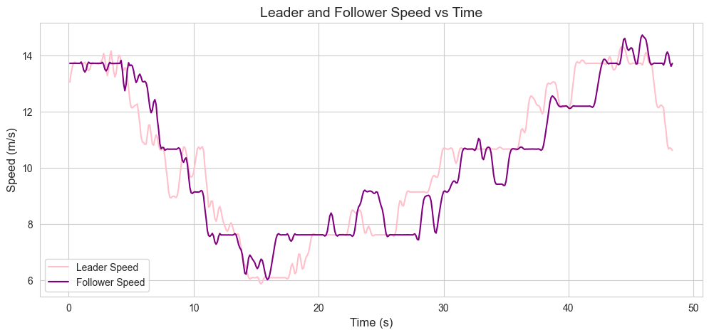
Figure 4: Leader and Follower Speed vs Time
The figure also illustrates that the speed of the follower vehicle closely follows that of the leader, though with some delays. This simulates real-life driver reaction. The knowledge of speed relations is important in traffic flow modeling and autonomous driving systems
Acceleration Behavior (Time-Series)
Acceleration fluctuates frequently, indicating that drivers continuously adjust speed in response to traffic conditions.
As shown in Figure 5, the acceleration of both leader and follower vehicles is plotted over time.
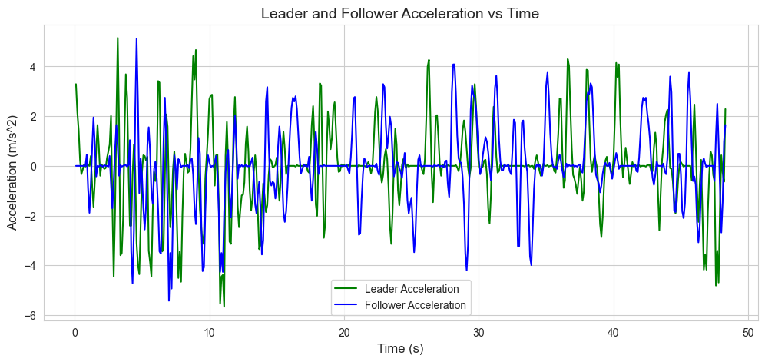
Figure 5: Leader and Follower Acceleration vs Time
The figure indicates fluctuations in acceleration, which show continuous driver adjustments in reaction to road conditions. Acceleration patterns are significant in analyzing road stability, fuel consumption, and road safety. This information will help in designing intelligent transportation systems.
Spacing Behavior
Spacing between vehicles changes over time, showing that drivers do not maintain a constant distance.
As shown in Figure 6, the spacing between the leader and follower vehicles is plotted over time.
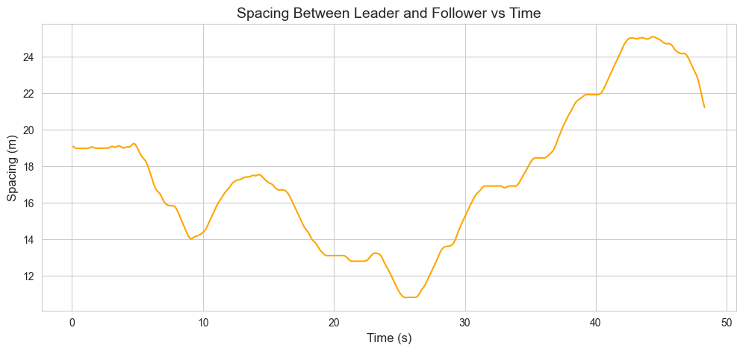
Figure 6: Spacing Between Leader and Follower vs Time
From the figure, it can be observed that the spacing is not constant and varies over time. This represents the real-world driving scenario. The spacing is related to crash risk and safety. This information can be used to design an adaptive cruise control and improve safety
IDM Simulation Findings
The follower behavior simulated appears to follow a trend similar to that of the actual data, although some differences exist. This suggests that the IDM model simulates behavior, although not exactly as in real life.
As shown in Figures 7-10, the actual and simulated vehicle behavior are compared using the IDM model.
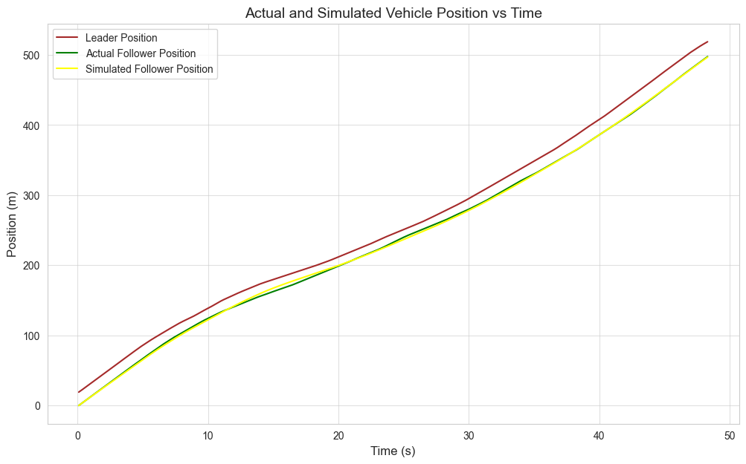
Figure 7: Actual vs Simulated Vehicle Position
The figure shows that the simulated position follows the general trend of the actual data but with some differences.
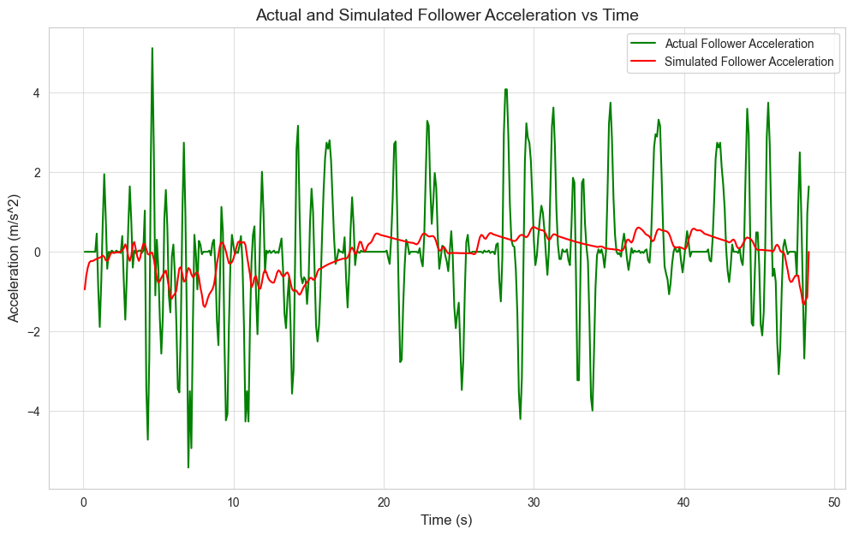
Figure 8: Actual vs Simulated Follower Speed
The simulated speed captures the overall trend but does not perfectly match real-world variations.
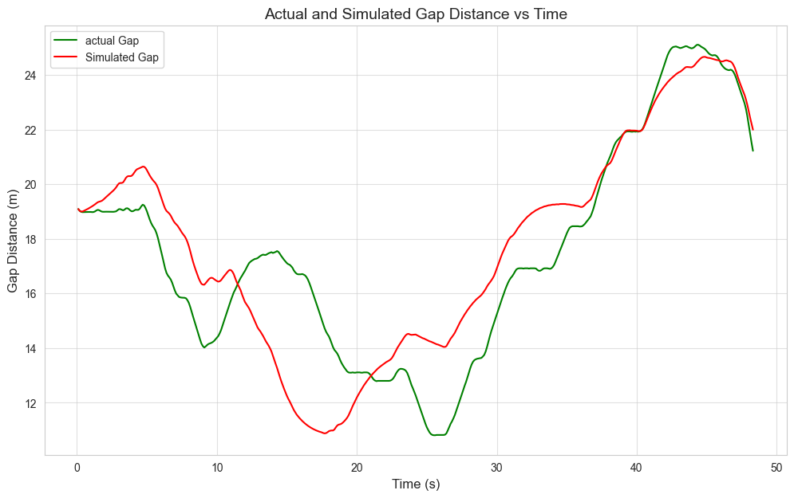
Figure 9: Actual vs Simulated Gap Distance
The gap comparison shows that the model approximates spacing but does not fully replicate real-world variability.
This IDM simulation is helpful in the prediction of traffic behavior, testing transportation policies, and designing vehicle automation. Nevertheless, the distinction between the actual and simulated data shows the requirement for sophisticated models.
3.2 Relevance to the Transportation Industry
Each finding has important implications:
Travel Patterns
Understanding which days have higher travel demand helps transportation planners manage congestion and improve scheduling of infrastructure use.
Vehicle Age
Older vehicles may contribute to increased emissions and safety risks. This information can support policies related to inspections and environmental regulations.
Vehicle Type Differences
Different vehicle types behave differently in terms of lifespan and usage. This helps in designing roads and traffic systems that accommodate diverse vehicles.
Speed and Acceleration Behavior
These findings are essential for:
- Traffic flow modeling
- Safety analysis
- Development of autonomous vehicles
Spacing Behavior
Spacing variability is directly related to crash risk and is important for designing driver assistance systems such as adaptive cruise control.
Simulation (IDM Model)
Simulation models like IDM are useful for:
- Traffic prediction
- Testing transportation policies
- Designing intelligent transportation systems

4. Conclusion
This project effectively analyzed the transportation data and simulated the behavior of vehicles following each other using Python. From the results, it is evident that there is a significant trend in the behavior of vehicles. The IDM model effectively showed the ability to approximate the behavior while indicating the areas for improvement.
This project shows the significance of data analysis and simulation in enhancing transportation. It supports the use of Python in the field of engineering.
5. References
Federal Highway Administration (FHWA).
National Household Travel Survey (NHTS).
Federal Highway Administration (FHWA).
Next Generation Simulation (NGSIM) Dataset.
CIVE 202 Course Materials.

