# Lab 7 – Week 9

# (MongoDB – Create/Delete Database/Collection/Documents)

## --***********************

## -- Name: Zelalem Setegn

## -- ID: 131846206

## -- Date: July 23, 2021

## -- Purpose: Lab 7 DBS311

## --***********************

1.

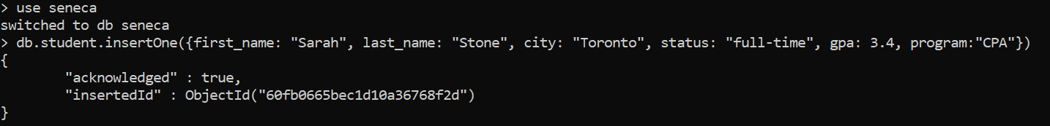

2. 

3.



4.

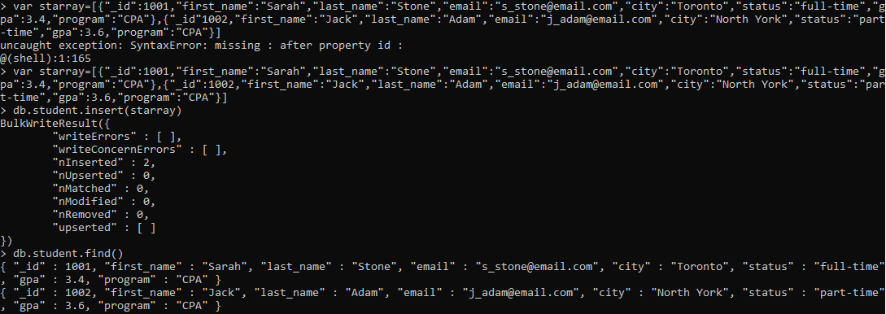

5.

6.

