# **Title**

**iDentity-Biometric Face Recognition Time Management System**

# **Aim**

iDentity is a Python Django web application that uses machine learning and facial recognition. This project seeks to invest in the growing market for AI applications by developing a cloud-based facial recognition system based on machine learning and deep learning. The project aims to create a centralized facial recognition time management system for targeting workplaces. The core of this project:

* **Security** – Ensure that data is delivered securely and that the programe is not utilized outside the company’s PCs.
* **Accuracy** - In order to minimize the risk of the software mismatching a user’s face while also ensuring that it does so as correctly as possible, the purpose of this step is to guarantee that.

Why was this form selected?

Like other biometrics systems, facial recognition technology analyses and compares distinctive characteristics to identify or authenticate users. Using a digital or networked camera, facial recognition software may identify faces in photos, measure their characteristics, and then compare them to templates that have already been stored in a database. The wide range of potential uses for face-scanning biometric technology demonstrates its versatility (Anon., 2022).

Facial recognition is a technology that has the capability to benefit society by increasing safety and security, reducing crime, and removing the need for human interaction. This project’s main objective is to provide a system that uses Biometric facial recognition technology to simplify clocks in and out in a workplace. Completely automated and easy to use and set up because, fully automated, we can eliminate human error. Biometric face recognition is used extensively in various contexts, including applications like Facebook or smartphones, workplaces, airports, colleges, and banks. The use of facial recognition software provides an extra layer of security for the workplace or premises by making it possible to determine whether or not an unauthorised person is present in a specific location. The third aim is to improve and reduce administrative overload by tracking employees’ working hours, so we can see when an employee has finished on a specific day. This cost-saving measure forbids false claims of hours worked, such as overtime, instead of paying employees for falsely reported hours worked.

The application will feature a front-end in which the admin can interact so they can log in to the system. The system’s administrator may add new staff using a form or, under the visitor’s menu option, can add visitors. Admin can view details of employees and their details and also what timetables are working. The front end will be linked to a back-end database containing personnel data and face attributes.

# **Objectives**

This project’s main objective is to construct a web application that makes the workplace safe and straightforward to access without the need for a key card, as well as to automate the login and log out and create a more Covid-compliant workplace. And offering an automatic and trustworthy Time management system that uses facial recognition technology, human process mistakes may be reduced.

**The objectives of this project:**

* To learn a new programming language Python
* To improve my knowledge about machine learning and better understand how Biometric facial recognition works and how we can improve it.
* To fully build and develop a professional web application with an inbuild facial recognition system
* To understand the Django framework to build my project
* And to improve my experience and knowledge of how to do academic research

**Achievable:**

1. Launch the system and log in as the admin
2. Log out of the system
3. View employees in the system
4. View employee timetables
5. An administrator can add new employees to the system through a new employee form
6. An administrator can add visitors to the system through the visitor form
7. Warning message if an unauthorised person tries to access the building
8. Employee hours worked or if they had worked overtime.
9. Weekly reports on how many hours they worked that week to employees through email.

The application should meet the above objectives and goals to ensure the companies have an easy-to-use Biometric Face Recognition Time Management System.

# **Background**

Once, the only way to keep track of employee attendance was with pen and paper sheets. Biometric attendance solutions are quickly becoming the go-to tool for businesses that want to cut down on time theft and the costs that come with it. Even though biometrics isn’t a perfect answer, the pros of a biometric time management system far outweigh any possible cons (Anon., 2020). Also, we lived our life the last two years where we were restricted because Covid 19 using the Biometric time management system makes office space much more covid compliant and reduces the need to use the keycard and fob system.

**Companies that work with Facial Recognition:**

* Megvii, headquartered in Beijing, is the world’s largest third-party authentication software provider. They do this by using their expertise in image recognition and deep learning software technology. Their main product, Face++, is the world’s most popular open-source computer vision platform. Face++ employs cutting-edge biometric technology to recognise and analyse 106 facial data points. It supports a wide range of software development kits (SDKs), including PHP, Java, Python, iOS, and Ruby. It is often used by law enforcement to arrest criminals and analyse CCTV networks in urban areas (Anon., n.d.).
* Cognitec is a German company that makes software and hardware for biometrics. It is a big company that makes face recognition software and services that can be used worldwide. Based on the widely used FaceVACS technology, they offer customised facial recognition solutions that are easy to use (Anon., n.d.).
* Clear Secure: The biometric technology company Clear Secure offers members a secure identification and verification service. The secure identification platform CLEAR, the company’s main product, is widely used at stadiums and airports. Large security check lines can be passed by members in under 5 minutes.
* iProov is a cyber-security firm established in London that provides biometric authentication to its internet customers while maintaining high security, privacy, and usability. It is extensively utilised in various public and government sectors, financial institutions, digital identity providers, and travel companies, to name a few. iProov Face Verifier is a remote face verification authentication program that allows businesses to compare a user’s face to a pre-enrolled biometric template (Anon., n.d.).

**What is the key benefit of the application:**

1. High precision

Even if a biometric attendance system can’t do anything else for you, it can help you keep track of your employees’ attendance and might be worth the price of admission by itself. Because there are so many different biometric markers, it is tough for someone to fake their attendance (Anon., 2020).

1. Can simplify payroll

Biometric attendance systems can make this service easier by turning it into an automated process that doesn’t cost anything extra and is just as accurate as its original tracking functions (Anon., 2020).

1. No need for physical contact

It can help businesses stop the spread of infections or viruses and recognise staff members wearing masks (Anon., 2020).

1. Enhance security in the workplace

As mentioned earlier, a Biometric face attendance system can enhance security through the camera.

**The biggest issue with Biometric systems**

1. The process of collecting biometric data and mapping it to identity is the biggest obstacle (Anon., 2019).
2. The primary concern with the biometric approach is privacy. (Anon., 2019)
3. If the information is hacked even once, it might result in various negative outcomes (Anon., 2019).
4. It is expensive, and other expenses are related to setting up, running, and maintaining the system (Anon., 2019).

# **Research Approach**

The first question in this project is how I can do it and what I need to do to make it happen because this is a new technology that we did not cover in college, so I need to do a few crash courses to take the challenge. I need to research what APIs are out there that can make project development much more manageable.

**Technologies & Concept**

1. **Django**

Web applications may be developed with Django and launched in a couple of hours. Django handles a lot of the difficulty associated with web development, allowing you to concentrate on developing your app without having to create the wheel. It is open source and free (Anon., 2019). Django was created to make it as simple as possible for developers to create applications from scratch (Anon., 2019).

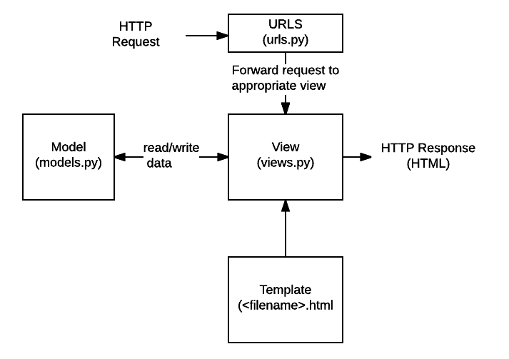 (Anon., n.d.)

The above image shows the Django framework I like to use for my project.

1. **Python**

Python is simple to use, simple to understand, and adaptable. It indicates that Python, a programming language used to build machine learning, may be utilised with any operating system, including Windows, Linux, Unix, and macOS (Kumar, 2021). The Python library offers fundamental components, so programmers don’t always have to start from scratch. Python libraries enable you to access, handle, and manipulate your data, which is necessary for machine learning (Kumar, 2021).

1. **OpenCV**

It is a free and open-source library of computer vision and machine learning software (Anon., n.d.). The collection contains more than 2500 optimised algorithms, including several both established and cutting-edge computer vision and machine learning methods. These algorithms may be used to identify landscapes, detect related images in an image database, erase red eyes from flash shots, track eye movements, and create overlay markers. Additionally, they can be used to recognise faces and detect objects, classify human actions in videos, track camera movements, track moving objects, extract 3D models of objects, create 3D point clouds from stereo cameras, stitch images together to create high-resolution images of entire scenes, and extract 3D models of objects (Anon., n.d.).

1. **Trust 720P HD camera**

HD camera with inbuild microphone for image recognition for the project

**Grant Chart**

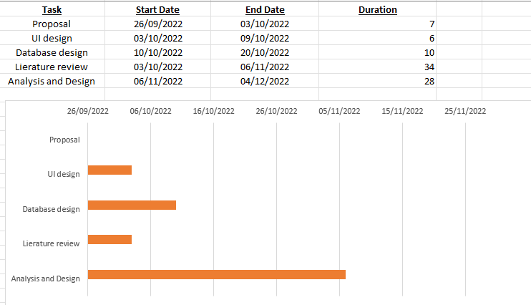

# **Potential Outcomes**

This project’s potential outcomes are developing a user-friendly web app for small businesses to manage and automate their clock in and out and enhance their security.

# **Bibliography**

Anon., 2019. *Django overview | Django.* [Online]   
Available at: https://www.djangoproject.com/start/overview/  
[Accessed 2 October 2022].

Anon., 2019. *Nutech Pros and Cons of Biometrics:.* [Online]   
Available at: http://www.nutechsolution.com/pros-cons-biometrics/  
[Accessed 1 october 2022].

Anon., 2020. *The 8 Main Advantages of Biometric Attendance Systems - NCheck Bio Attendance.* [Online]   
Available at: https://www.ncheck.net/biometric-attendance-systems-advantages  
[Accessed 01 October 2022].

Anon., 2022. *Biometric Facial Recognition - FindBiometrics.* [Online]   
Available at: https://findbiometrics.com/solutions/facial-recognition/  
[Accessed 30 September 2022].

Anon., n.d. *About.* [Online]   
Available at: https://opencv.org/about/#:~:text=OpenCV%20(Open%20Source%20Computer%20Vision,perception%20in%20the%20commercial%20products.  
[Accessed 2 10 2022].

Anon., n.d. *Facial Recognition Market Top Companies | Facial Recognition Companies Revenue by 2028.* [Online]   
Available at: https://www.emergenresearch.com/blog/top-10-leading-facial-recognition-companies-in-the-world  
[Accessed 19 10 2022].

Anon., n.d. *MDN Web Docs Django introduction.* [Online]   
Available at: https://developer.mozilla.org/en-US/docs/Learn/Server-side/Django/Introduction  
[Accessed 2 10 2022].

Kumar, S., 2021. *Why Python is Best for AI, ML, and Deep Learning.* [Online]   
Available at: https://www.rtinsights.com/why-python-is-best-for-ai-ml-and-deep-learning/#:~:text=The%20Python%20library%20provides%20base  
[Accessed 2 10 2022].