
4th International Seminar of Science and Applied Technology
Politeknik Negeri Bandung
Bandung, 15 October 2025

${Date Sent}
LETTER OF ACCEPTANCE

Dear Authors: ${List of Authors}
Thank you for your submission to the ${Conference Name}. We are pleased to inform you that your paper titled “${Paper Title}” has been provisionally accepted for oral presentation by the conference committee.
Please note the following requirements:
- Revise your paper according to the feedback from the editor and reviewers. The revised version must strictly follow the provided template and have a similarity score of less than 20%.
- Upload the camera-ready manuscript (Word), presentation file (PPT), and—if you are an online presenter—the presentation video link via our submission system at https://submeet.id no later than ${Supporting Materials Deadline}.
- Complete the registration payment no later than ${Payment Deadline}. Payment details and instructions for uploading the proof of payment are available in the submission system.
- The final decision on publication is the authority of the E3S Publisher, and will be made after payment is confirmed.
- To be included in the proceedings, at least one author must attend and present the paper at the conference. Papers not presented will be withdrawn from the final program and proceedings. Please note that no refund will be issued in such cases.
The presentation schedule will be announced shortly. We sincerely thank you for your contribution to ${Conference Name} and look forward to welcoming you at ${Conference Location}.

Best regards,
General Chairman
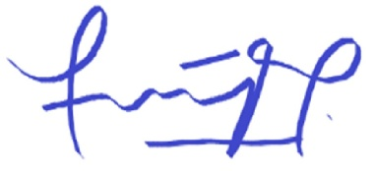

Purwinda Iriani, Ph.D.
E-mail: issat@polban.ac.id

