

Data Technician

Name:
Course Date:
Table of contents
Day 1: Task 1 2
Day 1: Task 2 2
Day 2: Task 1 3
Day 2: Task 2 3
Day 3: Task 1 4
Day 3: Task 2 5
Day 4: Task 1 6
Day 4: Task 2 7
Course Notes 7
Additional Information 8

Day 1: Task 1

Please research the different versions of Tableau, compare and contrast them below and explain the limited functionality on ‘Tableau Public’.

Different Tableau versions | There are three versions of Tableau; Desktop + Server, Public and Cloud.  The limits of ‘Tableau Public’; No private workbooks, everything is public.  Usage of limited data sets such as Excel, CSV and Google Sheets.  Limited Data Size & Storage 10GB

Day 1: Task 2

Using the EMSI_JobChange_UK dataset, create your own dashboard, I want to see a bar chart showing percentage change and a UK based map showing the key city locations impacted.

Paste your print screen here | 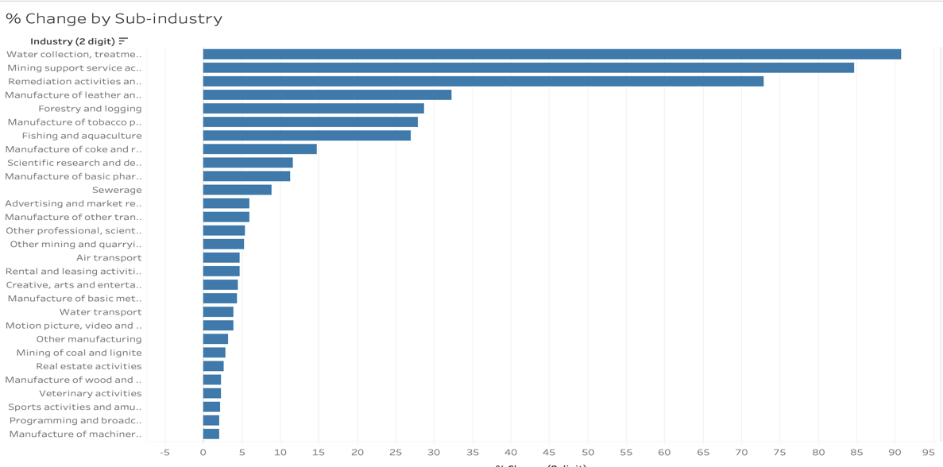  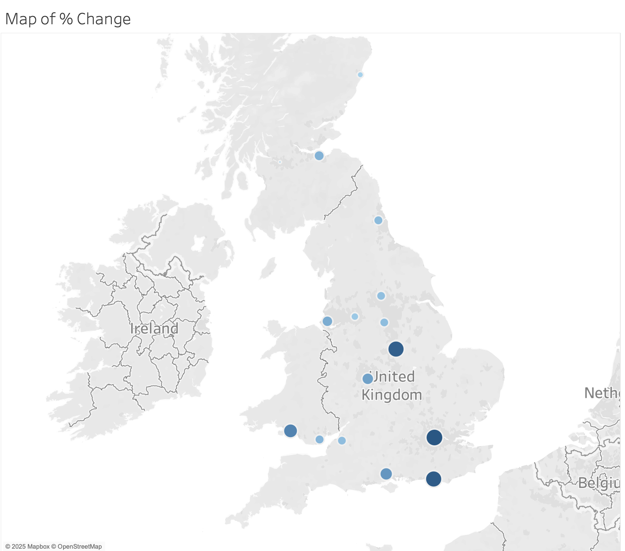

Day 2: Task 1

Using the Spotify data set, conduct an analysis to find trends and key information that could be used by an organisation for future projects.

There is no set scope for the analysis, simply to find trends and document them below:
Paste your print screens here | 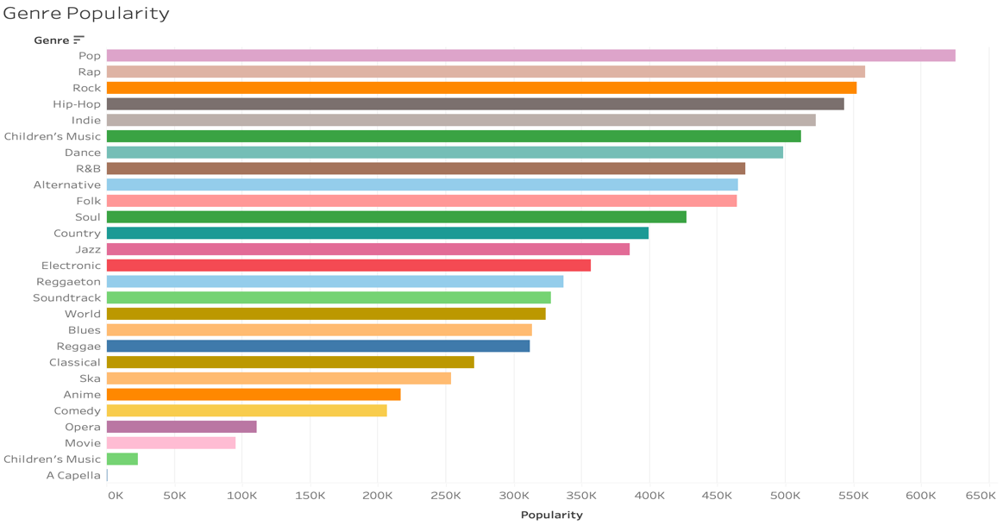  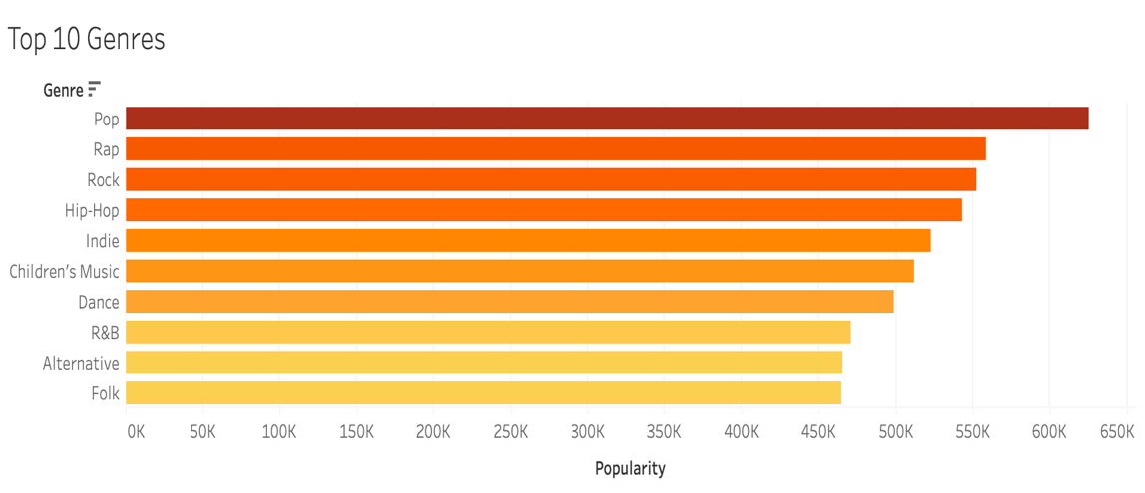  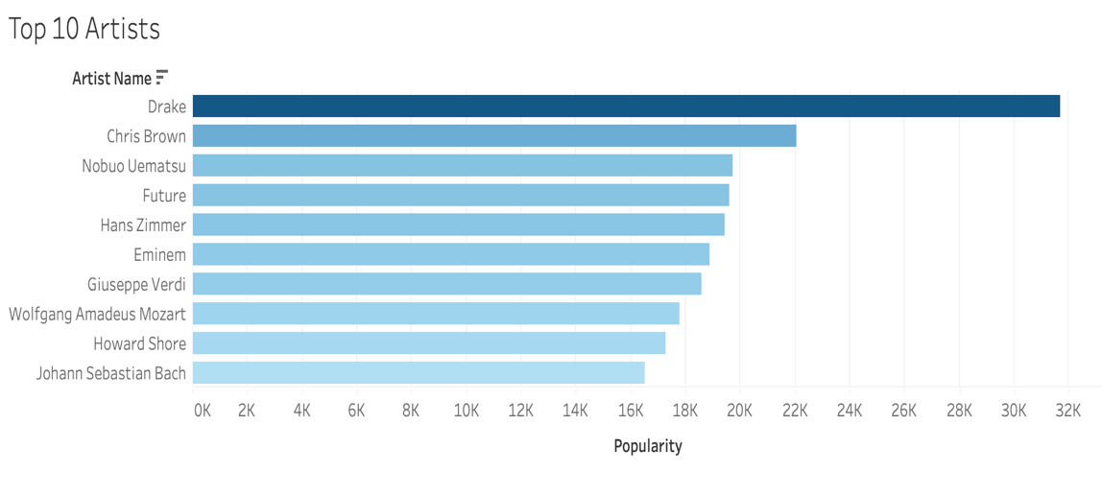  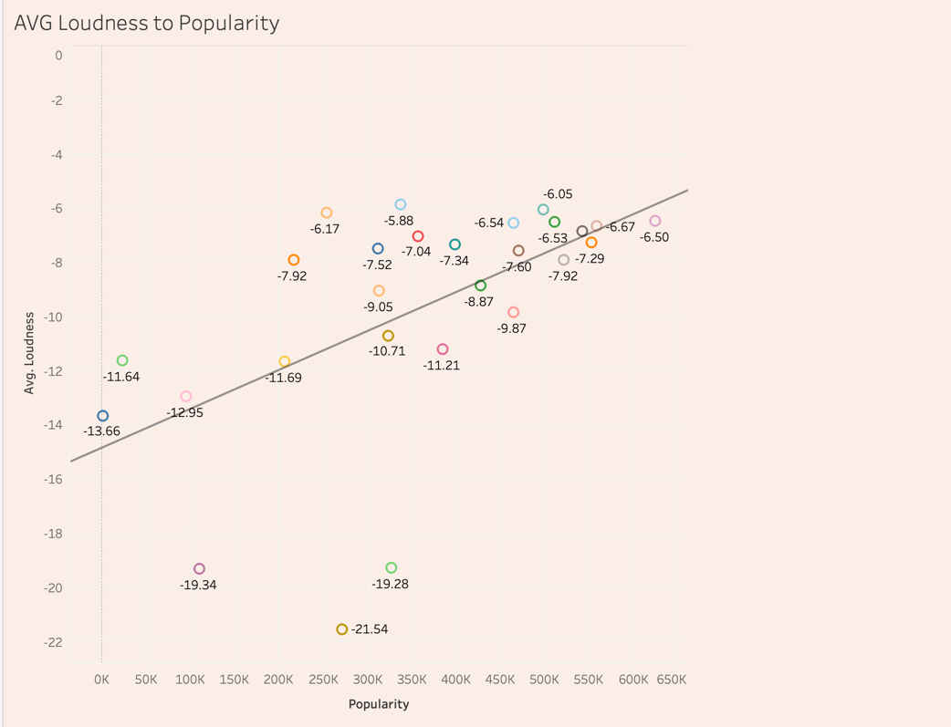  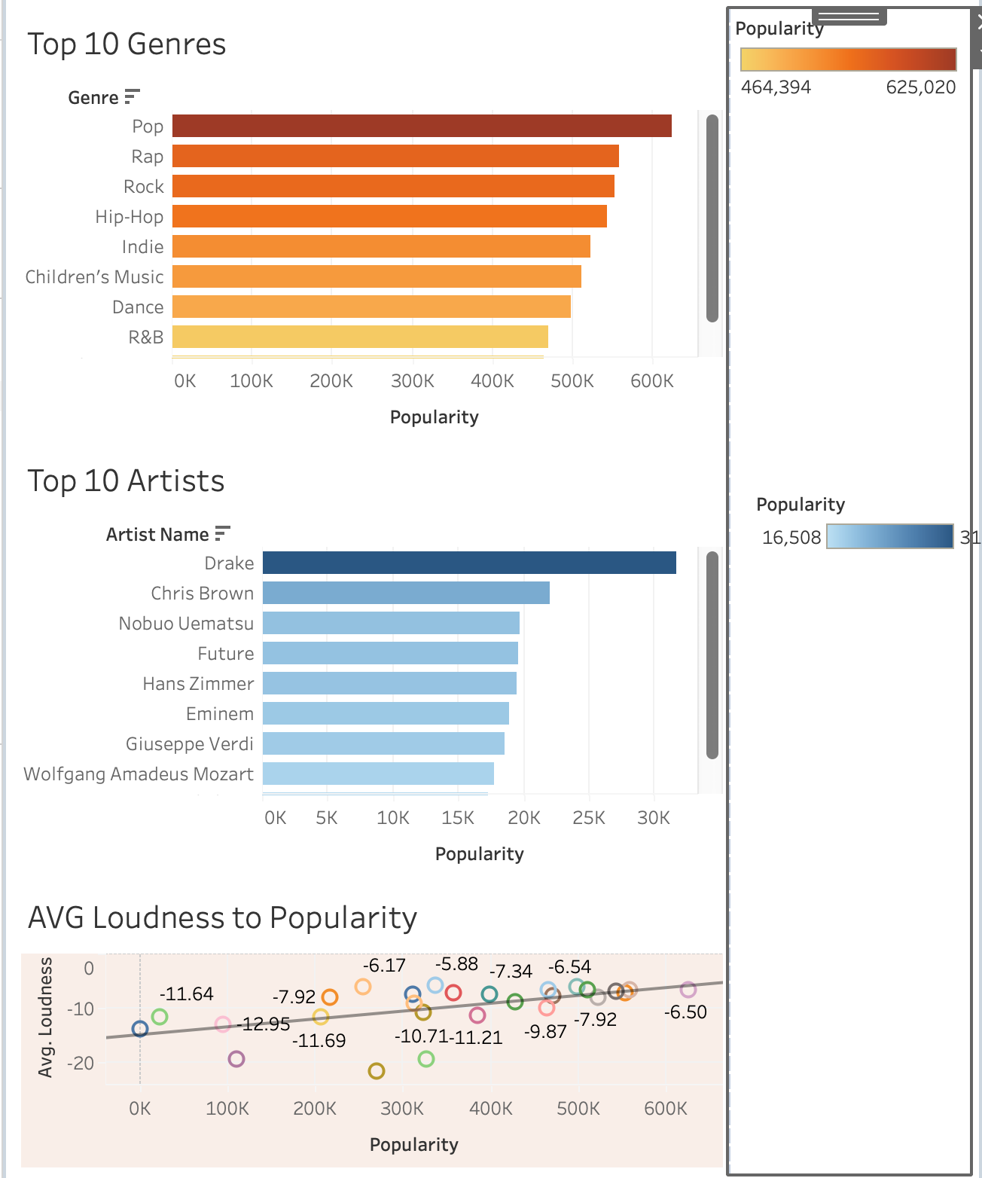

What did you find? | I analysed this Spotify dataset and here is the data that I found:  I measured ‘Genre Popularity’ and my data showed that the most streamed genre is ‘Pop’ (625,020 streams) and the least streamed genre is ‘Acapella’ with a figure of (1,107 streams).  I then went on to find the top ten most streamed genres so that I can understand what the audience are really drawn to. As previously stated ‘Pop’ is the top streamed genre, followed by ‘Rap’ in second (558,848 streams) and then ‘Rock’ in third (552,791 streams). In addition, ‘Folk’ is ranked tenth, ‘Alternative’ is ranked ninth and ‘R&B’ is ranked eighth.  My results also discovered the most streamed artist which is ‘Drake’ in first, ‘Chris Brown’ in second and ‘Nobuo Uematsu’ in third. This result gives me confidence with my previous results as ‘Drake’ and ‘Chris Brown’ are globally recognised Rap and Hip-Hop stars.  Digging deeper, I looked at the most streamed songs and ‘Home’, ‘You’ and ‘Stay’ were the top 3. Unfortunately, I couldn’t find the artist name of the songs.  I moved on to find out if the ‘Average Loudness’ of a track has any correlation with the ‘Popularity’ of the genre. My results show me that there is a positive correlation with average loudness of genre and popularity. A majority of the clusters move to the right of the chart and sit between -7 dB and -6 dB, the less popular genres have a lower average of -13 dB to -22 dB. Studies show that most music falls between -5 dB and -15dB (modern pop at the louder end and acoustic/jazz at the quieter end)

Day 2: Task 2

Using the Health data set, conduct an analysis to find trends and key information that could be used by an organisation for future support.

There is no set scope for the analysis, simply to find trends and document them below.

- Data can be lifesaving and is being used more within the NHS, reflect on how this data could support decision making for the NHS.

Paste your print screens here
What did you find and any reflections on how the NHS could use this?

Day 3: Task 1

Please complete Lab 1 ‘Get Data in Power Bi Desktop’. Once complete, paste a print screen below and in the collaboration board.

“Teaching is the best way to learn, so please listen out for support requests from the class and we’ll work through the challenges together”

Paste your completed lab here | 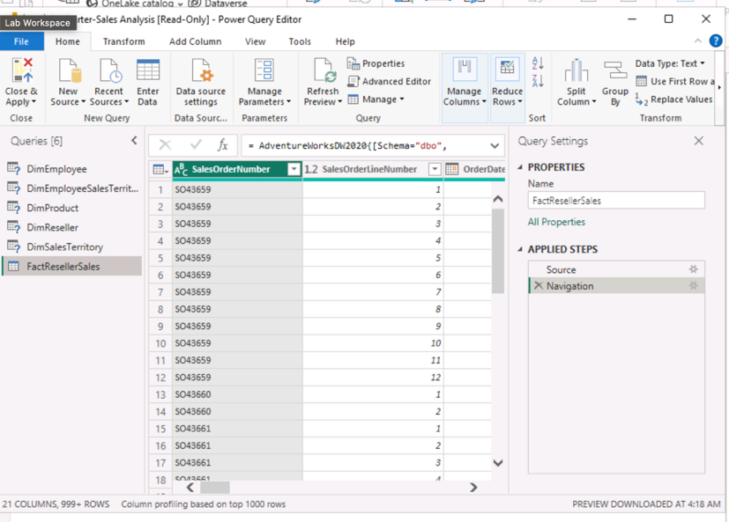

Day 3: Task 2

Please complete Lab 2 ‘Load Transformed Data in Power BI Desktop’. Once complete, paste a print screen below and in the collaboration board.

“Teaching is the best way to learn, so please listen out for support requests from the class and we’ll work through the challenges together”

Paste your completed lab here | 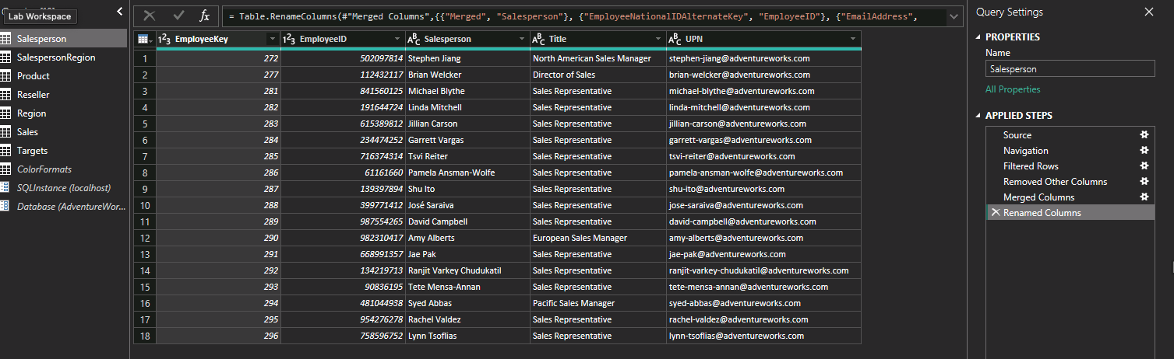

Day 4: Task 1

Please complete Lab 6 ‘Design a Report in Power BI Desktop’. Once complete, paste a print screen below and in the collaboration board.

“Teaching is the best way to learn, so please listen out for support requests from the class and we’ll work through the challenges together”

Paste your completed lab here

Day 4: Task 2

Please complete Lab 9 ‘Create a Power BI Dashboard’. Once complete, paste a print screen below and in the collaboration board.

“Teaching is the best way to learn, so please listen out for support requests from the class and we’ll work through the challenges together”

Paste your completed lab here

Course Notes

It is recommended to take notes from the course, use the space below to do so, or use the revision guide shared with the class:

Additional Information

We have included a range of additional links to further resources and information that you may find useful, these can be found within your revision guide.

END OF WORKBOOK

Please check through your work thoroughly before submitting and update the table of contents if required.

Please send your completed work booklet to your trainer.

