

Data Technician

Name:
Course Date:
Table of contents
Day 1: Task 1 3
Day 1: Task 2 3
Day 1: Task 3 4
Day 2: Task 1 5
Day 3: Task 1 9
Day 3: Task 2 10
Day 3: Task 3 11
Day 4: Task 1 12
Day 4: Task 2 13
1. Scenario Background 13
2. Data Laws and Regulations 14
3. Azure Service Recommendations 14
4. Data Types and Data Modelling 14
5. Data Storage Formats and Structures in Azure 14
6. Additional Considerations 15
Submission Guidelines: 15
Course Notes 17
Additional Information 17

Day 1: Task 1

Please research and complete the below questions relating to key concepts of cloud.

Be prepared to discuss the below in the group following this task.

What can cloud computing do for us in the real-world? | Cloud computing allows us to store, access and process data and applications online.
How can it benefit a business? | Cloud Computing can benefit a business because you are able to access files anywhere, collaborate with employees, real time analytics, scalability, cost effective, data storage, integration with BI tools, security protocols, data back-up and recovery.
What’s the alternative to cloud computing? | The alternative to Cloud Computing is using a local computer. All servers, storage and software are handled on-site with a local computer. The organisation manages their IT and hardware.
What cloud providers can we use, what are their features and functions? | Amazon Web Services (AWS) – Largest provider, offers computing, storage and databases.  Microsoft Azure – Integrates all of Microsoft’s products, supports cloud apps, virtual machines and analytics. A cost-effective solution.  Google Cloud Platform (GCP) – Strong in data analytics, AI and Machine Learning.  Netflix – A video streaming platform that gives user access to a large library of movies and series  Slack – A team communication software that allows users to communicate with their employees via text or call.  Dropbox – A file storage and sharing platform.

Day 1: Task 2

Please research the below cloud offerings, explain what they are and examples of use cases.

Cloud Offerings | Explain what it is | When / how might you use this service in the real-world?
IaaS (Infrastructure as a service) | IaaS provides access to virtual computing services such as virtual computing or data storage space.  AWS EC2 and MS Azure Virtual Machines. | Users would use IaaS when:  Users want to store large volumes of data securely online.  Use cloud servers for back-up and recovery if systems ever fail.  Creating virtual environments to collaborate.
PaaS (Platform as a service) | PaaS is a service that allows users to build, test and deploy apps without managing hardware and servers.  MS Azure App Service, AWS Elastic Beanstalk and Google App Engine. | Users would use PaaS when:  Users want to build web or mobile apps, using a built-in framework.  Developing and managing API’s for connecting different software systems.  To run analytics or machine learning workflows without handling
SaaS (Software as a service) | SaaS delivers ready to use applications over the internet. Users can access via the internet and don’t need to install or run any maintenance. SaaS helps businesses save time, reduce costs and access software anywhere.  MS Outlook 365, Slack, Salesforce (CRM), Xero (Accounting) and Netflix. | Users would use SaaS when:  Users would like to communicate with team members via text or video call.  Users can upload documents and collaborate in real time with colleges or clients.  Users would use when they want to manage their client profiles.  Users can access accounting platforms which can help reduce time and automate their work.

Day 1: Task 3

Please research the below terms and explain what they are, when they would be appropriate and a real-world example of where it could be implemented (i.e. what type of organisation).

Public Cloud | A public cloud deployment model is where computing resources (servers, storage, networks and applications) are made accessible over the internet via a third party.  A public cloud is an appropriate choice when an organisation wants to benefit from high powering services to match their demand for better costs, more flexibility and a time efficient turnover.  A real-world example would be:  Ecom store using a public cloud to support their website via holiday sale seasons.  Data analytics is another time a public cloud would be used. The public cloud allows users to have access to servers which can run large data-processing or machine learning jobs.  An organisation can use a public cloud for back up and data recovery.  Best for being cost efficient, scaling or a fast output.
Private Cloud | A private cloud is a personal cloud environment only used by one organisation. The private cloud can be hosted on site or by a third party, but the cloud cannot be shared with others. An appropriate time to use a private cloud is when you need full control of the build of the cloud and keeping sensitive data private or when complying with Data Acts and GDPR regulations.  Banks would be a real-world example of using private clouds as the data that they hold is extremely valuable and sensitive, leaked data could lead to the failure of the business.  Hospitals also store sensitive data so they would use a private cloud.  Government agencies have private documents that can be detrimental on a global scale if leaked, so they use a private cloud to keep their data very secure.
Hybrid Cloud | A hybrid cloud combines public and private clouds, allowing organisations to have access to both public and private sides of the cloud. A hybrid cloud would be appropriate when some workloads need high security and protection but also needs access for scalability. In addition, when a business wants to be cost efficient, as they can pay for the services they need tailored for their organisation.  A real-world example would be retailers keeping customer data private but using the data for marketing on public apps.
Community Cloud | A community cloud is a shared cloud environment used by organisations with shared interests or common concerns. A community cloud is appropriate when multiple organisations need to collaborate in a secure environment, also when shared regulations need to be met or working within compliance requirements.  Universities would use a community cloud when sharing researched data.  Healthcare providers when collaborating on patient care systems.  Government agencies when running joint projects.

Day 2: Task 1

Describe, with examples, the three major areas that the Computer Misuse Act deals with.

Area | Description | Example

The computer misuse act 1990 is an act where an individual can be criminalised because of computer related offense. Describe three extra powers that the Police and Justice Act 2006 (Computer Misuse) has added.

Description

Look at the below website to answer the questions:
https://www.gov.uk/personal-data-my-employer-can-keep-about-me

Write down three items of data which a company can store about an employee.

Give three more examples of data that an employer can only store if they first get the employee’s permission.

Conduct further research to answer the below questions.

Question | Answer
Provide one example of: Copyright infringement
Provide one example of: Plagiarism

What are two consequences of copyright infringement and software piracy?
Give three possible consequences for individuals when using pirated software

Listed below are some laws which we have covered today:

1. Computer Misuse Act 1990
2. Police and Justice Act 2006 (Computer Misuse)
3. Copyright, Designs and Patents Act 1988
4. Copyright (Computer Programs) Regulations 1992
5. The Health and Safety (Display Screen Equipment) Regulations 1992
6. Data Protection Act 2018
7. Consumer Rights Act 2015

- Insert a number in the first column of each row to match each of the statements with one of the above Acts.

- One of statements is incorrect and not illegal. For this statement, write ‘Not illegal’.

Act number | Clause
 | With some exceptions, it is illegal to use unlicensed software
 | Any product, digital or otherwise, must be fit for the purpose it is supplied for
 | Unauthorised modification of computer material is illegal
 | It is illegal to create or use a hacking tool for penetration testing
 | Personal data may only be used for specified, explicit purposes
 | Employers must provide their computer users with adequate health and safety training for any workstation they work at
 | It is illegal to distribute hacking tools for criminal purposes
 | It is illegal to distribute an illicit recording
 | Personal data may not be kept longer than necessary
 | Gaining unauthorised access to a computer system is illegal
 | Employers must ensure that employees take regular and adequate breaks from looking at their screens
 | It is illegal to prevent or hinder access (e.g. by a denial-of-service attack) to any program or data held in any computer
 | Personal data must be accurate and where necessary kept up to date

Day 3: Task 1

Please complete the below lab (3) ‘Explore relational data in Azure’ and paste evidence of the completed lab in the box provided.



Completed lab | 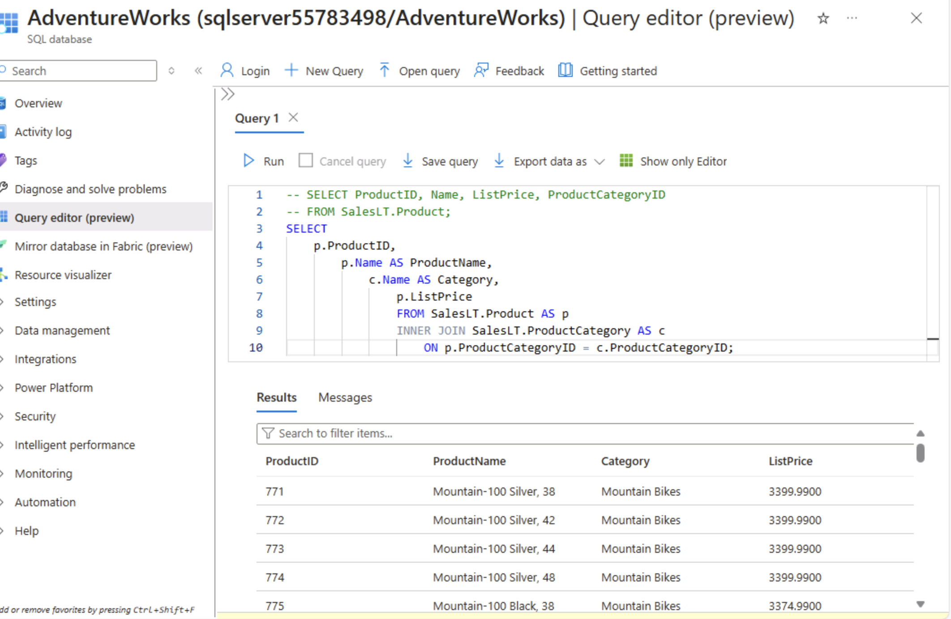

Day 3: Task 2

Please complete the below lab (4) ‘Explore non-relational data in Azure’ and paste evidence of the completed lab in the box provided.



Completed lab | 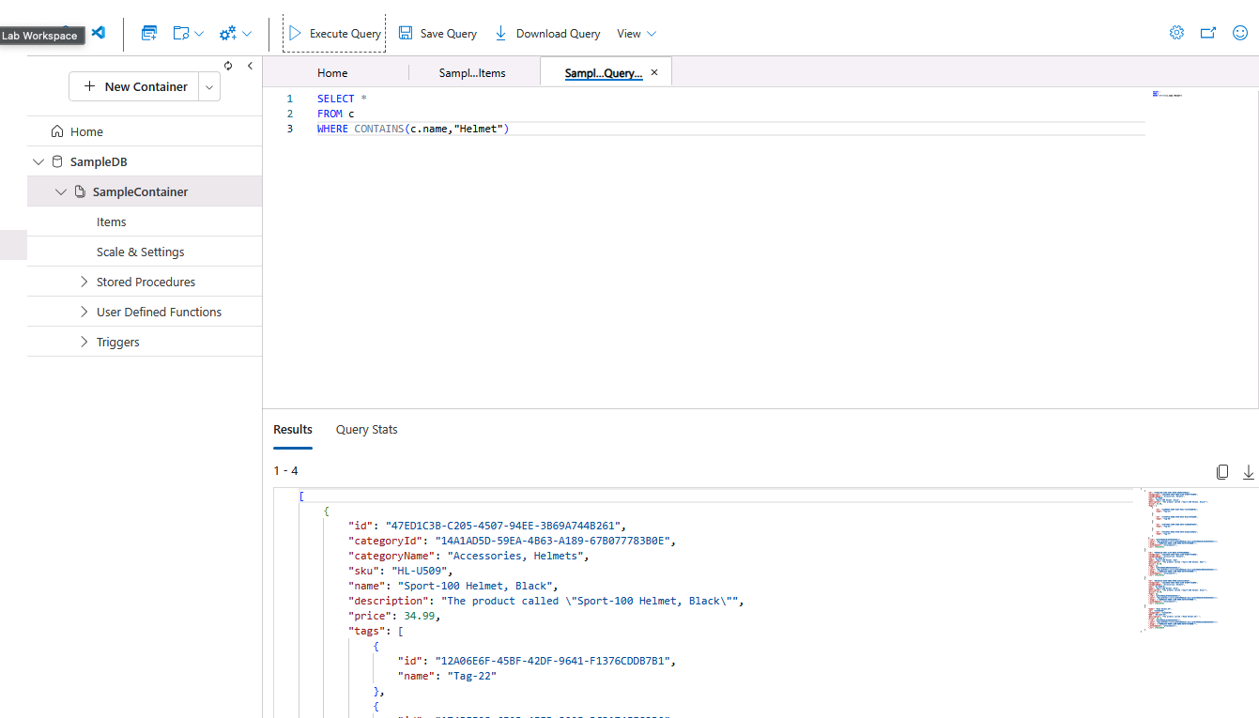

Day 3: Task 3

Please complete the below lab (5) ‘Explore data analytics in Azure’ and paste evidence of the completed lab in the box provided.

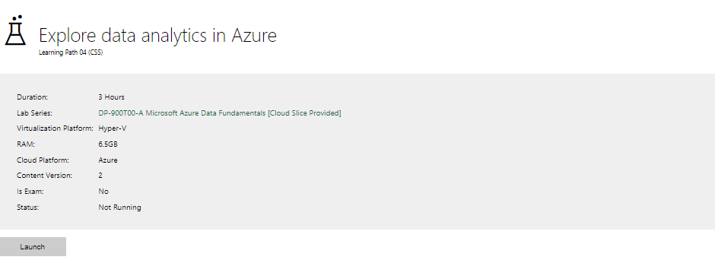

Completed lab

Day 4: Task 1

In your teams, complete the Azure DP-900 practice exam and paste your result below – this is open book and please research and discuss your answers as a team.


Result

Day 4: Task 2

1. Scenario Background
"Paws & Whiskers" is a growing pet shop that aims to improve its business by analysing sales, customer information, and inventory data. Currently, the data is collected manually or stored in spreadsheets. Management is interested in transitioning to Microsoft Azure to streamline data storage, analysis, and reporting, enabling them to make data-driven decisions.

2. Data Laws and Regulations
Identify and explain the data laws and regulations relevant to handling customer data within the proposal. Ensure you cover the following points:
- GDPR Compliance: Highlight the importance of adhering to the General Data Protection Regulation (GDPR), particularly as it relates to storing and processing customer information.
- Data Protection Act (DPA) 2018: Outline how the DPA 2018 may affect the way "Paws & Whiskers" collects and stores data, ensuring compliance with UK laws on data privacy.
- Other Industry Standards: Research any additional data protection standards or regulations that may apply to pet shop data, particularly if they involve sensitive or payment information.

3. Azure Service Recommendations
Recommend Microsoft Azure services that would suit the company’s data analysis needs and explain why these services are suitable. Your recommendations should include:
- Data Storage: Identify suitable storage options, such as Azure Blob Storage or Azure SQL Database, and discuss the benefits of each for storing large datasets, including inventory, sales transactions, and customer details.
- Data Analysis Tools: Recommend tools such as Azure Machine Learning for customer behaviour analysis or Azure Synapse Analytics for analysing sales trends.
- Data Integration and Automation: Explain how services like Azure Data Factory could automate data collection and integration processes, improving efficiency.

4. Data Types and Data Modelling
Define the types of data "Paws & Whiskers" will need to work with and describe your approach to data modelling:
- Data Categories: Identify key data types, such as customer demographics, transaction history, pet inventory, and product categories.
- Data Modelling Approach: Outline how you would structure this data using a relational model or a data warehouse approach, considering factors like tables, entities, relationships, and primary keys.

5. Data Storage Formats and Structures in Azure
Discuss how you would store data within Azure and the formats you would recommend:
- Data Formats: Specify recommended formats (e.g., CSV for raw data imports, JSON for structured data, Parquet for analytics) and explain why these formats are suitable for specific data types.
- Data Security and Encryption: Include recommendations for securing data using Azure’s built-in encryption features and access controls to ensure compliance with data privacy regulations.

6. Additional Considerations
Provide any other considerations that might enhance data handling and efficiency in Azure, such as:
- Backup and Disaster Recovery: Outline a backup plan using Azure Backup or Azure Site Recovery to safeguard against data loss.
- Data Visualisation: Discuss potential use of Power BI within Azure for creating dashboards that provide management with real-time insights into sales and customer trends.
- Future Scalability: Comment on how Azure services can scale as the business grows, accommodating larger datasets and more complex analyses.

Submission Guidelines:
- Structure: Ensure your report is well-organised, with sections for each task (e.g., Data Laws, Azure Services, Data Types, etc.).
- Formatting: Include headings, bullet points where appropriate, and any visuals or diagrams that support your explanations.
- References: Cite any resources or regulations referenced in the report.
- Length: Aim for 1500-2000 words.

Focus on data mining and data modelling
Client has data pipeline

Course Notes

It is recommended to take notes from the course, use the space below to do so, or use the revision guide shared with the class:

Additional Information

We have included a range of additional links to further resources and information that you may find useful, these can be found within your revision guide.

END OF WORKBOOK

Please check through your work thoroughly before submitting and update the table of contents if required.

Please send your completed work booklet to your trainer.

