y3 = 31.71*sqrt(x--0.4279) starting @ x = 1.0911

y4 = 30.18*sqrt(x-1.841) starting @ x = 2.2823

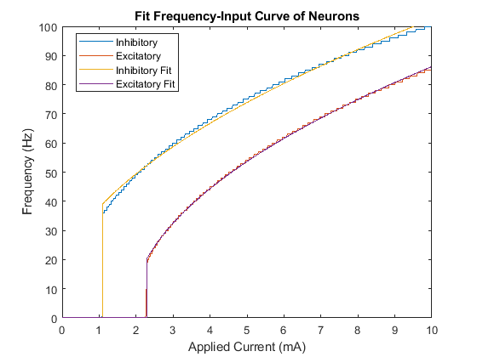

Applied these fits to the model:

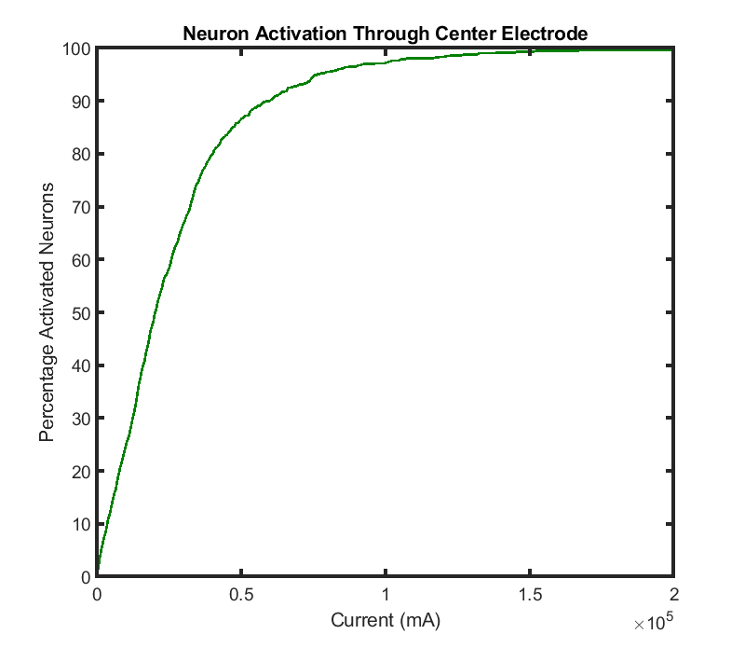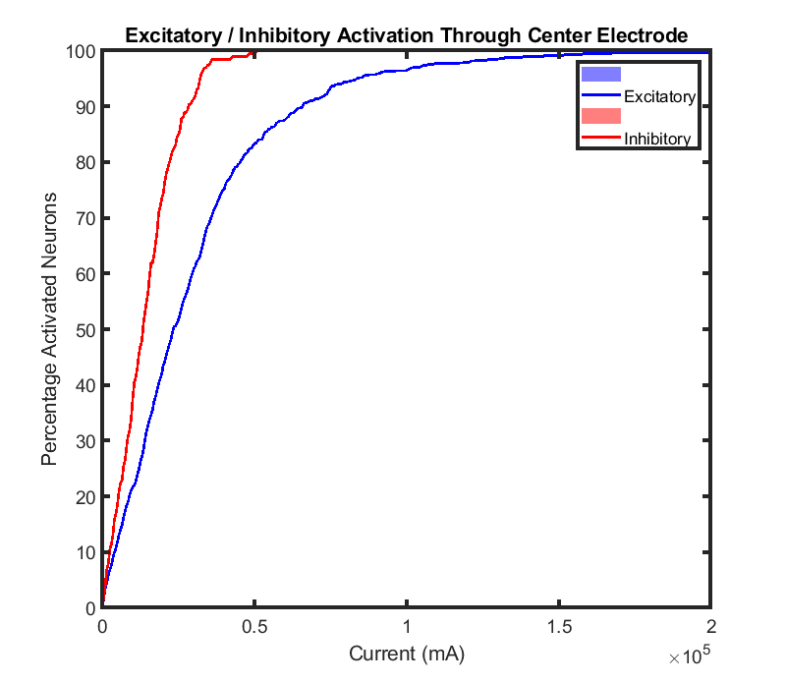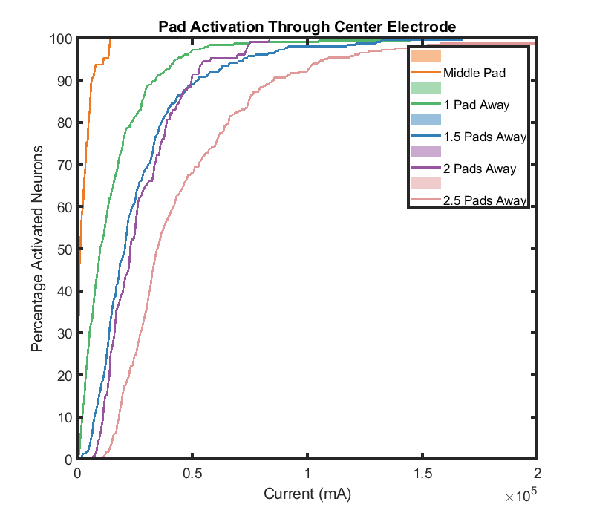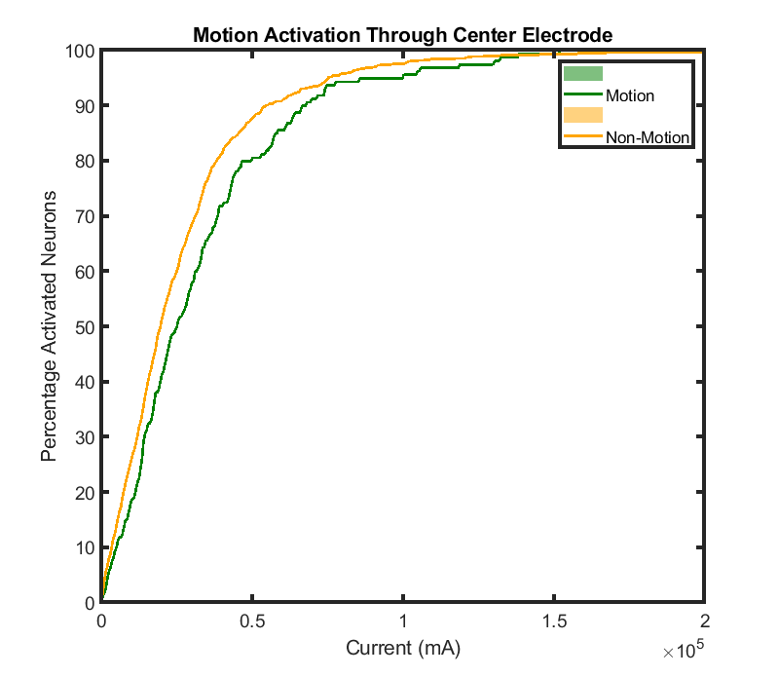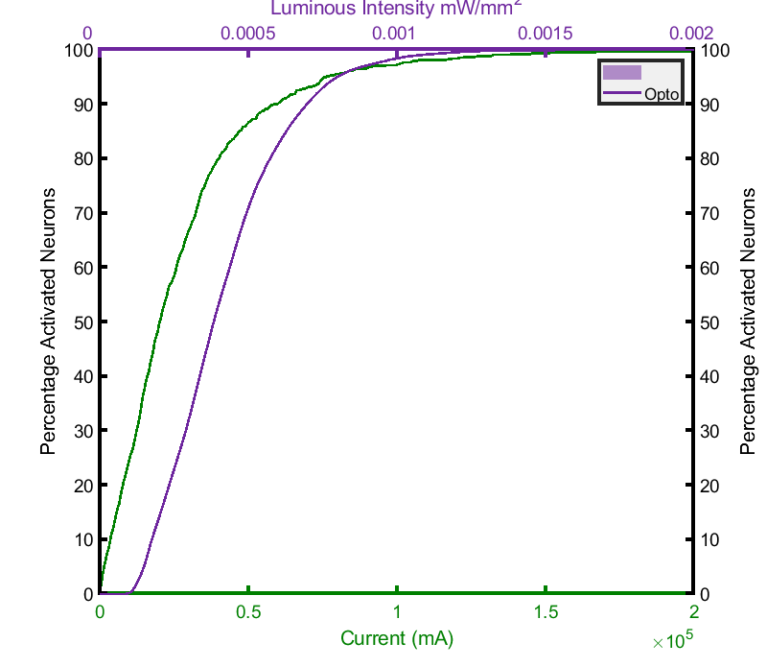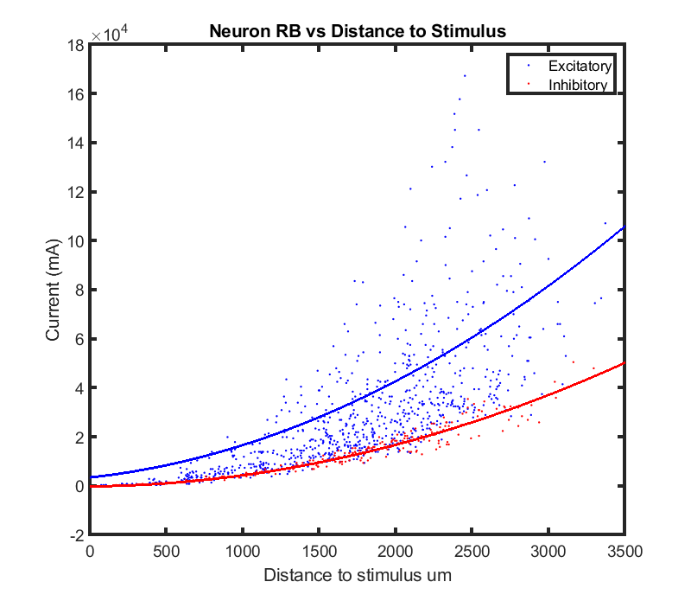

Given the following bounds:

1. MS -> No UB

2. Opto -> No UB

3. MS+opto -> UB threshold 50%, 10% of neurons, 5%

4. MS+opto -> No UB

|  |  |  |  |
| --- | --- | --- | --- |
| MS | Opto | MS+Opto (All +) | MS + Opto (All -) |
| 4 (stalls) | 5.25 (stalls) | 5.25 (stalls) | 1.41 |

C:\Users\HB\AppData\Local\Microsoft\Windows\INetCache\Content.Word\sols.tif