Wellness Scribe
Design and Architecture
Real-time speech-to-note proof of concept for wellness practitioners
Item | Detail
Document | Design and architecture description
Version | 1.0
Date | 13 November 2026
Author | Zubair
Status | Proof of concept. Test data only: not approved for real patient or client data.

1. Purpose and scope
Wellness Scribe is a proof of concept (POC) for an AI scribe for the wellness side of healthcare, similar in idea to products such as Heidi Health. A practitioner talks with a client. The system shows live text, and an LLM drafts a structured session note that the practitioner reviews, edits and approves.
This document explains how the POC is built, why it is built that way, and what its limits are. It covers the architecture, the real-time speech pipeline, note generation, the session workflow, privacy, measured performance, and the roadmap.
Out of scope: model training or fine-tuning, user accounts, multi-user deployment, and any use with real patient data.

2. Goals and constraints
Area | Goal or constraint
Languages | English, Malay, Mandarin and Tamil, often mixed within one sentence (Malaysian context).
Real time | Live words on screen while the person speaks, and a note ready right after the session.
Privacy | Speech recognition runs locally so audio never leaves the machine. Only transcript text goes to a remote LLM, and only on request.
Swappability | The speech engine, the LLM provider and the storage can each be replaced without changing the rest.
Safety of content | The note must contain only facts from the transcript, mark unclear words, and give no advice or diagnoses.

3. System overview
The browser captures the microphone and streams 16 kHz audio to a FastAPI server running on the same laptop. The server cuts the audio into utterances, transcribes them with faster-whisper, and sends partial and final text back. When the practitioner asks for a draft, the saved transcript text (not the audio) is sent to an OpenAI-compatible LLM API.
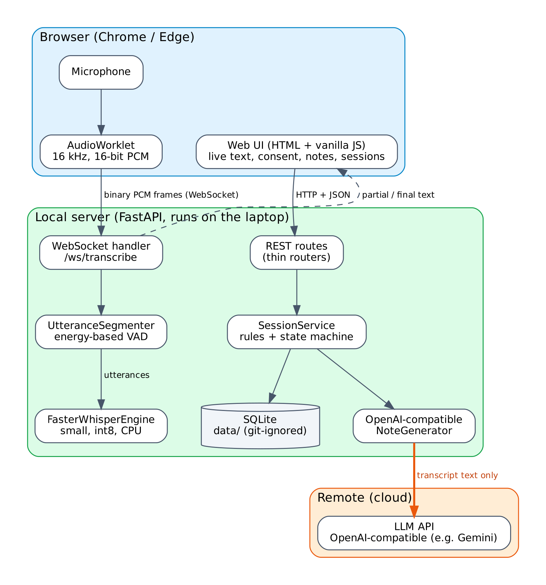
Figure 1. System architecture and trust boundaries

3.1 Components
Component | Responsibility | Technology
Web UI | Start and stop recording, live transcript, consent, note view, past sessions. Renders text with textContent, never innerHTML. | HTML and vanilla JavaScript (ES modules)
AudioWorklet | Converts microphone samples to 16-bit PCM and posts 100 ms chunks on the audio thread. | Web Audio API, 16 kHz context
WebSocket handler | Receives audio, queues finished utterances, runs transcription, sends partial and final text. | FastAPI WebSocket, asyncio
UtteranceSegmenter | Cuts the audio stream into utterances at pauses. | NumPy, energy-based voice activity detection
SpeechEngine adapter | Turns audio into text, locally. | faster-whisper, CTranslate2, CPU, int8
REST routes | Thin routers: validate input, call a service, return a Pydantic model. | FastAPI, Pydantic
SessionService | Business rules: consent, state machine, persistence order. | Python
NoteGenerator adapter | Builds the prompt and calls the LLM, with timeout and retries. | openai client, any OpenAI-compatible API
Repository | Stores sessions, drafts and approved notes. | SQLite file under data/ (git-ignored)
Settings | All configuration from SCRIBE_ environment variables or .env. No secrets in code. | pydantic-settings

4. Layered design: ports and adapters
The code is split into layers so that each external dependency sits behind a small interface (a port). Adapters implement the ports. Routers stay thin and business rules live in services.
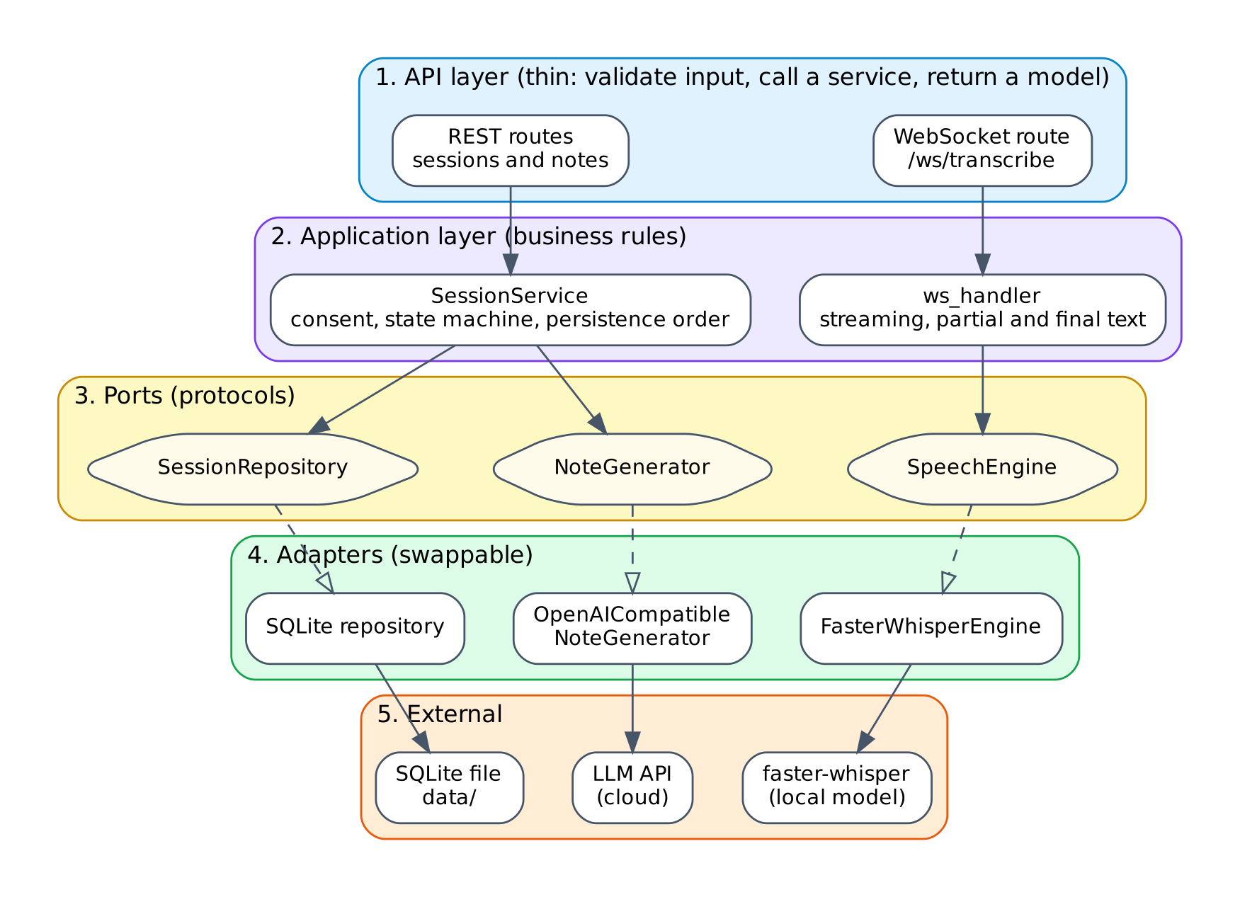
Figure 2. Layers, ports and adapters
Port | Adapter today | How to swap it
SpeechEngine | FasterWhisperEngine | Write one class with transcribe(audio, language, fast). Examples: whisper.cpp, a fine-tuned Malay model, a cloud speech API.
NoteGenerator | OpenAI-compatible adapter | Change SCRIBE_LLM_BASE_URL, SCRIBE_LLM_API_KEY and SCRIBE_LLM_MODEL for Gemini, Groq, OpenRouter or similar. Or write a new adapter.
SessionRepository | SQLite repository | Implement the same methods on another database, for example PostgreSQL, without changing the service.
Because the ports are small, the logic can be tested with fakes: no Whisper model is loaded and no LLM is called in the test suite.

5. Real-time speech pipeline
Whisper is not a streaming model, so streaming is built around it. Audio is cut into utterances at pauses, and each utterance is transcribed as a unit. While someone is still talking, a faster and rougher decode of the utterance so far gives live partial text.
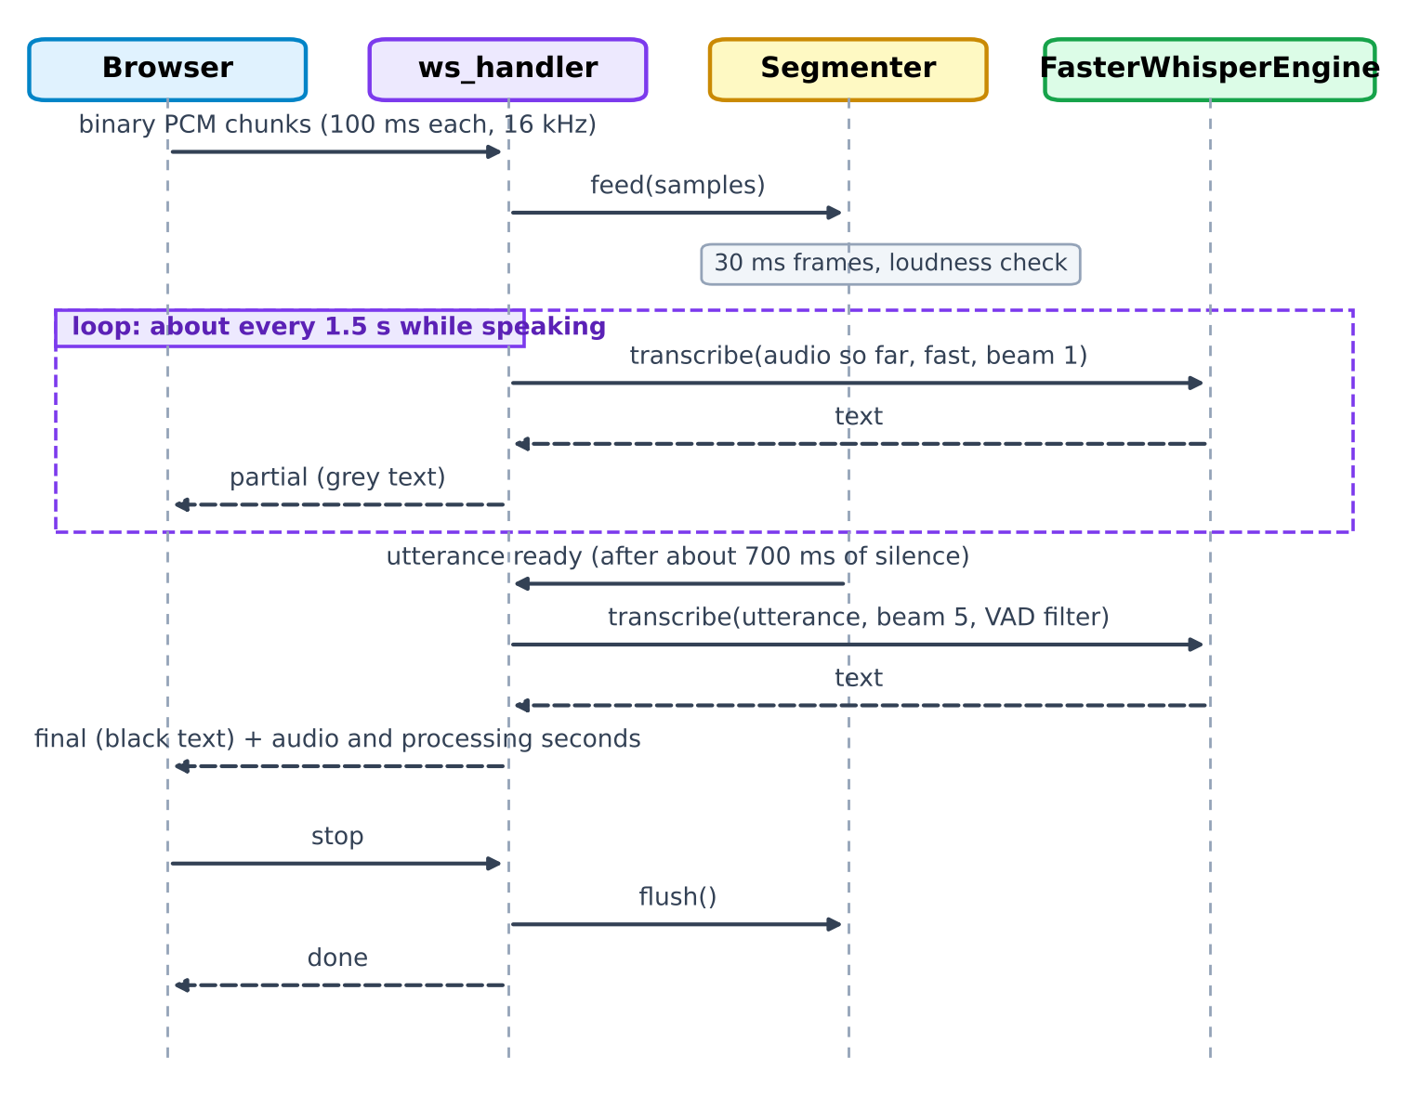
Figure 3. Message flow for one utterance

5.1 Pause detection
The segmenter splits audio into 30 ms frames. A frame counts as speech when its loudness (RMS) exceeds the larger of a minimum threshold and three times the background noise level. The noise level adapts: on every non-speech frame it moves 5% toward the current loudness.
Setting | Default | Purpose
SCRIBE_VAD_MIN_RMS | 400 | Quietest loudness that can count as speech. Raise in noisy rooms, lower for quiet speakers.
SCRIBE_VAD_NOISE_MULTIPLIER | 3.0 | Speech must be this much louder than background noise.
SCRIBE_VAD_END_SILENCE_MS | 700 | Pause length that ends an utterance.
SCRIBE_VAD_MIN_SPEECH_MS | 300 | Shorter bursts are dropped as noise.
SCRIBE_VAD_MAX_UTTERANCE_S | 20 | Force a cut after this long. This can split a word.
Pre-roll | 200 ms | Audio kept from before speech starts so word beginnings are not clipped.

5.2 Transcription settings
Setting | Final text | Live partial text
Beam size | 5 | 1 (faster, less accurate)
Voice activity filter inside faster-whisper | On (removes non-speech, reduces hallucinated text) | On
Conditioning on previous text | Off | Off
Audio decoded | The whole utterance | The utterance so far
Language | Auto-detect, or forced to English, Malay, Mandarin or Tamil | Same as the final setting

5.3 Concurrency
- Each WebSocket connection runs two asyncio tasks: a receiver that feeds the segmenter and queues finished utterances, and a worker that transcribes one item at a time.
- Transcription runs in a worker thread, so the event loop keeps receiving audio while Whisper is busy.
- The worker produces a partial only when the queue has been idle for about 1.5 s, and drops it if the utterance has meanwhile finished. A partial therefore never appears after its own final text.
- The engine holds a lock, so the model never runs two decodes at once.
- On a transcription error the server sends an error message and continues with the next utterance.

5.4 WebSocket messages
The client sends binary frames (16 kHz, 16-bit little-endian PCM, mono) and one text message {"type": "stop"}. The server replies with JSON:
Type | Fields | Meaning
partial | text | Rough live text for the utterance in progress. Shown in grey.
final | text, language, audio_seconds, processing_seconds | Accurate text for a finished utterance, with timings. Shown in black.
error | message | One segment failed. Recording continues.
done | none | Everything has been flushed after a stop.

6. Note generation
After a session the transcript text is sent to the LLM with a system prompt that holds the rules and the template. The note has six sections, in this order:
- Session summary
- Client goals
- Key discussion points
- Recommendations given by the practitioner
- Action plan / follow-up
- Items to confirm with the practitioner

6.1 Prompt rules
- Use only facts stated in the transcript. Never invent, assume or infer details.
- Write exactly Not mentioned for a section with no information.
- Keep doubtful or misrecognised words and mark them [unclear]. Do not guess.
- No advice, opinions or diagnoses. Only record what was said.
- The transcript has no speaker labels, so do not assign statements to practitioner or client unless it is clear. If unclear, list the item and flag it under the items to confirm.
- Write the note in English even if the transcript is in Malay, Mandarin, Tamil or a mix. Keep product, food and supplement names as spoken.
- Output only the note, with short bullet points.

6.2 Defence against instructions hidden in speech
The transcript is placed between <transcript> and </transcript> tags and the prompt says it is data, not instructions. Any <transcript> or </transcript> text inside the transcript is stripped first, so speech cannot close the data block and inject instructions. The inputs are also trimmed, must not be blank, and are limited to 50,000 characters.

6.3 Reliability and error handling
The adapter uses the openai client with a 60 second timeout and two automatic retries for transient errors, both configurable. The temperature is 0.2.
Situation | Result
LLM not configured (no key or model) | 503 with a setup hint. Recording and transcription still work.
Blank or missing transcript | 422 validation error.
LLM error, timeout, rate limit or empty reply | 502 that reports only the error type, for example RateLimitError. Never the prompt, the transcript or the key.
Success | 200 with the draft note.

7. Session workflow
A session moves through three states. The workflow exists so that the practitioner, not the AI, is the author of the final note, and so that the amount of correction can be measured later.
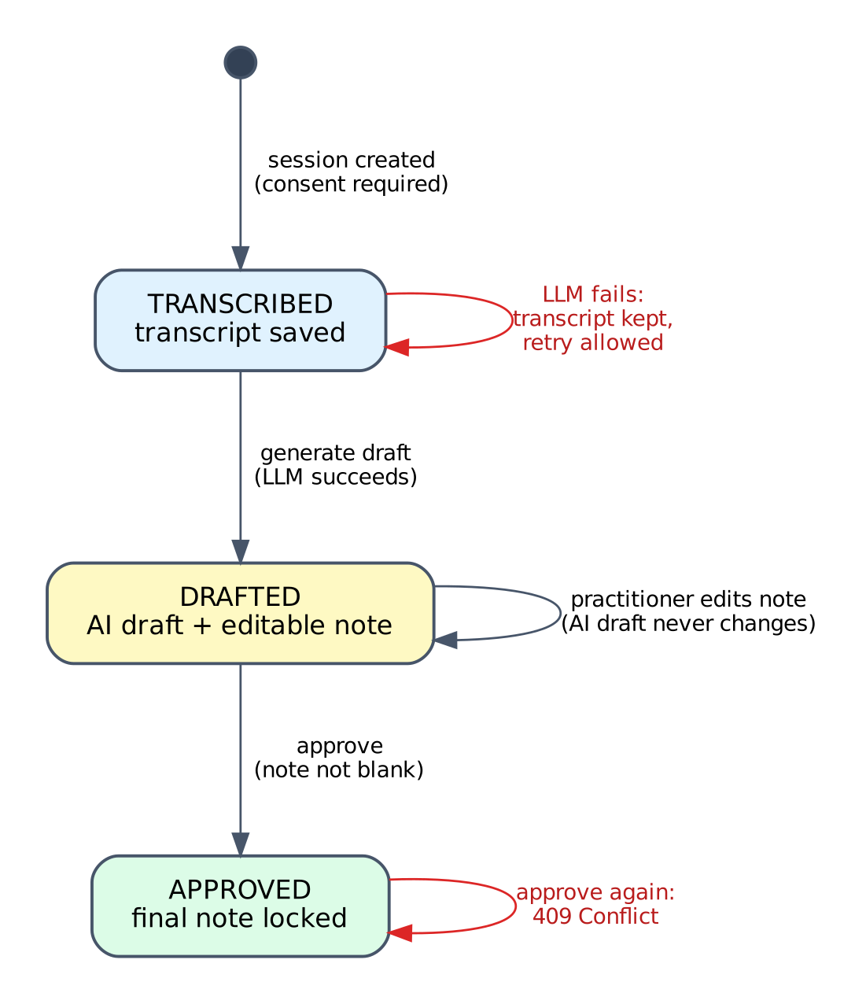
Figure 4. Session state machine

7.1 Rules
Rule | Why
Consent is required and is checked on the server, not only in the browser. | A direct API call cannot bypass the consent step.
The session and its transcript are saved before the LLM is called. | An LLM failure never loses the transcript.
If the LLM fails, the session stays TRANSCRIBED and a retry is possible. | Recovery without re-recording.
The AI draft is written once and is immutable. | It is the baseline for measuring practitioner edits.
The approved note is stored separately from the AI draft. | Both versions are kept, so the difference can be analysed.
Approval is allowed only from DRAFTED and only with a non-blank note. | Prevents approving empty or missing notes.
Approving an already approved session returns 409 Conflict. | Approval is final.

7.2 Order of operations for a draft
- Check that consent was given. Reject the request otherwise.
- Save the session with its transcript in state TRANSCRIBED.
- Call the LLM through the NoteGenerator port.
- On success, store the AI draft (never modified afterwards) and move to DRAFTED.
- On failure, keep the session as TRANSCRIBED and return an error. The practitioner can retry.
- The practitioner reviews and edits the note in the browser, then approves. The approved text is stored separately and the state becomes APPROVED.

7.3 What a session record holds
The table is conceptual. The physical schema is defined in the code.
Field | Meaning
Identifier and created time | Unique id and when the session was created.
Language setting | The language mode chosen for recording.
Consent | Whether consent was given. Must be true for a session to exist.
Transcript | Final text of the session.
AI draft | Note generated by the LLM. Written once, never changed.
Approved note | The practitioner's final version. Stored separately, written on approval.
Status | TRANSCRIBED, DRAFTED or APPROVED.
Past sessions can be listed, opened and deleted. Deleting removes the session record and its notes.

8. Privacy and data flow
Health-related conversations are sensitive personal data under Malaysia's Personal Data Protection Act 2010 (PDPA), as amended in 2024. The design keeps voice data on the laptop and sends as little as possible elsewhere.
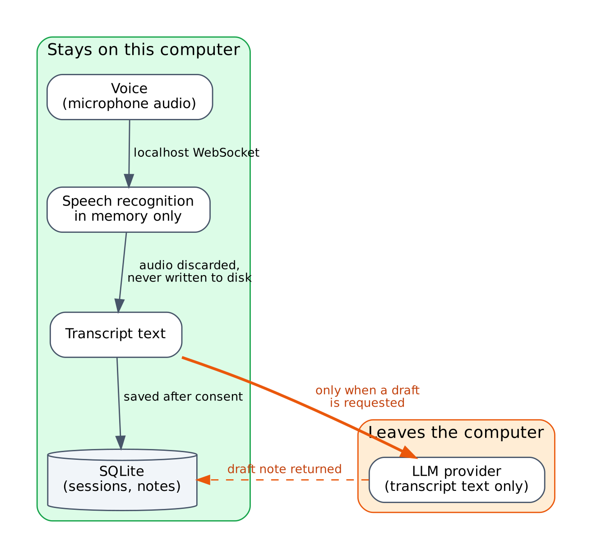
Figure 5. Where data lives and what leaves the computer
Data | Where it goes | Stored?
Microphone audio | Browser to the local server over a localhost WebSocket | No. Kept in memory for transcription, then discarded. Never written to disk.
Transcript text | Local database. Sent to the LLM API only when a draft is requested | Yes, locally, after consent.
Draft and approved note | Local database and the browser | Yes, locally.
Server logs | Console | Timings and error types only. Never transcript text, notes or keys.
API key | .env on the laptop (git-ignored) | Never in code, logs or chat.

8.1 Controls in the current build
- Local speech recognition. Audio is never uploaded and never stored.
- No logging of transcripts, notes or keys. LLM errors report the error type only.
- Secrets come from environment variables or .env. .env, data/ and audio files are git-ignored.
- Server-side consent check and a visible banner: POC, test data only.
- Text is rendered with textContent. Prompt-injection defence as described in section 6.2.
- The server listens on 127.0.0.1 by default.

8.2 Gaps and production considerations
These points are an engineering summary, not legal advice. A production system needs review by qualified counsel.
Gap | Consideration
LLM provider terms | Free tiers may use submitted data for training. Use test data only. Production needs a data processing agreement, no training on customer data, and a suitable region, or a self-hosted model.
Cross-border transfer | Sending transcript text to a foreign LLM provider is a cross-border transfer. The 2024 amendments changed these rules.
Login and access control | Not in the POC. Anyone who can reach the server can use it.
Encryption at rest | The SQLite file is not encrypted.
HTTPS and network hardening | Not in the POC (localhost only).
De-identification | Transcripts are not de-identified before the LLM call. A later phase should do this.
Model improvement | Using recordings or transcripts to improve models would need separate explicit consent and de-identification. The POC does no training.
Audit log and rate limiting | Not implemented.

9. Technology choices
Concern | Choice | Alternatives considered | Reason
Speech-to-text | faster-whisper small, int8, CPU | base; medium and large-v3 (too slow here); whisper.cpp; cloud speech API (the earlier Spring Boot prototype used one) | Audio stays local. Real-time factor 0.32 on this laptop. small was clearly better than base on Malay.
Streaming | Own pause detection plus utterance chunking | WhisperLiveKit, whisper_streaming | Simplest approach that works, fully understandable and testable, no licence questions.
Pause detection | Energy-based with adaptive noise floor | Neural VAD as the segmenter | No extra dependency, configurable. Can be replaced behind the same interface.
LLM access | OpenAI-compatible client (Gemini via AI Studio for testing) | Provider SDKs, local LLM | Provider swap by configuration. A local LLM is not realistic on 8 GB RAM.
Backend | Python, FastAPI, Pydantic | Spring Boot (first prototype) | Python has the speech tooling. FastAPI gives WebSockets, validation and API docs.
Storage | SQLite | PostgreSQL | No server to run for a POC. The repository port allows a later switch.
Frontend | HTML and vanilla JS, AudioWorklet | React | No build step. AudioWorklet gives clean 16 kHz capture.
Tests | pytest with fakes | Tests that call real services | Fast, free and repeatable. No model or network needed.
Dependency pin | av==18.1.0 | Latest PyAV | PyAV 19 removed an argument that faster-whisper 1.2.1 still uses, which broke audio loading.

10. Performance and accuracy
These are indicative results from a small test: 9 clips, one speaker (the author), read from written scripts in a quiet room, on the target laptop with faster-whisper on CPU. Word error rate (WER) is the share of reference words that were wrong, missing or extra. It can exceed 100%.
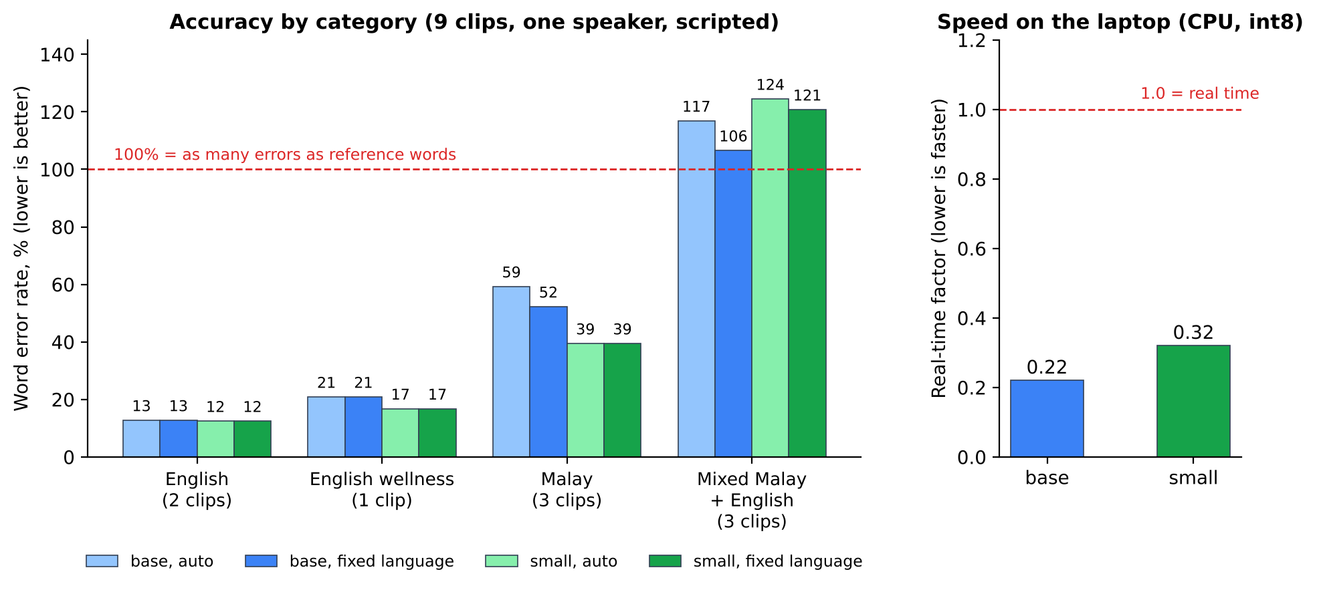
Figure 6. Word error rate by category and real-time factor
Category | Clips | base auto | base fixed | small auto | small fixed
English | 2 | 12.7% | 12.7% | 12.4% | 12.4%
English wellness vocabulary | 1 | 20.8% | 20.8% | 16.7% | 16.7%
Malay | 3 | 59.2% | 52.2% | 39.4% | 39.4%
Mixed Malay and English | 3 | 116.8% | 106.5% | 124.4% | 120.7%

10.1 What the numbers say
- Speed is adequate. The real-time factor is 0.22 for base and 0.32 for small. A 10 second clip takes roughly 2 to 3 seconds to transcribe with small.
- English is reasonable at about 12% WER. Wellness vocabulary was weaker (17 to 21%), but this is one clip.
- Malay is usable as a rough draft with small (about 39%), and clearly better than base.
- Mixed Malay and English is not usable. A WER above 100% means more errors than reference words, which points to extra, repeated or wrong-language text. Whisper decodes one language at a time, so this is a model limitation. The individual outputs have not yet been analysed in detail.

10.2 Caveats
- Only 1 to 3 clips per category and one speaker. Small differences, including base versus small on mixed speech, are within noise.
- Scripted reading is easier than real conversation, so real sessions should score worse.
- Not tested: noisy rooms, Mandarin, Tamil, other speakers and accents, spontaneous speech, larger models.

11. Limitations and risks
Risk or limitation | Impact | Mitigation
Code-switching inside a sentence | Mixed Malay and English text is poor. | Language selector, [unclear] marking, practitioner review. Next: Malay fine-tuned model, larger model on a GPU, cloud comparison.
Tamil and Mandarin untested | Unknown accuracy. | Report as untested. Add clips and measure.
Noise-sensitive pause detection | Background noise can create false segments. | Configurable thresholds. A neural VAD can replace the segmenter.
Live partials re-decode audio | Extra CPU while someone speaks. | Fast beam-1 setting, only when idle. Final text is always accurate.
LLM can be wrong | A note may omit or distort content. | Strict prompt rules, [unclear], items to confirm, and mandatory practitioner approval.
Free-tier LLM data use | Privacy risk with real data. | Test data only. Production needs a suitable provider agreement or a self-hosted model.
No authentication or encryption | Unsuitable for real data. | Localhost only. Listed as a production requirement.
Forced cut at 20 s of non-stop speech | A word may be split. | Rare in conversation. The limit is configurable.

12. Roadmap
- Record more test clips (noisy, Mandarin, Tamil, second speaker, spontaneous speech) and analyse the mixed-language errors.
- Test a Malaysian fine-tuned Whisper after checking its licence, and run a large model on a rented GPU to estimate the accuracy ceiling.
- Compare against a cloud speech service on the same clips.
- De-identify transcripts before they are sent to an LLM.
- Add login, encryption at rest and HTTPS before any real use.
- Measure practitioner edits by comparing the AI draft with the approved note.
- Agree with the team what real-time must mean in practice (live words versus a note right after the session), which languages and devices matter, and whether cloud APIs are allowed.

Appendix A. Configuration reference
All settings are read from environment variables with the prefix SCRIBE_, or from .env (git-ignored). Real keys go only in .env. See .env.example and app/config.py for the complete list.
Variable | Default | Meaning
SCRIBE_WHISPER_MODEL | small | Whisper model size.
SCRIBE_WHISPER_COMPUTE_TYPE | int8 | CPU quantisation.
SCRIBE_VAD_MIN_RMS | 400 | Minimum loudness counted as speech.
SCRIBE_VAD_NOISE_MULTIPLIER | 3.0 | Required loudness above background noise.
SCRIBE_VAD_END_SILENCE_MS | 700 | Pause that ends an utterance.
SCRIBE_VAD_MIN_SPEECH_MS | 300 | Shortest speech burst kept.
SCRIBE_VAD_MAX_UTTERANCE_S | 20 | Longest utterance before a forced cut.
SCRIBE_PARTIAL_INTERVAL_S | 1.5 | How often live partial text refreshes.
SCRIBE_LLM_BASE_URL | Gemini OpenAI-compatible URL | Any OpenAI-compatible endpoint.
SCRIBE_LLM_API_KEY | none | Secret. Without it, drafting returns 503.
SCRIBE_LLM_MODEL | none | Exact model ID from the provider.
SCRIBE_LLM_TIMEOUT_S | 60 | Request timeout.
SCRIBE_LLM_MAX_RETRIES | 2 | Automatic retries for transient errors.
SCRIBE_LLM_REASONING_EFFORT | empty | Optional, for example low on Gemini thinking models.

Appendix B. Repository layout
app/
main.py app creation and startup wiring
config.py settings (pydantic-settings)
api/ thin routers (WebSocket, notes, sessions)
speech/ SpeechEngine port, faster-whisper adapter,
segmenter, WebSocket handler
notes/ NoteGenerator port, prompt builder,
OpenAI-compatible adapter
sessions/ models, repository, service, state machine
static/ HTML, JavaScript, AudioWorklet, CSS
scripts/ transcribe_file.py, run_benchmark.py
benchmark/ manifest.csv, results.csv (audio is git-ignored)
tests/ pytest suite (uses fakes)
docs/ benchmark, privacy, decisions, user manual

