Multivariate statistics for The Economist Rankings

This paper is divided into three parts: Data Processing and reconstruction, data exploration and ranking strategy analysis. It combines discriminant analysis, hierarchical clustering, principal component analysis and variance analysis. The code to implement everything in this article is attached in the appendix at the end of the article. For ease of programming and interpretation, the variables at each level are numbered in table 1.

|  |  |  |  |  |
| --- | --- | --- | --- | --- |
|  |  | Variables | Code | Weight |
| A. Open new career opportunitie |  | Number of industry sectors that recruited graduates | A1 | 8.8% |
| Percentage of graduates in jobs 3 months after graduation | A2 | 8.8% |
| Percentage of graduates finding jobs through careers services | A3 | 8.8% |
| Student rating of careers service | A4 | 8.8% |
| B.Personal development and educational experience | B1.Faculty  quality | Number of faculty per student | B11 | 1.8% |
| Percentage of faculty with PhD | B12 | 3.5% |
| Student rating of faculty | B13 | 3.5% |
| B2.Student  quality | Average GMAT score | B21 | 6.6% |
| Average number of years' work experience | B22 | 2.2% |
| B3.Student  diversity | International diversity score | B31 | 2.9% |
| Percentage of women students | B32 | 2.9% |
| Student rating of culture and classmates | B33 | 2.9% |
| B4.Education experience | Student rating of programme | B41 | 2.2% |
| Overseas exchange places available (% of intake) | B42 | 2.2% |
| Number of languages on offer | B43 | 2.2% |
| Student assessment of facilities | B44 | 2.2% |
| C. Increase in salary |  | Percentage increase in salary | C1 | 5% |
| Post-MBA salary ($) | C2 | 15% |
| D. Potential to network |  | Breadth of alumni network | - | 3.3% |
| Internationalism of alumni | - | 3.3% |
| Alumni effectiveness | - | 3.3% |

Table 1：Data summary

1. **Data Processing and reconstruction**

There were 22 missing values in the data set due to errors in data confidentiality and collection. This situation falls within the acceptable range. This paper adopts the predictive matching method to fill with mice to complete the data set.

This article reconstructs the Economist's ranking collection. Because of the missing variables that belong to d and the use of Z-score, you can see from figure 1 that the Reconstructed Total score does not match, but does not change drastically.

In addition, as you can see from figure 2, the top schools (1-15) don't change their ranking much (falling or rising) . This was followed by a larger change in the 80-100 ranking, with the middle-ranked schools experiencing the most dramatic changes. Figure 3 shows the statistics for the Reconstructed Score.

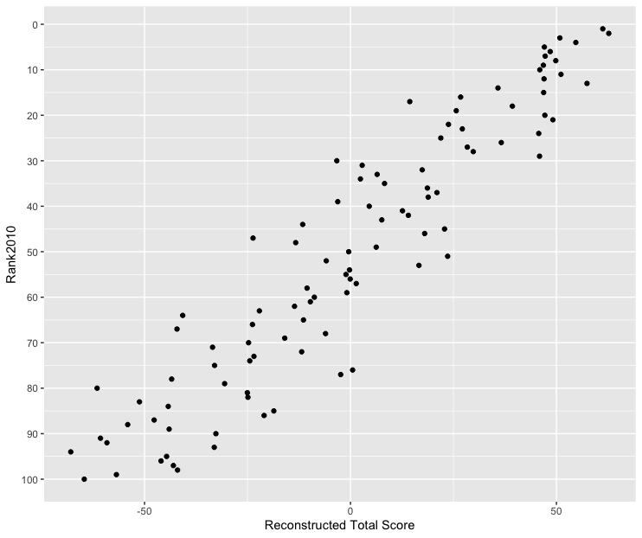

Figure 1：Fit of reconstructed scores with rank2010

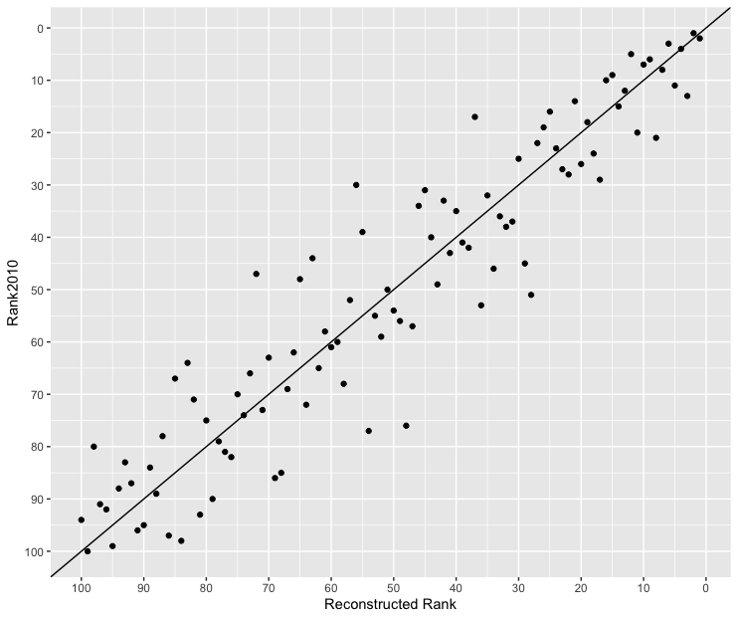

Figure 2: Fit of reconstructed rankings with rank2010

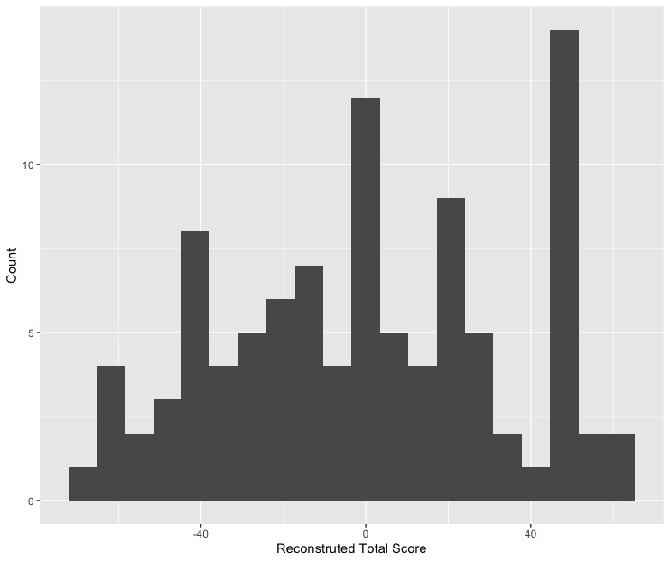

Figure 3：Distribution of reconstructed total score

**2. Data exploration**

2.1 Geographical location of a school and the number of languages on offer

One-way Anova analysis was used to examine the relationship between the variables B43 and 20 countries. The larger p (0.709) was unable to reject the original hypothesis, which showed that there was no significant relationship between the number of languages and the presence of business schools in different countries.

In order to further explore the relationship between geographical location and B43, this paper attempts to group analysis. Table 2 groups business schools by country and calculates the mean of variable B43. Table 3 groups business schools by country to calculate the mean of the variable b 43 ranking.

The ordering of tables 2 and 3 is similar. Looking at the order of the two tables, the top five were Belgium, Germany, Ireland, Mexico, and the Netherlands. In addition to Mexico, the other four are all European countries. The last six are India, Spain, Denmark, Italy, Japan, Switzerland, which are different continents. That there is a relationship between geographical location of a school and the number of languages on offer. But in the context of reality, it can be inferred that business schools in countries that border multiple countries and have an open culture may offer a larger number of languages.

|  |  |
| --- | --- |
| **Country** | **mean of B43** |
| Belgium | 6 |
| Germany | 6 |
| Ireland | 6 |
| Mexico | 6 |
| Netherlands | 6 |
| Monaco | 5 |
| America | 4.73913 |
| Singapore | 4.5 |
| Britain | 4.176471 |
| France | 4.166667 |
| Australia | 4 |
| China | 4 |
| Hong Kong | 4 |
| Canada | 3.25 |
| India | 3 |
| Spain | 2.75 |
| Denmark | 2 |
| Italy | 2 |
| Japan | 2 |
| Switzerland | 0 |

Table 2: mean of number of languages on offer group by country

|  |  |
| --- | --- |
| **Country** | **mean of Rank** |
| Belgium | 28 |
| Germany | 28 |
| Ireland | 28 |
| Mexico | 28 |
| Netherlands | 28 |
| America | 45.81522 |
| Singapore | 50 |
| Hong kong | 50.33333 |
| Australia | 51.2 |
| Britain | 52.17647 |
| France | 52.66667 |
| Canada | 59.25 |
| Monaco | 60 |
| China | 66.5 |
| India | 72 |
| Spain | 74.25 |
| Denmark | 79 |
| Italy | 79 |
| Japan | 79 |
| Switzerland | 95 |

Table 3: mean of rank of number of languages on offer group by country

2.2 Faculty quality and education experience

The variables of Faculty quality are (B11, B12, B13), Education experience and (B41, B42, B43, B44). Figure 4 is the result of Pearson Test, and you can see that the variables B41 and B13, B44 and B13, are strongly positively correlated. Variables B41 and B11, B42 and B13, B44 and B11 are negatively correlated.

In order to explore the relationship between the two groups of variables accurately, canonical correlation analysis was used. The results are shown in Table 4. Referring to the specific meaning of the variables in Table 1, it is easy to know that students'evaluation of teachers is positively correlated with their evaluation of curriculum, and that students'evaluation of teachers is positively correlated with their evaluation of school services. The increase of teacher's proportion is related to the decrease of curriculum evaluation and school service evaluation. The increase of student's evaluation will lead to the decrease of overseas exchange proportion.

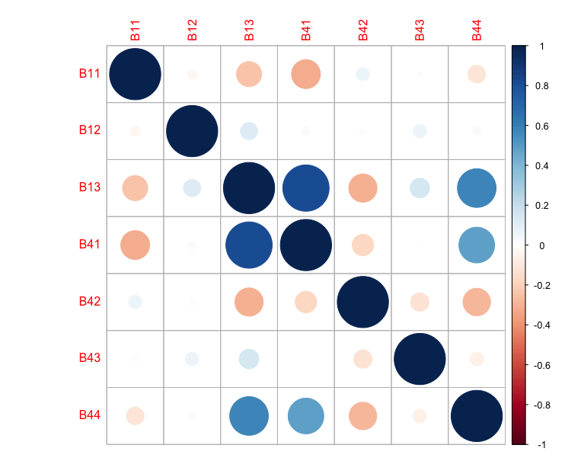

Figure 4: Pearson Test for faculty quality and education experience

|  |  |  |  |  |  |  |  |
| --- | --- | --- | --- | --- | --- | --- | --- |
|  | **R** | **RSquared** | **LR** | **ApproxF** | **NumDF** | **DenDF** | **pvalue** |
| 1 | 0.8684 | 0.7541 | 0.2399 | 14.6841 | 12 | 246.3464 | 0 |
| 2 | 0.1435 | 0.0206 | 0.9754 | 0.3922 | 6 | 188 | 0.8834 |
| 3 | 0.0638 | 0.0041 | 0.9959 | NaN | 2 | NaN | NaN |
| $a.Coefficients |  |  |  |  |  |  |  |
|  | [,1] | [,2] | [,3] |  |  |  |  |
| [1,] | -0.10845189 | -0.8990874 | -0.3459507 |  |  |  |  |
| [2,] | -0.07355427 | -0.324948 | 0.9251247 |  |  |  |  |
| [3,] | 0.9913768 | -0.2933439 | -0.1564048 |  |  |  |  |
| $b.Coefficients |  |  |  |  |  |  |  |
|  | [,1] | [,2] | [,3] | [,4] |  |  |  |
| [1,] | -0.9391205 | 0.54084709 | -0.3249199 | -0.09107166 |  |  |  |
| [2,] | 0.1381005 | -0.03050706 | -0.6592209 | 0.70172459 |  |  |  |
| [3,] | -0.1771083 | -0.47397416 | -0.6217038 | -0.37363961 |  |  |  |
| [4,] | -0.2600261 | -0.69419179 | 0.2708124 | 0.59973494 |  |  |  |
| $XUCorrelations |  |  |  |  |  |  |  |
|  | U1 | U2 | U3 |  |  |  |  |
| B11 | -0.3386 | -0.8739 | -0.3488 |  |  |  |  |
| B12 | 0.0411 | -0.3473 | 0.9368 |  |  |  |  |
| B13 | 0.9921 | -0.1214 | 0.0313 |  |  |  |  |
| $YVCorrelations |  |  |  |  |  |  |  |
|  | V1 | V2 | V3 |  |  |  |  |
| B41 | -0.9545 | 0.2728 | -0.0851 |  |  |  |  |
| B42 | 0.3502 | 0.1782 | -0.6478 |  |  |  |  |
| B43 | -0.1565 | -0.5549 | -0.5995 |  |  |  |  |
| B44 | -0.6522 | -0.5128 | 0.3715 |  |  |  |  |

Table 4: Canonical Correlation Analysis for faculty quality and education experience

1. Analysis of ranking strategies of business schools

Figure 5 is the result of the Pearson Test Analysis, which includes all the variables in categories a, B, and c, the standardized weighted total score TS, and the ranking score rankScore (100 in first place, 99 in second place, and so on) . We can see that TS and rankScore are nearly the same, which shows that TS can still reflect the initial ranking to a great extent even though it has lost the d variable. As you can see from figure 5, the variables A1, A2, A3, A4, B13, B21, B31, B41, and C2 are strongly positively correlated with business school rankings.

Business schools were artificially divided into five groups, the first group (1-20) , the second group (21-40) , and so on. To further explore the relationship between various variables and rankings, use discriminant analysis to analyze and calculate six sets of variables for loading(A, B1, B2, B3, B4, C, code meaning refer to table 1). The results show that the load of B4 is the highest, the loading for Education experience is 0.29, and the loading for Open new career opportunity is 0.18. The results of discriminant analysis and the correlation analysis of figure 5 are verified, and the above two kinds of variables are mined.

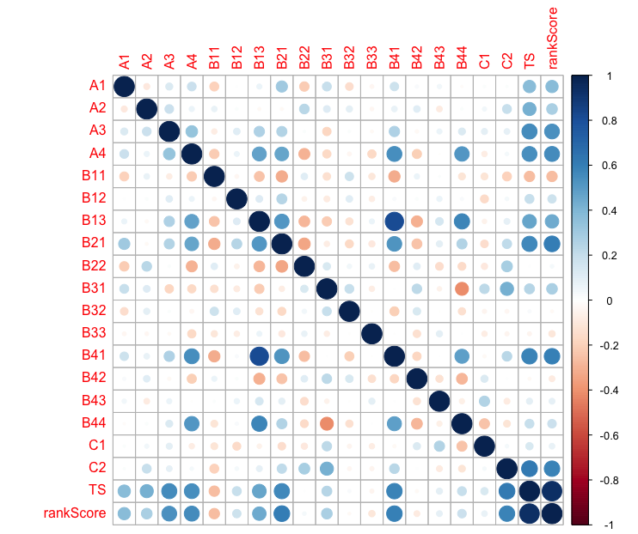

Figure 5: Pearson Test for all variables

|  |  |  |  |  |  |  |
| --- | --- | --- | --- | --- | --- | --- |
| Variable | A | B1 | B2 | B3 | B4 | C |
| Loading | 0.1825103180 | 0.0864645284 | 0.0107183208 | 0.0273151289 | 0.2887696836 | 0.0002254598 |

Table 5: Discriminant analysis and loadings

3.1 The differences between British and American business schools

Using data from business schools in the US and UK, the variables a, B1, B2, B3, B4, C and 6 were grouped into the following six groups:

(A1, A2, A3, A4)

(B11 ,B12, B13)

(B21,B22)

(B31, B32, B33)

(B41, B42, B43, B44)

( C1, C2)

The result is shown in figure 6. From left to right, from top to bottom are the results of principal component analysis of the above six groups of variables. Although there are fewer business schools in the UK than there are in the US, it can be observed from the visual examination that the US and the UK are more concentrated in local areas in the B2 and B3 related graphs, whereas in a, the c-related graphs are obviously clustered in the same region.

In order to further investigate the differences between British and American business schools under different categories of variables, Hotelling’s T^2 test was conducted based on the above six groups of variables. The results are shown in Table 5. Among them, Group B2 had the lowest p value, that is, the most likely to have differences, and Group C had the highest p value, that is, the least likely to have differences. If a small significance level of 0.3% is taken, the results of Hotelling’s T^2 test and principal component analysis can confirm each other. Student quality and student diversity, therefore, determines the difference between UK and US schools.

As can be seen from table 6, the average ranking of US business schools is 10 places higher than that of UK business schools, and the average score of US business school students is 30 points higher than that of the UK in GMAT(B21). That's the central difference.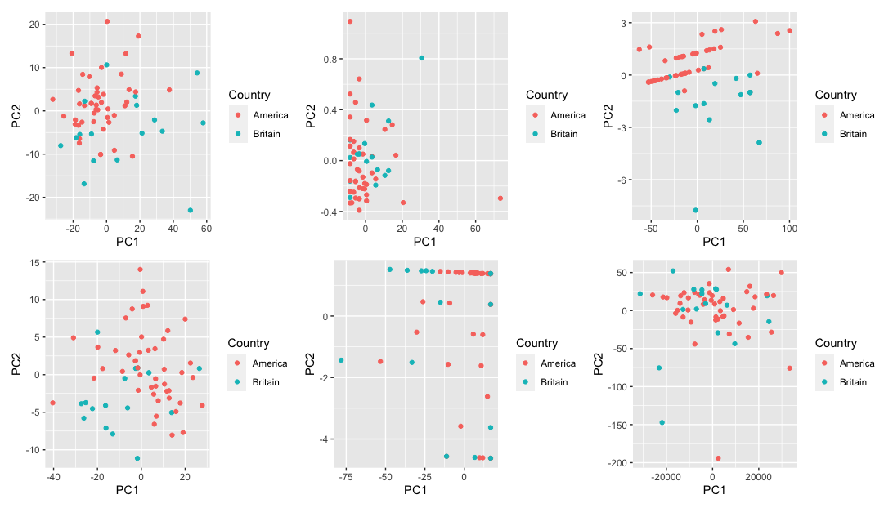

Figure 6：Principal component analysis of six groups of variables

|  |  |  |  |  |  |  |
| --- | --- | --- | --- | --- | --- | --- |
| Variables | A | B1 | B2 | B3 | B4 | C |
| P value | 0.0424 | 0.003 | 0.00008 | 0.0003 | 0.0053 | 0.4 |

Table 6 : Hotelling’s T^2 Test of six groups of variables

|  |  |  |  |  |  |  |
| --- | --- | --- | --- | --- | --- | --- |
| **Country** | **Rank** | **B21** | **B22** | **B31** | **B32** | **B33** |
| America | 43.21739 | 676.3043 | 4.521739 | 37.36957 | 31.84783 | 4.086957 |
| Britain | 54.76471 | 642.3529 | 7.294118 | 48.82353 | 28.64706 | 4.164706 |

Table 7: The mean of six groups variables

3.2 Ranking analysis of schools

First, 100 business schools are divided into 6 categories by hierarchical clustering method, and then the classification is visualized by principal component method. The result is shown in figure 7. You can see from figure 7 that similar schools are spread out. In category C, for example, Hult International Business School ranks 27th and Manchester Business School 61st. The results potentially suggest that schools with a preference for the same variables may have different rankings. In other words, schools with similar rankings use different ranking strategies.

Table 8 gives the detailed statistical results of the clustering. A schools have the most schools and the highest average. We can ignore classes e and f because both classes have only one school and are outliers. The lowest average is in the D category. Most a schools are European or American, most of them in the United States, followed by the United Kingdom. Interestingly, Class D schools are also the largest in the United States and the United Kingdom, because most of the schools in the data set are in those two countries.

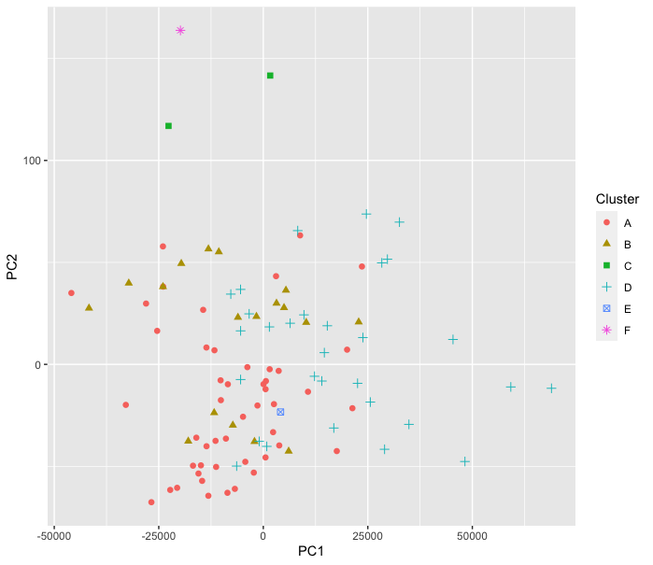

Figure 7: Hierarchical clustering for all business schools

|  |  |  |  |  |  |  |
| --- | --- | --- | --- | --- | --- | --- |
| **Group** | **A** | **B** | **C** | **D** | **E** | **F** |
| min rank | 1 | 17 | 27 | 33 | 39 | 51 |
| max rank | 60 | 95 | 61 | 100 | 39 | 51 |
| average rank | 27.25 | 65.44444 | 44 | 79.53333 | 39 | 51 |
| Country |  |  |  |  |  |  |
| America | 29 | 2 | 1 | 13 | 1 | 0 |
| Australia | 1 | 3 | 0 | 1 | 0 | 0 |
| Belgium | 0 | 1 | 0 | 0 | 0 | 0 |
| Britain | 7 | 4 | 1 | 5 | 0 | 0 |
| Canada | 1 | 1 | 0 | 2 | 0 | 0 |
| China | 0 | 0 | 0 | 1 | 0 | 0 |
| Denmark | 0 | 0 | 0 | 1 | 0 | 0 |
| France | 3 | 3 | 0 | 0 | 0 | 0 |
| Germany | 1 | 0 | 0 | 0 | 0 | 0 |
| Hong Kong | 1 | 1 | 0 | 1 | 0 | 0 |
| India | 0 | 0 | 0 | 1 | 0 | 0 |
| Ireland | 1 | 0 | 0 | 0 | 0 | 0 |
| Italy | 0 | 1 | 0 | 0 | 0 | 0 |
| Japan | 0 | 0 | 0 | 1 | 0 | 0 |
| Mexico | 0 | 0 | 0 | 1 | 0 | 0 |
| Monaco | 0 | 0 | 0 | 0 | 0 | 1 |
| Netherlands | 0 | 1 | 0 | 1 | 0 | 0 |
| Singapore | 0 | 0 | 0 | 2 | 0 | 0 |
| Spain | 3 | 1 | 0 | 0 | 0 | 0 |
| Switzerland | 1 | 0 | 0 | 0 | 0 | 0 |
| Variables |  |  |  |  |  |  |
| A1 | 10.4375 | 9.166667 | 10 | 8.833333 | 11 | 8 |
| A2 | 84.9375 | 85.72222 | 79 | 79.43333 | 81 | 100 |
| A3 | 71.72917 | 54.16667 | 63.5 | 52.5 | 73 | 83 |
| A4 | 3.83125 | 3.294444 | 3.3 | 3.513333 | 3.8 | 3.2 |
| B11 | 0.4979167 | 0.5777778 | 0.25 | 0.6433333 | 0.5 | 0.9 |
| B12 | 94.9375 | 89.33333 | 78 | 91.73333 | 18 | 88 |
| B13 | 4.458333 | 4.111111 | 4.25 | 4.286667 | 4.6 | 4 |
| B21 | 680.1042 | 628.6667 | 617.5 | 639.3667 | 685 | 513 |
| B22 | 5.375 | 7.5 | 6.5 | 4.8 | 5 | 6 |
| B31 | 45.125 | 46.55556 | 73.5 | 34.36667 | 25 | 73 |
| B32 | 31.125 | 33.38889 | 29.5 | 31.5 | 25 | 67 |
| B33 | 4.075 | 4.188889 | 4 | 4.126667 | 4.5 | 4 |
| B41 | 4.391667 | 4.033333 | 4.25 | 4.19 | 4.5 | 4 |
| B42 | 20.54167 | 24.05556 | 25.5 | 22.63333 | 1 | 100 |
| B43 | 4.875 | 1.944444 | 6 | 4.7 | 6 | 5 |
| B44 | 4.364583 | 4.133333 | 3.75 | 4.316667 | 4.5 | 3.7 |
| C1 | 67.125 | 47.33333 | 235.5 | 63.5 | 73 | 111 |
| C2 | 99239.04 | 99138.22 | 102124 | 73693.77 | 87489 | 111440 |

Table 8: Detailed statistical results of the clustering

**References**

1. Bickerstaffe, G. and Ridgers, B. (2007) "Ranking of business schools", Journal of

Management Development, 26(1), 61–66.

2. Naude´, P., Henneberg, S. and Jiang, Z. (2010) “Varying routes to the top: Identifying different strategies in the MBA marketplace”, Journal of the Operational Research Society, 61(8): 1193–1206. [this is the same as the 2009 digital pre‐release (DOI)]

3. Proudlove, N.C. (2012) “Cracking the rankings Part (i): Understanding the Financial Times MBA rankings”, OR Insight, 25(4), 221–240. [this is the same as the 2011 digital pre-release (DOI)]