Measle vaccinations around the world

Aditya Arora

University of Toronto

Over the past decades, the World Health Organization (WHO) has been documenting raw data of vaccinations done in various countries over time. An example of this is measles, a highly contagious illness that is caused by a virus. Measles were first discovered way back in 1765, and vaccinations for measles first came in 1963. Since then, the World Health Organization has been documenting the percentage of measle vaccinations given according to the countries’ world bank, which is classed into four categories. Based on this data, I discovered several specific issues regarding the data provided. One of the issues found with this experiment is not bringing in how much medical equipment is provided in each country, as more developed countries can provide better health facilities rather than developing countries with less health facilities. Another issue regarding this experiment is the fairness in technology, as many countries still lack the technology needed to provide better health support to patients in third world countries. Population is also another issue, as some countries are overpopulated with not enough resources to help everyone with medical needs. Therefore, I believe that the data provided by the World Health Organization regarding measle vaccinations is not accurate as certain issues such as population, health equity and technological fairness in different countries.

According to the World Health Organization, they claim that half the world lacks access to essential health services, with 100 million people still pushed into extreme poverty because of health expenses (WHO, 2017). This brings the idea of population as a major issue with health concerns. To further explain this, look at India, the second largest populated country in the world. With nearly 1.38 billion citizens and poor health conditions, the world bank has ranked India as number 63 out of the 190 countries in the world. Given such a massive population and the harsh living conditions, I believe that this could be one of the major causes as to why lower income countries are expected to see less percentages of measle vaccinations. According to Dr. Christopher Garimoi Orach at the Makerere University, he says, “little food, unclean water, low level of sanitation and shelter, failure to deal with the environments that lead to high exposure to infectious agents and lack of appropriate medical care.” (Orach, 2009). These reasons further prove why lower income countries receive less measle vaccinations compared to other countries. Another reason as to why population plays a major role in this study is due to many not being educated enough, which causes shortage of doctors or medical workers. This breaches out to many other issues such as poverty, which could also further Christopher’s explanation as to why low-income countries receive the least amount of vaccinations of measles. This leads to my next point, where not only does population effect this case study, but also health equity across the world.

Countries around the world depend on their economy. As of 2020, the United States has an economy of $21.44 trillion dollars (Silver, 2020), making it the richest country in the world. This does not mean every other country is rich, as there are many countries that don’t even have a $1000 GDP. Due to this, many countries have people living in poverty. With the poor conditions people live in, certain countries cannot afford the necessary equipment to treat patients with poor health conditions. This is where most of the low-income countries struggle. To take an example of this, I conducted a test to analyze the World Health Organization’s data. The following results show as follows:

According to this data, over the past 37 years, the world bank lowest income countries always receive the least amount of vaccinations for measles. If we compare specific countries, for example:

United states have always had 99% of kids vaccinated for measles, whereas Zimbabwe only stays near the low to mid 70 percentile of vaccinations. Comparing the two countries, this shows unfairness in health equity. According to the Tax Policy Center, they claim that the United States has spent over $1.2 trillion in 2019 (Tax Policy Center, 2019). This means that with such strong investments per year, it is clear why the United States always has a 99% vaccination rate each year. Zimbabwe, in comparison, can’t invest as much money into healthcare, which leads to less health equipment, less facilities and poor working environments for medical staff. This explains why countries like Zimbabwe always tend to end up in the lower end of vaccinations per year.

Looking at more observations of the data created, I also observed the average percentage for each country in the past 37 years. By looking at this chart, more and more countries are slowly getting more vaccinations as time goes by, but not as much as countries that are considered high income. Of course, these observations are not only limited to just health equity, but also technological fairness in different countries.

For the past few years, technology has been changing the world. According to J. Clement from statista.com, she claims that over 4.57 billion people use the internet everyday (Clement, 2020). Due to technology slowly changing how the world works, technology today helps create better facilities for health care, with top of the line equipment and new machines for health workers to work with. This makes it easier for health care workers as they can diagnose and provide medical help to patients faster than using traditional methods. The problem with this is that many of the low-income countries can’t afford technologically advanced systems, hence making it more difficult for health workers to provide medical care or vaccinations to patients. According to Musa Ahmed Zayyad and Mehmet Toycan, they say, “these strategic benefits of e-health technology make it significantly relevant for developing countries, where access to basic social amenities such as quality healthcare is hampered by poor government policies, political unrests, and lack of modern technology infrastructure (Luna et al., 2014).” (Zayyad and Toycan, 2017). This shows that modern technology also plays a huge role in the analysis of vaccinations for measles, as many low-income countries lack the basic technological necessities to provide proper healthcare for their country. To further my point of technological fairness, Allison Portnoy, Mark Jit, Matthew Ferrari, Matthew Hanson, Logan Brenzel, and Stephane Verguet conducted a study based on measle vaccinations with low-income countries, like what I analyzed earlier. According to their data, this is what they found:

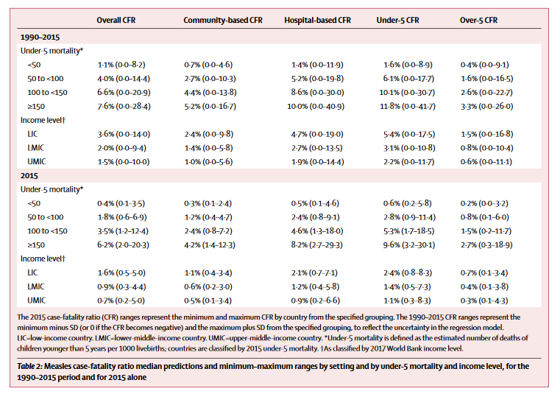

As for observation, the death rate for lower-income and lower-middle-income countries is significantly higher than higher-income and upper-middle-income countries (Portnoy, Jit, Ferrari, Hanson, Brenzel, Verguet, 2020).

To conclude, many countries are still slowly developing as time goes by. Vaccinations for measles and other viruses are becoming more accessible by lower-income and lower-middle-income countries, but there is still very little change when it comes to population control, health equity and technological fairness. Measles is a very deadly virus for children and should be vaccinated at all costs, no matter which country they live in. As technology keeps becoming more accessible, developing countries are using it to their full advantage to provide the best medical care they can for basic needs. As more data is given by the World Health Organization, will lower-income countries begin to rise in the percentage of vaccinations for measles?

Works Cited

World Health Organization: WHO. (2017, December 13). World Bank and WHO: *Half the world lacks access to essential health services, 100 million still pushed into extreme poverty because of health expenses.* World Health Organization. <https://www.who.int/news-room/detail/13-12-2017-world-bank-and-who-half-the-world-lacks-access-to-essential-health-services-100-million-still-pushed-into-extreme-poverty-because-of-health-expenses>

Christopher Garimoi Orach. (2009, October 1). *Health equity: challenges in low income countries.* PubMed Central (PMC). <https://www.ncbi.nlm.nih.gov/pmc/articles/PMC2877288/>

Silver, C. (2020, August 03). *The Top 20 Economies in the World.* Retrieved August 16, 2020, from <https://www.investopedia.com/insights/worlds-top-economies/>

Tax Policy Center. (2020). *How much does the federal government spend on health care?* <https://www.taxpolicycenter.org/briefing-book/how-much-does-federal-government-spend-health-care>

Clement, J. (2020, July 24). *Digital users worldwide 2020.* Statista. <https://www.statista.com/statistics/617136/digital-population-worldwide/>

Zayyad, M. A., & Toycan, M. (2018). Factors affecting sustainable adoption of e-health technology in developing countries: an exploratory survey of Nigerian hospitals from the perspective of healthcare professionals. *PeerJ, 6,* e4436. <https://doi.org/10.7717/peerj.4436>

Portnoy, A., Jit, M., Ferrari, M., Hanson, M., Brenzel, L., & Verguet, S. (2019). Estimates of case-fatality ratios of measles in low-income and middle-income countries: a systematic review and modelling analysis. *The Lancet Global Health*, 7(4), e472–e481. <https://doi.org/10.1016/s2214-109x(18)30537-0>