

**A Project On**

**Hospital Management System**

Course Code: 1204

**Submitted By:**

**Md. Zubaer Hossain Alvi Ahasan** ID: 20171077010 ID: 20171057010

**Ayesha Siddika Sk. Samsunnahar Piya** ID: 20171065010 ID: 20171068010

…………………………..

Signature

**Amit Hasan** ID: 20171048010

**Department of Computer Science and Engineering**

**North Western University, Khulna**

*Date :*

**2**

**“All praises are due to Almighty Allah”**

We are very much happy to complete the project after facing a lot of troubles and obstacles. But it makes a happy end with the help of our respectable teachers. We have taken efforts in this project .However; it would not have been possible with out the kind support and help of many individuals and teachers. We would like to extend our sincere thanks to all of them .The authors wish to express their profound gratitude to their supervisor lecturer **Md. Rashid Al Asif** for the helpful contribution giving necessary guidance, suggestions and encouragement to authors in all the phases of the work. He inspired the authors to delve into the publications and research works of several researches related to the topic to have the idea of the efforts and works that were done. The authors also wish to express their gratitude to the head of the department of Computer Science and Engineering.The authors also like thank all the teachers of CSE department of NWU who helped the authors providing guidelines to perform the work.

We also express our respect and gratitude to all other teachers and students for their initial help to develop the project.

**Authors**

**Abstract**

To build the **Hospital Management System**, we the group members decided to work some special task. For doing this activities we use file management system on C language in which every input result will be automatically save in a file. One can easily store the information about Patient or Employee and Inventory which is needed to input Registration of the Patient or employee and Inventory Item on the **HMS**. If the given Patient or Employee ID matches with the record stored in the file then the system works. This helps us to save a lot of paperwork and show the any saved record of the Patient or Employee and Inventory Item. We can use this project for such kind of activities at any time. We hope that our project is quite successful.

**3**

**Contents**

**Title Page**--------------------------------------------------------------------------------- 1

**Acknowledgement** ---------------------------------------------------------------------- 2

**Abstract** ---------------------------------------------------------------------------------- 2

**Chapter-1: Introduction**

1.1 Introduction -------------------------------------------------------------------------- 4

1.2 Scope of the project ----------------------------------------------------------------- 4

1.3 Development methodology -------------------------------------------------------- 4

**Chapter-2: Requirement Analysis**

2.1 Introduction ------------------------------------------------------------------------ 5

2.2 Problem Definition ---------------------------------------------------------------- 5

2.3 Requirement Analysis -------------------------------------------------------------- 6

**Chapter-3: System Design**

3.1 Software design ------------------------------------------------------------------- 7

3.2 Relation to the work --------------------------------------------------------------- 7

3.3 Flow chart -------------------------------------------------------------------------- 7

**Chapter-4: Implementation and Maintenance**

4.1 Implementation -------------------------------------------------------------------- 9

4.2 Testing -------------------------------------------------------------------------------10

4.3 Maintenance ---------------------------------------------------------------------- 11

**Chapter-5: Discussion and Conclusion**

5.1 Discussion ------------------------------------------------------------------------- 11

5.2 Conclusion ------------------------------------------------------------------------ 11

5.3 Limitation --------------------------------------------------------------------------- 12

5.4 Future Work ---------------------------------------------------------------------- 12

**Chapter-6: Appendix -------------------------------------------**-------------(12—18)

**4**

**Chapter--1: Introduction**

* 1. **Introduction**

There rises a variety of problems in our everyday life. Software is a numerical code by which computers can reduce human hardship working complexity and time. Hospital is one of the important part in our busy life. We can go hospital special time or moment or day through HMS to solve the project we have used the C language.

* 1. **Scope of the project**

Our Hospital Management Project has the following benefits---

* To save all record of patient or employee and inventory item.
* Easy to operate.
* It is less time consuming.
* Very effective in **HMS** to save record of patient or employee and inventory item in a hospital.
* It is most faster, error less and reliable.
  1. **Development methodology**

A simple software development life cycle will be followed to develop this software. This software will be developed using the procedure oriented technology. This would help us for the future expandability as well as increase the robustness of this software. After these moduleshave been incorporated this software would be very easier to add additional features in future.

**5**

**Chapter-2: Requirement Analysis**

**2.1 Introduction**

Hospital Management is one of the important part in our busy Administrative life. We can save to registration information of the patient or employee and thr inventory item, to solve the project we have used only C language under our supervisor. The name of our project is “Hospital Management System". Now we, the group members are trying to implement our required coding for this project. We hope that, we are quite successful in our project for software development.

**2.2 Problem Definition**

We are going to make a project on Hospital Management System which will show the information of the Patients or employees which is highly important feature used in our daily Administrative life.

That provides the following features:

* Adding new Patients or employees and inventory item.
* Modifying any information.
* Searching any record.
* Viewing all saved record in system database.
* Delete any record from system database.
* Password to enrich system security.
* Back previous menu from the current menu.
* Exit from the system.

**6**

**2.3 Requirement Analysis:**

|  |  |  |
| --- | --- | --- |
| **SL**  **No.** | **Name of**  **Requirements** | **Requirements Details** |
| 01 | Add New Entry | Adding New Record of Patient or Employee and Inventory |
| 02 | Modify Any Entry | Modifying Any Record of Patient or Employee and Inventory |
| 03 | Search Any Entry | Searching Any Record of Patient or Employee and Inventory |
| 04 | View All Record | Viewing All Record of Patient or Employee and Inventor |
| 05 | Delete Any Record | Delete Any Record of Patient or Employee and Inventory |
| 06 | About of HMS | Showing About the Project of **HMS** |
| 07 | Password | Set, Remove, Reset Password for authentication |
| 08 | Back Menu | Back From the Current Menu in the **HMS** |
| 09 | Exit | Exit From the Current Menu in the **HMS** |

[Fig:2.3 Requirement Analyses]

**7**

**Chapter-3: System Design**

**3.1 Software design**

Design the software is now not so tough. We have built a user interface where the user can give input as required.

**3.2 Relation to the work**

In this project we use file management system where various patient, employee and inventory item information are saved of a hospital. There are Registration Number, Patient Name, Guardian Name, Gender, Blood Group, Age, Address, Phone Number, About Disease, Referred Doctor Name, Related Treatment History of a patient or Registration Number, Employee Name, Guardian Name, Gender, Blood Group, Age, Salary, Address, Phone Number, Designation of a employee and Item Name, Date of Purchase, Quantity of Item, Price of one Item and automatically show total amount for inventory option. We can use this information to save of the file for a patient or employee and inventory item to **HMS**.

**3.3 Flow chart**

The flow chart of the project is given below where the symbols used in the flowchart indicates the following tasks—

* This symbol indicates the start and end of the

Flowchart

* This symbol indicates the input and output
* This symbol indicates the processing

Operation

* This symbol indicates the decision process
* This symbol indicates the direction of the Process

8

Input data of according to instructions of patients or employee and inventory item in a hospital

Save all input data in file of “pat.txt”, “emp.txt”,”invP.txt” and “invH.txt”

Read all saved data in file of “pat.txt”, “emp.txt” ,”invP.txt” and “invH.txt”

No

Are the saved data matches the search input?

Yes

Show related result

[ Fig: Flowchart of the Hospital Management System.]

**9**

The process of Hospital Management System is shown in the flowchart shortly. The steps of

the process is given below---

**Step-1:** Initializes the system.

**Step 2:** Input data of according to instructions of patients or employee and inventory item.

**Step 3:** Save data in file.

**Step 4:** Read data in file.

**Step 5:** [Compare data]

If saved data match with record of patient or employee and inventory from file.

Then give related results.

**Step 6:** End of the system.

**Chapter-4: Implementation and Maintenance**

**4.1 Implementation**

To implement the project we have to use only C language.

**1.1**Read the all record according to patient or employee and inventory

**1.2**CheckPatient or Employee and Inventory from the file search.

**1.3**View all the contain data from the file.

* Edit: edit a single data from the file.
* Delete: delete a single data from the file.

**1.4** If need to be secured all the data here has a password function system used to

**10**

Protect and the system will follow rule

* The system will open by password
* Reset and remove function are used

**1.7**If want to be back the previous system from current menu with flow instruction from the any menu.

**1.8**If want to be exit the system with flow instruction from the any menu.

**4.2 Testing**

The Hospital Management System works as follows. Here are two primary menu and six sub-menus.

They works as follows:

* **Main Menu:** It’s basically a welcome screen which greets the user and lets the

user chooses between three options below.

**<1>Sign Up:** Here user can create a User Name and Password for security

enrichment.

**<2>Log In:** Here user can use the previously created User Name and Password to

Log into the system.

**<3>Exit:**Here user can be exit.

* **Operation List:**After Logging into the system here the operations which can be

done by this system are listed below for the user to choose from.

**<1>Adding new entry:** Firstly a new user must add a new patient or employee or inventory.

**<2>Modifying a record:**The system will ask for some previous information’s for the user input for searchingwith the UID of a patient or employee and inventory item name when matched the UID then we can modify the record in the “pat.txt” ,” emp.txt” , “invH.txt” and ”invP.txt”, file. If file record matches the input thatrecord is shown and a confirmation message is delivered whether theuser wishes to edit that certain record. If the user selects Y <Yes>”then the system asks for new data for edit of the fields (Patient or employee and inventory item)from user and Press any key <No> then the system return the back menu. After user input the system finally finishes the edit processand display a message that the record has been edited successfully.

**11**

**<3>Searching a record:** The system will ask to the name of patient or employee and inventory item then user submit a patient or employee or inventory item name .If matched any name then show record of that name. And if no matched any record then the system show a massage that “Invalid Name”.

**<4>Show all Record:**The system will be show all record of patient or employee or inventory item from file ,And If there have no record then the system show the massage that “There Have No Record”.

**<5>Deleting Any record:**The system will ask for UID for patient or employee and name for inventory when matched a UID or Name(inventory) for the user input for searchingthe record delete in the file. If file record matches the input UID thatrecord is shown and the system finally finishes the delete process anddisplay a message that the record has been deleted successfully.

**<6>Back Menu:**The system will back menu from the current menu.

**<7> Exit from the system:**Press exit option then will show that you sure or not sure to the exit .If you sure to the exit then press one with command yes and if you not sure to the exit then you press two for command No then you go to the main menu ,Simply Exits the system.

**Chapter 5: Discussion and Conclusion**

**5.1 Discussion**

In this chapter we have discussed about project benefits, limitations and our future plans. A

designer must consider further modification and maintenance of the system. We, while in

design phase, kept in mind to keep the scope of future modification of the system. Our goal was to make system such as that the personnel involved in this system will be sufficient to maintain it.

**5.2 Conclusion**

The project “Hospital Management System ” is a complete and customizable solution for

**12**

Registration and Inventory System purpose. We are working for the further development of this software and on that note, we come to the end of this project. We are not yet an experience system analyst but we are confident enough to announce that Hospital Management System works better.

**5.3 Limitation**

* File system is not secure at all
* File error cannot be shown
* As thread operation not perform thus the project may not work properly sometimes.

**5.3 Future Plan**

* We want to make it more user friendly.
* We will reduce input fields and increase output fields.
* We will create better and more accurate information about hospital, doctor schedule, patient bill system in a hospital.
* We want to enrich the design of our project.

**Chapter-6: Appendix**

The Hospital Management system helps us to save record of patient or employee or inventory item effortlessly. We used only C language to complete this project. In the project, various functions, two primary menus and six sub-menus are present whose tasks are well defined. The delete function to delete all the data one by one. A password is used to secure the system.

When we want to exit from this application from the any menu and there are a option for confirm or not confirm for exit .There are three menu of patient or employee and inventory item for entry record , modify any record, search any record, show all record and delete any record to flow instructions.

13

**There are some screen shots which show how to operate this application:**

* By pressing one for sign up , By pressing two for log in of this application.

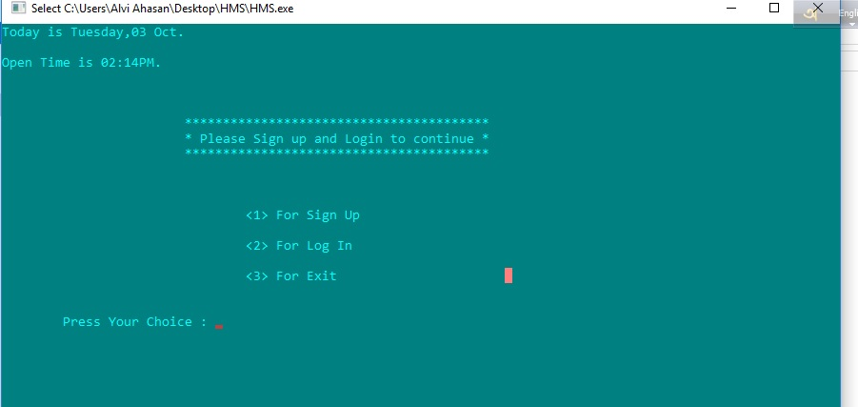

[Fig: **Main** console of this application.]

* By pressing one then it will successfully exit from this application. And by pressing two then it will back from the exit menu.

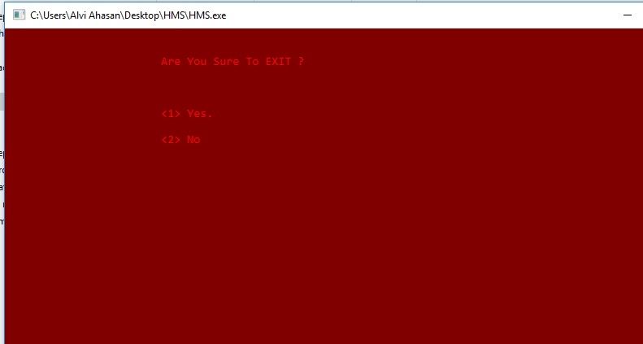

[ Fig: **Exit** option of this application.]

**14**

* By pressing wrong input to any menu of this application and press any key for back menu.

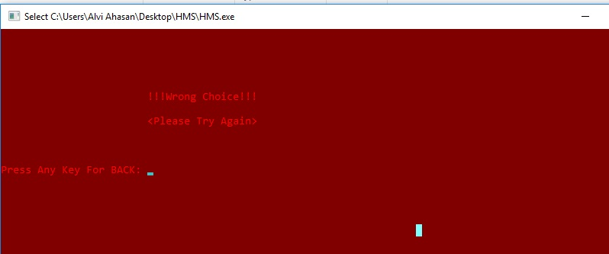

[Fig: **Error** massage for any menu of this application.]

* By pressing one for registration and inventory item of an employee.
* By pressing two for registration and inventory item of a patient.

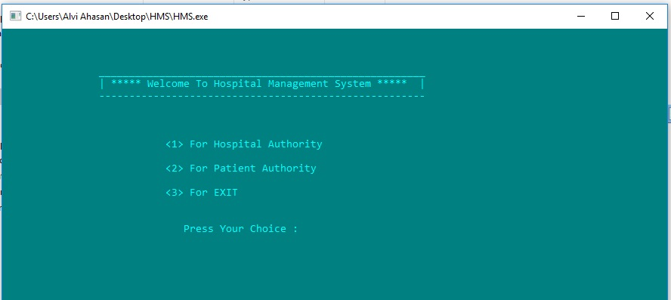

[Fig: **User catagory** option of this application.]

**15**

* By pressing one for registration new employee, modify, search, and delete any employee and list of all employees.
* By pressing two for add new inventory item, modify, search, delete any inventory item and list of all inventory item of employee.
* By pressing three for know about of this application.

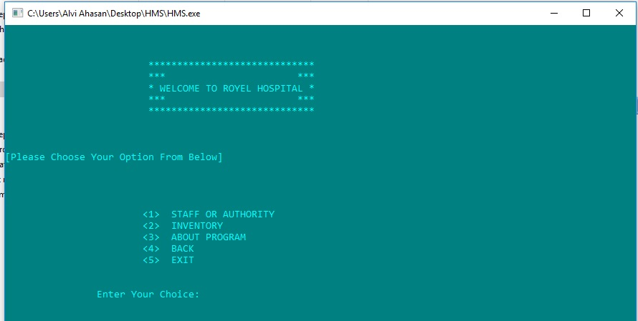 [Fig: Employee main menu option of this application.]

* By pressing one for registration new patient, modify, search, and delete any patient and list of all patients.
* By pressing two for add new inventory item, modify, search, and delete any inventory item and list of all inventory item of patient authority.
* By pressing three for know about of this application.

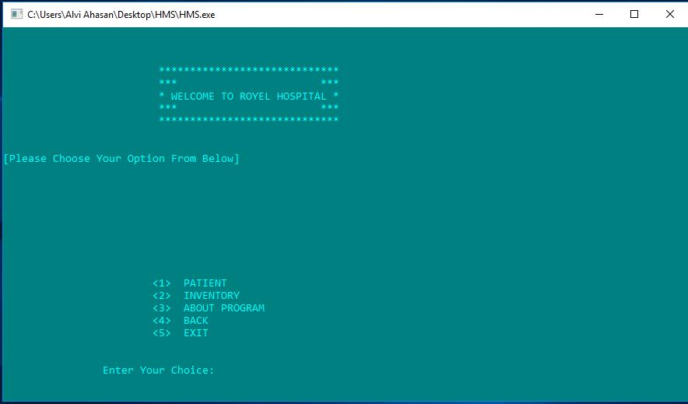

[ Fig: Patient main menu option of this application.]

**16**

* By pressing user choice for registration new employee, modify, search, and delete any employee and list of all employees.

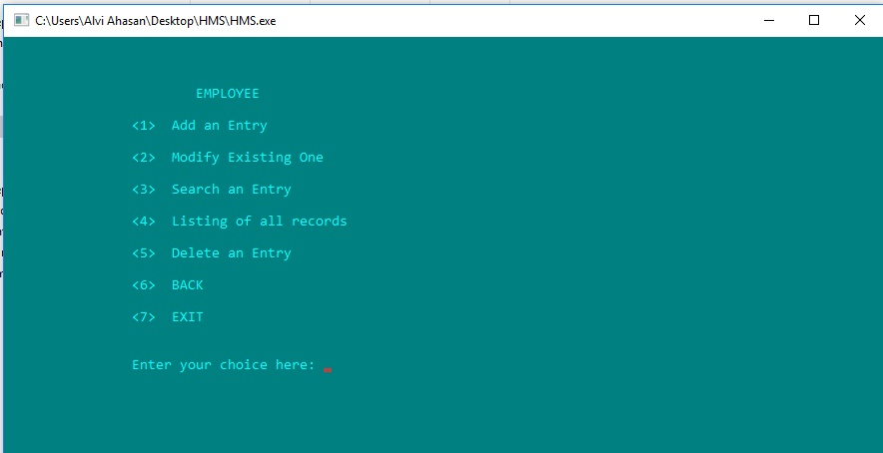

[Fig: Employee record base option of this application.]

* By pressing user choice for registration new patient, modify, search, and delete any patient and list of all patients.

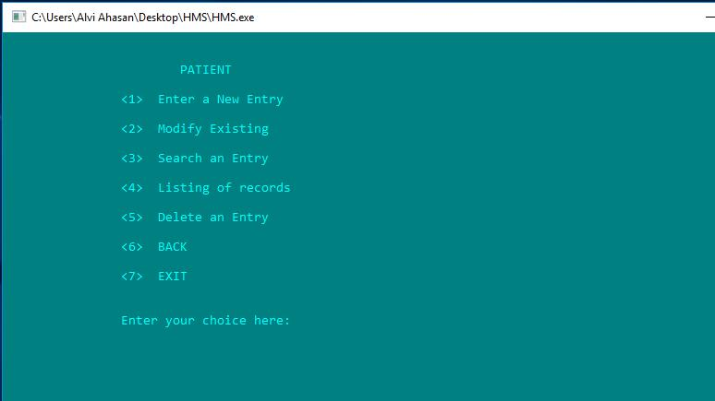

[ Fig: Patient record base menu of this application]

**17**

* Giving input about a employee to the employee id, name, guardian name, gender, blood group, age, salary, address, phone number and designation of a employee.
* Giving input about a patient according to the same way to employee (id, name, guardian name, gender, blood group, age, address, phone number, any treatment record, reference Dr.name and current treatment record to modify of a patient).

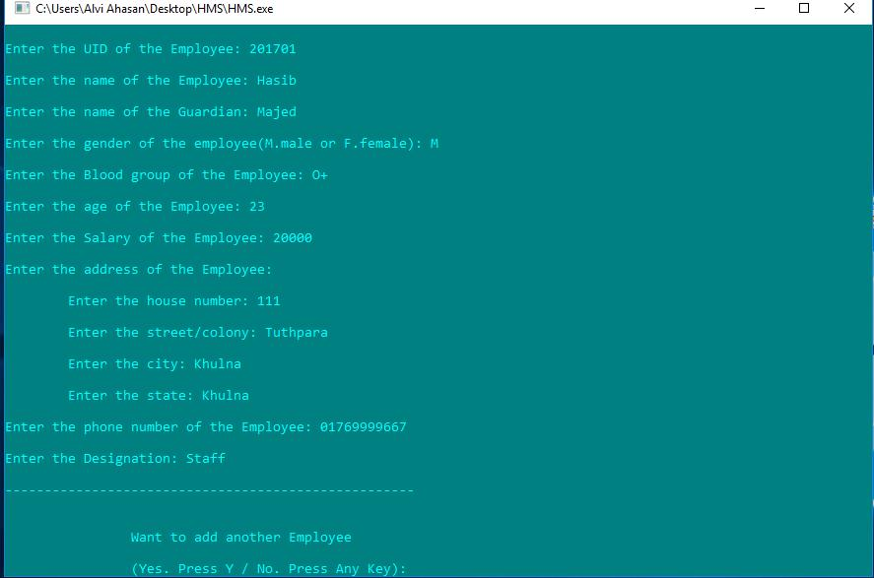 [Fig: To input of employee record option]

**18**

* Giving output about a employee to the employee id, name, guardian name, gender, blood group, age, salary, address, phone number and designation of a employee.
* Giving output about a patient according to the same way to employee (id, name, guardian name, gender, blood group, age, address, phone number, any treatment record, reference Dr.name and current treatment record from modify of a patient).

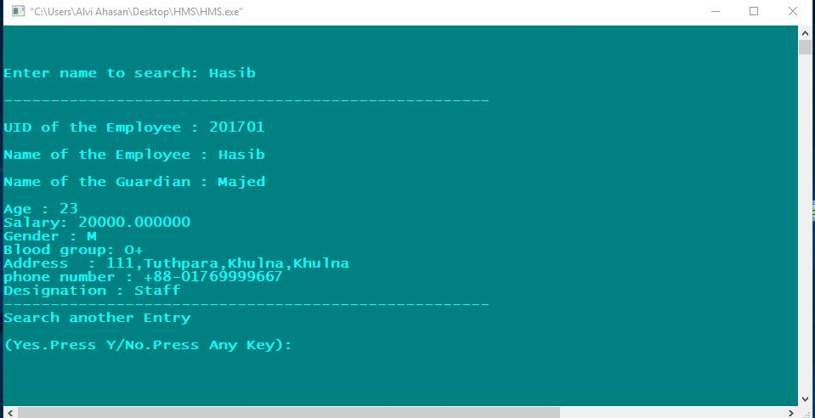

[Fig: To output of employee record option]

* To search a record With a employee or a patient or a invantory item name.If record not found from file then show this massage and we want to back menu from current menu then we will press any key from keyboard.

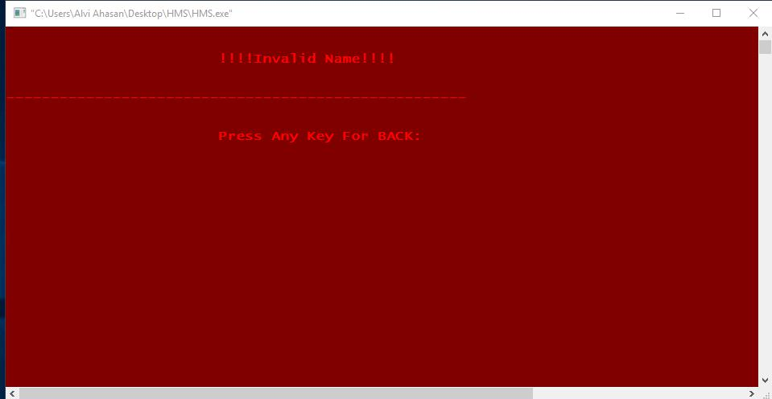

[Fig: To search a wrong name]