Создание Dockerfile jupyterhub c предустановленными библиотеками oauthenticator, dockerspawner, jupyterhub-nativeauthenticator.

FROM jupyterhub/jupyterhub:latest

RUN pip install --no-cache \

oauthenticator \

dockerspawner \

jupyterhub-nativeauthenticator

#COPY jupyterhub_config.py /srv/jupyterhub/jupyterhub_config.py

Сборка Dockerfile **zms-notebook:latest** с предустановленной библиотекой psycopg2 для соеденения с postgres.

FROM jupyter/minimal-notebook:latest

USER root

RUN apt-get update && \

apt-get install -y --no-install-recommends \

libpq-dev gcc && \

apt-get clean && \

rm -rf /var/lib/apt/lists/*

RUN pip install --no-cache-dir psycopg2-binary

USER jovyan

CMD ["start-notebook.sh"]

Конфигурационный файл jupyterhub_config.py

from nativeauthenticator import NativeAuthenticator

from dockerspawner import DockerSpawner

c.JupyterHub.authenticator_class = NativeAuthenticator

c.JupyterHub.spawner_class = DockerSpawner

c.JupyterHub.log_level = 'DEBUG'

c.JupyterHub.hub_ip = '0.0.0.0'

c.JupyterHub.spawner = DockerSpawner

c.JupyterHub.db_url = 'sqlite:///data/jupyterhub.sqlite'

c.DockerSpawner.network_name = 'jupyter-network'

c.DockerSpawner.remove = True

c.DockerSpawner.volumes = {"jupyterhub-user-{username}": "/home/jovyan/work"}

c.Spawner.notebook_dir = "/home/jovyan/work"

c.DockerSpawner.image = "zms-notebook:latest"

c.GenericOAuthenticator.enable_auth_state = True

#c.Authenticator.allowed_users = set()

c.Authenticator.admin_users = {'zmcadmin'}

c.NativeAuthenticator.open_signup = True

c.Authenticator.allow_all = True

c.Spawner.start_timeout = 120

docker-compose.yaml

services:

db_postgres:

image: postgres:16

volumes:

- /var/lib/postgresql/data:/var/lib/postgresql/data

container_name: zubaev

environment:

POSTGRES_USER: zms

POSTGRES_PASSWORD: 123456

POSTGRES_DB: test_db

ports:

- "5434:5432"

restart: unless-stopped

networks:

- jupyter-network

jupyterhub:

build: .

volumes:

- /var/run/docker.sock:/var/run/docker.sock

- /srv/jupyterhub/data:/srv/jupyterhub/data

- ./jupyterhub_config.py:/srv/jupyterhub/jupyterhub_config.py

ports:

- "8000:8000"

networks:

- jupyter-network

volumes:

jupyterhub_data:

networks:

jupyter-network:

name: jupyter-network

Контейнер внутри

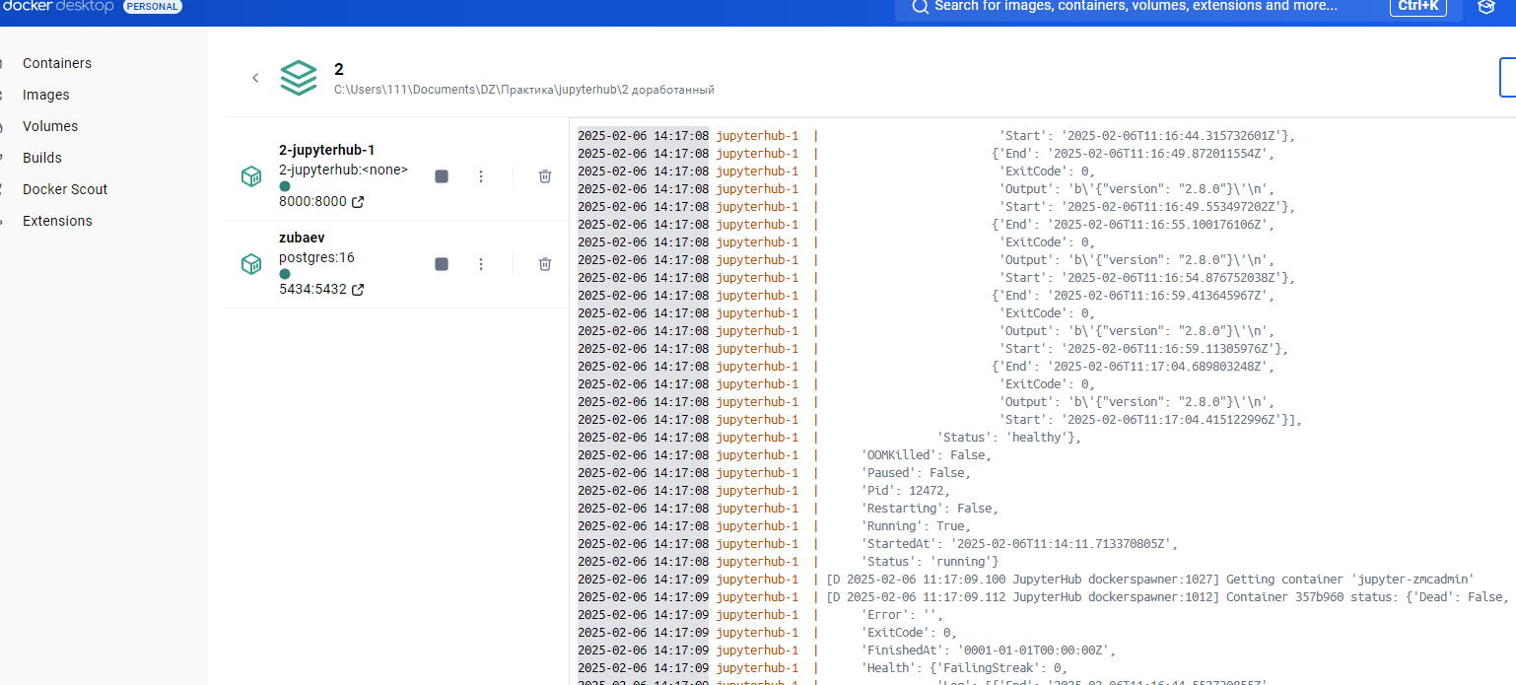

**Регистрация пользователя User1**

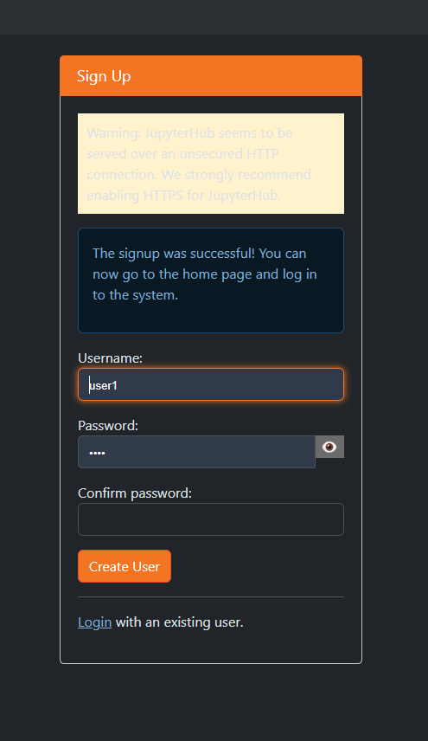

Список контейнеров

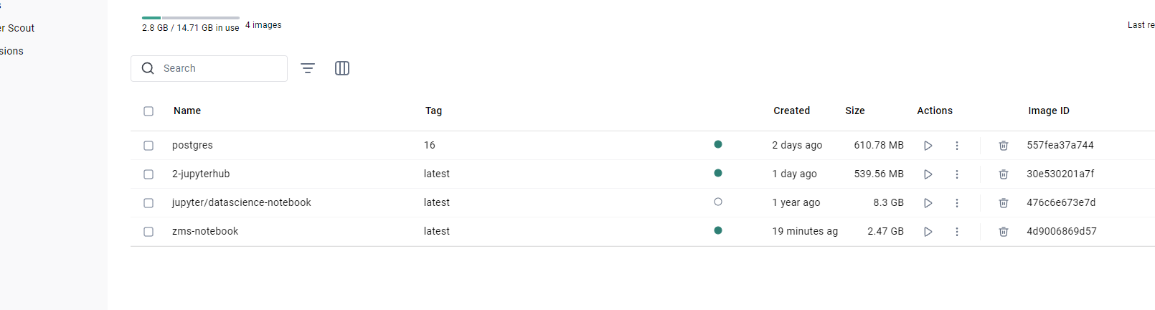

Каталоги созданные для пользователей

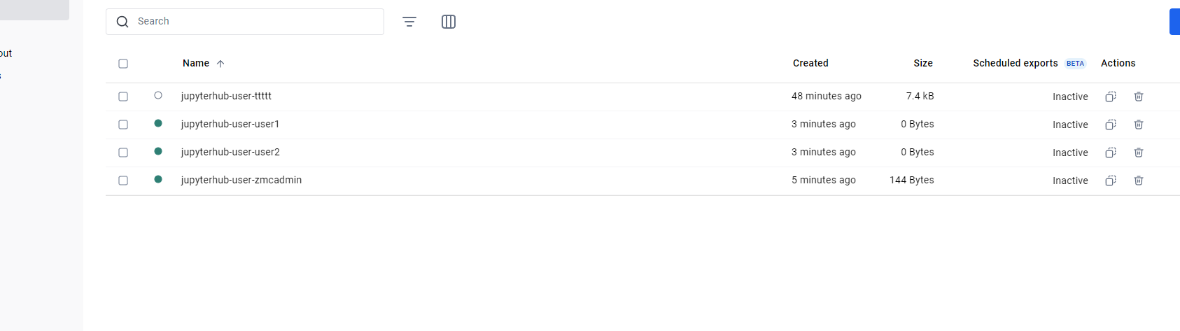

Список пользователей JupuyerHub

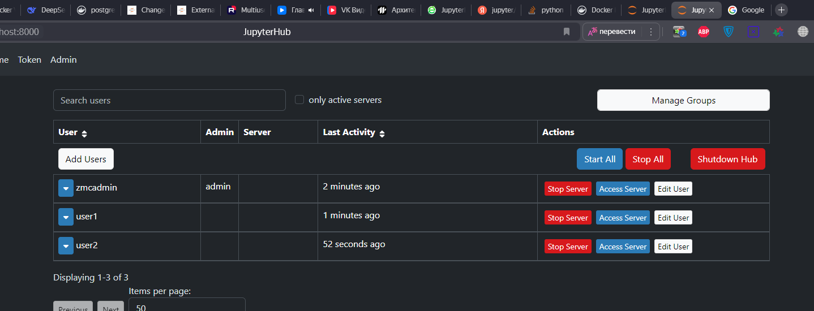

Создание таблицы в Postgres Через Jupyter

